**Lowe Family Cookbook**

**2020 Edition**

© 2019

Print available at http://www.blurb.com/

Cover by Diane Wong-Kone

This book is dedicated to the cooks in our family.

# Foreword

Yvonne Chan Cheng

你吃了没 (*nei sik zuo mei*)? – “Have you eaten yet?” These warm and welcome words of a familiarChinese idiom, rang through the ears of our great-grandfather Ching Lowe (1858-1952) as he frolicked with friends in the village of Ping Shan (平山) in southern China. Breathless and happy with beads of sweat gathering at the ends of his full head of shiny black hair, he would enter the steamy kitchen of his family’s abode filled with the familiar redolence of stir-fried vegetables seasoned with a mixture of minced garlic and ginger and steamed white fish atop a bed of fermented red bean curd garnished with aromatic green scallions. Until, one day, food became scarce and his traditional, agrarian world grew ever more chaotic and insecure due to the aftermath of the Taiping Rebellion (1850-1964) coupled with severe drought and famine which struck the Pearl River Delta.

Our intrepid great-grandfather departed his homeland to seek opportunity and a new life in a foreign land. He set sail on the stormy, uncertain South China Sea through the vast Pacific Ocean to the sandy shores of California where he met and married May Moon Mar of Monterey. Their descendants, like the fruits of the transplanted Meyer lemon, have firmly sunk roots in the soil of a shared Earth where the food and flavors from their Chinese heritage enhance daily life – homemade *bao*, steamed dumplings (*fun gaw*), butterfly cookies (*don san*), steamed taro root (*wu tao go*), sweet crescent cookies (*teem gok*) and baked braids of leftover dough.

Although the discriminatory Chinese Exclusion Act of 1882 banned immigration of Middle Kingdom kindred from joining their brethren in California who built the First Transcontinental Railroad and harvested fruit, the men and women who earlier settled in California bore children who automatically became Americans. The San Francisco Earthquake of 1906 destroyed immigration records which allowed a handful of Chinese merchants who were naturalized citizens to reregister as United States citizens. These newly minted citizens gave hope to reams of “paper sons” – those in China who paid to come to America by adopting the surname of their sponsor.

The first volume of our family cookbook aimed to preserve the treasured recipes of older generations of family members who graced our lives with fond memories of food prepared for special occasions as well as staples served for simple meals. The second volume represents a Chinese-American Inclusion Act – a call to all, in particular the younger generation, to submit their favorite recipes, which not only reflect the advent of the microwave, food processor, and electric pressure cooker but also our family’s history through food. Furthermore, these recipes display the host of cultures within the far-reaching branches of our family tree.

The Chinese brought over kumquats, loquats, persimmon, and pomelos. In addition, the Meyer lemon, smooth-skinned sunshine on a vine, originated in China. Hearty, productive, and vigorous, the Meyer lemon symbolizes our family’s history in California which is inextricably tethered to a rich culture that spans millennia. An “Improved Meyer Lemon” arose in the 1950s. We also offer an updated version of our family cookbook – *Lowe Family Cookbook: 2020 Edition*. We have added entries from our growing clan as well as commemorate the excellent cooks in our family who have enriched our lives immeasurably with delightful and delicious memories stemming from food made with love and care.

[食飯!](https://www.omniglot.com/soundfiles/cantonese/bonappetit_ca.mp3) Sek Fahn!

Cheryle, Diane, Annette & Yvonne

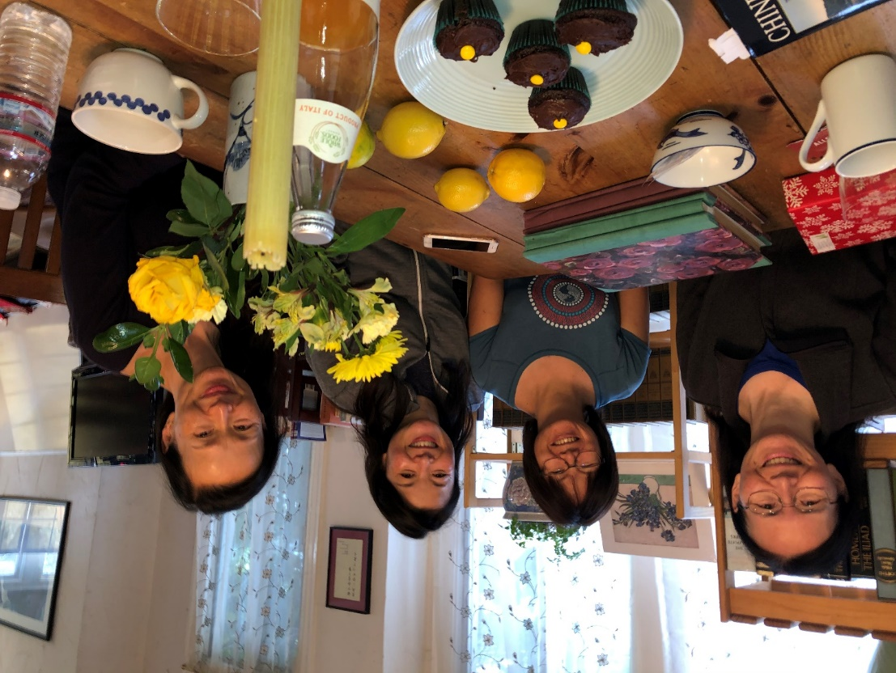

# Acknowledgements

Thank you to everyone who contributed recipes, stories, and photos. We especially thank Karen and Yvonne for hosting the cookbook gatherings.

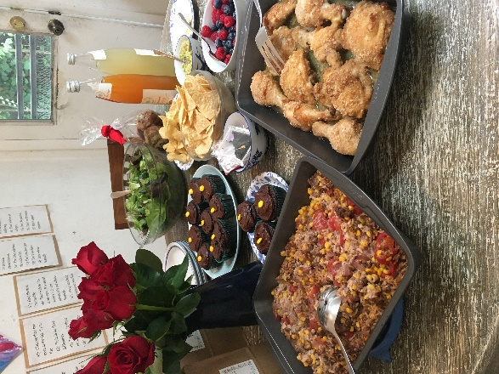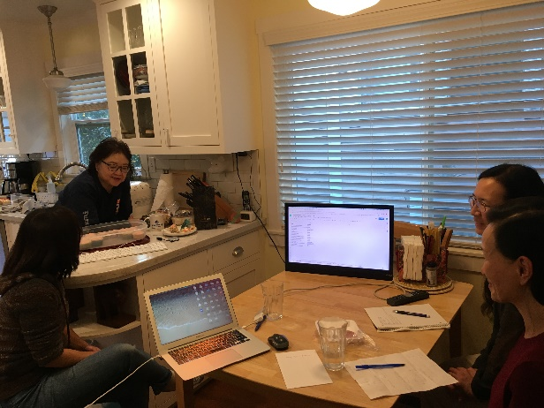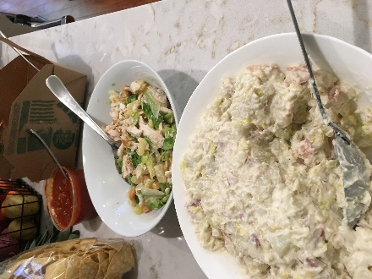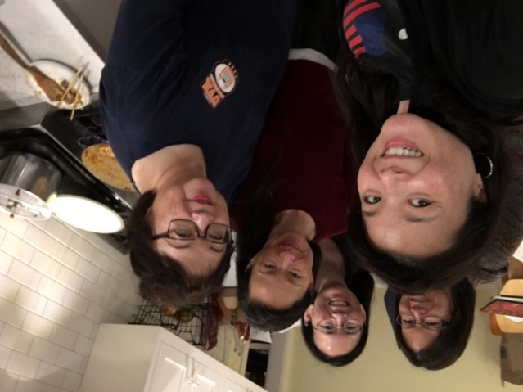

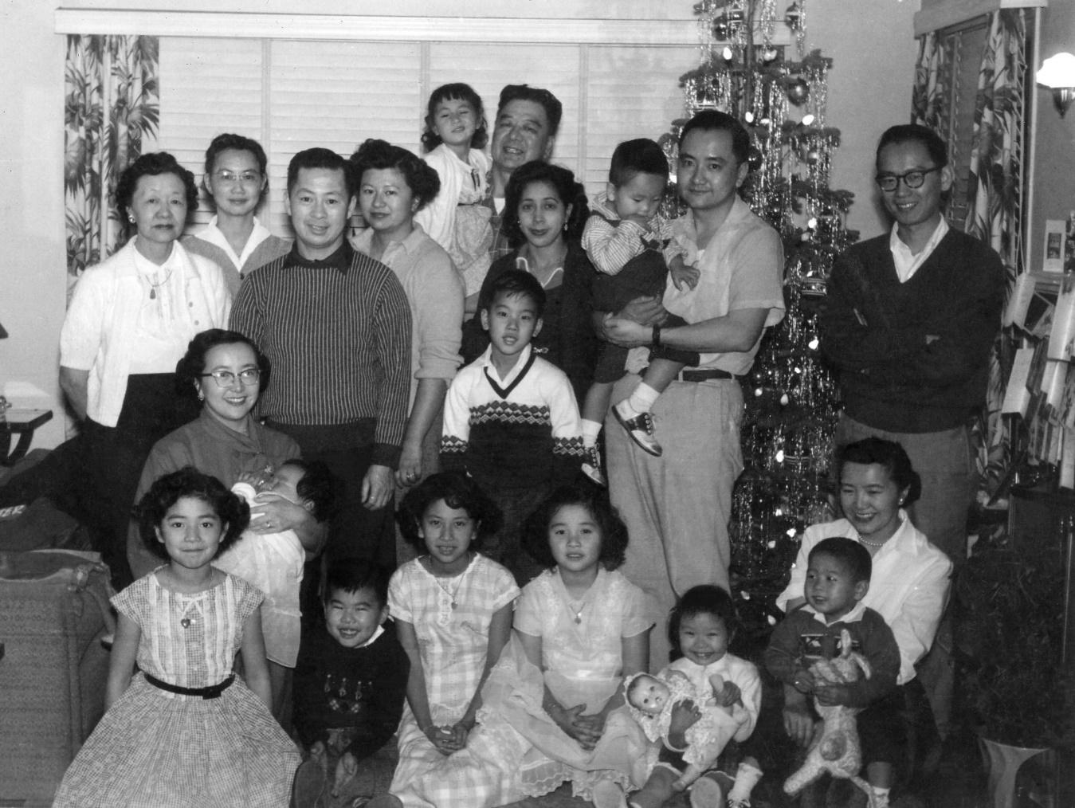

The Lowe family in Oakland at Christmas, 1957. From left to right, top row: Daisy Chan, Edith Lowe, George Louie, Gladys Louie, Roberta Lowe, Robert Lowe, Lydia Lowe, Arthur Wong, David Chan, and Warren Ng; middle row: Evelyn Wong holding Shirley Wong and Reagan Louie; bottom row: Barbara Lowe, Brandon Louie, Mary Lowe, Karen Lowe, Wendy Ng, and Elsie Ng holding Douglas Ng.

**Table of Contents**

Foreword 5

Acknowledgements 7

Appetizers 11

Breads 29

Generations of Pomelos 44

Soups & Salads 45

Side Dishes 63

Main Dishes 81

Desserts 153

Miscellaneous 205

Homage to The Yellow Cookbook 220

A Brief History of the Mar Family 221

Photo Captions 225

Finding Home 233



# Appetizers



Family portrait in Edith Lowe’s yard, Sacramento 1977. From left to right, top row: Calvin Lowe, Ken Miyao, Bill Trygg, David Chan, Gladys Louie, Denise Chan, Lydia Lowe, Roberta Lowe, Robert Lowe, Al Lowe, Evelyn Wong, Gary Ng, Arthur Wong, and Susanna Wong; middle row: Reagan Louie, Karen Miyao, Mary Lowe, Daisy Chan, and Edith Lowe; bottom row: Cullen Lowe, Barbara Trygg holding Darrin Trygg, Cheryle Miyao, Yvonne Chan, Clifford Chan, Elsie Ng, Carlton Chan, Sam Wong holding Diane Wong, and Annette Chan.

**Appetizers**

Crab Wonton 13

Fried Wonton 13

Fried Stuffed Chicken Wings 14

Curry Crescents for a Party 15

Easy Cha Siu Bow for a Party 15

Mini Shrimp Rolls 16

Art's Onion Pancake 16

Minced Clam Dip 17

Spinach Dip 17

Miyao Miyao Salsa Pico de Gallo 18

Paper Wrapped Chicken 19

Korean Fried Chicken Wings 19

Lumpia 20

Spinach Balls 21

Spam Musubi 21

Diane’s Camping Egg Rolls 22

Chicken in Foil 23

Vietnamese Cold Spring Rolls 24

Chicken Wing “Drumsticks” 25

Omuk 25

Fun Gaw (Steamed Dumplings) 26

Japanese Style Grilled Mussels 28

## Crab Wonton

Source: Gladys Louie

Submitted by: Mary Lowe

Use sweetened chili sauce for dipping.

Two 8 oz. pkgs cream cheese, softened

4 stalks chopped green onions

1 small can water chestnuts, chopped

Dash Worcestershire sauce

6 oz. - 8 oz. crab meat or imitation crab, shredded

1 package wonton skins

Mix together cream cheese, green onions, water chestnuts, Worcestershire sauce, and crab. Fill wonton skins with filling and fold accordingly. Deep fry and drain on paper towel.

## Fried Wonton

Source: Gladys Louie

Submitted by: Mary Lowe

*Got the filling recipe from Auntie Gladys, who originally got the recipe from Parks & Recreation.*

2-3 lbs. ground pork

⅓ lb. shrimp, cleaned and chopped

2-3 Chinese black mushrooms, finely chopped

1 can water chestnuts, finely chopped

2 packages wonton skins

Dash powdered garlic, salt and pepper

1 t. soy sauce

½ t. sesame oil

Combine all ingredients, except wonton skins. Place about 1 t. meat mixture on a wonton skin; fold the square diagonally and use egg whites or water to seal. Deep fry and drain on paper towel.

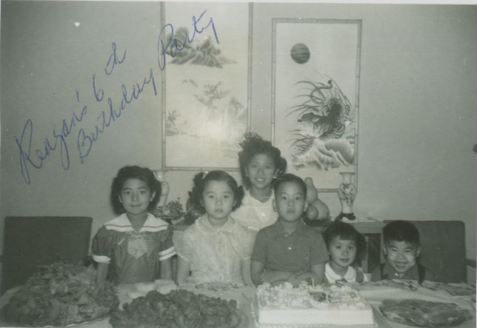

## Fried Stuffed Chicken Wings

Source: *Treasured Recipes From Two Cultures - American and Chinese*, St. Mark’s United Methodist Church

Submitted by: George Louie

16 chicken wings, boned (about 3 lbs.)

¼ lb. ham (preferably Virginia Ham), cooked and sliced matchstick thin

OR 3 Chinese sausages (lop cheung), pre-steamed 15 minutes and sliced in matchstick slivers

¼ c. (1 lb. size) bamboo shoots (jook soon), cut into matchsticks

AND/OR ⅓ c. celery, cut into matchsticks

8 large dried Chinese mushrooms (shitake), pre-soaked for 2 hours and sliced fine

Green onions or scallions, white part, sliced thinly

To bone chicken wings:

Wing portion is in three sections, i.e. little drumstick, wing, and tip. Start with the little drumstick, cut tendons at top, cut down with sharp boning knife, removing meat from bones and continue on to the wing section. Leave the tip as it is because it is used as a handle. This is not difficult to do and improves with practice. A few small holes may occur but keep to as few as possible.

Marinate boned chicken wings for several hours with:

2 T. or more soy sauce

Uncle George’s tip: Use sherry if you don’t have rice wine

½ t. garlic powder or chopped garlic

2 t. rice wine

Hoisin sauce

1 t. fresh or ground ginger (optional)

Stuff marinated chicken wings with sliced ingredients. Dip chicken wings into the “Jow” brand fry mix batter or any deep fry batter. Fry in hot oil until golden brown. OR if prefer not to have batter, dip wings in flour, then in milk, then in an unseasoned flour and cornstarch mixture. May be fried in an inch of oil in electric skillet.

Variations: The stuffed chicken wings may be steamed about 25 minutes (no batter), then pan fry in a little oil until lightly brown. Serve with thickened gravy.

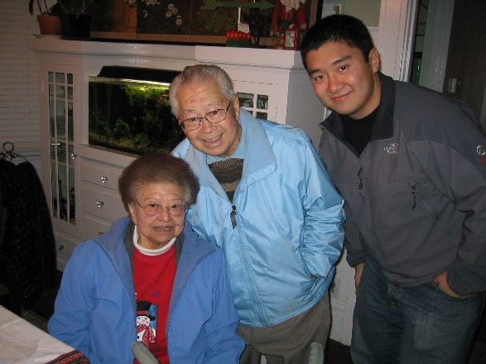

## Curry Crescents for a Party

Source: Evelyn Wong

Submitted by: Diane Wong-Kone

Pillsbury crescent dough (in the refrigerator section at the grocery store)

Ground beef

Curry (to taste)

Onion (chopped)

Salt and pepper (to taste)

1 egg (beaten)

Oil for frying

Add 1 T. oil to pan and cook onion until translucent. Add beef and brown meat. Add spices to taste. Cool mixture. Spoon into pre-made dough. Roll into crescents according to package instructions. Brush tops with egg for a shiny glaze. Bake on cookie sheets in oven at 350°F for ~10 minutes or until golden brown.

## Easy Cha Siu Bow for a Party

Source: Evelyn Wong

Submitted by: Diane Wong-Kone

Pillsbury biscuits (in the refrigerator section at the grocery store)

Cha siu (Chinese BBQ pork)

Green onion (chopped)

Hoisin sauce

Soy sauce

Sugar (not too much)

Cornstarch (just enough to thicken the sauce)

1 egg (beaten)

~ 2" cut wax paper squares

Cook cha siu, green onion, hoisin, soy sauce, a little sugar and cornstarch in a pan until sauce is thickened. Cool. Meanwhile, peel off pre-made biscuit dough and flatten into circles. Put a spoonful of meat into the center of each dough circle. Fold up the sides of the dough and pinch closed. Put wax paper squares on a cookie sheet and put the bow on the wax paper. Brush top of bows with egg glaze. Bake at 350°F for ~10 minutes or until golden brown.

## Mini Shrimp Rolls

Source: Unknown

Submitted by: Mary Lowe

These are good--and you don’t have to fry them.

1 pound medium cooked shrimp, peeled and deveined

6 oz. reduced-fat cream cheese

1 c. shredded part-skim mozzarella cheese

1½ c. finely chopped cabbage

3 green onions, finely chopped

½ c. shredded carrot

1 T. reduced sodium soy sauce

2 garlic cloves, minced

48 wonton wrappers

2 T. flour

3 T. water

Chop shrimp; set aside. In a mixing bowl, beat cream cheese until smooth. Add mozzarella cheese, and mix well. Stir in the cabbage, green onions, carrot, soy sauce, garlic and shrimp. For each shrimp roll, place 1 T. of shrimp mixture across the bottom third of a wonton wrapper to within ¼ inch of bottom and side edges. Combine flour and water until smooth, brush a ¼ inch wide strip on side edges and fold side edges over 1/4 inch. Brush side edges and top edge with water mixture. Fold bottom third of wonton wrapper over filling, then bring top over and pinch edges to seal completely.

Lightly spray rolls with nonstick cooking spray. Place on a baking sheet coated with nonstick cooking spray. Bake at 400°F for 15-18 minutes or until golden brown, turning once. Serve warm.

Yield: 4 dozen.

Art's Onion Pancake  
Source: Art Wong

Submitted by: Diane Wong-Kone

*Art made these for his kids, Nat and Courtney, when they were growing up. They make a great, quick snack.*

flour tortillas  
green onions  
oil for frying  
  
Drizzle a little oil in heated pan and place 1 tortilla in pan. Sprinkle a generous amount of chopped green onion on top. Fold tortilla in half. Brush with oil. Flip and fry until crisp. Cut into wedges. Serve immediately.

## Minced Clam Dip

Source: Unknown

Submitted by: Karen Miyao

*Our family loves this dip. Whenever I make this for a party, I have to make a separate serving for our family or else it will disappear before our guests have arrived! (Note: this recipe has been modified since it was last published.)*

2 (3 oz.) pkgs of cream cheese

1 (7 oz.) can minced clams

½ clove garlic, grated fine

½ t. Worcestershire sauce

2 t. lemon juice

4 T. clam juice

2-3 drops of Tabasco

Salt to season

Allow cream cheese to soften to room temperature. Drain clam juice, reserving 4 tablespoons. Blend all above ingredients. Season with salt. Refrigerate. Serve with plain potato chips. Makes 1 cup.

## Spinach Dip

Source: Knorr’s

Submitted by: Mary Lowe

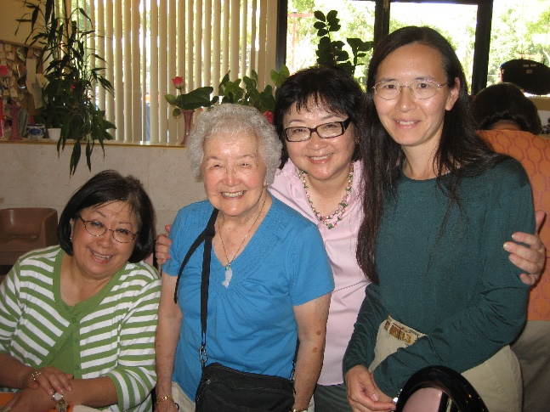*This is a great party/potluck dip. This recipe is from the Knorr’s Leek Soup box and has been around for years.*

1 round French bread

1 baguette French bread

1 (10 oz.) package frozen chopped spinach

1½ c. sour cream

1 c. mayonnaise

3 chopped green onions

8 oz. chopped water chestnuts

1 pkg Knorr Leek or Vegetable soup mix

Thaw and squeeze chopped spinach until dry. Stir together spinach, sour cream, mayonnaise, soup mix, water chestnuts, and green onions. Blend well. Cover and refrigerate two hours. Stir before serving.

Cut off the top of the bread similar to a lid. Spoon out inside of bread. Pour mixture into bread shell. Put lid back on bread until ready to serve.

Slice baguette French bread and cut into halves. Bread that was spooned out can be toasted and used for dipping.

## Miyao Miyao Salsa Pico de Gallo

Source: Karen Miyao

Submitted by: Karen Miyao

*When tomatoes are at their peak here in the Sacramento valley during summertime... (note: This replaces the salsa recipe I submitted for the earlier cookbook. I no longer use the food processor, which I think changes the flavor of the salsa.)*

4-5 heirloom tomatoes

1-- 28oz can organic DiNapoli can whole tomatoes (I think these are the BEST can tomatoes because they are from our California valley and flavor is great... my opinion: better than San Marzanos can tomatoes from Italy.)

½ chopped red onion

½ chopped yellow onion

3 stems chopped green onions

4-5 finely chopped fresh garlic cloves

¾ - 1 c. chopped cilantro with a little bit of stems

4-5 chilis (I use a mix of jalapeños, shishito, serrano and others. I include some Thai chilis sometimes as Kenny grows different varieties. You may add and use your desired number of chilis, dependent upon degree of heat/spice you desire or like. I just chop entire chili sans stem...with seeds and all ribbing.)

I chop all by hand... only because it's my opinion that if done by food processor or other machines, it changes chemical balance and many a time can easily over chop.

For seasoning add a little sugar, fresh ground pepper, Lawry's season salt, kosher salt, garlic salt.

Everything is by taste.

Optional: You can add fresh corn kernels or frozen uncooked baby corn kernels (I don’t even cook because tomato acidity kind of cooks), chopped cucumber sans seeds, or fresh chopped avocado. If adding fresh avocado, you may have to eat salsa within a few days.

One may cut down portions to half... this is how much I normally make because I give away a lot every time.

## Paper Wrapped Chicken

Source: Lydia Lowe

Submitted by: Mary Lowe

2 lbs. chicken thighs and breast meat, cut into pieces

5 whole green onions, cut 1“ length

Coriander leaves

Mary’s tip: Wrap and freeze into batches. Whenever needed, defrost (30 min.) and cook.

Marinade:

3 T. soy sauce

3 T. dry sherry

3 T. hoisin sauce

1 T. sesame oil

1 T. sugar

Dash pepper

Mix together marinade - marinate chicken in marinade for at least 30 minutes. Wrap in foil or parchment with coriander and green onions. Deep fry 6-8 packets at a time for about 3 minutes or oven bake at 400°F for about 12 minutes.

## Korean Fried Chicken Wings

Source: Adapted from America’s Test Kitchen

Submitted by: Karen Miyao

1 tablespoon toasted sesame oil

1 teaspoon garlic, minced to paste

1 teaspoon grated fresh ginger

1¾ cups water

3 tablespoons sugar

2–3 tablespoons gochujang (Korean chili paste)

1 tablespoon soy sauce

2 quarts vegetable oil

1 cup all-purpose flour

3 tablespoons cornstarch

3 pounds chicken wings, cut at joints, wingtips discarded

Marinate chicken in white wine or sherry, grated ginger, chopped fresh garlic, soy sauce, little sugar.

Combine sesame oil, garlic, and ginger in large bowl and microwave until mixture is bubbly and garlic and ginger are fragrant but not browned, 40 to 60 seconds. Whisk in ¼ cup water, sugar, gochujang, and soy sauce until smooth; set aside.

Heat vegetable oil in Dutch oven over medium-high heat to 350 degrees. While oil heats, whisk flour, cornstarch, and remaining 1½ cups water in second large bowl until smooth. Set wire rack in rimmed baking sheet and set aside.

Place half of wings in batter and stir to coat. Using tongs, remove wings from batter one at a time, allowing any excess batter to drip back into bowl, and add to hot oil. Increase heat to high and cook, stirring occasionally to prevent wings from sticking, until coating is light golden and beginning to crisp, about 7 minutes. (Oil temperature will drop sharply after adding wings.) Transfer wings to prepared rack. Return oil to 350 degrees and repeat with remaining wings. Reduce heat to medium and let second batch of wings rest for 5 minutes.

Heat oil to 375 degrees. Carefully return all wings to oil and cook, stirring occasionally, until deep golden brown and very crispy, about 7 minutes. Return wings to rack and let stand for 2 minutes. Transfer wings to sauce and toss until coated. Return wings to rack and let stand for 2 minutes to allow coating to set. Transfer to platter and serve. One can also wait up to two hours to refry chicken in 375°F oil.

Karen’s variation using teriyaki sauce:

I add my own sauce to the recipe they provided as I thought it needed more of something and less of gochujang as I can't take too much spice.  My teri sauce is boiling together 1 small can tomato sauce, 1 c. sugar, 1 c. Kikkoman soy sauce, ¼ c. white wine or sherry. I also add grated ginger, garlic, black pepper.

## Lumpia

Source: Shirley Wong-Jose

Submitted by: Shirley Wong-Jose

*They always disappear fast at any potluck party. Tim and Jessica love this Filipino version of Chinese egg rolls!*

1 package eggroll skins

~1 lb. ground beef (ground turkey or chicken may be substituted)

1 package frozen vegetables (mixed peas, corn, & carrots work well)

1 diced potato

oil for frying

soy sauce, oyster sauce, salt and pepper for seasoning

Brown meat in skillet. Season with salt, pepper, oyster sauce, and soy sauce to taste. Add potato. Just before removing from heat, add frozen vegetables. Note: The vegetables will still look semi-frozen when filling is removed from the heat, but will finish cooking during the frying of the lumpia. Let filling cool. Wrap in egg roll skins. Heat oil in wok or skillet and fry lumpia until golden brown. Serve with soy sauce or sweet and sour sauce.

## Spinach Balls

Source: Unknown

Submitted by: Diane Wong-Kone

*My co-worker introduced this to me and then I started making them for taiko potlucks. I often skip the parmesan. Some additives or substitutes I’ve used include mushrooms, finely chopped cashews, and panko breadcrumbs. Panko and onion powder are good substitutes for lower sodium.*

2 10-oz. boxes of frozen, chopped spinach

2 cups Pepperidge Farm herb bread stuffing

1 medium onion, finely chopped

4 eggs, beaten

¾ cup melted butter

½ cup parmesan cheese

½ tsp garlic salt

¼ tsp pepper

Cook and drain spinach very well. Mix all ingredients in a bowl and then refrigerate. Make into balls. Cook 20 minutes at 350˚F. Good with honey mustard! Makes 60 spinach balls

## Spam Musubi

Source: Unknown

Submitted by: Annette Chan

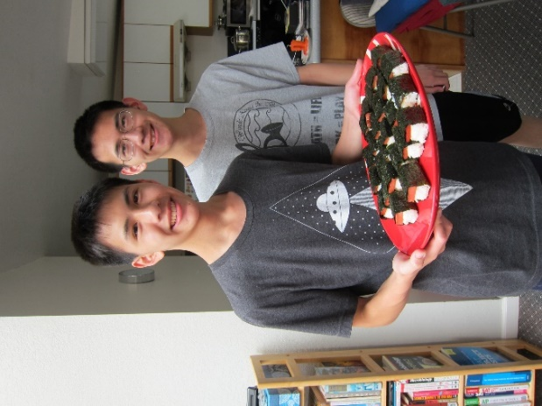2 cups medium-grain, California rice (regular cups, not rice cooker cups)

2 ½  cups water

6 Tbsp. rice vinegar

¼  cup soy sauce

¼  cup oyster sauce

½  cup white sugar

12 oz. container Spam

10 sheets sushi nori (dry seaweed)

2 Tbsp. vegetable oil

1. Wash rice in 5 changes of water. Soak the uncooked rice for 4 hours. Drain.

2. Cook the rice with 2 ½ cups of water, using a rice cooker. Mix in the rice vinegar. Allow the rice to cool.

3. Mix together the soy sauce, oyster sauce, and sugar. Slice the Spam into 10 slices, and marinate the slices in the sauce for 5 minutes.

4. Heat oil in a pan over medium heat. Cook the Spam slices for 2 minutes per side, until lightly browned. Cut each slice into 4 pieces.

5. Cut each nori sheet into 4 long strips.

6. Form approximately 1”x1”x3”-blocks of rice with a sushi mold or with your hands. Dip your fingers in water to keep rice from sticking to them. Place a cube of rice in the center of a piece of nori. Top with a piece of Spam. Wrap nori around the rice and Spam, sealing edge with a small amount of water.

7. Musubi can be served warm or chilled.

## Diane’s Camping Egg Rolls

Source: Recipes from the Members of the Northern California Fly Fishing Board

Submitted by: Diane Wong-Kone

*In 2000, my friend, Dawn, and I were part of the Nevada Bird Atlas Crew, and we traveled all over the state with our dogs, camping and birding. One day I decided to make egg rolls on the camp stove. After weeks of working in the Great Basin and eating PBJ sandwiches, these were a treat. Dawn put this recipe in the NCFFB cookbook. We were limited to whatever ingredients we could find at the local small grocery store/gas station in rural Nevada. We couldn’t find oyster sauce but did find shrimp. Feel free to substitute and add to the recipe.*

1 pound lean ground meat or firm tofu, drained and crumbled

2 tablespoons oil for stir-frying

1 package coleslaw cabbage mix (preferably one with carrots)

¼ pound bean sprouts

3 green onions

¼ to ½ pound little shrimp, diced

2 tablespoons oyster sauce (optional)

1 package egg roll wrappers

Splash of soy sauce to taste

Stir-fry meat/tofu in oil in a wok or skillet over high heat until lightly browned (adding minced ginger is great!). Add cabbage mix, bean sprouts, green onions, and shrimp. After a couple minutes, add oyster sauce, if using, and soy sauce to taste. Let mixture cool.

Using 1-2 tablespoons filling, wrap rolls. Take a wrapper with one corner pointed toward you and add filling across the wrap (so it’s between the side corners and not pointed toward you). Fold the corner pointed toward you over the filling; bring the two side corners together so you have a packet that looks like an envelope. Moisten top flap with water. Roll over the last corner to seal. Lay egg roll, flap side down, on a plate until they are all rolled. If you are in the desert, you will need to cover the egg rolls with a damp paper towel to prevent drying. Fry rolls in vegetable oil a few at a time, turning occasionally, until golden. Drain on paper towels and eat. Although best eaten right out of the wok, they can also be eaten cold as camp snacks.

## Chicken in Foil

Source: Modified from *Treasured Recipes From Two Cultures - American and Chinese*, St. Mark’s United Methodist Church

Submitted by: Cheryle Miyao-Quock

*I remember Uncle George and Paw-Paw making this dish for parties. Time-consuming but worthwhile. Someday, I’ll make it for Dean and his mom, who also enjoys this dish.*

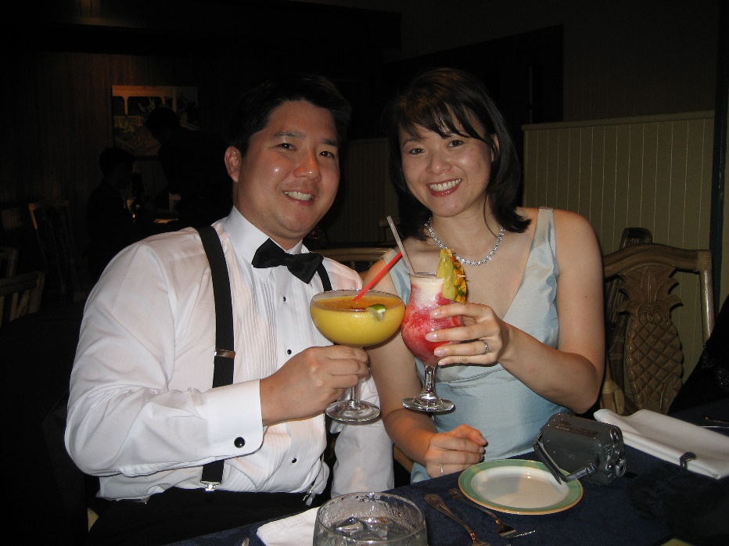2 lbs chicken breasts or thighs, sliced thin

Marinade

3 T. catsup

¼ t. MSG

¼ t. ng heung fun (five spice)

1 heaping t. hoisin sauce, or more to taste

6 T. salad oil

3 T. soy sauce

1 ½ t. salt

1 ½ T. rice wine

2 t. cornstarch

Optional:

Green onions, sliced thin or chopped

Cilantro, chopped

Lop cheung (Chinese sausage), sliced thin, ⅛ inch diagonal

Marinate sliced chicken for a few hours in above mixture. When chicken is ready to be wrapped, chop and mix in some green onions and/or Chinese parsley (cilantro).

Cut squares of foil measuring 4-inch square. Place small amount, about 1 t. chicken mixture with one optional slice of lop cheung in middle of foil. Fold the two corners together to make a triangle, or fold a rectangle, if preferred. Fold edges of foil over twice to seal tightly.

Place in roasting pan and roast 16-18 minutes in 350°F oven. If meat is thick, roast 18-20 minutes.

Makes about 70 pieces.

## Vietnamese Cold Spring Rolls

Source: Modified from Heather Feather, online recipe accessed on February 22, 2002

Submitted by: Diane Wong-Kone

*I think it’s the peanut sauce that makes these taste so good.*

Yield: Approximately 24 rolls

You can use any cooked meat or fish combo that you prefer. Vegetarians may omit meat.

1 package clear edible rice paper sheets

½ lb cooked chicken, sliced

½ lb cooked small shrimp (peeled, deveined, halved)

1 bunch fresh cilantro leaves

1 bunch fresh mint leaves

1 head leafy lettuce, washed and separated into leaves

1 cucumber, peeled and cut into very thin strips

1 cup fresh bean sprouts, optional

1 package vermicelli rice noodles, prepared according to package directions

Have all meats precooked and cold and the rice noodles prepared already (the noodles should be white, long and at room temp). Make sure all veggies and herbs are cleaned, dried, and set out before you start.

Dip a sheet of rice paper wrapper into water very quickly, no longer than a second or two (or they will get too soggy) and lay flat on a work surface.

On one edge, lay a small handful of noodles, a few strips of meat, some shrimp, some cilantro and mint leaves, a lettuce leaf, some cucumber strips and bean sprouts, all to taste but don't overstuff. Carefully start to roll up eggroll style, tucking in the sides, then continue to roll up-but not too tightly or the spring roll will split.

Serve immediately, or wrap in plastic wrap. It is best to make just as many as you plan to serve (store any extra unassembled fillings in fridge and roll later).

Peanut Sauce:  
1 tablespoon peanut oil  
2 garlic cloves, minced   
1 teaspoon chili paste  
1 tablespoon tomato paste   
½ cup water   
½ teaspoon sugar   
2 tablespoons natural peanut butter (no sugar added)  
¼ cup hoisin sauce

Sriracha hot sauce

Heat oil in a medium saucepan. Add the garlic, chili and tomato paste and fry about 30 seconds until the garlic is golden brown. Add the water, sugar, peanut butter and hoisin sauce and whisk to dissolve. Bring to a boil, then reduce heat and simmer 3 minutes. Remove from heat and serve at room temperature. Top with a dab of Sriracha hot sauce.

## Chicken Wing “Drumsticks”

Source: *Stella Chan’s Secrets in the Art of Chinese Cooking* by Stella Chan

Submitted by: Diane Wong-Kone

*This is one of several recipes my mom bookmarked in her cookbook.  She often made this recipe for family party potlucks.*

10 chicken wings (yield 20 drumsticks)

1 egg white – slightly beaten

⅓ cup cornstarch – mixed with 1 teaspoon baking powder

Peanut oil for deep-frying

Marinade for wings:

1 teaspoon five-spice powder

½ teaspoon sugar

½ teaspoon MSG (optional)

1 teaspoon rice wine

1 teaspoon salt

1 teaspoon soy sauce

Discard wing tips. Cut between the joints. Remove the smaller bone of the lower wing. Cut skin loose around the small end and push skin and meat up to form drumstick. Marinate wings for 1 hour. Add egg white. Coat wings evenly. Dredge in cornstarch mixture. Deep-fry for 3 minutes. Drain. Let cool. Deep-fry once again right before serving.

Secrets:

1. Using egg white to coat the wings will help to seal the juice inside the meat. Hence the meat will be juicier.
2. Using cornstarch and baking powder helps to make the outside layer crisp.
3. To deep-fry twice: –the first time is to cook the meat and seal the juice in the meat. The second time is to make the outside crisp. Make sure the oil is very hot before you deep-fry for the second time.

## Omuk

Source: Wendy Chang

Submitted by: Diane Wong-Kone

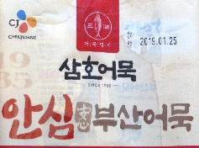*This is a cold fish dish you get at Korean restaurants, along with kimchi and other things to eat (banchan) with the main meal.*

4 sheets of omuk (fish cake)

3 T. soy sauce

1 ½ T. sugar

1 t. sesame oil

Omuk package – this can be found frozen in Asian/Korean grocery stores.

½ c. water

Place all in a saucepan. Cook on medium until evaporated.

## Fun Gaw (Steamed Dumplings)

Source: Edith Lowe & basic recipe from *Florence Lin’s Complete Book of Chinese Noodles, Dumplings, and Breads*

Submitted by: Elsie Ng & Wendy Chang

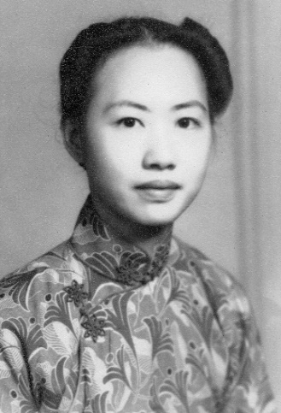

*Some of my fondest childhood memories are of Auntie Edith’s kitchen. Her counter was an exotic, well-organized, jarred collection of dried yams, dried bananas, hung joe, dried vegetables, and the like. Sometimes near her back porch was homemade rice wine fermenting in the sun. But, my favorite memory of Auntie Edith was her cooking. Homemade bao, fun gaw (steamed dumplings), don san (butterfly cookies), wu tao go, teem gok (sweet crescent cookies), even baked twists of leftover dough . . . mmm, delicious! We kids loved the goodies that came from Auntie’s kitchen!*

*One time, when I asked Auntie Edith for a recipe, she told me, “A wun (Chinese rice bowl) of that, a chigun (Chinese soup spoon) of this . . . .” Hmm. Following is my best approximation of her fun gaw.*

**Meat Filling:**

½ lb. lean ground pork

3-4 dried Chinese mushrooms, soaked, then diced very small

3 T finely chopped green onions

1 t cornstarch

½ t sugar

1 T soy sauce

1 T dry sherry

2 T peanut oil

1 t salt

⅛ t white pepper

½ T oyster sauce

1 T cornstarch mix

Mom says to add 1 T chung choy. A friend says to add 1 T ha mei (small dried shrimp, minced) plus 1 rib of celery (diced small).

Mix the pork with the cornstarch, sugar, soy sauce, and sherry. Stir fry until the pork separates into bits—don’t overcook. Set aside to cool in a bowl. (If using the ha mei, stir fry with the pork.)

Stir fry the mushrooms, green onions, (chung choy and/or celery) for a minute. Season with salt and pepper. Add back the cooked pork. Season with the oyster sauce. Mix together the cornstarch and water, add to the pan, and stir until all is well mixed. Transfer to a bowl and let it cool. It is best to make this a day ahead and refrigerate it overnight.

**Dough:**

½ lb. wheat starch, about 1½ cups

½ C tapioca flour

¼ t salt

1½ C boiling water

2 T peanut oil

Combine the wheat starch, tapioca flour, and salt in a large mixing bowl. Make a well in the center and pour in all the boiled water. Mix the flours and water together well. Add the oil. Continue to mix until a ball forms. Turn the hot dough onto a work surface and knead the dough until it is very smooth—about 2-3 minutes. Place the dough in a tightly closed plastic bag and let it rest for 5 minutes.

Divide the dough into four pieces. Keep three of them in the plastic bag to stay warm. Roll the fourth piece into a long sausage shape about 8” long. Cut into 10 pieces. If you want to use a tortilla press, oil the press lightly, then press a dough piece into a 3- inch round. Press the remaining pieces.

Place about 2 t of filling into the middle of the dough round. Fold over to make a half moon shape. Press or pleat edges together. If pleating, just pleat the front edge of the half moon. Set the dumpling upright on a flat surface and push the corners inward so that the dumpling stands upright when it is steamed.

Make 10 dumplings at a time. Place the finished dumplings on an oiled tray while the rest are being made. (There will probably be leftover meat mixture.)

Oil your steamer. Steam about 5 minutes or until dough is translucent. Let the dumplings cool a little before removing them from the steamer. If you remove them too soon, they will tear. Serve. Enjoy!

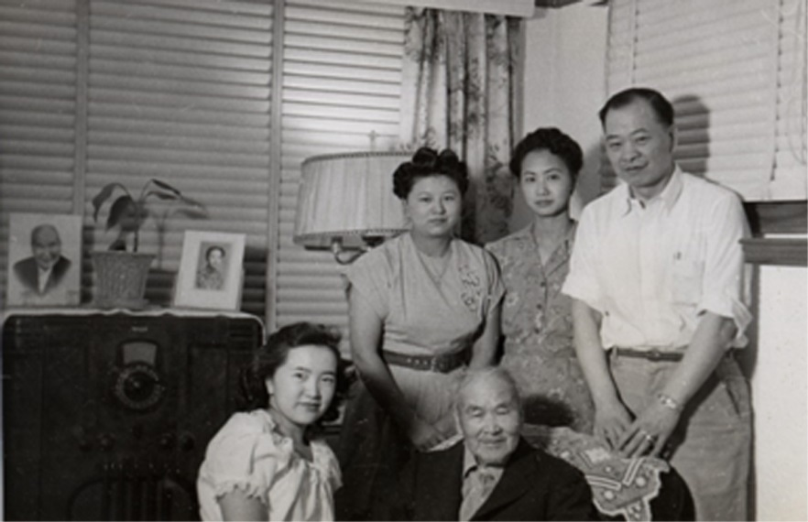

## Japanese Style Grilled Mussels

Source: Unknown

Submitted by: Diane Wong-Kone

*Adama likes to order the grilled mussels at sushi restaurants. This is the recipe I use when I make them at home.*

The dressing recipe is for about a dozen New Zealand Green-lipped or two dozen black mussels. If using fresh: quickly sauté in a hot pan with a touch of oil until they pop open. Remove from pan. Served on the half shell.

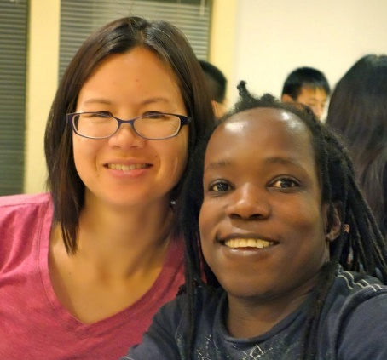  
Dressing:  
1 clove garlic, minced   
1 tsp ginger, minced  
½ tsp lemon zest, minced  
½ lemon, juiced  
1½ tsp wasabi prepared  
2 tsp white sugar  
1 whole green onion, sliced fine  
¾ c mayonnaise  
1 tsp soy sauce  
¼ tsp toasted sesame oil  
1 or 2 finely chopped green onions

Toppings:   
Panko breadcrumbs

Tobiko (flying fish roe, found in Asian markets)

Green onion

Loosen mussel from shell but leave adductor muscle attached for easier eating. Arrange in a large baking pan, broiler safe.

Combine all ingredients for dressing. Place about a tablespoon of dressing over mussel half. Sprinkle with a little panko. Broil or grill on the hot BBQ until bubbly and lightly browned. (Alternately, 450˚F oven, top shelf, 5-10 min. in a pan). Remove from baking pan and top with Sriracha, green onion and optionally with some tobiko.

# Breads

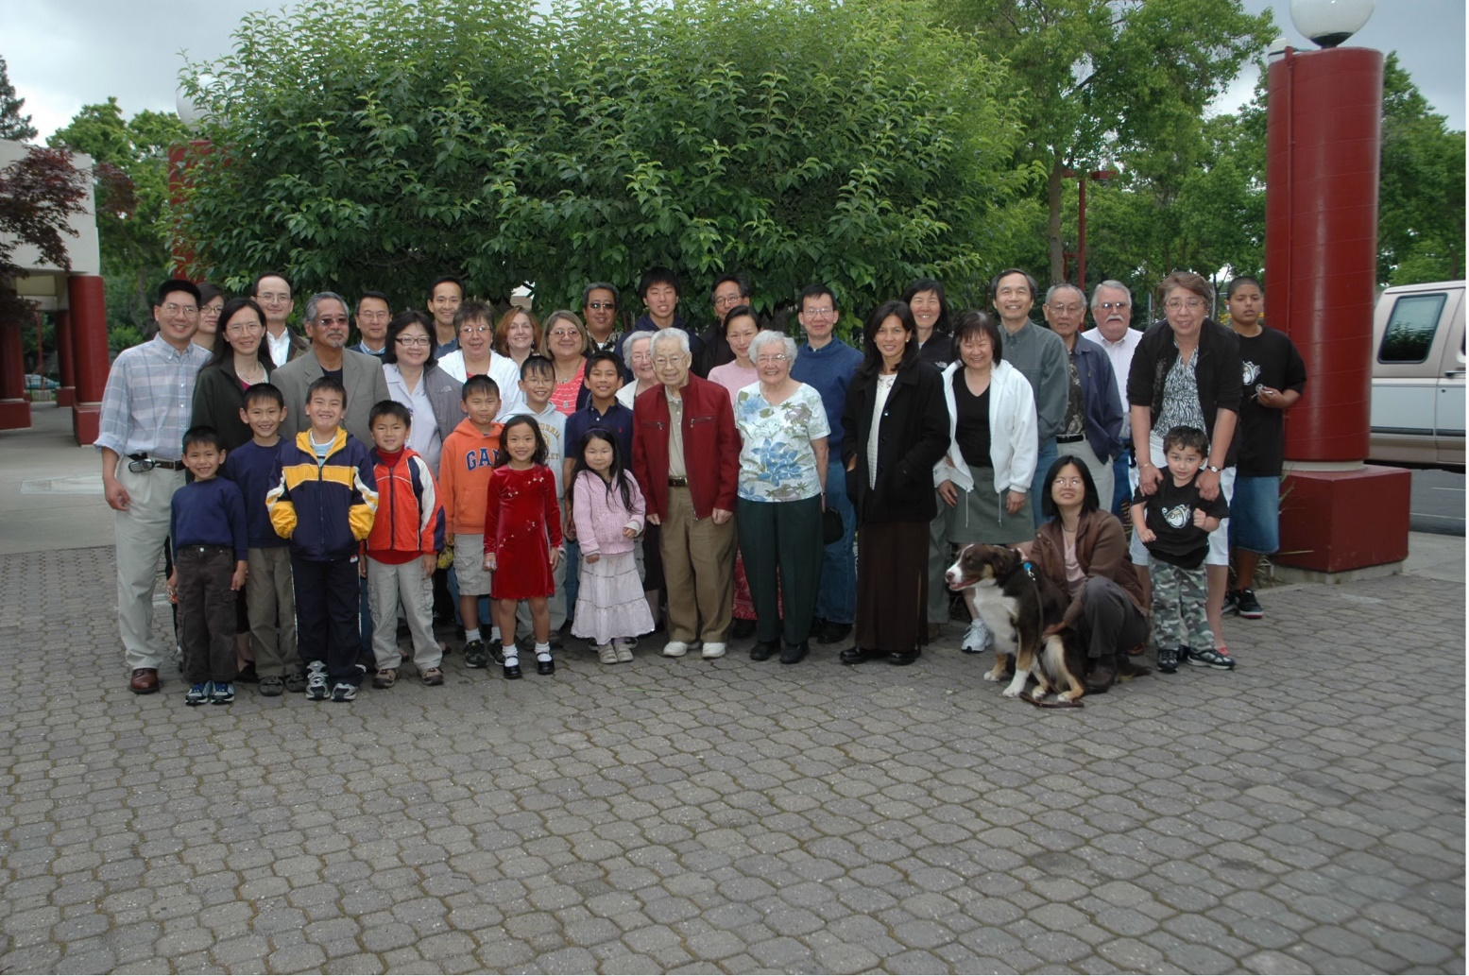

Family photo at Dragon Palace Restaurant, Sacramento, 2008. From left to right, top row: Jennifer Chan, Clifford Chan, Douglas Ng, Carlton Chan, Debi Lowe, Calvin Lowe, Ralston Louie, and Reagan Louie; middle row: Charles Lee, Annette Lee, Ken Miyao, Karen Miyao, Mary Lowe, Roberta Lowe-Taylor, Evelyn Wong, Yvonne Chan Cheng, Andrew Cheng, Robin Louie, Sammy Chang, Sam Wong, Thom Taylor, Barbara Lowe, and Darrin Trygg; bottom row: Thomas Lee, Philip Lee, Nicholas Chan, Matthew Chan, Joseph Cheng, Maria Chan, Samuel Cheng, Joseph Chan, Annie Cheng, George Louie, Elsie Ng, Regina Chan, Wendy Chang, Charlie (Diane’s dog), Diane Wong, and Robert Trygg (held back by Barbara).

**Breads**

Armenian Bread 31

Banana Nut Bread 32

Zucchini Bread 32

Chinese Bow (Steamed) 33

Bow 33

Baked Barbecue Pork Bun 34

Green Onion Buns (Hua Juan, Flower Rolls 36

Pumpkin Pancakes 37

Chinese Donuts (Yow Til or Fried Ghost) 37

Perfect Biscuits 38

French Toast 39

Snack Rolls 39

Best Blueberry Muffins 40

Year of the Dog Banana Nut Muffins (Gluten-free) 41

Raspberry Streusel Muffin Tops 42

Almost No Knead Bread 43

## Armenian Bread

Source: Becky Ferguson

Submitted by: Karen Miyao

*Makes beautiful loaves.*

5 lbs. flour

2 c. sugar (save ½ c. to mix with yeast/warm water)

2-3 t. Mahleb*

1 dozen eggs

1 12 oz. can evaporated milk

1 can warm water (12 oz.)

2 t. vanilla

2 pkgs dry yeast

1 lb. butter

Egg

Sesame seeds

Dissolve yeast in warm water with ½ c. sugar (let it get a fair amount of foam on it). Melt butter. Beat eggs slightly.

Put flour in a large bowl and make a hole in center. (I mix up all the dry ingredients first—flour, 1½ c. sugar, Mahleb, and then make a hole in center and put in liquids). Add all the rest of the ingredients (dump in the hole) and mix well. Knead for 30 minutes or until dough is no longer sticky. Let rise for 3-4 hours.

Roll into strands, approximately 12”-14” long and ¾” thick. Braid three strands to make a loaf (cover and let rise in warm place); can get 3 loaves to a jelly roll pan (grease the pans). Makes 12-14 loaves. You can make smaller strands and get more loaves, if you wish. By the time you get the last loaves made, the first pan should be ready for the oven. Just before baking, brush lightly with beaten egg and sprinkle with sesame seeds.

Bake 325°F for 20-25 minutes.

*Mahlab is a spice made from dried, ground, sour black cherry pits, used in the Middle East (Greece, Turkey, Syria). Mahlab has a highly fragrant nutty, bittersweet, sour taste. Can be purchased at Middle Eastern stores or on-line.

## Banana Nut Bread

Source: Daisy Chan

Submitted by: Annette Chan & Yvonne Chan Cheng

*You can add raisins with the nuts. This bread tastes very good sliced and toasted.*

½ c. shortening

1 c. sugar

2 eggs

2 c. flour

1 t. salt

½ t. soda

½ t. baking powder

1 c. chopped nuts

3 very ripe bananas mashed

Cream shortening and add sugar; beat eggs and add to creamed mixture. Sift dry ingredients together and add to creamed mixture. Add mashed bananas and mix well. Add nuts and put in greased loaf pan. Bake in 350˚F oven for 1 hour.

## Zucchini Bread

Source: Lydia Lowe

Submitted by: Mary Lowe

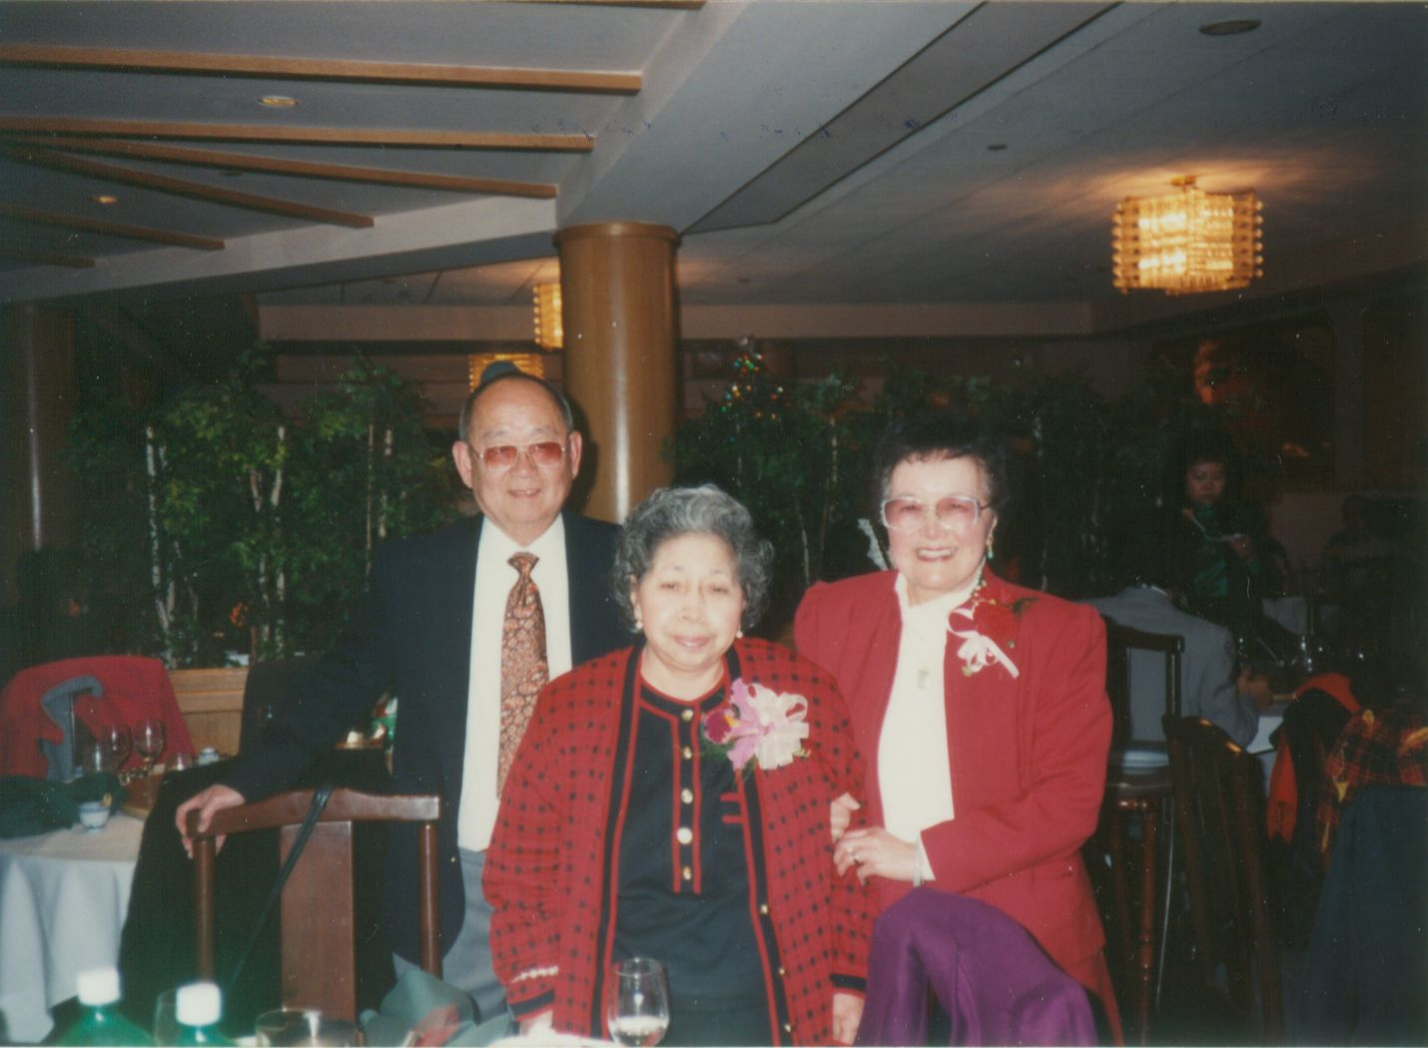1 c. oil

2 c. sugar

3 eggs

2 c. peeled/shredded zucchini

3 t. vanilla

3 c. flour

1¼ t. salt

1 t. baking soda

¼ t. baking powder

1 t. cinnamon

½ c. chopped walnuts or raisins

Mix together oil, sugar, eggs, zucchini and vanilla. Sift together flour, salt, baking soda, baking powder and cinnamon. Add to first mixture. Stir in nuts or raisins until blended. Bake in two greased and floured 9x5-inch loaf pans at 325°F for 1 hour. Makes 2 loaves.

## Chinese Bow (Steamed)

Source: Lydia Lowe

Submitted by: Evelyn Wong

8 c. flour

1 yeast cake or dry yeast

1 c. sugar

1 c. warm milk

1 c. warm water. If not enough, add more water

3 T. Crisco

Dissolve yeast in warm milk. Then add flour, Crisco, and sugar. Mix and knead a few times until smooth. Add more water if dough is stiff. Let dough rise in a warm place for about 1 ½ hours. Dough should be double in size. Punch dough down and pinch off a piece, about 2 inches in diameter. Spread out dough and fill with filling (see Edith Lowe’s Bow recipe). Let buns rise again. Steam about 15-20 minutes.

## Bow

Source: Edith Lowe

Submitted by: Evelyn Wong

Not quite 5 lbs. flour

1 rice bowl (about 1½ c.) lukewarm water

Dissolve 1½ cake yeast in above water

1 egg

1 c. sugar

Knead for 20 minutes. Let rise for 1-2 hours.

Stuffing:

1 lb. pork, minced

1 lb. char siu (Chinese BBQ pork)

Parsley

Onion

Mushroom

Nam yue (fermented red bean curd)

Soy sauce

Salt

In a frying pan or wok, cook pork until done. Add onion and cook until translucent. Add mushroom and the rest of the ingredients. When done cooking, cool and use to fill the bow. {Editors; note: the recipe did not include baking directions. We suggest following instructions for the Baked Barbecue Pork Buns recipe submitted by Annette and Yvonne}.

## Baked Barbecue Pork Bun

Source: Daisy Chan and Denise Chan

Submitted by: Annette Chan & Yvonne Chan Cheng

*When our mother finished making these buns for dinner, we could never wait to eat them, and we often ate more buns before dinner than during the meal. The recipe for the char siu (Chinese BBQ pork) was from Man Lung Grocery Store in Oakland Chinatown. The store made excellent char siu, and our grandmother (Daisy Chan) got the recipe from them.*

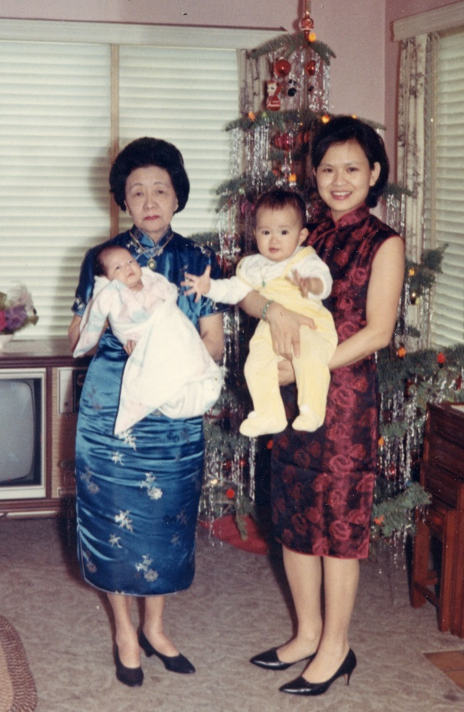

Filling:

3-3½ lbs. pork butt, shoulder or tenderloin

4 T. dark soy sauce

2 T. light soy sauce

5 T. sugar

3 T. honey

2 T. hoisin sauce

1 T. grated fresh ginger

1 T. Shao Hsing rice wine or dry sherry

1½ t. salt

½ cube fermented red bean curd (manufactured by Chan Moon Kee, Hong Kong)

⅛ t. saltpeter (potassium nitrate)*

Remove excess fat from the pork. Cut the pork into 2-inch-wide strips (with the grain).

Combine the dark soy sauce, light soy sauce, sugar, honey, hoisin sauce, ginger, rice wine or sherry, salt, bean curd, and saltpeter. Rub mixture over the pork. Cover and marinate in the refrigerator at least overnight or up to 3 days, turning several times.

Place the pork on a pan lined with foil. Roast for 30 minutes at 350°F, turning once halfway through. Increase the heat to 425°F and roast 10 minutes.

Let cool and dice.

Dough:

1 c. warm milk (105-110°F)

½ c. unsalted butter or ⅓ c. vegetable oil

¼ c. sugar plus 1 T. sugar

½ t. salt

1 package active dry yeast

¼ c. warm water (105-110 °F)

4. c. unbleached all-purpose flour

2 large eggs, room temperature

Mix together ¼ c. sugar and vegetable oil or cut the butter into the ¼ c. sugar. Mix together the yeast, ¼ c. warm water, and 1 T. sugar. Mix together warm milk and 2 eggs. Add the milk mixture to the oil/butter mixture. Add the yeast mixture.

Add 2 c. flour and salt. Mix together. Slowly add the remaining 2 c. of flour. Add just enough flour to keep dough from sticking to your hands. If dough is too sticky, add more flour (you can add up to 1 c. of extra flour). Dough should be very soft, but it should not stick to your hands.

Oil a pot. Put dough in pot. Coat the dough with a thin layer of oil. Cover the dough, and let it double in size in a warm location. Punch down the dough. Knead it into a ball. Cover the dough, and let it double in size again in a warm location.

Making the bow:

Egg wash:

1 egg yolk

½ t. sugar

1 t. water

Flatten a piece of dough, fill it with pork filling, seal the bow bottom, and invert the sealed end onto a greased pan. Repeat with the rest of the dough. Place the bow about ½ inch apart from one another. Let rise again. Bake at 375°F for 20 minutes. Mix together the egg, sugar, and water. Brush on egg wash when bows turn light brown. Cook a few minutes longer.

Makes 20 buns.

Note (to make plain buns with no pork filling):

You can also break off pieces of the dough, tuck ends of dough into the middle to make the dough a round shape (this is the preferred method; do not roll into balls). Invert the dough onto a greased pan about ½ inch apart from each other, let rise, and bake at 375°F for 20 minutes. Can brush egg wash on these buns, as well (see above).

*Saltpeter or potassium nitrate can usually be found in a drugstore.

## Green Onion Buns (Hua Juan, Flower Rolls)

Source: Denise Chan

Submitted by: Annette Chan & Yvonne Chan Cheng

2 T. Crisco shortening

1 package yeast

¼ c. warm water

2 T. sugar

1 t. salt

¾ c. hot water

4 c. flour

⅓-½ c. water

Crisco shortening

¼ t. salt

Chopped green onion

Vegetable oil

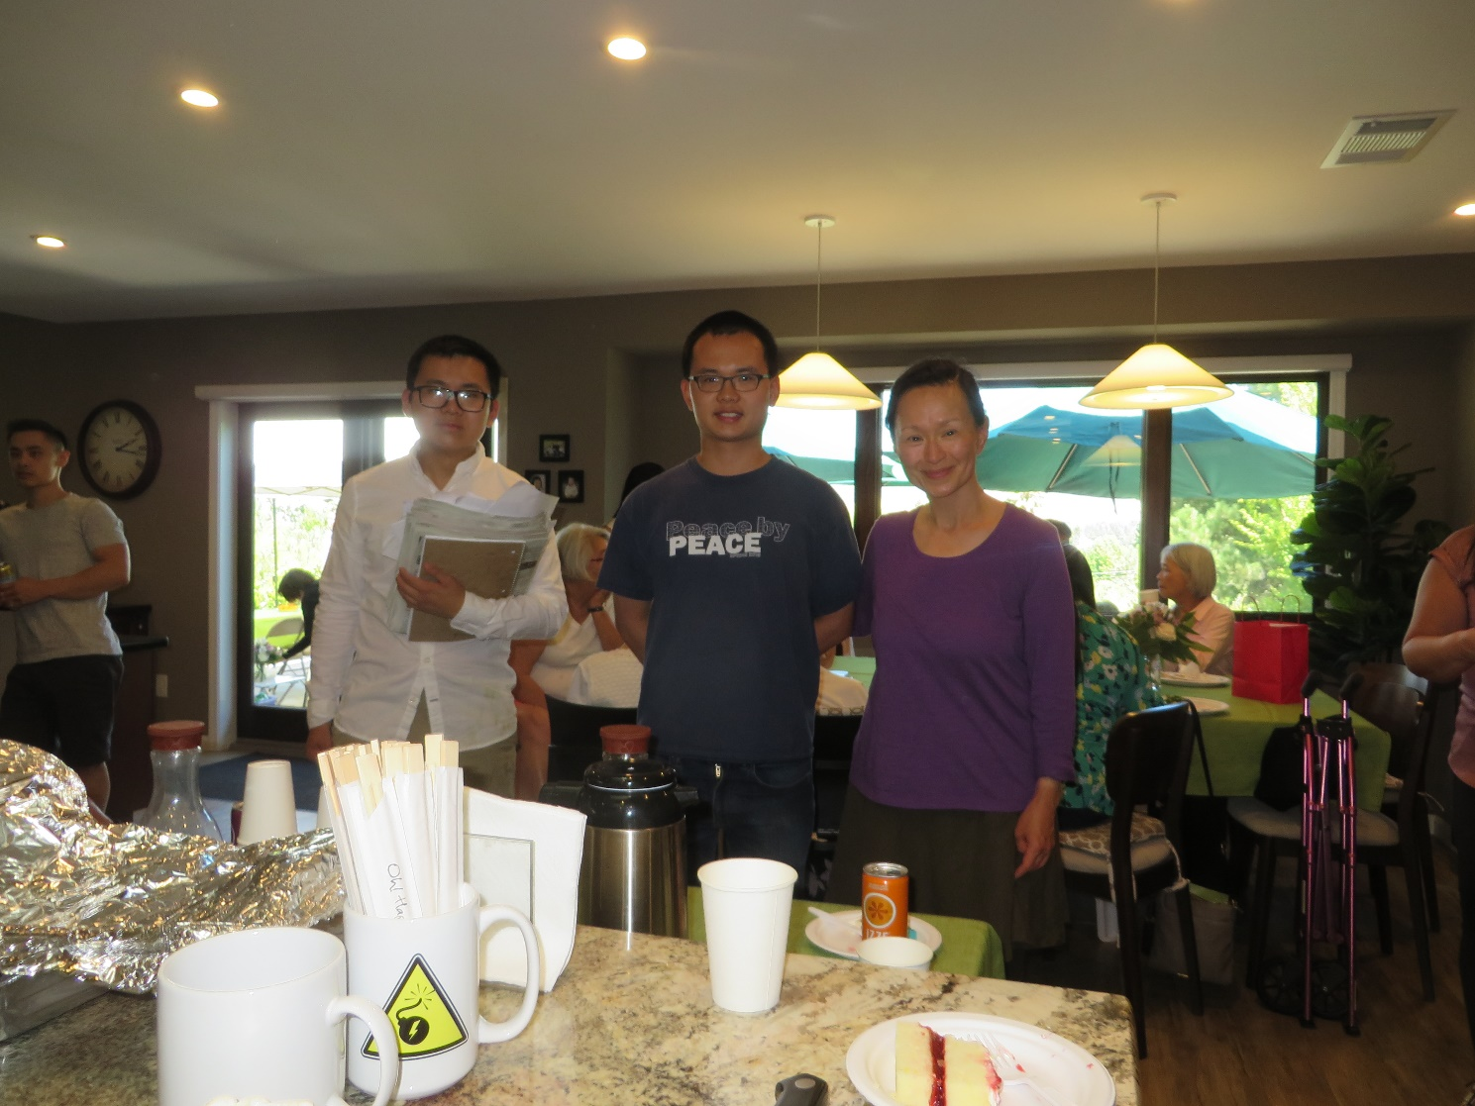Put 2 tablespoons shortening in bowl. Sprinkle 1 package yeast on top of ¼ cup warm water. Sprinkle ½ tablespoon sugar on top of yeast and put rest of the sugar in bowl with shortening. Add 1 teaspoon salt to shortening. Add ½ cup hot water to shortening. Mix to melt the shortening. Mix yeast mixture with toothpick to dissolve the yeast. Add ¼ cup hot water to shortening mixture. When shortening mixture is warm (not hot) add yeast mixture to it. Sift 4 cups flour into shortening mixture. Mix flour in slowly. Add ⅓ to ½ cup water as needed to just mix the flour in. Dough should be a little sticky. Knead until dough is smooth and doesn’t stick to bowl (add flour if needed). Spread a little Crisco shortening on bottom of bowl and on top of dough. Cover bowl. Let rise in warm oven for 1-2 hours until double original size (note: to warm oven, set oven to 150°F, and turn oven off when preheated to 150 °F). Knead dough a little. Cover bowl. Let rise ½-1 hour in warm oven. Knead dough a little. Roll dough out to ¼-½ -inch thick square. Spread thin layer of vegetable oil on top of dough. Sprinkle salt on top of oil. Then sprinkle chopped green onion on top of dough. Roll dough up into a log, slice into chunks, and press down each chunk of dough with a chopstick. Place in steamer about 1 inch apart from each other. Let rise about 1-1½ hours at room temperature. Steam 20 minutes. You can also fill with pork filling to make bow. Slice the steamed buns and toast the slices in a toaster oven, or top slices with ham and cheese.

## Pumpkin Pancakes

Source: IHOP

Submitted by: Mary Lowe

*These pancakes are only available during Halloween and Thanksgiving at IHOP. I found this recipe for them, and now I can have them whenever I want.*

2 eggs

1¼ c. buttermilk

4 T. butter, melted

3 T. canned pumpkin

¼ c. sugar

1¼ t. salt

1¼ c. all-purpose flour

½ t. baking powder

½ t. baking soda

¼ t. cinnamon

¼ t. allspice

Combine eggs, buttermilk, butter, pumpkin, sugar and salt in a large bowl. Use an electric mixer to blend ingredients. Combine remaining ingredients in a small bowl. Add dry ingredients to wet ingredients and blend with mixer until smooth. Preheat skillet over medium heat. Coat pan with Pam cooking spray. Pour the batter in ¼ c. portions into the hot pan. Should form 5-inch circles. When the batter stops bubbling and edges begin to harden, flip the pancakes. They should be dark brown. This will take from 1 to 2 minutes. Flip the pancakes and cook until dark brown.

## Chinese Donuts (Yow Til or Fried Ghost)

Source: Daisy Chan

Submitted by: Evelyn Wong

*In Mandarin, Chinese Donuts are called Youtiao. In Cantonese, they are called* yàuhjagwái, or “oil-fried devil.”

6 c. flour

2 c. warm water

1 yeast cake

2 t. salt

1 t. sugar

¼ c. lime water*(or ½ t. for softer donuts)

Dissolve yeast in warm water. Pour the water and yeast into the flour, salt, sugar, and lime water, and mix well. Cover bowl with a wet dishtowel. Be careful not to touch the dough with the towel. Let dough rise in a warm room away from draft. When the dough has risen to twice the size, take the dough out of the bowl and knead it like bread, only thinner.

*Lime water may be made by mixing calcium hydroxide. This is often sold as powdered lime or pickling lime in the canning section of the grocery store.

Cover with wet towel again and let it rise again. Third time, knead and roll it on a board about ¼-inch thick. Cut strips out 3 inches long and pull a little. Set on board until it rises again, or twice the size. Fry in deep fat and drain on paper. Cover dough with wet towel every time while waiting for it to rise.

Alternative method:

3 c. flour

½ c. water

½ yeast cake

1 ½ t. salt

1 ½ t. sugar

½ t. lime water

Dissolve yeast in warm water. Pour the water and yeast into flour mixture as in directions above and mix well. Let it rise. Follow directions as above.

Note: If you don’t feel like making these from scratch, you can buy Bridgeford’s frozen bread dough. It may not taste as good, but it’s less time consuming.

## Perfect Biscuits

Source: Lydia Lowe

Submitted by: Mary Lowe

2 c. flour

½ t. salt

4 t. baking powder

½ t. cream of tartar

2 t. sugar or more if necessary

½ c. shortening

⅔ c. milk

Sift flour, salt, baking powder, cream of tartar and sugar together. It's wise to sift 3 times. Cut in shortening. Use blending fork and cut shortening in flour into coarse cornmeal size.

Measure ⅔ c. milk. Make a well in dry ingredients. Add almost all the milk. Stir just until dough follows fork around bowl. Now add rest of the milk if necessary.

Flour board and cut with biscuit cutter. Lay next to each other so sides will not dry. Heat oven to 450°F. Bake 12-15 minutes (watch closely).

Don't knead any more than you have to. Kneading makes biscuits hard.

Can be used for strawberry shortcake, but use more sugar.

## French Toast

Source: Carlton Chan

Submitted by: Carlton Chan

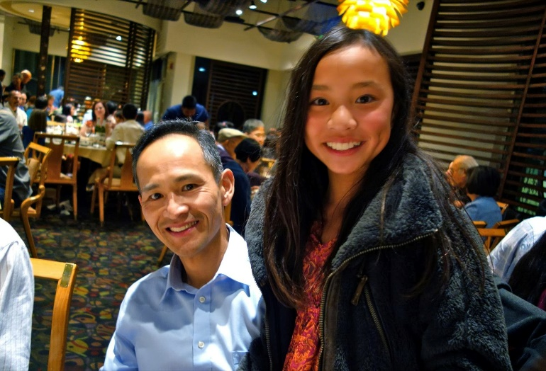

Bread, preferably fresh baked, sliced

5 eggs

Cinnamon

⅛ c. oil

3 t. vanilla extract

¾ c. milk

Powdered sugar

Frozen fruit (strawberry, mixed berry, blueberry)

Beat eggs, milk, cinnamon, and vanilla extract with an electric mixer until well mixed. Soak both sides of a slice of bread with the egg mixture. Fry with oil until light brown on both sides. Repeat with the remaining slices of bread. Arrange the bread on a plate. Place fruit on top of the bread. Lightly dust with powdered sugar. Serve with maple syrup.

## Snack Rolls

Source: Karen Miyao

Submitted by: Cheryle Miyao-Quock

*Mom makes these rolls for family gatherings, especially on Thanksgiving and Christmas. Use these to make delicious post-holiday ham and turkey sandwiches.*

2 packages active dry yeast

2 c. warm water

½ c. sugar

¼ c. shortening or softened butter

1 egg

2 t. salt

6½-7 c. flour

1 egg yolk

1 T. water

Sesame seeds

Dissolve yeast in warm water. Stir in sugar, shortening, 1 egg, salt and 3½ c. of the flour. Beat until smooth. Mix in remaining flour to make dough easy to handle. Place dough in greased bowl; then turn so greased side is up. Cover, refrigerate at least 2 hours. When dough rises, punch it down. Cut off amount of dough needed and return remaining dough to refrigerator. Dough can be kept 3 to 4 days. About 2 hours before baking, shape bits of dough into 1-to 1¼-inch rolls. Blend egg yolk and 1 T. water, brush tops of rolls with mixture and dip into sesame seeds. Place 1 inch apart on greased baking sheet. Cover, let rise 1-1½ hours. Bake at 400°F for 10 minutes. Can be split and filled for little sandwiches.

## Best Blueberry Muffins

Source: *The Easy Way to Artisan Breads &* *Pastries* by Avner Laskin

Submitted by: Diane Wong-Kone

*This is the blueberry muffin recipe I like to make. It’s quick and easy, but sometimes my muffins turn blue if the blueberries aren’t fresh..*

Servings: Makes 1 dozen

1 cup cold milk

½ cup butter (unsalted)

¾ cup fresh or frozen blueberries

1 ½ cups unbleached all-purpose flour

1 tablespoon baking powder

½ cup sugar

1 teaspoon salt

1 large egg

Preheat oven to 400˚F. Grease muffin pan or use paper liners.

In a small saucepan, bring the milk and butter just to a boil and remove from heat. Place blueberries in a bowl and pour the milk and butter mixture over. Stir gently. Combine the dry ingredients in a separate bowl using a wooden spoon. Blend in the blueberry mixture. Add the egg and continue mixing until smooth. Spoon batter into muffin pan, filling cups up to ¾ full.

Bake 18-20 minutes, or until golden and a toothpick inserted in the center of one or two muffins comes out clean. If necessary, turn the pan halfway through baking to ensure even browning.

Carefully remove muffins from the pan while warm and let them finish cooling on a wire rack.

## Year of the Dog Banana Nut Muffins (Gluten-free)

Source: Unknown

Submitted by: Christina Wong



Ready in 35 minutes

Makes 12 muffins

141 calories

**Topping**

5 T. almond flour

1 ½ T. coconut oil

3 T. brown sugar or turbinado sugar

1 t. cinnamon

**Muffins**

2 c. almond flour

½ t. baking soda

1 t. cinnamon

¼ t. nutmeg

Christina’s Tip: The banana, butter, and coconut oil in the recipe can make a conventional paper liner greasy. I recommend using a grease-free paper liner for banana muffins.

Pinch of fine sea salt

3 eggs

⅓ c. agave nectar or honey

1 t. vanilla extract

3 T. melted butter

2 large bananas

1¼ c. toasted walnuts

Preparation

1. Preheat the oven to 350°F. Line a muffin tin with grease-free muffin or cupcake liners.
2. Combine the muffin topping ingredients in a small bowl. Using a fork, mash the mixture while turning the bowl until the coconut oil is well incorporated and the mixture is crumbly. Cover the bowl and refrigerate while making the muffin batter.
3. Mash bananas and set aside.
4. Sift together 2 cups of almond flour with the baking soda, cinnamon, nutmeg, and salt.
5. In a separate bowl, whisk together the eggs, agave nectar, vanilla extract, and melted butter. Fold in mashed bananas and mix well.
6. Slowly add the flour mixture into the wet ingredients, about a third of the flour mixture at a time. Add in a cup of walnuts.
7. To assemble muffins, first use a scoop or spoon to place batter into liners. Sprinkle the remaining ¼ cup of walnuts on top of muffins, followed by the muffin topping mix.
8. Bake for 20-23 minutes, or until a skewer placed in the middle of a muffin comes out clean.

## Raspberry Streusel Muffin Tops

Source: Sunset Magazine, April 1992

Submitted by: Cheryle Miyao-Quock

*The best part of a muffin is the top.*

2⅓ c. all-purpose flour

1 c. firmly packed brown sugar

½ c. chopped almonds

½ t. ground nutmeg

¾ c. butter or margarine

2 t. baking powder

1 t. baking soda

1 large egg

⅔ c. regular or nonfat milk

1 c. raspberries, fresh or unsweetened frozen (thawed)

Preheat oven to 350°F.

In a bowl, combine flour, sugar, almonds, and nutmeg. With your fingers, rub in butter until the mixture forms coarse crumbs; set aside ¾ cup of this mixture.

To bowl, add baking powder and baking soda. Stir to mix thoroughly, then make a well in center; add egg and milk and beat to blend, then stir to incorporate and evenly moisten dry ingredients. Gently stir raspberries into batter.

Spoon batter in ⅓ c. size mounds about 2 inches apart on lightly greased baking sheets, 12” x 15” size. Firmly squeeze the reserve crumb mixture to form large lumps, then coarsely break lumps into chunks about the size of peanuts. Scatter chunks evenly over batter mounds.

Bake until well-browned, 20-22 minutes. Remove the muffins tops from pans with wide spatula and serve, or let cool on racks. Serve warm or cool.

To store, wrap airtight and hold at room temperature up until the next day; freeze to store longer.

## Almost No Knead Bread

Source: America’s Test Kitchen

Submitted by: Cheryle Miyao-Quock

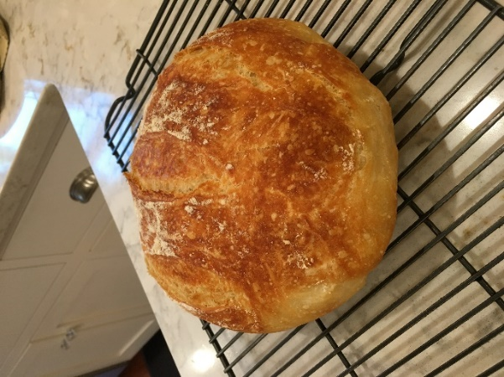*For those of you who are familiar with the no knead bread phenomenon started by Mark Bittman when he published Jim Lahey’s recipe in the NYT, this is a better variation of that bread. I use bread flour for a chewier texture. This makes an impressive loaf. People will think you bought it at an artisanal bakery*.

3 c. (15 ounces) all-purpose flour or bread flour

1½ t. salt

¼ t. instant or rapid-rise yeast

¾ c. plus 2 T. water, room temperature (if using bread flour, add a little more water)

6 T. mild-flavored lager (or non-alcoholic lager)

1 T. distilled white vinegar

Vegetable oil spray

1. Whisk flour, salt, and yeast together in large bowl. Add water, lager, and vinegar. Using rubber spatula, fold mixture, scraping up dry flour from bottom of bowl until shaggy ball forms. Cover bowl with plastic wrap and let sit at room temperature for at least 8 hours or up to 18 hours.
2. Lay 18” x 12” sheet of parchment paper on counter and spray with oil spray. Transfer dough to lightly floured counter and knead 10 to 15 times. (Dough will be sticky.) Shape dough into ball by pulling edges into middle. Transfer dough, seam side down, to center of parchment and spray surface of dough with oil spray. Pick up dough by lifting parchment overhang and lower into heavy-bottomed 5 or 7 quart Dutch oven (let any excess parchment hang over pot edge). Cover loosely with plastic and let rise at room temperature until dough has doubled in size and does not readily spring back when poked with finger, about 2 hours.
3. Adjust oven rack to middle position. Remove plastic from pot. Lightly flour top of dough and, using razor blade or sharp knife, make one 6-inch-long, ½ -inch-deep slit along top of dough. Cover pot and place in oven. Heat oven to 425 degrees. Bake bread for 30 minutes, starting timing as soon as you turn on oven. (Note: if your Dutch oven lid knob is plastic, cover with aluminum foil or remove, plugging the hole with foil.)
4. Remove lid and continue to bake until loaf is deep brown and registers 210 degrees, 20 to 30 minutes longer. Carefully remove bread from pot; transfer to wire rack and let cool completely, about 2 hours. Bread can be wrapped in aluminum foil and stored in a cool, dry place for up to two days.

Variations:

* Rosemary, Parmesan & Olive: Mix 2 c. (4 ounces) grated Parmesan cheese, 1 T. minced rosemary, & ½ c. chopped pitted green olives in step 1.
* Pecan & Cranberry: Mix ½ c. dried cranberries & ½ c. toasted pecan halves in step 1.
* Whole wheat: Replace a third of the all-purpose flour with whole wheat: 2 c. all-purpose + 1 c. whole wheat. Add 2 ½ T. honey or sugar.

# Generations of Pomelos

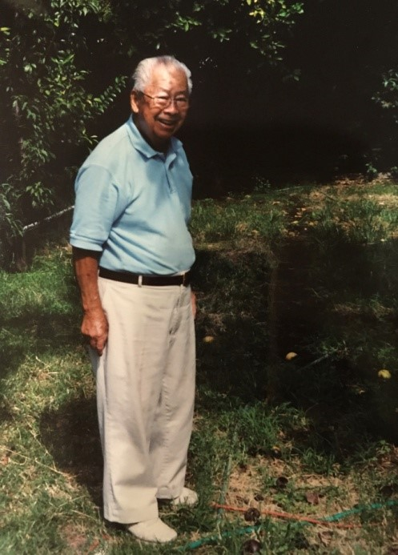Visiting Uncle George and Auntie Gladys in Sacramento would not be complete without visiting their yard, which was full of fruit trees including peaches, Asian pears, kumquats, Chinese red dates, and Chinese pomelo. Edith Lowe lived next to Uncle George and Auntie Gladys and the pomelo tree grew in her yard. The fruit grew high on the tree and as a young boy Doug, at the request of Uncle George, would climb it to harvest the fruit. Uncle George liked to invite the family to get some fresh fruit, saying “Pick some more!” Although the old house has been sold, the Chinese grapefruit tree is still with the family. Doug collected the seed and made cuttings, and new generations or grafts of Uncle George’s pomelo tree produce fruit in Doug and Wendy’s yards.

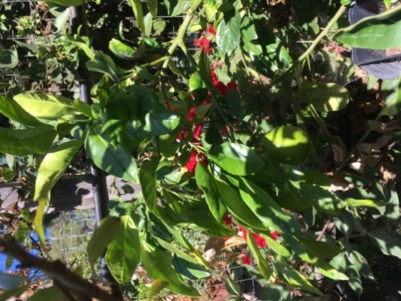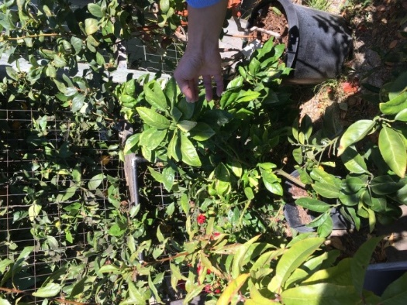

# Soups & Salads



Family gathering at Dragon Palace Restaurant in Sacramento for Uncle George’s 90th birthday, October 3, 2009. Left to right, top back row between red posts: Jennifer Chan, Clifford Chan, Dean Quock, Cheryle Miyao-Quock, Carol Fong, Douglas Ng, Ralston Louie, Thom Taylor, and Debi Lowe; middle standing row: Calvin Lowe, Annette Lee, Charles Lee, Andrew Cheng, Sammy Chang, Denise Chan, Brian Shen, Robin Wu, Reagan Louie, Ryan Louie, Barbara Lowe, Karen Miyao, Evelyn Wong, Eva Hing, Ken Miyao, Mary Lowe, George Hing, and Sam Wong; middle sitting row: Diane Wong, Yvonne Chan Cheng, Wendy Chang, Roberta Lowe-Taylor holding Christopher Trygg, Elsie Ng, George Louie, and Brandon Louie; bottom sitting row with balloons: Annie Cheng, Joshua Cheng, Robert Trygg, Nicholas Chan, Matthew Chan, Joseph Chan, Samuel Cheng sitting behind Thomas Lee and Maria Chan, Philip Lee, Regina Chan, and Carlton Chan.

**Soups & Salads**

Post-Holiday Dinner Jook (Rice Congee) 47

Shrimp Wonton 47

Old Country Potato Salad 48

Potato Salad 48

Asian Noodle Salad 49

Macaroni Salad 49

Spicy Cold Noodles 50

Spicy Thai Noodles 50

Cold Duck Salad (Leung-ban knop) 51

Cabbage Salad 52

Cantonese Chicken Pineapple Salad 52

Margaret’s Chicken Salad 53

Broccoli Salad 53

Spinach Salad 54

Strawberry Spinach Salad 54

Quinoa Salad with Corn, Tomatoes 55

Chinese Summer Noodle Salad 56

Shell Salad 57

Potato Salad 57

Gai Jow - Chicken Wine Soup 58

Chicken Ramen Soup 59

Creamy Butternut Squash Soup 60

Winter Melon Soup (Dung Gwai Tong) 61

Top Stock 61

Instant Pot Golden Lentil & Spinach Soup 62

## Post-Holiday Dinner Jook (Rice Congee)

Source: Karen Miyao

Submitted by: Cheryle Miyao-Quock

*Mom makes this jook after every Thanksgiving and Christmas, using the bones from the turkey and ham. For a thicker consistency, add more rice.*

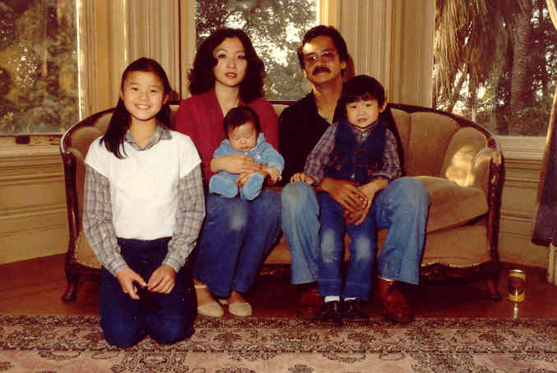

Turkey carcass

Ham bone

1 c. sweet rice

½ t. white pepper

1 t. salt

Water - enough to cover the bones (or use homemade broth*)

1 T. chicken bouillon or more to taste

8-10 dried shitake mushrooms

Wash rice. Add rice and remaining ingredients to large pot (10 qt). Bring to boil and simmer for 2½-3 hours. Remove carcass and/or bones.

*Broth can also be made from the turkey neck bone boiled with onions, carrots and celery.

## Shrimp Wonton

Source: Evelyn Wong

Submitted by: Diane Wong-Kone

¾ lb. shrimp (washed and de-veined)

1¼ t. salt

½ lb. pork (minced or ground)

1 t. grated ginger

1 t. sugar

White pepper (to taste)

1 T. soy sauce

1 T. dry sherry or rice wine

2 t. sesame oil

2 t. cornstarch

2 green onions

6 water chestnuts, chopped

1 package wonton skins

1 egg (beaten)

Chop shrimp into small pea-sized morsels. Mix with ¼ t. salt and set aside. Mix together pork, ginger, sugar, white pepper, and remaining salt, soy sauce, sherry, sesame oil, cornstarch, green onions and water chestnuts. Mix well. Fold in shrimp mixture. Set aside for 30 minutes. Fold wonton. Drop in boiling water until dumplings float. Then transfer to soup. Add Chinese mushrooms and bok choy if desired.

## Old Country Potato Salad

Source: Recipe modified from the Old Country Potato Salad Recipe seen on *Cook Off America, 2000*

Submitted by: Annette Chan

3 lbs. potatoes, cooked and chopped (Yukon Gold is good.)

10 hard-boiled eggs, chopped coarsely

½ red onion, chopped (about 3/4 c.)

2 dill pickles, chopped

Dressing:

1½ c. mayonnaise

1-2 T. Dijon mustard

1 t. salt

½ t. pepper

½ t. paprika

1 t. dried dill

Lemon juice from one small lemon

Put potatoes, eggs, onion, and pickles in a bowl. Mix together dressing ingredients. Pour dressing over potatoes. Mix.

## Potato Salad

Source: Captoria Young (Cousin Cappy)

Submitted by: Annette Chan & Yvonne Chan Cheng

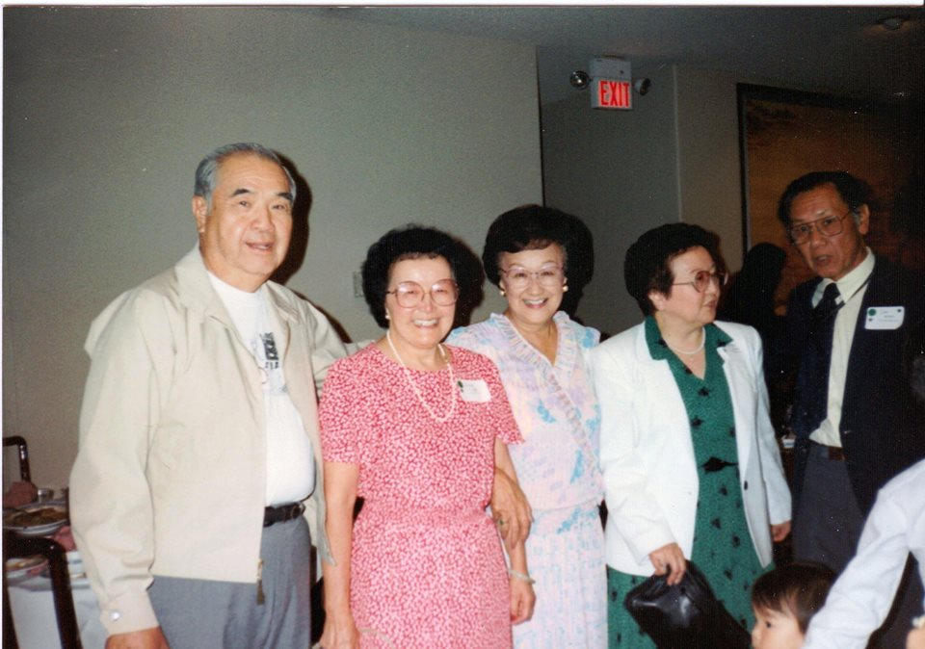*This is a crunchy, tasty, hearty potato salad that Cousin Cappy and Cousin Ray prepared for summer barbecues at their Sacramento home.*

3 lbs. potatoes

1 ½ c. shredded lettuce

¾ c. dry onion, chopped medium size

1 ½ c. Best Food mayonnaise

2 T. prepared mustard

Some bacon chips (small amount)

Boil potatoes until tender*. Peel, cool well, and dice. Place potatoes in large mixing bowl. Pour in all above ingredients. Mix well, cover and place in refrigerator for about 1 hour before serving.

*Cooking the potatoes: Cover potatoes with water. Bring to boil. Simmer covered for 30-40 minutes or until tender.

## Asian Noodle Salad

Source: Evelyn Wong

Submitted by: Diane Wong-Kone

Dressing:

¼ c. balsamic or Chinese dark vinegar

3 T. peanut butter

3 T. oil

1 T. sesame oil

2 T. soy sauce

1 t. hot pepper sauce

2 T. sugar

½ t. black pepper

Salad (choice and proportions of ingredients may vary):

½ lb. cold long noodles, cooked and drained

Lettuce (broken into bite-size pieces)

Chicken meat (cooked and shredded)

Cucumber

Bean sprouts

Cilantro

Green onion

Shredded carrot

Mix dressing and pour over salad ingredients. Top with toasted peanuts or sesame seeds.

## Macaroni Salad

Source: Evelyn Wong

Submitted by: Diane Wong-Kone

½ bag (~8 oz.) macaroni

2 eggs (boiled)

1 stalk celery (chopped)

½ t. onion (chopped, optional)

Salt and pepper (to taste)

Paprika (to taste)

½-¾ c. mayonnaise

1 T. sweet pickle relish plus some relish juice

Boil macaroni in salted water until tender. Drain and cool. Meanwhile chop boiled eggs, celery, and onion. When macaroni is cool, add in chopped ingredients and enough mayonnaise to moisten. Add spices, pickle relish, and relish juice to taste. Chill and serve.

## Spicy Cold Noodles

Source: Unknown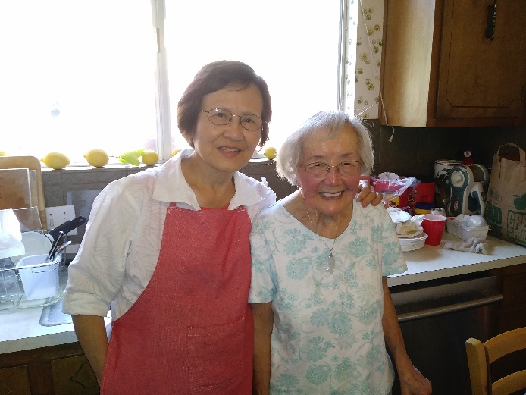

Submitted by: Elsie Ng

1 lb. thin dry or fresh Chinese noodles

3½ T. sesame oil

3½ T. black soy sauce

1½ T. Chinese rice vinegar

2 T. sugar

1 t. salt

½ to 1 T. chile oil

4-6 T. chopped green onions

Char-siu (Chinese BBQ pork) or cooked chicken breast for garnish

Cook noodles according to package directions. Rinse with cold running water. Drain, place in a large bowl, and set aside. In another bowl, blend the sesame oil, soy sauce, vinegar, sugar, salt, chili oil, and green onions to make sauce. Pour over noodles and toss gently to mix. The chili flavor will become more pronounced within a few hours. For best flavor, cover and set aside for several hours at room temperature, or store overnight in refrigerator. Toss gently before serving to redistribute the seasonings. If desired, garnish with thin slices of char-siu or shredded chicken.

## Spicy Thai Noodles

Source: *California the Beautiful Cookbook*

Submitted by: Karen Miyao

½ c. (4 oz.) smooth peanut butter

2 T. lemon or lime juice

¼ c. (2 oz.) soy sauce

1 t. red pepper flakes

3 T. sesame oil

10 drops hot chile oil

1 lb. spaghettini, linguine or other thin pasta

¾ c. (6 oz.) olive oil

8 green onions, washed, trimmed and cut diagonally into ½” pieces

⅓ c. chopped cilantro

A few cilantro sprigs

2 T. chopped peanuts

To make sauce, whisk together until smooth the peanut butter, lemon juice and soy sauce, then blend in the red pepper flakes, sesame oil and hot chile oil; set aside. Cook the pasta in plenty of boiling salted water until done. Drain it thoroughly, and then toss with the olive oil. Let it sit until cooled to room temperature, tossing frequently. Pour the peanut mixture over the noodles and toss to coat. Add the green onions and cilantro leaves and toss to combine. Mound the noodles in a bowl, or spread them on a platter, and garnish with chopped cilantro sprigs and chopped peanuts. Serves 6-8.

## Cold Duck Salad (Leung-ban knop)

Source: Daisy Chan

Submitted by: Diane Wong-Kone

*My mom once sent this recipe in as an entry in a salad contest. It didn't win, but it's a good recipe.*

Dressing:

Hoisin sauce

Mustard (mix dry mustard powder with water, then mix with oil until shiny)

1 can lychee

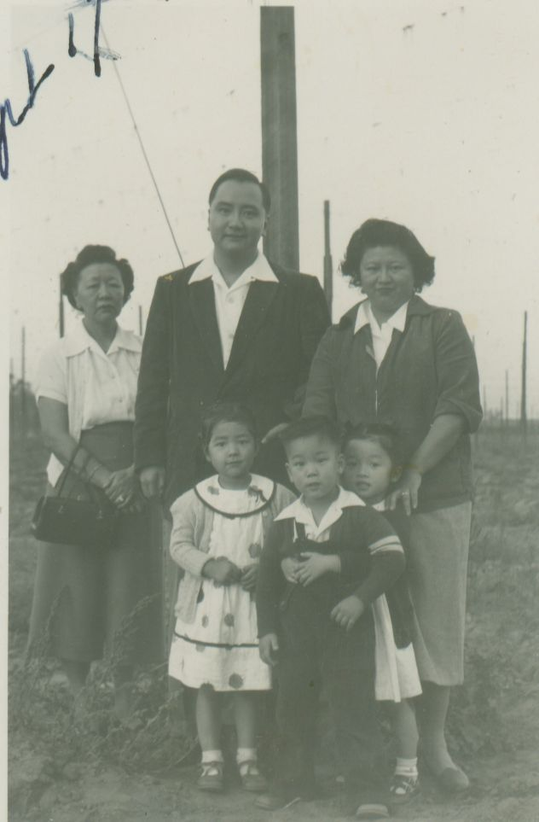1 can pineapple

Ketchup

Cornstarch

Bath for veggies:

1 c. sugar

1 c. vinegar

2 c. water

Salad ingredients:

Green onion (chopped)

Duck meat (shredded)

Celery (chopped)

1 bell pepper (chopped)

Carrot (chopped)

Sesame seeds

Make a sweet and sour sauce (dressing) by mixing lychee water, pineapple juice, ketchup and cornstarch. Heat in a saucepan to cook. Add hoisin and mustard. Let cool.

Chop the vegetables and soak in salted water until soft (~½ hour). Then rinse well.

Meanwhile, boil together sugar, vinegar, and 2 cups water.

Briefly soak the now soft veggies in the hot sugar-vinegar water that has been boiled and remove.

Add sliced duck and green onion, and mix with the sweet and sour sauce dressing. Garnish with sesame seeds, lychee and pineapple pieces.

## Cabbage Salad

Source: Unknown

Submitted by: Karen Miyao

*This is a simple and flavorful salad. For a large crowd, I recommend doubling or tripling the recipe.*

½ head cabbage, chopped thinly

2 T. sesame seeds, toasted

⅛ c. salad oil

⅛ c. sesame oil

3 T. rice vinegar

2 T. sugar

Salt & Pepper

1 package flavored ramen noodles (preferably Nissin chicken flavored ramen noodles)

Chopped cooked chicken, optional

Minced green onions, optional

Mix sesame seeds, oils, vinegar, sugar, and salt/pepper to taste in a jar. Shake to mix. Pour over chopped cabbage. Mix. Crumble flavored noodles over cabbage and toss. Serve. For variety, add cooked and shredded chicken and green onions.

## Cantonese Chicken Pineapple Salad

Source: Daisy Chan

Submitted by: Evelyn Wong

1 chicken breast (cooked and shredded)

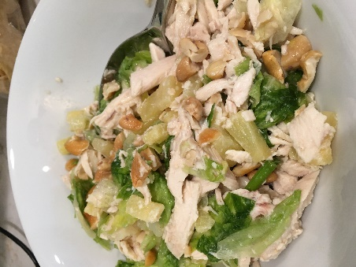1 head lettuce (chopped to bite size)

½ t. dry mustard

1 t. Chinese salt

3 stalks green onion (julienned, including the green tops)

1½ c. or 1 bunch cilantro (cut coarsely)

1 T. toasted sesame seeds

1 T. sesame oil

¼ c. vegetable oil

1 can pineapple tidbits, well-drained

½ c. cashew nuts (chopped coarsely)

1½ c. noodles or long rice for frying

Toss chicken, lettuce, onion, cilantro, sesame seeds, mustard, Chinese salt, and sesame oil together. Chill for 2 hours. Then add 1 can pineapple tidbits, well drained, and cashew nuts. [Editor’s note: we recommend mixing in lettuce, onion and cilantro with the pineapple and cashew nuts.] Toss again. Decorate the salad with ~ 1 ½ c. fried long rice or fried noodles. Long rice should be deep fried in oil until it puffs up. Use a 2 quart sauce pan with about 2 inches of oil.

## Margaret’s Chicken Salad

Source: Shirley Wong-Jose

Submitted by: Shirley Wong-Jose

*This is a favorite at family get-togethers and holiday parties.*

½ c. peanut oil

1 T. sugar

3 T. cider vinegar

1 pkg ramen noodles

½ -1 head Napa cabbage

3-4 green onions

3 T. slivered nuts (peanuts, walnuts, or almonds)

1 cooked, shredded chicken breast

Dressing:

Dash sesame oil

1 t. salt

½ t. black pepper

Hoisin and a little soy sauce

1-2 t. sugar

Cilantro

Sweet Chinese preserved scallions

Mandarin orange slices or pineapple

Combine salad ingredients in large bowl. Proportions may be varied depending on how big a salad you want to make. Mix dressing ingredients. The sugar balances the hoisin (plum) sauce. If you want to skip the sugar, then skip the hoisin. Garnish with cilantro and, if desired, with Mandarin orange or pineapple slices. Note: The addition of fruit tends to make the salad wet, so add the fruit last, just before serving.

## Broccoli Salad

Source: Tiffany Gee

Submitted by: Cheryle Miyao-Quock

2 lbs. uncooked broccoli florets (Costco size bag)

2 c. mayonnaise

1 c. sugar

2 T. balsamic vinegar

½ red onion, sliced into rings

3-4 strips cooked bacon, crumbled

Combine mayo, sugar, and balsamic vinegar to create the dressing. Toss dressing with broccoli, onions, and bacon. Serve immediately.

## Spinach Salad

Source: Shirley Wong-Jose

Submitted by: Shirley Wong-Jose

8 c. spinach

1 lb. bean sprouts

Bacon

Hard-boiled eggs

Dressing:

½ c. oil

¼ c. catsup

¼ c. cider vinegar

¼ c. sugar

1 grated onion

1 T. Worcestershire sauce

½ t. salt

Mix salad ingredients in a salad bowl. Mix dressing ingredients and mix in with the salad. Chill and serve.

## Strawberry Spinach Salad

Source: Fran Kanemoto

Submitted by: Karen Miyao

Dressing:

½ c. sugar

1 T. toasted sesame seeds

1 T. toasted poppy seeds

½ c. olive oil

½ c. cider vinegar

½ t. paprika

½ t. Worcestershire sauce

Mix all ingredients.

Salad:

1 bunch spinach

1 pint strawberries, sliced

Toasted slivered almonds

Slivered red onions (optional)

Toss salad with dressing.

## Quinoa Salad with Corn, Tomatoes

Source: Karen Miyao

Submitted by: Karen Miyao

*For those of you who really don’t like quinoa…after I tasted this dish, I so totally luv it--plus it's pretty healthy!!*

2 Tablespoons extra virgin olive oil

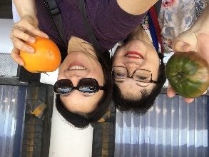½ c. chopped yellow onion from one small onion

1 c. prewashed quinoa (if not washed, follow package instructions for rinsing)

1⅔ c. low sodium vegetable broth (or chicken broth)

1 teaspoon salt--divided

1 c. chopped tomatoes, from two medium tomatoes

1¼ c. fresh cut cooked corn, from two cobs

2 scallions, white & green parts, finely chopped

1 small jalapeño pepper, seeded n finely chopped

2 Tablespoons lime juice from 1 large lime

1 avocado, cut into bite-sized chunks

Heat 1 Tablespoon olive oil in a medium sauce pan over medium low heat. Add the onions n cook, stirring frequently, until soft n translucent about 5 min. Add the quinoa to the onions and continue cooking, stirring constantly, for 3--4 minutes. Add the vegetable broth and stir in 1/2 teaspoon salt. Turn heat up to high and bring to boil. Cover pan tightly w lid, turn the heat down to low n simmer for 17--20 minutes or until liquid is absorbed and quinoa is cooked. Transfer the cooked quinoa to a mixing bowl and chill in the refrigerator.

When the quinoa is cool, add the remaining tablespoon of olive oil, tomatoes, corn, scallions, jalapeño, cilantro, 1/2 teaspoon salt and lime juice. Taste and adjust seasoning if necessary. Right before serving, scatter the avocado chunks over top.

NOTES: The quinoa will cling to the avocado, so it's best to scatter it over the top rather than mix in. Also, be very careful when chopping jalapeño peppers. The juices and seeds can irritate your skin, so it's a good idea to wear gloves at the very least, keep your hands away from your eyes and wash them well when done.

I use white quinoa and my own homemade salsa pico de gallo (recipe in this cookbook). My friend who shared this recipe with me uses the Trader Joe's corn salsa and white quinoa.

Mary’s tip: Microwave corn-on-the-cob in the microwave with the husk on, ~3-4 minutes for one ear of corn. Remove corn from microwave with a towel/potholder and cut off the stem end. The husk and silk will slide right off.

## Chinese Summer Noodle Salad

Source: Evelyn Wong

Submitted by: Diane Wong-Kone

*I found this recipe in an old newspaper clipping in my mom’s cookbook.*

*Char-roasted peppers add a nice flavor to this dish. To turn it into a dinner salad or light meal, just add strips of grilled eggplant.*

12 ounces dried Chinese egg noodle, or 1 pound fresh

1 tablespoon or more peanut or corn oil

2 green onions, trimmed, chopped

1 cup shredded cooked chicken

1 cup asparagus, cut on the diagonal into 1-inch pieces, blanched

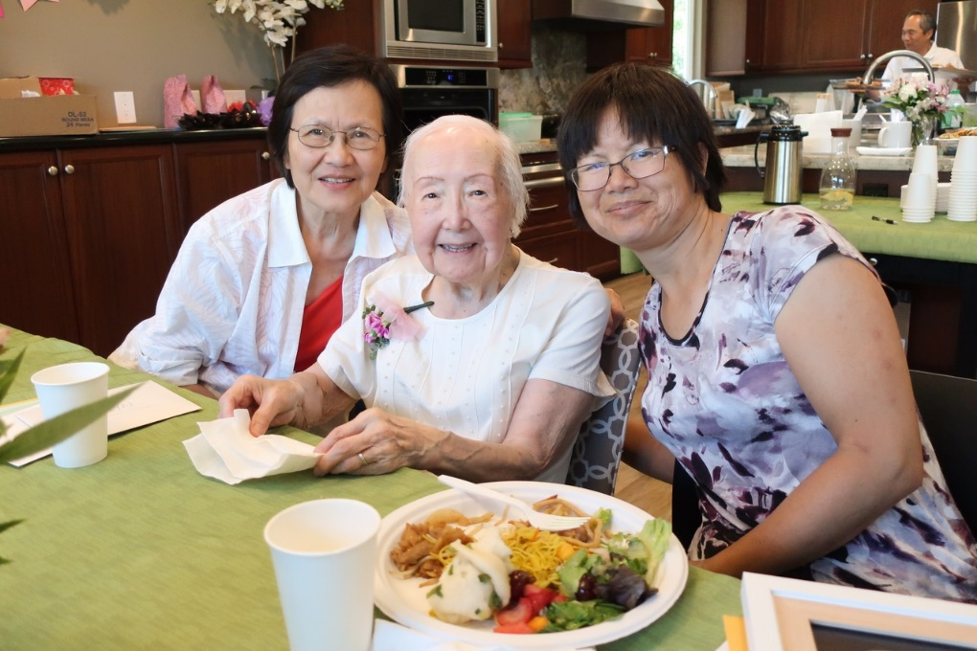1 small red bell pepper, roasted, cut into ¼ - inch strips

Black or white sesame seeds, toasted

Sesame – Peanut Dressing

¼ cup chunky peanut butter

1 teaspoon finely minced garlic

2 tablespoons peanut or corn oil

1½ teaspoons sesame oil

½ teaspoon salt

2½ teaspoons soy sauce

1½ tablespoons red wine vinegar or balsamic vinegar

1/3 cup cold water or chicken broth

1½ tablespoons sugar

1 teaspoon chile oil, or to taste

Drop the noodles into 4 quarts of boiling water. Stir with chopsticks, reduce heat to medium and cook for 4-5 minutes for dried noodles or 1-22 minutes for fresh. Drain and then rinse under cold water. Transfer noodles to a large bowl and toss with the oil. Cover and refrigerate.

The dressing: Combine all dressing ingredients in a bowl and mix until thoroughly blended.

To serve, toss the noodles with the green onions and chicken. Pour the dressing over the noodles and mix thoroughly to coat each strand. Scatter the asparagus and the red pepper strips on top. Garnish with sesame seeds.

Serve cold or at room temperature.

Serves 6.

## Shell Salad

## Potato Salad

Source: Unknown, from Gladys Louie’s recipe collection

Submitted by: Lowe Family Cookbook Editors

*If we’re lucky, we are able to find written recipes with instructions, albeit vague*.

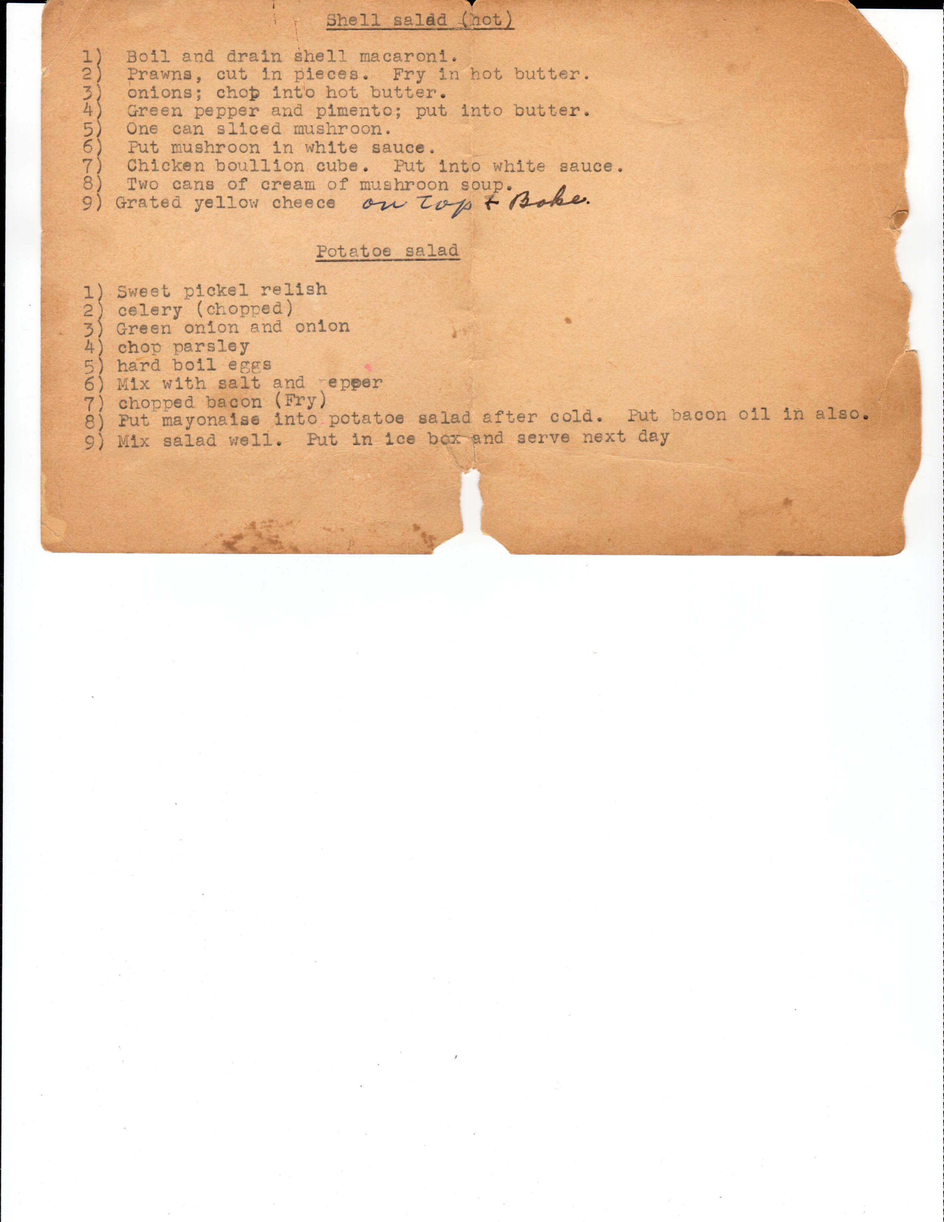

## Gai Jow - Chicken Wine Soup

Source: Mrs. Hazel Cheang, *Treasured Recipes from two Cultures – American and Chinese*, St Mark’s United Methodist Church

Submitted by: Lowe Family Cookbook Editors

*Traditionally for many centuries, Chicken Wine Soup (Gai Jow) and Black Vinegar Pigs Feet (Ger Guerk Cho) are a “must” for new mothers to help their spirits and recover from childbirth. It’s delicious at all times!*

1 pullet chicken, cut up in approx.. 2 ½ “ pieces

2 large chunks of ginger (each about size of an apricot), peeled and sliced

8 to 9 dried Chinese mushrooms, presoaked 3 hours

5 dried red dates (hung joe), presoaked 3 hours

½ c. raw peanuts (optional), shelled, not salted, and without the brown skin

1½ to 2 cups dried wood fungus (mook yee). Soak overnight, drain water. Sprinkle salt and oil over all mook yee. Rub and clean each fungus, removing hard particles that may be on, pinching off the stem part. Wash 3 to 4 times until white cloudy material is cleaned off. Drain well. Warm a pot add mook yee and stir to dry, Remove and set aside.

1 cup gin or rice wine purchased in Chinese stores

2 pcs rock sugar (bing tong), each of the size of a cherry

Water and salt

Heat very little oil in a large pot and brown chicken pieces. Add ginger and continue browning. Add mushrooms and red dates. Add water to cover chicken at least 2” over top of chicken. Simmer 15-20 minutes until barely tender. Do not add salt at this point.

Then add 1 cup or more gin. Simmer an additional 15 minutes. Then add peanuts, mook yee, and rock sugar; simmer 5 to 10 minutes more.

Add salt to taste when ready to serve. At time of serving, may add ½ c. of gin according to taste and heat until it is simmering hot. Do not boil. Serve.



## Chicken Ramen Soup

Source: Annette Chan

Submitted by: Annette Chan

64 oz. low-sodium chicken broth

1 tablespoon soy sauce

¼ cup sherry

2 teaspoon ground ginger

2 dashes black pepper

2 cloves garlic, minced

2 medium carrot, sliced

3 stalks celery, sliced

1 red bell pepper, cut into 2-inch long strips

4 green onions, sliced

1 tablespoon sesame oil

2 10-oz. cans cooked chicken, drained, or 20 oz, shredded, cooked, boneless, skinless chicken

4 uncooked packs of Ramen noodles

2-4 eggs, cooked (see below)

2 sheets of roasted seaweed, cut into thin strips

Heat the broth, soy sauce, sherry, ginger, pepper, garlic, carrot, celery, red pepper, and green onions to a boil. Boil, covered, for about 15-20 minutes.

Stir in the sesame oil, noodles, and chicken. Reduce the heat to medium, and boil gently for 3-4 minutes or until the noodles are done.

Place the ramen in medium-sized bowls, and put egg and seaweed on top.

Cooking soft-boiled eggs: Fill a pan with water, and bring the water to a boil. Gently lower the eggs into the water, and then simmer for 6-7 minutes. Remove the eggs with a slotted spoon, and place them into a bowl of ice water. Peel the cooled eggs, cut in half lengthwise, and place them in the bowls of ramen.

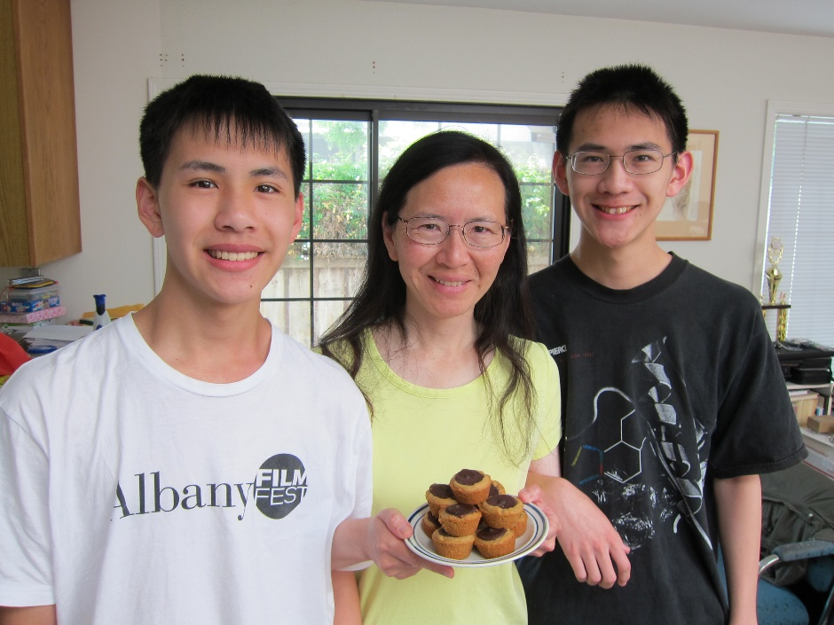

Serves 4.

## Creamy Butternut Squash Soup

Source: Merrill Stubbs online recipe

Submitted by: Diane Wong-Kone

*I made this one Thanksgiving and dad liked it so much, mom started making this soup. I usually add a little cayenne and paprika.*

Serves 4-6.

2 tablespoons unsalted butter

1 large leek, white and light green part only, chopped (about 1 cup)

1 3-to-4-pound butternut squash, peeled and cubed

¼ teaspoon freshly ground nutmeg

½ teaspoon freshly ground black pepper

Salt to taste

3 tablespoons dry sherry, plus more to finish (or brandy), optional

2 to 3 cups chicken stock

1 cup milk

2 tablespoons heavy cream, plus more for serving

Cut squash in quarters and remove seeds. Cut approximately 1-inch wide wedges and cut off skin with knife.  Cut squash into cubes.

Melt the butter in a large stockpot over medium-low heat. Add the leek and cook, stirring with a wooden spoon, until softened—this should take about 5 minutes (if leek starts to brown, add a tablespoon or so of water).

Add the squash, nutmeg, pepper and ½ teaspoon salt and continue to cook for another 5 minutes, stirring frequently.

If using, add the sherry and cook for a couple of minutes to reduce, then add enough chicken stock just to cover the squash (if you have added all of the stock and still need more liquid, add some water).

Increase the heat to high and bring the soup to a boil. Reduce the heat and simmer, partially covered, for about 20 minutes, or until the squash is tender.

Using a blender, food processor, or immersion blender blend the soup with the milk in several batches, adding more liquid if necessary.

Return to the pot and heat until just simmering. Taste and add more salt and pepper if necessary. Stir in another splash of sherry and the cream just before serving, adding a drizzle of cream to garnish each bowl if you like.

Note: If using pumpkin – add a little maple syrup.

## Winter Melon Soup (Dung Gwai Tong)

Source: Mrs. Lillie Jue, *Treasured Recipes From Two Cultures - American and Chinese*, St. Mark’s United Methodist Church

Submitted by: Cheryle Miyao-Quock

*Paw Paw and Uncle George would make this soup with the winter melons Uncle grew in his garden. This is not their recipe, but I’m sure it is similar.*

½ lb. lean pork, thinly sliced

3 Chinese dried mushrooms, presoaked 2 hours, thinly sliced. Save soaking water; add to soup.

½ lb. winter melon

1½ quarts water

Salt to taste

½ t. MSG seasoning powder

Simmer ½ lb. lean pork in 1½ quarts of water until meat is tender. Add mushrooms which have been soaked and thinly sliced. Pare off rind from winter melon and remove seeds. Cut melon into pieces about 2” square. Add to stock and simmer about 1 hour or until melon is tender. Add seasoning powder and salt to taste.

## Top Stock

Source: A Tradition of Soup – Flavors from China’s Pearl River Delta, Teresa M. Chen

Submitted by: Diane Wong-Kone

*Soup bones, trimmed of meat are available at Chinese butchers or 99 Ranch. The amount of ingredients I use is usually limited by the size of my pot. The type of meat and bones used may vary. This generic stock may be used as a base for wonton, winter melon, and other Chinese soups.*

2 pounds chicken breast bone

2 pounds pork neck bone

1 ham shank bone (optional)

10-20 black mushroom stems (optional)

1-2 cups shrimp shells (optional)

1 pound chicken gizzards

1 pound chicken feet, toenails clipped off (optional)

4 ounces fresh ginger, peeled and cut into thick slices

Rinse ingredients. Bring 5 quarts water to a boil in a large pot. Add half of the ginger and all of the bones, gizzards, and chicken feet (if using) to boiling water. Boil until fat and scum rise to top (~10 minutes). *Feiseui* – Discard the liquid, then drain and rinse the solids in cold water. Fill pot with 5 quarts water, parboiled solids, shrimp shells, and mushroom (if using), and the remaining ginger. Bring to a boil and boil 10 minutes. Reduce heat to medium-high and boil, with lid elevated by a pair of chopsticks, for 3 hours or more. Strain stock. It will keep in the freezer for a month. *Note: If you are using meat, remove the meat after less than an hour of boiling, chill, thinly slice and serve with condiments like oyster sauce. This is commonly done with beef shank and pork loin.

## Instant Pot Golden Lentil & Spinach Soup

Source: Carlton Chan

Submitted by: Carlton Chan

*A thick and hearty lentil soup packed full of flavor. Made specifically for the “it” appliance of the moment, The Instant Pot!*

PREP: 5 MINS

COOK: 30 MINS

TOTAL: 35 MINS

INGREDIENTS:

2 teaspoons olive oil

½ medium yellow onion, diced (about 1 cup)

2 medium carrots, peeled and diced (about 1 cup)

1 medium stalk celery, diced (about ½ cup)

4 medium cloves garlic, minced (about 2 tablespoons)

2 teaspoons ground cumin

1 teaspoon ground turmeric

1 teaspoon dried thyme

1 teaspoon kosher salt + more to taste

¼ teaspoon freshly ground black pepper+ more to taste

1 cup dry brown lentils, rinsed well in cold water

¼ cup white rice (optional – thickens the sauce)

4 cups low-sodium vegetable broth

8 ounces (about 6 cups) baby spinach

DIRECTIONS:

Hit “Sauté” button on Instant Pot. Add oil. When hot, add the onions, carrots, and celery. Sauté, stirring occasionally, until tender, about 5 minutes. Add the garlic, cumin, turmeric, thyme, 1 teaspoon salt, and ¼ teaspoon pepper and cook, stirring constantly, for one minute.

Add the lentils and pour in the broth. Stir.

Place the lid on the Instant Pot and make sure the release valve is in the “sealing” position. Press the “Manual” button and set the timer at 12 minutes.

The Instant Pot will warm up for about 10 minutes and then start cooking. After the 12 minutes is up, quick-release by flipping the release valve to “venting” (a little bit at a time at first).

Once venting is complete, remove the lid of the Instant Pot. Stir in the spinach. Taste and add additional salt and pepper if desired. Serve.

# Side Dishes

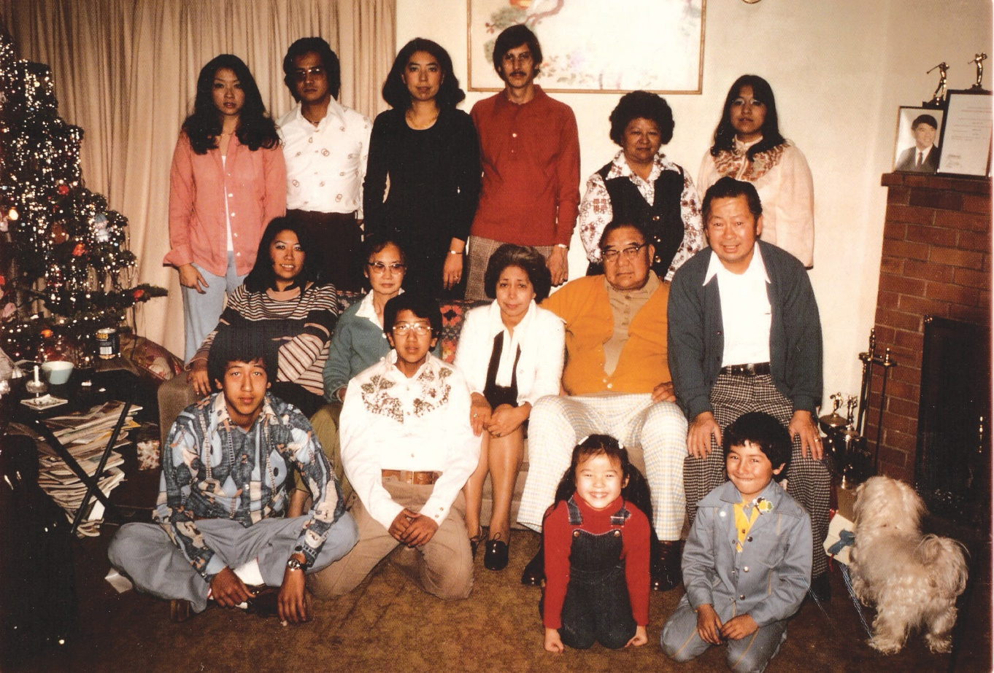

Family Christmas at George and Gladys’ home in Sacramento circa 1975. Left to right, top row: Karen Miyao, Ken Miyao, Barbara Trygg, Bill Trygg, Gladys Louie, and Roberta Lowe; middle row: Mary Lowe, Edith Lowe, Lydia Lowe, Robert Lowe, and George Louie; bottom row: Calvin Lowe, Cullen Lowe, Cheryle Miyao, Darrin Trygg, and Toby, the neurotic maltese.

**Side Dishes**

Hamburger with Baked Beans 65

Beans (Pop’s style) 65

Bitter Melon (Fu Gua Gai) 66

Curry Coconut Milk Eggplant 66

Malanzana al forno (Baked Eggplant) 67

Egg Tofu with Vegetables 67

Creamed Spinach 68

Stir-Fried Baby Bok Choy 68

Stir-Fried Summer Squash 69

Sticky Rice (Naw Mai Faun) 69

Sticky Rice 70

Annette’s Sticky Rice 70

Sticky Rice Cake (Naw Mai Go) 71

Sweet Rice Cake 71

Turnip or Radish Cake with Chinese Sausages – Law Bok Gow 72

Taro Root Cake (Wu Tao Go) 73

Idaho Potato Pancake 73

Rice Pilaf 74

Arroz 74

Stuffing 75

Fried Apples 75

Stuffing for Turkey 76

Stir-Fried Tofu with Oyster Sauce 76

Szechuan Eggplant in Chili Garlic Sauce 77

Baked Artichokes 77

Aloco (Fried Plantain) 78

Macaroni and Cheese 79

President Reagan’s Macaroni and Cheese 80

## Hamburger with Baked Beans

Source: Jess

Submitted by: Mary Lowe

*From Jess, a CHP co-worker, who always had us celebrate Groundhog Day every year. He made this for the celebration, and everyone loved them. I’ve been making these beans since 1972.*

1 medium chopped onion

1 lb. ground beef

2½ lb. can Van de Kamps Pork & Beans

½ c. molasses

½ c. catsup

3 strips bacon cut into small pieces

½ t. dry mustard

1 pinch salt

Worcestershire sauce to taste

Sauté bacon and chopped onion. Brown ground beef with the bacon and onion. Add Pork & Beans, molasses, catsup, dry mustard, salt and Worcestershire sauce. Mix and pour into casserole or baking dish. Bake 375°F oven for ½ hour. After baking you may garnish with tomato slices or wedges.

## Beans (Pop’s style)

Source: Sam Wong Sr.

Submitted by: Diane Wong-Kone

*This is the recipe my grandfather, aka “Pop” on the far right in the photo, used as an army cook in Paris in WWI. My mom made it a lot for family dinners.*

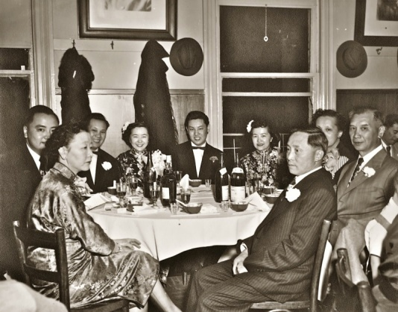2 lbs. pink beans (wash and clean)

4 cloves garlic

2 bay leaves

½ c. vinegar

Combine in pot. Cover beans with water and bring to boil. Then add ½ c. vinegar, bay leaves and garlic; boil for ¾ hour or until tender.

Season with:

1 t. pepper

1 T. sugar

2 T. salt

½ bottle catsup (~7 oz.) or to taste

Add hot dogs (sliced at an angle) to cooked beans.

## Bitter Melon (Fu Gua Gai)

Source: George Louie

Submitted by: George Louie

*Karen loves this dish.*

2 bitter melons, seeds removed and cut into 1” strips

1 lb. chicken (breast OK) or pork

Uncle George’s tip: Add a few drops of sesame seed oil to finish off a Chinese dish.

2 t. black bean & garlic sauce

7 oz. chicken broth (½ can)

sugar

oil

cornstarch

¼ t. sesame oil

Stir fry chicken/pork in oil, and add black bean and garlic sauce and a little sugar. Add chicken broth and melon. Stir-fry for 5 minutes. Mix cornstarch with water and add to chicken to make a gravy. Add ¼ teaspoon sesame oil to dish before serving.

## Curry Coconut Milk Eggplant

Source: Carlton Chan

Submitted by: Carlton Chan

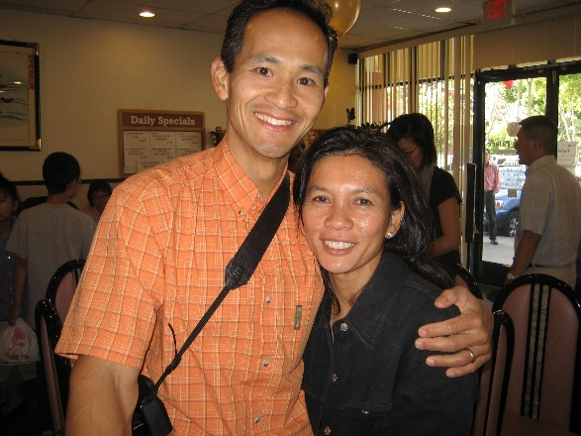

3-4 handfuls of mushrooms, any kind is fine, sliced

2 large eggplants or 4 Japanese eggplants, cut into ¾ “ cubes

1 can (13.5 oz.) coconut milk

3-4 T. curry powder

¾ c. soy sauce

3 packs of vermicelli

2 cans chicken broth

1 red onion, chopped

¼ c. oil

Place vermicelli in boiling water and let sit for 5-7 minutes. Preheat wok, and then add the oil. Place mushrooms, eggplant, and onion in wok. Stir fry until the oil coats the vegetables and mushrooms. Stir fry for 4-5 minutes more. Add 1 can of chicken broth and the vermicelli. Mix. Let mixture come to a boil. Cover and simmer until eggplant is soft. Mix in coconut milk and soy sauce. Mix in the curry powder. Cover and cook for 2 minutes. Add second can of chicken broth until the sauce lightens. Can add more soy sauce to taste.

Note: If you do not have a large wok, you can cut the recipe in half.

## Melanzana al forno (Baked Eggplant)

Source: Unknown

Submitted by: Diane Wong-Kone

*Although the big round eggplants are better for stuffing, I have sometimes substituted the thinner-skinned, oblong Japanese eggplant in this recipe as I think the skin on these eggplants isn’t as bitter tasting.*

2½ lbs. eggplant

4 T. olive oil

3 cloves garlic, minced

1 t. salt

⅓ to ½ c. pine nuts (or substitute walnuts)

2 c. peeled tomatoes (with liquid)

2 T. minced fresh parsley

½ t. basil

fresh ground black pepper to taste

⅓ c. grated Parmesan cheese

½ c. dry breadcrumbs

2 eggs, beaten

½ lb. mozzarella, cut into strips

Cut eggplants in half lengthwise. Scoop out the inside, leaving a ¼-inch layer inside the skin. Chop scooped out eggplant. Heat oil in a large pan. Add garlic. Add eggplant and salt. Sauté on high heat for about 10 minutes. Stir constantly until the eggplant just starts to turn color. Add the nuts, tomato chunks, parsley, basil, and a generous amount of black pepper. Stir the mixture. Turn down heat. Simmer for 10 minutes. Add Parmesan cheese and breadcrumbs. Stir thoroughly. Mixture should be moist but thick, not runny. Add more breadcrumbs if needed and stir in eggs. Spoon into eggplant shells. Put mozzarella cheese on top. Bake in a 350oF oven for 35-40 minutes.

## Egg Tofu with Vegetables

Source: Wendy Chang

Submitted by: Gary Ng

1.  Slice egg tofu into ½“ slices. Place on paper towels for 30 minutes to drain water out.

2.  Prepare vegetables. Mince some garlic.

3.  Pan fry egg tofu in a skillet until brown on both sides. Set aside.

4.  Stir fry vegetables with the garlic. Add a little salt. Place vegetables on a dish.

5.  Top vegetables with the egg tofu. Dilute some oyster sauce with some water, 1:1. Brush oyster sauce on tops of egg tofu. Serve.

## Creamed Spinach

Source: Lawry’s Restaurant, Los Angeles

Submitted by: Cheryle Miyao-Quock

*I got this recipe from the Lawry’s Restaurant in Beverly Hills. The restaurant serves it with prime rib, but it also goes well with chicken and fish dishes. Believe it or not, this tastes best with frozen spinach, not fresh spinach.*

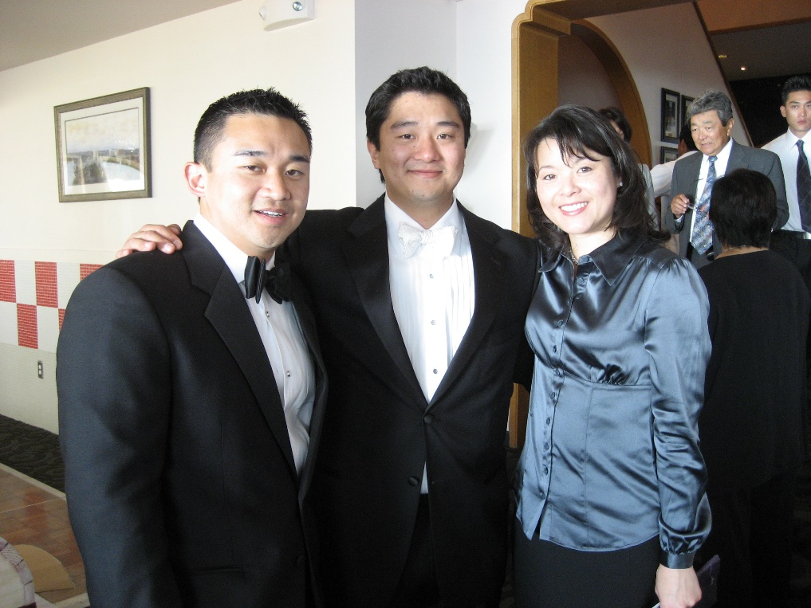

1 10-oz. package frozen chopped spinach

2 slices bacon, chopped

½ c. finely chopped onion

2 T. flour

1 t. Lawry’s Seasoned Salt

¼ t. Lawry’s Seasoned Pepper

1 clove garlic, minced

1 c. milk

Cook spinach according to package directions. Drain well. Fry bacon and onion together until onions are tender, about 10 minutes. Remove from heat. Add flour, salt, pepper and garlic. Blend thoroughly. Slowly add milk, return to heat and stir until thickened. Add spinach and mix thoroughly. Makes 4 servings.

## Stir-Fried Baby Bok Choy

Source: David Chan

Submitted by: Annette Chan & Yvonne Chan Cheng

About 1-2 lbs. baby bok choy

About ¼ c. oil

3 cloves garlic, finely chopped

2 pieces ginger (optional)

About 2 t. salt

Chicken broth

About 3 t. cornstarch plus about 3 t. water

Separate the leaves of the baby bok choy, and wash them. Heat oil in a wok. Add garlic, ginger, and salt. Stir-fry about 15 seconds. Add baby bok choy. Stir-fry about 1-1½ minutes. Add chicken broth until cover about ¾ of the bok choy with chicken broth. Cover the wok. Let cook for about 4-6 minutes (check every 2 minutes, want bok choy to be tender but not mushy). Arrange bok choy on a plate. Mix some of the cornstarch and water mixture into the remaining chicken broth in the wok (want to thicken the sauce slightly), and stir-fry about 15-30 seconds. Pour sauce on the bok choy.

## Stir-Fried Summer Squash

Source: David Chan

Submitted by: Annette Chan & Yvonne Chan Cheng

2 T. oil

1-1½ lbs. summer squash, cut into 1/2-inch slices, peeled or unpeeled

1 T. chopped garlic

About 1 t. salt

Pepper

Heat the oil in a wok. Add garlic, salt, and pepper. Stir-fry until the garlic turns light brown. Add the squash and stir-fry it over medium heat, stirring and tossing occasionally, until the squash is tender, about 8-10 minutes.

Note: You can also add the squash, stir-fry about 1 minute, cover, and cook about 5 minutes. Be careful not to burn the squash if you cook it this way.

## Sticky Rice (Naw Mai Faun)

Source: Gladys Louie

Submitted by: Cheryle Miyao-Quock

Goo-Paw always made this for the holidays. I don’t know if she changes the recipe every time she makes it, but every year, it turned out even better than the last.

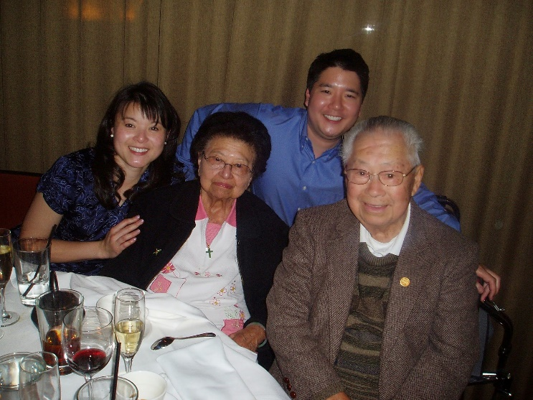3 c. sweet rice

2 c. long grain rice

1 t. salt

1 lb. lop cheung (Chinese sausage), steamed

6 shitake mushrooms, dice into small pieces

½ lb. ham, chopped

1 lb. char siu (Chinese BBQ pork), diced

2 ½ cans chicken broth (Swanson’s chicken broth)

2 T. dried shrimp (optional)

Chinese whiskey (just enough to cover shrimp)

2 T. oyster sauce or to taste

3 stalks green onions

A few drops sesame oil

Chinese parsley (cilantro), chopped

Wash rice. Cook rice in broth and salt in rice cooker. Par boil dried shrimp, and then soak in whiskey. Add remaining ingredients to cooked rice. Drain shrimp and add to rice mixture. Before serving, add a few drops of sesame oil and garnish with Chinese parsley.

## Sticky Rice

Source: Daisy Chan

Submitted by: Annette Chan & Yvonne Chan Cheng

*This is the sticky rice that our father, David Chan, would make every Thanksgiving.*

2 c. Calrose rice (use rice cooker cup)

2 c. glutinous rice (use rice cooker cup, soak rice overnight in water)

Cook rice with chicken broth or water (4 cups in rice cooker).

Stir-fry in oil the following: diced Chinese sausage, diced ham, dried mushrooms (soaked in water, cleaned, stems removed, and diced), chopped green onions, and diced button mushrooms. Add cooked rice.

Add:

1 t. salt

1 T. dark soy sauce

2 T. oyster sauce

Mix everything together. If you cook the rice with broth instead of water, omit the salt and use less soy sauce and less oyster sauce.

## Annette’s Sticky Rice

Source: Annette Chan

Submitted by: Annette Chan

*This is a relatively quick way to make sticky rice. You basically cook everything together in a rice cooker and then add the seasonings. You don’t need to stir fry this*.

2 Chinese pork sausages, diced

¼ lb. cooked ham, diced

2 c. sweet rice (regular cups, not rice cooker cups)

3 c. cold water

1 green onion, finely chopped

½ t. salt

1 T. oyster sauce

1½ t. dark soy sauce

Chinese dried black mushrooms (soak in warm water for 30 minutes). Rinse, squeeze dry, remove and discard the stems, and dice.

Wash rice in 4 changes of water. Steam rice in rice cooker with Chinese pork sausages and mushrooms. Mix together the salt, oyster sauce, and dark soy sauce, and add this mixture to the rice, along with the ham and green onion. Mix together gently (don't want to turn the rice into a paste). Can be used as stuffing for poultry.

## Sticky Rice Cake (Naw Mai Go)

Source: Daisy Chan

Submitted by: Evelyn Wong

3 c. water

3 c. rice flour

¼ t. five spice powder

½ t. salt

1 c. cooked glutinous rice (Naw Mai)

¼-½ t. gon suey (potassium carbonate solution, Koon Chun brand), optional

2 c. mix ingredients (see below)

Mix and stir fry (chow):

Salted pork, cut into small pieces

Ham, cut into small pieces

Chinese sausage (lop cheung), cut into small pieces

Dried shrimp (pre-soaked)

Mushroom (pre-soaked), cut into small pieces

Oil pan. Mix together all ingredients, pour into greased pan, and steam for 3 hours.

## Sweet Rice Cake

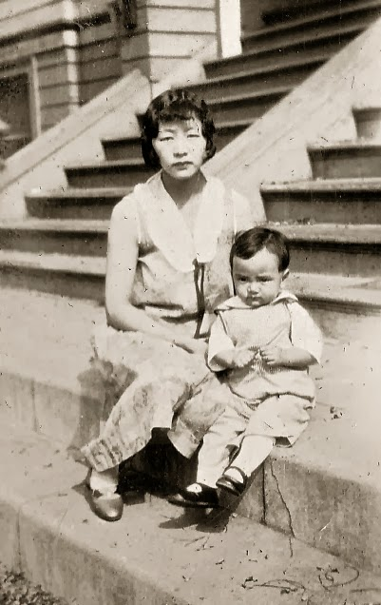Source: Daisy Chan

Submitted by: Annette Chan & Yvonne Chan Cheng

*Traditionally eaten during Chinese New Year.*

1 lb. glutinous rice flour

1 lb. brown sugar (Chinese cubed brown sugar)

3½ c. water

Toasted sesame seeds

1 red date

Dissolve sugar in water over low heat. Mix sugar-water mixture with rice flour. Pour into a greased pan. Steam for 3 hours. Garnish with toasted sesame seeds and red date.

## Turnip or Radish Cake with Chinese Sausages – Law Bok Gow

Source: Unknown

Submitted by: Diane Wong-Kone

*This is one of the recipes I look at as a guideline, but actual proportions may vary. See notes for Chinese Salt in Miscellaneous section.*

Ingredients:

~2 lb. turnip (1 large daikon), grated or chopped fine, drain in colander

2½ c. rice flour

~¼ c. corn starch

2½ c. water

2 pcs Chinese sausages (~100g), rinsed and chopped

6-8 pcs dried Chinese mushroom, pre-soaked, chopped, reserve water

4 pcs dried scallop, pre-soaked and torn into strips (optional)

~ ⅛ c. dried shrimps, chopped

1-2 stalks green onion, chopped

Seasonings (adjust proportions to taste):

2 tsp Chinese rock sugar (available in Chinese grocery) or brown sugar

1 tsp salt (Chinese 5-spice salt works well)

1 tsp soy sauce

½ tsp ground white pepper

Combine the corn starch and rice flour with 2½ cups of water (inclusive of those collected from draining the turnip, soaking the mushrooms and scallops). Stir and mix well until smooth. Set aside.

Heat 3 tablespoons of oil in wok over medium heat, sauté cook chopped sausages, stir fry till fragrant, then add in shrimp, mushrooms, scallops, and green onions. Keep stir frying, about 3 minutes, toss in the turnip strips, add seasonings, and stir well. In about another 5 minutes, the strips will be softened and juice will exude from them.

Turn to low heat, slowly stir in flour mixture into the turnips (give the mixture a good stir before pouring in to avoid flour settling at the bottom). Turn and mix well until all incorporated like a soft batter that is not runny, almost like a sticky dough. Turn off heat. Grease dish for steaming (2 round cake pans work well). Transfer the turnip batter into the pan, smooth top with spoon. Steam the turnip cake over high heat for 40 minutes. Check doneness by inserting a toothpick to see if it comes out clean.

**To serve**  
Cut out your preferred size and serve hot, or let cool, chill it in fridge, invert from dish, then cut into about 1cm thick slices and pan fry (chilling makes the cake firmer and thus pan frying easier).

Serve with soy sauce mixed with a little rice vinegar or chili sauce.

## Taro Root Cake (Wu Tao Go)

Source: Daisy Chan

Submitted by: Evelyn Wong

2 c. water

2 c. rice flour

¼ t. five spice powder

1 t. or less salt

1 c. taro root (diced small)

1-1½ c. mix ingredients (“chow” recipe below)

Mix and stir fry (chow):

Salted pork, cut into small pieces

Ham, cut into small pieces

Chinese sausage (lop cheung), cut into small pieces

Dried shrimp (pre-soaked)

Mushroom (pre-soaked), cut into small pieces

Oil pan. Mix together all ingredients, pour into greased pan, and steam for 3 hours.

## Idaho Potato Pancake

Source: Edith Lowe

Submitted by: Karen Miyao

This is my mom’s recipe per Auntie Gladys.

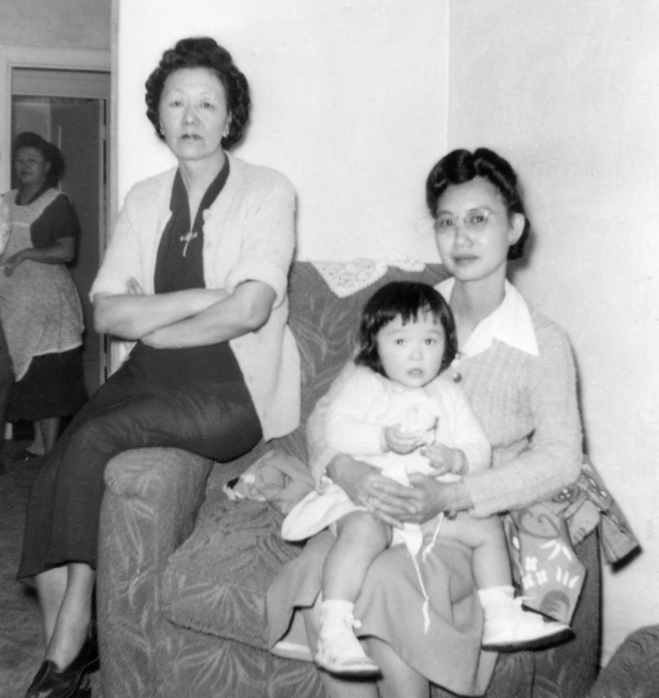

3 medium Idaho potatoes, peeled and grated

½ c. flour (or just enough to make it into the consistency of pancake batter)

½ t. salt

2 strips bacon, cut and fried

2 T. dry shrimp (soaked in water for ½ hour)

½ c. green onions, chopped

½ c. cilantro, chopped

Stir fried ong choy or minced turkey, optional

Mix all ingredients together. Fry like a pancake. Delicious with ketchup.

## Rice Pilaf

Source: Unknown

Submitted by: Karen Miyao

*A good alternative to plain white rice.*

1 c. uncooked long grain rice

1 c. vermicelli, broken into small pieces

¼ c. butter

3 c. boiling chicken broth

Melt butter in skillet. Add vermicelli and brown. Add washed rice and broth. Stir until thoroughly mixed. Cover with tight lid and simmer. Do not stir until all moisture is absorbed. Add salt and pepper to taste. Fluff with fork.

## Arroz

Source: Nat Wong

Submitted by: Nat Wong

*Christina says, “…reminds me of my grandma's recipe. When I miss her, I add about ½ cup diced onions with the garlic in that recipe. She liked her rice with onion :o)”*

3 Tbsp vegetable oil

1 cup rice

1 tsp minced garlic

½ tsp salt

½ tsp cumin

½ cup tomato sauce

14 oz chicken broth

3 Tbsp chopped cilantro

Heat the oil on medium. Add rice and coat in the oil. Add garlic/salt/cumin and stir until the rice starts to become golden. Add tomato sauce/broth/cilantro and bring to a boil. Simmer until cooked.

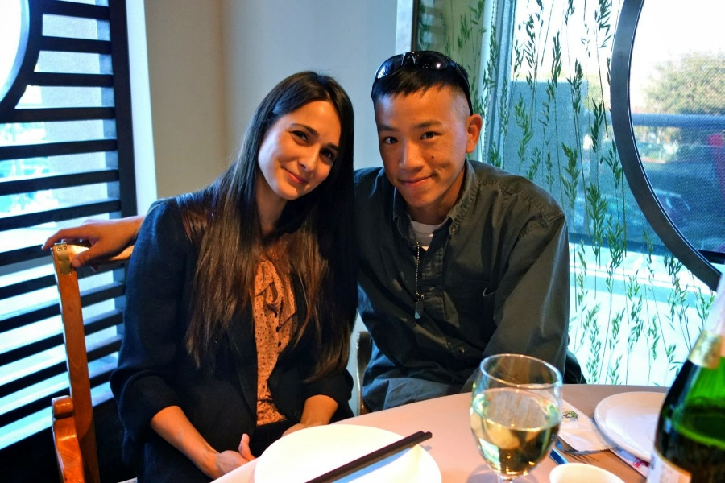

## Stuffing

Source: Daisy Chan

Submitted by: Annette Chan & Yvonne Chan Cheng

*This stuffing can be used to stuff a turkey. We make it every Thanksgiving*.

1 roll pork sausage

1 c. Chinese sausage, diced

1 c. ham, diced

¾ c. dried mushrooms (soaked in water, cleaned, stems removed, diced)

½ t. five spice powder

2 T. soy sauce (light)

½ t. sugar

8-10 chestnuts (soaked overnight in water and then cooked for about 10 minutes with a pressure cooker or simmered for 2 hours in water until soft)

1 c. button mushrooms, sliced

1 yellow onion, chopped

½ c. celery, chopped

12 oz. Parisian French Bread stuffing mix (turkey on front of box)

1 can chicken broth (can use water instead)

About 5 c. water

1 loaf of white bread, toasted, chopped into squares

Butter

Fry pork sausage until almost cooked through. Add Chinese sausage, ham, dried mushrooms, five spice powder, soy sauce, and sugar. Stir fry 1-2 minutes. Add button mushrooms, yellow onion, celery, and chestnuts, and cook until done. Heat the chicken broth and water (can omit the chicken broth and just use water) until hot. Add the hot boiling broth and water to the stuffing mix and bread slowly, mashing together with a masher. Mixture should be thick and slightly dry. Add the meat mixture. Put in a buttered bowl. Put pads of butter on top of the stuffing. Loosely cover stuffing with foil. Bake 30 minutes at 350°F. Uncover for last 10 minutes.

## Fried Apples

Source: Diane Wong-Kone

Submitted by: Diane Wong-Kone

1 apple (peeled and sliced)

Approximately ¼ stick of butter

Cinnamon sugar (to taste)

Raisins and almonds (optional)

Peel apple, core and slice. Heat skillet. Melt butter. Add apple slices and cook until soft. Sprinkle cinnamon sugar (mix more sugar than cinnamon into the mixture) onto apple pieces. Raisins and sliced almonds can be added if liked. Serve on the side or on top of pork chops.

## Stuffing for Turkey

Source: Evelyn Wong

Submitted by: Diane Wong-Kone

*My mom makes this stuffing every year at Thanksgiving, and it always disappears fast.*

1 package Jimmy Dean lean sausage

3-4 stalks celery, chopped

1 medium onion, chopped

1 package Pepperidge Farm breadcrumbs

1-2 c. chicken broth

Salt and pepper

Cook sausage in pan until brown. Add onion and celery and cook until translucent. Add chicken broth and breadcrumbs. Add salt and pepper to taste. Stuff in turkey and bake, or put in a casserole dish and bake at 350°F for about 1 hour.

## Stir-Fried Tofu with Oyster Sauce

Source: David Chan

Submitted by: Annette Chan & Yvonne Chan Cheng

*Our father would make this almost every day. The dish takes on the flavor of whatever you add to it (e.g. roast pork, roast duck, etc.). We often used whatever leftovers we had to make this dish.*

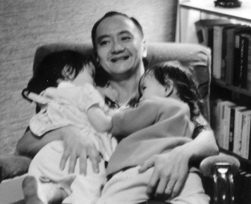

About ¼ c. vegetable oil

About 1 t. salt

2 cakes of tofu (extra firm or silken or anything in between), cut into squares

About 2 T. oyster sauce

About 1 T. light or dark soy sauce

Peas, pieces of roast pork, etc. (optional)

Hot water or room-temperature chicken broth

About 3 t. cornstarch plus about 3 t. water

Heat oil and salt in wok. Add tofu, oyster sauce, soy sauce, and peas (or roast pork, or etc.). Add water or chicken broth to cover about ¾ of the tofu. Stir-fry about 15 seconds. Cover. Cook about 1 minute. Check the tofu (it should be soft), and cook longer if necessary. Add some of the cornstarch and water mixture (want sauce to be slightly thickened), and stir-fry about 15-30 seconds.

## Szechuan Eggplant in Chili Garlic Sauce

Source: Wendy Chang

Submitted by: Gary Ng

About 16-18” of Japanese eggplant (the long skinny kind)

6 cloves of garlic, minced

2 green onions, either diced or in 2” strips

Sauce:

1 T ground bean sauce (not bean sauce, but GROUND bean sauce, must be brown color, not black bean sauce)

2 T soy sauce (start with less, depends on how salty the soy sauce is)

2-3 t brown sugar

1 T dry sherry

1-2 t chili sauce

(For later) 1 t sesame oil

1. Slice eggplant into 2” x 3/4” strips. Steam until soft, but not mushy. Optional: brown steamed eggplant with a little oil in a skillet. Set aside.

2. Stir fry green onions and garlic. Add sauce mixture and cook until it bubbles. Add eggplant and gently stir fry. May add some water if you need to. Taste and adjust with more soy or sugar or chili sauce.

3. Drizzle sesame oil, stir. Serve.

Baked Artichokes  
Recipe by: Diane Wong-Kone

Submitted by: Diane Wong-Kone

2 artichokes  
~ ½ stick of butter (enough to drizzle over the artichokes)  
2-3 cloves garlic (chopped fine)  
Breadcrumbs  
Parmesan cheese (optional)

Clean artichokes and cut stems and thorns off with scissors. Steam/boil for about 20-30 minutes or until the petals are soft enough to open the choke. In heatproof plate, place the artichokes stem-side down and open to form a flower. Meanwhile, melt butter in a pan and cook garlic for a minute or two. Drizzle garlic butter over opened up artichokes. Then sprinkle breadcrumbs and parmesan cheese. Cover plate with aluminum foil. Bake in 350oF oven for another ½ hour.

## Aloco (Fried Plantain)

Source: Adama Kone

Submitted by: Diane Wong-Kone

Servings: 2. Serves 4 if used as a side dish.

*This Ivoirian dish is sometimes served with attiéké (fermented cassava) and fried fish, but Adama and I like to simply boil an egg, cut it into wedges and eat it with the plantains and spicy sauce. The fried plantains also taste great fresh out of the pan. Plantains are ripe when they are yellow and black. Unripe plantains are not as sweet and a bit bitter but can be used. If they are too ripe and soft, the plantains will burn easily.*

4 ripe plantains

salt

2 large eggs

Cut ends off plantains. Slice partway and remove peel. Cut plantain in half lengthwise and then in half again, lengthwise. Cut into large dice. Place in a single layer on a plate and sprinkle with salt. Set aside while prepping the sauce. Boil eggs.

When sauce (below) is simmering, fry the plantains. Heat pan then add oil ~1/2 inch deep, or use a deep fryer if you have one. Add the plantains in a single layer, stirring occasionally. Plantains will take a little while to cook. They are done when they turn golden and a little reddish in color. Remove with slotted spoon. Peel and cut eggs in quarter wedges and place on plate with plantains. Serve with sauce pimenté.

**Sauce Pimenté for Aloco**

Try adding berebere (Ethiopian spice – sold in stores).

2-3 T. oil

1 T. tomato paste

1 ripe tomato, diced

½ - 1 onion, diced

1-2 cloves garlic, chopped fine

1 habanero, seeded and chopped fine (use gloves if sensitive to pepper oil)

1 tsp. fresh chopped parsley (optional)

Salt and pepper to taste

Water

Heat small pot. Add oil. When heated, add tomato paste. Simmer and stir a little until oil turns red. Sauté onions and habanero. Stir a little. Add tomatoes and garlic. Cover with water to double the liquid volume. Boil and reduce a bit. Add spices and parsley. Sauce will be wet but not too thin. Taste and adjust spices as desired

## Macaroni and Cheese

Source: Carlton Chan

Submitted by: Carlton Chan

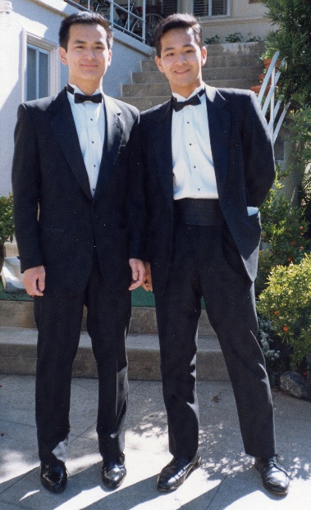1 pound elbows, shells, cavatappi, farfalle, fusilli or other short, tube-shaped pasta

Kosher salt

4 tablespoons unsalted butter

¼ cup all-purpose flour

4 cups whole milk

1 clove garlic, finely grated

1 teaspoon smoked or hot paprika

 Freshly ground pepper

12 ounces sharp or white Cheddar cheese, grated

12 ounces fontina or Gruyère, grated

For Topping (OPTIONAL):

1 cup coarse bread crumbs or panko

4 tablespoons melted butter or olive oil

¼ cup finely grated Parmesan cheese (optional)

 Kosher salt and freshly ground pepper

PREPARATION

Cook pasta in a large pot of salted boiling water until it’s barely al dente. It should be more al dente than your average pasta: It’s going to continue to cook in the oven. Drain and set aside.

Meanwhile, heat butter in a medium pot over medium heat. (The pot should be large enough to hold all the pasta when cooked.) Whisk in flour and cook, whisking constantly, until the flour is foamy and just starting to turn a light golden brown, about 4 minutes. Slowly whisk in milk to avoid clumping. Add garlic, paprika and season with salt and pepper. Bring to a simmer, whisking constantly and paying special attention to the edges of the pot to make sure the flour mixture is totally incorporated.

Add grated cheese and whisk to blend until the cheese is completely melted. The sauce will seem thick at first and thin out as the cheese melts; it will thicken while it bakes. Season with salt and pepper and add cooked pasta, stirring to coat well.

Heat oven to 425°F. Line a rimmed baking sheet with aluminum foil to catch any cheesy drips.

Make the optional topping: Combine bread crumbs, melted butter and Parmesan, if using, in a medium bowl. Season with salt and pepper and, using your hands, mix well to ensure the bread crumbs are evenly coated.

## President Reagan’s Macaroni and Cheese

Source: *The Sacramento Union* newspaper (from Gladys Louie’s recipe folder)

Submitted by: Cheryle Miyao-Quock

*I found this recipe in Goo-Paw’s recipe collection. I wanted to submit this because it represents her love of pasta, or as she called them “nooloos”, and President Reagan (hence her first son’s name).*

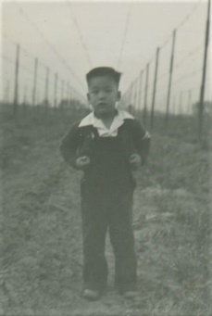

½ lb. macaroni

1 t. butter

1 egg, beaten

1 t. salt

1 t. dry mustard

3 c. grated cheese, sharp

1 c. milk

Boil macaroni in water until tender and drain thoroughly. Stir in butter and egg. Mix salt and mustard with 1 T. hot water and add to milk. Add cheese, reserving enough to sprinkle on top. Pour into buttered casserole, add milk, sprinkle with cheese. Bake at 350°F for about 45 minutes or until custard is set and top is crusty.

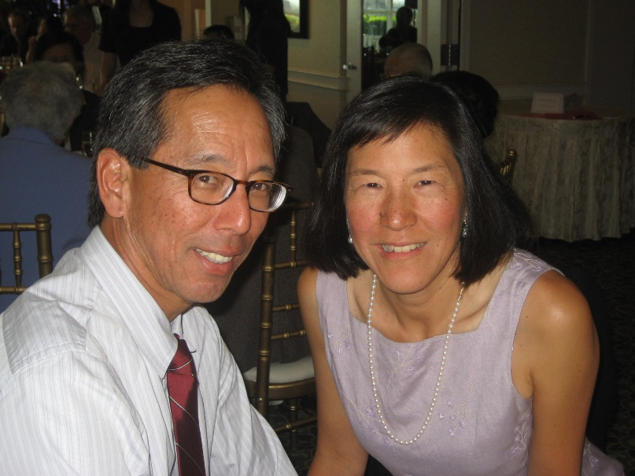

# Main Dishes

Family gathering at the Chinese Cultural Center in Visalia, CA, circa 2007. Left to right, top row: Roberta Lowe, Julie Pacheco, Derrick Miyao, Ken Miyao, and Barbara Lowe; middle row: Sam Wong, Evelyn Wong, Elsie Ng, Mary Lowe, Karen Miyao, and Shirley Wong-Jose; bottom sitting row: George Louie, Brandon Louie, and Tim Jose.

**Main Dishes**

Chinese Roast Chicken 85

Squab (Young Pigeon) 85

Chinese Roast Chicken 86

Red-Simmered Chicken 86

Chicken with Chinese Leeks 87

BBQ Curry Chicken 87

Teriyaki Chicken 88

Chicken Adobo 88

Curry Chicken 89

Soy Sauce Chicken 90

Batter for Fried Chicken or Fried Prawns 90

Fried Chicken 91

Fried Chicken Chinese Style 92

Fried Chicken 92

Rice Krispies Chicken 93

Panko Fried Flank Steak or Chicken 94

Chicken Cacciatore 95

For App (Roast Duck) 96

Smoked Turkey 96

Ja Gee Duck (Fried Crispy Duck) 97

Turkey Pot Pie with Cranberry-Pecan Crust 98

Water Eggs (Seui Gaidaan) 99

Meat Loaf 99

Hungarian Short Ribs 100

Tri-Tip 100

Beef Teriyaki 101

Flank Steak Skewers 101

Marinade for Spare Ribs 102

Barbecue Ribs 103

Beef Brisket Stew 104

Prime Rib Roast 105

Standing Rib Roast 105

Prime Rib 106

Beef Stew 106

Chili 107

Cha Siu (Chinese BBQ Pork) 107

Side Pork (Cau Yook) 108

Lop-yook (Chinese Bacon) 109

Fun See, Pork and Hairy Melon 109

Steamed Pork with Shrimp Paste 110

Basic Recipe for Steamed Minced Pork Strips with Salted Fish (Jing Ger Yook) 110

Steamed Pork Spareribs 111

Pork Shoulder 111

Roasted Pork Belly 112

Pulled Pork Recipe 112

Lamb Curry Stew 113

Steamed Dace with Salted Black Beans 113

Minced Oyster, Pork and Vegetables (Ho See Seung) 114

Honey Walnut Prawns 115

Fried Rice 116

Minute Rice Casserole 117

Tuna Casserole 118

Rigatoni Casserole 118

Tamale Pie 119

Cheese Pasta 119

Tamale Pie 120

Angel Hair Pasta with Shrimp 121

Chow Fun 121

Tomato Beef Chow Mein 122

Spaghetti Sauce 123

Pasticha 124

Honey & Coconut Caramelized Chicken 125

Best Instant Pot Ribs 126

Slow-Cooker Kalua Pork Sandwiches With Crispy Asian Slaw Recipe 128

Ger Guerk Cho - Black Vinegar Pigs Feet 129

“Korean” Chicken Recipe 129

Claypot Chicken (No Claypot) 130

Kung Pao Chicken 131

Mac and Cheeseburger 132

Ultimate Won Ton Filling 132

Stroganoff Chicken 133

Instant Pot White-Cut Chicken 133

Instant Pot Chicken Paprikash 134

Basil Chicken 134

Instant Pot Braised Chicken 135

Chicken and Egg Donburi 135

Instant Pot Fall-Off-The-Bone Chicken 136

Vegetarian Sushi Bake 136

Okonomiyaki 137

Steamed Chicken 138

Sushi Bake 138

California Roll Sushi Bake 139

Asparagus with Black Bean Beef 140

Best Chicken Stew 141

Hachis Parmentier 142

Brined Pork Tenderloin 143

Pork Chops with Curry & Green Chile Rub 144

Pork Chops with Scalloped Potatoes 145

Chicken (or Pork) Adobo 146

Chicken with Snow Peas 147

Lo Han Jai 148

Lucky Black-Eyed Peas 150

Pesto-Crusted Salmon with Wilted Spinach 151

Andy’s Spaghetti Saturday Pasta 152

## Chinese Roast Chicken

Source: Daisy Chan

Submitted by: Annette Chan & Yvonne Chan Cheng

4½ lbs. chicken, cleaned with salt

Marinade:

2 T. dark soy sauce

2 T. Chinese rice wine or dry sherry

¼ t. ground ginger

½ t. salt plus five spice powder (see note)

2 T. honey

½ t. salt

½ t. ground black pepper

Boil water in a large pot. Put chicken in the pot. Allow the water to boil again. Turn off the fire. Take chicken out of the pot, and place it in a bowl.

Mix the marinade, and rub the inside and outside of the chicken with the marinade. Allow the chicken to marinate in the bowl overnight in a refrigerator. Turn the chicken over about halfway through marinating it.

Let the chicken come to room temperature. Preheat oven to 350°F. Cover the top of a flat metal tray with aluminum foil (the aluminum foil should have high sides), and place a rack on the aluminum foil. Place chicken on the rack with its backside up, and place the tray on the lowest rung of the oven. Baste chicken with marinade. Bake for 45 minutes. Turn chicken over. Baste chicken with marinade. Bake for 35-45 minutes more or until brown.

Note: To make salt plus five spice powder, heat ¼ cup salt in a frying pan until the salt turns light brown. Turn off the heat. Wait about 4 minutes. Mix in 1 heaping teaspoon of five spice power.

## Squab (Young Pigeon)

Source: Daisy Chan

Submitted by: Evelyn Wong

1 squab

¾ t. Chinese salt

Soy sauce

Honey (to taste)

Sew both ends of squab to hold in the meat juice during cooking. Dip the bird in boiling water. Marinate squab in soy sauce and salt for ½ -1 hour. Bake 45 minutes at 350°F in a pan. Baste with soy sauce and honey.

## Chinese Roast Chicken

Source: Unknown

Submitted by: Evelyn Wong

1 whole fryer chicken

½ c. soy sauce

¼ c. lemon juice

2 T. honey

2 t. sesame oil

1 t. dry mustard

½ t. ground ginger

1 clove garlic

¼ t. pepper

Mix marinade ingredients and pour over chicken in a bowl. Refrigerate at least 1 hour to overnight. Bake in 350oF oven 1-1½ hours and use the marinade to baste the chicken. 4 servings.

## Red-Simmered Chicken

Source: Denise Chan

Submitted by: Annette Chan & Yvonne Chan Cheng

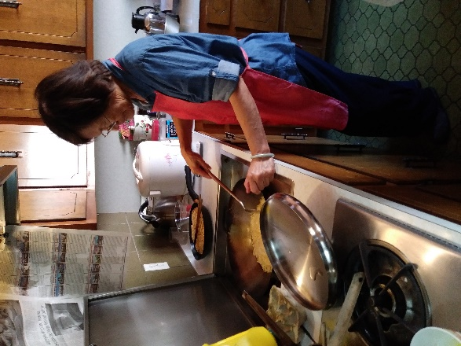1 chicken, cut into pieces

½ t. paprika

½ t. mustard powder

1 heaping T. cornstarch

3 cloves garlic, minced

1 piece ginger

2 T. white wine or sherry

3 T. dark soy sauce

3 T. light soy sauce

1 heaping T. sugar

2 green onions, cut into 1-inch pieces

½ -1 c. water

Oil

Salt to taste

Mix together paprika, mustard powder, and cornstarch. Cover chicken pieces with paprika mixture. Heat oil in a pan. Add chicken pieces; lightly brown over high heat. Heat oil in a pot. Add garlic and ginger to the pot; stir-fry over high heat for about 30 seconds. Add chicken to pot; coat with garlic mixture. Add wine or sherry, dark soy sauce, light soy sauce, sugar, and green onions to the pot. Stir chicken until coated with soy sauce mixture (about 5 minutes). Add ½ -1 cup water. Bring to a boil. Simmer, covered, about 50 minutes. Add salt to taste. Add more water if liquid starts to dry out.

## Chicken with Chinese Leeks

Source: Daisy Chan

Submitted by: Annette Chan & Yvonne Chan Cheng

*We make this dish with the Chinese leeks that are descendants of the plants our great grandfather Ching Lowe brought over from China.*

Oil

½ t. salt

3 fermented white bean curds

1 cut up chicken (marinated with ginger, garlic, light soy sauce, sugar, salt, and pepper)

1 T. white wine

About ¾ c. hot water

Cornstarch mixed with water

Chinese leeks (garlic chives), cut into 1-inch long pieces

Heat oil and add salt to the oil. Add the fermented bean curds. Stir fry, mashing up the bean curds. Add the chicken and marinade. Stir fry a little to mix. Add white wine and about ¾ cup hot water, and mix together. Cover. Cook 5 minutes. Stir fry. Cover. Cook 5 minutes or until done. Add hot water if needed. Add leeks, and stir fry about 30 seconds. Add cornstarch mixture to thicken the sauce. Stir-fry about 30 seconds.

## BBQ Curry Chicken

Source: Carlton Chan

Submitted by: Carlton Chan

1½–2 lbs. chicken thighs, bones removed

¾ c. soy sauce

4 T. curry powder

⅛ c. olive oil

Place chicken in a large Tupperware container. Pour in soy sauce, curry powder, and oil.

Mix. Cover and let sit in refrigerator for 2-3 hours. Preheat grill on high until temperature reaches 300°F. Open grill and place chicken to sear on one side. Close grill and let sit for 20-30 seconds. Open grill, flip chicken, and let sear on the other side. Close grill and turn heat down. Close direct heat to chicken if you have a three-burner grill; if not, turn heat down and watch so that chicken does not burn. Let chicken grill at about 250°F for about 25 to 30 minutes. Check chicken for readiness.

## Teriyaki Chicken

Source: *Centenary Favorites*, Centenary United Methodist Church, Los Angeles, CA, 1986

Submitted by: Wendy Chang

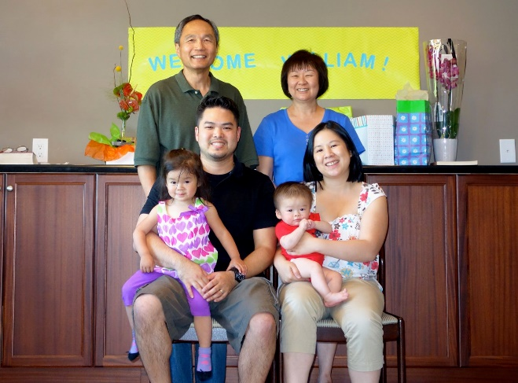Teriyaki Sauce for 3 pounds of chicken wings and drumettes:

½ c. light soy sauce (Kikkoman)

½ c. sugar

¼ c. brandy

2 cloves of garlic, minced

1 T. grated fresh ginger

Combine sauce ingredients and heat in the microwave only long enough to dissolve the sugar. Marinate chicken overnight, up to 2 days, but no longer because the chicken will get too salty.

Spray pan with PAM (non-stick oil spray). Place chicken on pan and baste with some of the marinade. Bake in a 325oF-350oF oven for 30 minutes. Turn chicken, and baste again. Cook for another 15-20 minutes or until chicken is done. Serve warm or cold.

## Chicken Adobo

Source: Shirley Wong-Jose

Submitted by: Shirley Wong-Jose

1 fryer or chicken pieces (wings work really well with this recipe)

1-2 T. oil

½ c. vinegar (the Filipino cloudy white vinegar works best but regular white or rice vinegar may be substituted)

1 bay leaf

Dash of oregano

2-3 cloves garlic (chopped fine)

½ c. soy sauce

Cooked rice to serve with it.

Heat oil in wok or large skillet. Brown chicken in the oil. Add vinegar and soy sauce. Simmer and brown (~10 min.). Add garlic, bay leaf and oregano. Simmer ~10 min. more. Pour off liquid and save. Spoon fat off of the surface of the liquid. Pour liquid back in with the chicken. Make extra sauce (as above) with added water for extra sauce for rice.

## Curry Chicken

Source: George Louie

Submitted by: George Louie

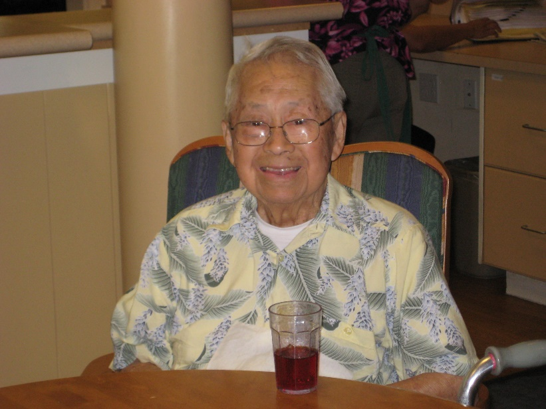2 lbs. chicken pieces (with bones, needed for flavor)

Marinade:

1 cube of ginger, about the size of a die, smashed

1 t. sugar

1 t. soy sauce

1 t. curry powder

1 t. garlic salt

2 t. whiskey wine

Marinate chicken for 2 hours or overnight in marinade.

2 potatoes, cut into large chunks

1 onion, chopped

½ t. salt or to season

2 t. curry powder, add more if you want a stronger curry taste

Bell pepper, chopped into chunks

3 t. cornstarch mixed with 1½ t. water

½ t. sugar (if possible, use the Chinese hard brown sugar)

½ t. salt

¼ t. sesame oil

Fry chicken in pot with potatoes and onions. Remove potatoes (save for later). Cover chicken and onions with water. Add salt and curry. Stir and boil ½ hour. Add potatoes, bell pepper, salt and sugar. Boil until vegetables are tender. Add cornstarch mixture to thicken. Before serving, add sesame oil.

## Soy Sauce Chicken

Source: Evelyn Wong

Submitted by: Diane Wong-Kone

*I found this recipe on a torn piece of newspaper, so I don't know the author. It's very similar to the marinade my mom uses (she doesn't measure exactly).*

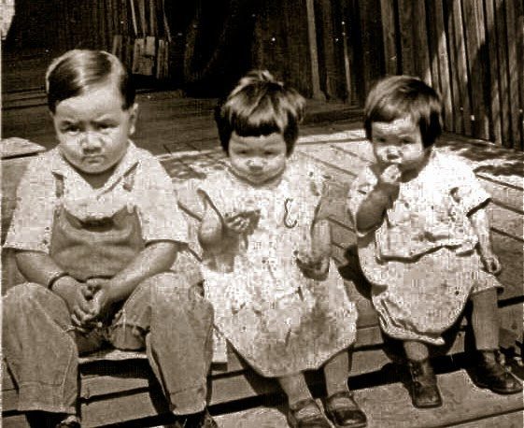

2 c. dark soy sauce

2 c. light soy sauce

¼ c. rock sugar or brown sugar

1 T. whole Sichuan peppercorns, roasted

1 whole star anise

½ t. fennel seed

2 slices fresh ginger root

2 c. chicken broth

½ c. dry sherry or rice wine

1 roasting chicken (4-4½ pounds)

Sesame oil (optional)

Put the braising ingredients into a pot large enough to hold chicken. Add the whole chicken and heat to simmering. Turn the chicken several times in the sauce while it simmers. Simmer for 20 minutes, then turn off the heat and let the chicken steep in the spices for 1 hour. The liquid can be saved and reused. Put sesame oil on chicken if desired.

## Batter for Fried Chicken or Fried Prawns

Source: Lydia Lowe

Submitted by: Diane Wong-Kone

¾ c. flour

1 c. cornstarch

½ t. baking soda

½ t. salt

½ t. baking powder

½ t. mei jing (MSG - optional)

This recipe provides batter mixture for one chicken cut into frying pieces. Deep fry. Alternate cooking method: Heat pan. Add enough oil to cover the bottom of the pan and heat the oil through. (You can test if the oil is ready by adding a bit of batter to see if it crackles). Dip chicken pieces in beaten egg and then flour mixture. Add chicken pieces to the pan. Brown on all sides. Cover pan and lower heat. Cook about 20 minutes, turning the chicken pieces occasionally.

## Fried Chicken

Source: Modified recipe from Crisco

Submitted by: Karen Miyao

*This recipe was on the back of a Crisco can, and I modified it a little bit. Delicious hot or cold.*

2 lbs. whole chicken, cut up, or 2 lbs. of chicken pieces

Marinade:

2 T. sherry or sake

1 T. soy sauce

½ t. salt

½ t. pepper

2 cloves garlic, minced

1 t. ginger, minced

Pinch of sugar

Seasoning:

1 c. flour

2 t. garlic salt

1 t. paprika

¼ t. poultry seasoning

1 t. pepper (for spicier chicken add ½ to 1 t. additional pepper)

Marinate chicken in marinade for at least a half an hour. Dip chicken in plain flour first then in egg wash. Then dip in seasoning. Fry.

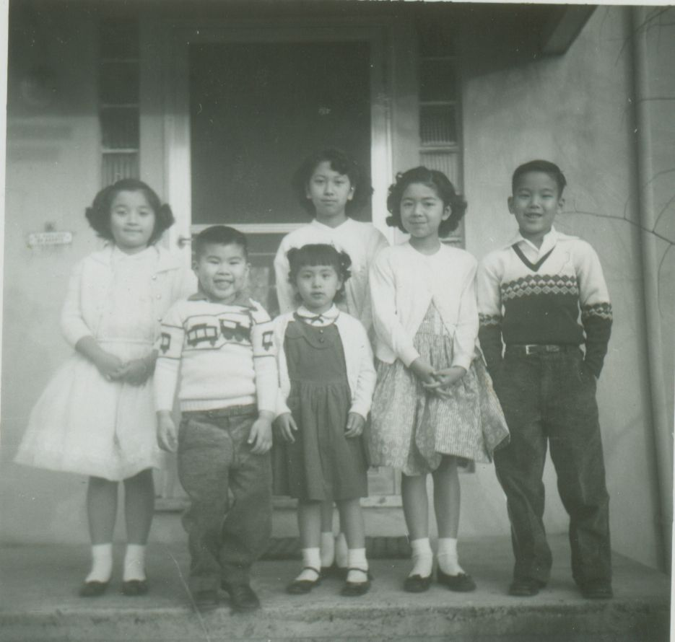

## Fried Chicken Chinese Style

Source: Daisy Chan

Submitted by: Diane Wong-Kone

*This recipe was not written down anywhere, but my mom (Evelyn Wong) remembers watching her mom cook this in the kitchen when she was a young girl growing up*.

1 whole chicken (cut in pieces for frying)

Fresh ginger (½ -1 inch chunk)

Rice wine (to soak ginger in)

Marinade:

~¼ c. soy sauce

~¼ c. rice wine

1-2 cloves garlic (chopped or pressed)

Salt (sprinkle over chicken)

2 eggs (beaten, for dredging chicken)

Flour

1 box cracker meal

Oil for deep frying

Soak ginger in wine overnight. Then crush ginger (save the juice) and squeeze out the ginger wine juice through a cheesecloth or garlic press over the chicken. Mix the marinade and marinate the chicken for about a half a day. Remove from marinade and pat dry. Dredge chicken parts in egg, then flour, then more egg, and then cracker meal. Place chicken on ventilated cookie cooling trays to let the pieces dry. Deep fry in oil; crackling should stay on.

## Fried Chicken

Source: David Chan

Submitted by: Karen Miyao

*A recipe from one of my favorite cousins.*

Cut 2 chickens into pieces and marinate in:

1 t. ground thyme

1 t. tarragon

1 t. pepper

2 T. sherry

Salt

2 T. soy sauce

Ginger and Garlic

Cracker Meal or flour

Marinate overnight. Before frying chicken, coat with two beaten eggs. Coat with cracker meal. For Chinese style, fry chicken in flour.

## Rice Krispies Chicken

Source: Gladys Louie (Kellogg’s Rice Krispies box)

Submitted by: Karen Miyao

*One of Goo-Paw’s signature dishes. Klinton and Derrick love to eat the Rice Krispies crust at the bottom of the pan.*

1 3-lbs. chicken, cut into serving pieces or 3 lbs. chicken wings

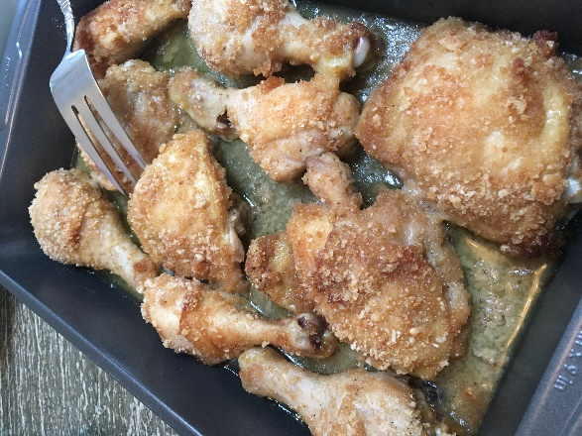

Marinade:

2 T. sherry, white wine, or sake

1 T. soy sauce

½ t. salt

½ t. pepper

2 cloves garlic, minced

1 t. ginger, minced

Pinch of sugar

Marinate chicken 30 minutes to overnight.

Coating:

*Yvonne made this for the cookbook gathering at her home.*

1 cube butter, melted

3 c. Rice Krispies cereal, crushed

Coat chicken in melted butter and then roll in Rice Krispies. Bake on greased shallow pan for 1 hour at 350°F, or until done. It is not necessary to turn chicken.

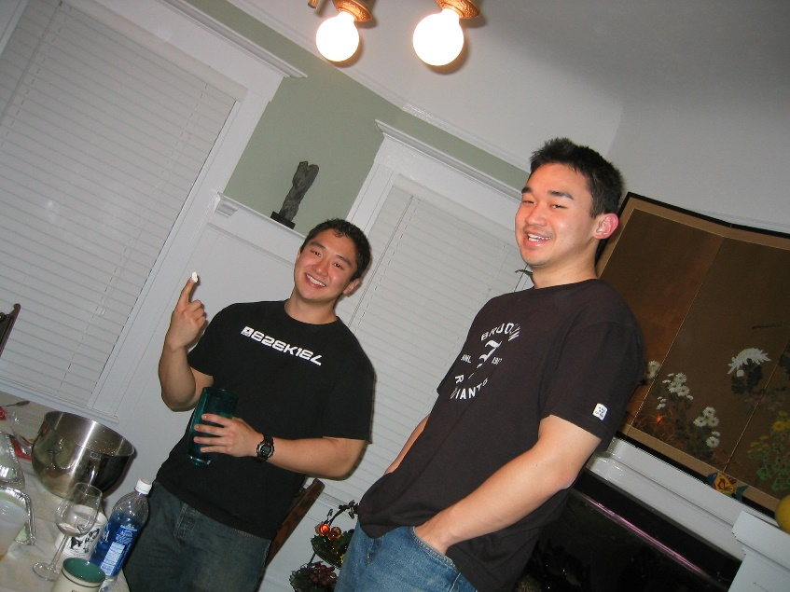

## Panko Fried Flank Steak or Chicken

Source: Debbie Yee

Submitted by: Karen Miyao

*One of the foods Kenny takes along on his fishing trips. Great for potlucks.*



1 package panko (Japanese bread crumbs)

1½-2 lbs. flank steak or chicken breasts, cut into bite-size pieces

Meat Marinade:

2 T. sherry, white wine, or sake

1 T. soy sauce

½ t. salt

½ t. pepper

2 cloves garlic, minced

1 t. ginger, minced

Pinch of sugar

Marinate meat overnight in above marinade.

Sauce:

1 c. Kikkoman Soy Sauce*

1 c. sugar

¼ c. sherry or white wine or sake

1 can (8 oz.) Del Monte* tomato sauce

Pepper to taste

½ t. fresh or powdered ginger (fresh is preferred)

¼ t. garlic powder or ½ clove of garlic, minced

Combine soy sauce, sugar, sherry, and tomato sauce in saucepan and bring to boil; cook until sugar is dissolved. Add pepper, ginger and garlic. Set aside.

Coat meat in flour and then dip in egg wash (1 egg mixed with 1 T. water). Roll in panko breadcrumbs. Deep fry meat and drain on paper towels. Dip one side of the fried meat into the sauce and flip dry side onto plate (don't need to dip the entire piece of meat, otherwise it may be too salty). Remaining sauce can be refrigerated for a long period of time and can be used for barbequing.

*I strongly suggest using these brands for this recipe.

## Chicken Cacciatore

Source: Unknown

Submitted by: Shirley Wong-Jose

*This is one of Jessica’s favorite recipes.*

Cooking oil

1 fryer chicken (cut-up into pieces)

2 onions (sliced; use less if you don’t like a lot of onion flavor)

2 cloves garlic (minced)

3 tomatoes (cored and quartered, or substitute a can of whole tomatoes)

1 green pepper (sliced)

Bay leaf

1 t. salt

¼ t. pepper

½ t. celery seed (optional)

1 t. Italian seasoning

1 can of tomato sauce (8 oz.)

¼ c. white wine

1 16-oz. package spaghetti (cooked al dente)

Heat oil in a skillet. Brown chicken pieces on all sides and remove from pan. Add onion and garlic to the remaining oil and cook until tender, but not brown. Return chicken to the skillet. Add tomatoes, green pepper, and bay leaf. Pour remaining spices on top. Cover and cook on low heat for 45 minutes. Add the wine and cook another 20 minutes. Meanwhile cook the spaghetti just until al dente. Be careful not to overcook the pasta. Put the spaghetti in a bowl and pour the chicken on top.

## For App (Roast Duck)

Source: Daisy Chan

Submitted by: Evelyn Wong

*My mom’s home version of the ducks hanging in the window in Chinatown.*

Using about 2 T. of salt, rub it inside and outside of a 4-5 lbs. duck. Place duck on rack in roasting pan, breast side down.

Mix a solution of:

1 c. brown sugar

3-4 cloves garlic, crushed or powdered

¼ c. light soy sauce

About 1 c. water, possibly more

Pinch of five spice powder (very important)

Pour over duck and marinate at least 6 hours. Roast for about 30-40 minutes at 375oF. Then turn and roast at 350oF for another 1-½ hours or until almost burnt (should have a nice brown roasted color like the kind you buy). Baste the duck occasionally.

Daisy Chan’s note: I use no gravy, for all the taste is in the duck, but I guess you could make a gravy using the drippings.

## Smoked Turkey

Source: Unknown

Submitted by: Elsie Ng

Brine:

10 oz. salt (Kosher salt preferable)

2 oz. curing salt (saltpeter)

2 oz. sugar

1 gallon of water

1. Soak turkey in brine for 3 days. Take turkey out and rinse.

2. Bring to boil (⅔ full) pot of water. Put in turkey when water starts to boil. When water starts to boil again,  turn heat to simmer (running boil) for 1 hour.

3. Start charcoal. Let it burn for about 40 minutes to 1 hour.

4. Soak hickory chips in water for 30 minutes.

5. Put turkey on rack and add a handful of hickory chips on top of the charcoal.

6. Let smoke for 15 minutes. Turn turkey over, add another handful of hickory chips, and let smoke for another 15 minutes.

## Ja Gee Duck (Fried Crispy Duck)

Source: Daisy Chan

Submitted by: Evelyn Wong

*This is a recipe for New Year’s, birthdays, or special family occasions.*

Part 1 (Marinade):

1 3-4 lbs. Duck.

1 T. soy sauce

1 T. whiskey

3 slices ginger (minced)

Part 2:

½ c. water chestnut flour

½ t. five spice powder

1 T. soy sauce

1 T. whiskey

1 garlic clove (minced)

Oil for frying

Garnish:

Cilantro

Peanuts (chopped)

Lemon wedges

The duck is whole at the beginning. Marinate duck in soy sauce, whiskey and ginger for 1 hour or more. “Bow” or brown duck in a wok. After the duck is brown all around, put the duck in a dish and steam until very tender, about 1 hour. Test for tenderness. Cool duck and shred the meat from the bone. Mix shredded duck with water chestnut powder (water chestnut starch), heung lees fun (five-spice powder), and seasonings. Form duck in a large patty. Freeze overnight. Fry in deep oil. Cut up duck in pieces, sprinkle cilantro and chopped peanuts on top. Add lemon wedges around the plate.

## Turkey Pot Pie with Cranberry-Pecan Crust

Source: Unknown

Submitted by: Mary Lowe

Prep: 15 minutes   Cook: 25 minutes   Bake: 30 minutes

3 T. butter, divided  
2 large sweet onions, diced  
½ c. all-purpose flour  
1 t. salt  
1 t. pepper  
4 (12-ounce) turkey tenderloins, cut into ½ inch cubes

2 T. vegetable oil  
1½ c. chicken broth  
1 c. milk  
1 (10-ounce) package fresh spinach, torn  
Cranberry-Pecan Crust (recipe below)

Melt 1 T. butter in a large skillet over medium-high heat; add onions, and sauté 15 minutes or until caramel colored. Place onions in a bowl, and set aside. Combine all-purpose flour, salt, and pepper; dredge turkey tenderloins in flour mixture. Melt remaining 2 T. butter with oil in skillet over medium-high heat; add turkey tenderloins, and brown on all sides. Gradually stir in chicken broth and milk. Bring to a boil, and cook, stirring constantly, 1 minute or until thickened. Stir in onions. Add spinach, stirring just until wilted. Pour turkey mixture into a lightly greased 13- x 9-inch baking dish. Bake, covered, at 350°F for 30 minutes. Remove from oven, and arrange desired amount of Cranberry-Pecan Crusts over pie before serving. Serve with any remaining Cranberry-Pecan Crusts on the side. Yield: 10-12 servings.

Cranberry-Pecan Crust  
Prep: 15 minutes   Bake: 10 minutes

1 (15-ounce) package refrigerated pie crusts  
½ c. finely chopped pecans, toasted

½ c. finely chopped dried cranberries

Unfold each pie crust, and press out fold lines. Sprinkle 1 pie crust with pecans and cranberries; top with remaining piecrust. Roll into a 14-inch circle, sealing together pie crusts. Cut into desired shapes with a 2- to 3-inch cutter. Place pastry shapes on a lightly greased baking sheet. Bake at 425°F for 8 to 10 minutes or until golden. Yield: 3 to 4 dozen.

## Water Eggs (Seui Gaidaan)

Source: Daisy Chan

Submitted by: Annette & Yvonne Chan Cheng

4 eggs

Salt

Ham, chopped

1⅓ c. boiling water

1 T. oil

Put 4 eggs in a bowl. Add salt. Add pieces of ham. Beat well. Slowly add 1⅓ cups boiling water, beating well. Add oil. Beat. Steam about 5-8 minutes. Check if firm by sticking a chopstick into it. Cook longer if necessary. Garnish with ham pieces, green onion, and oyster sauce.

Note: Add about ⅓ cup water per egg. Can add less water if you want steamed eggs to be firmer.

## Meat Loaf

Source: Daisy Chan

Submitted by: Annette Chan & Yvonne Chan Cheng

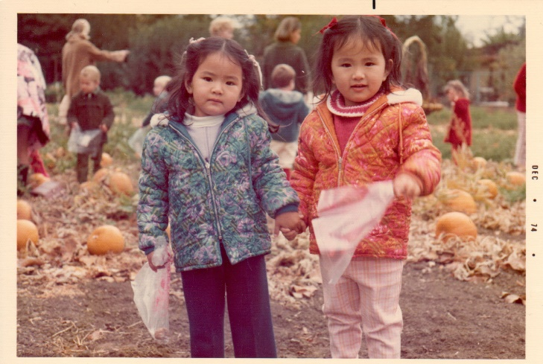1 envelope Lipton Recipe Secrets Onion Soup Mix

4 lbs. ground beef

2 c. oatmeal, less if mixture is too dry

1 can (14½ oz.) stewed tomatoes

1 can (10¾ oz.) cream of mushroom soup

1 package pork sausage (or pork and turkey sausage)

1 egg

1 T. garlic, minced

½ t. salt

½ t. pepper

2 T. light soy sauce

⅛ t. sugar

1 T. rice wine

2 T. ketchup

Vegetable oil

Preheat oven to 350°F. In a large bowl, combine all ingredients, except the vegetable oil. In a large baking pan, shape mixture into a loaf (can put mixture in a plastic bag, shape into a loaf, cut open the bag, and place the loaf in the baking pan). Cover loaf with some vegetable oil. Bake for 2-2½ hours (bake for 1 hour if you cut the recipe in half) or until done. Surface of loaf should be dark brown. Makes about 16 servings.

## Hungarian Short Ribs

Source: Evelyn Wong

Submitted by: Diane Wong-Kone

*A recipe my mom makes. A family fave.*

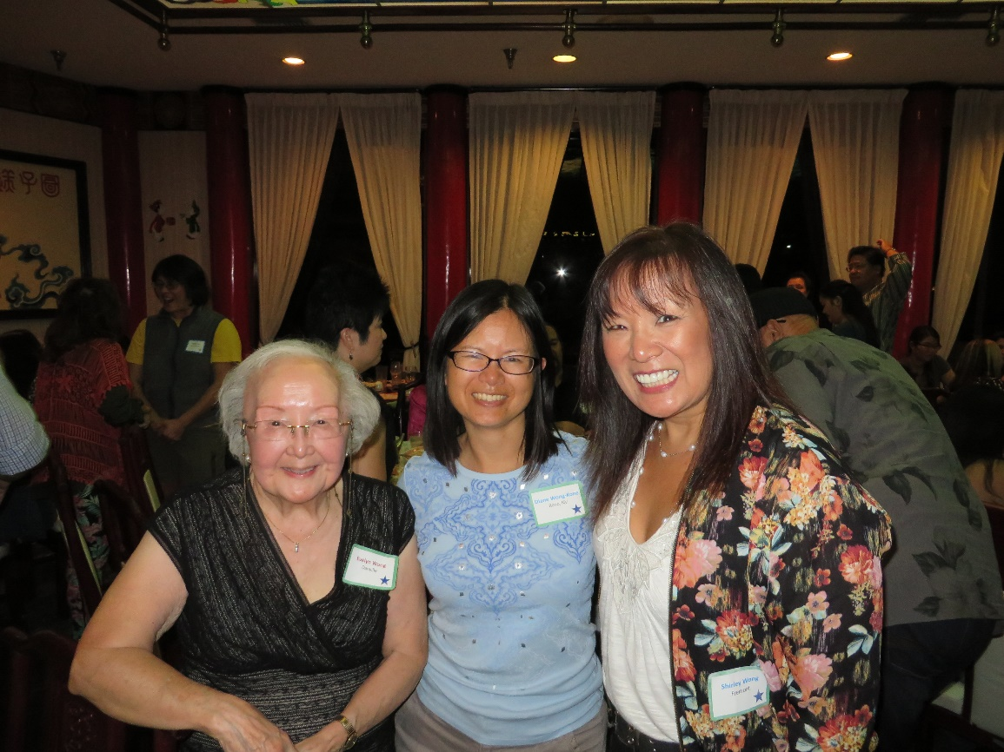4 lbs. beef short ribs

2 T. oil

2 medium onions, sliced

1 15-oz. can tomato sauce

1 c. water

¼ c. brown sugar

¼ c. vinegar

1 t. salt

1 t. dry mustard

1 t. Worcestershire sauce

6 oz. medium noodles

1 c. water

In Dutch oven, brown meat in hot oil, add onions. Blend together tomato sauce, 1 cup water, brown sugar, vinegar, salt, dry mustard, and Worcestershire sauce. Pour over meat. Cover and simmer ‘til tender. Stir in noodles and second 1 cup water. Cover and cook, stirring occasionally for 15-20 minutes. 6-8 servings.

## Tri-Tip

Source: Karen Miyao

Submitted by: Karen Miyao

1-1½ lbs. tri-tip

1-1½ pkg Good Seasons Italian dressing mix

1 T. wine or sake (water is OK, too)

1 T. olive oil

Mix seasoning mix with wine and olive oil to make a paste. Rub paste all over tri-tip. Grill over medium high heat or broil it for 8 minutes on each side for rare beef. Cook longer for well-done meat.

## Beef Teriyaki

Source: Noteworthy

Submitted by: Cheryle Miyao-Quock

*I like this sauce because it isn’t thick and cloyingly sweet like the bottled sauces.*

1½ c. soy sauce

1 c. sugar

½ c. sake

2 cloves garlic, finely chopped

2 slices fresh ginger, finely chopped

1 T. sesame seed

2 T. scallion tops, chopped

2 flank steaks

In saucepan bring to boil soy sauce, sugar, sake, garlic and ginger. Let cool. Add sesame seed and scallions. Marinate flank steak in sauce for at least 2 hours (or overnight). Barbecue on grill to desired doneness, basting occasionally. Slice thinly on the diagonal and serve over rice. Cook remaining marinade before serving.

Variation: I also use this marinade with chicken and firm fleshed fish such as salmon. Marinate chicken for 1 hour and marinate fish for 30 minutes.

## Flank Steak Skewers

Source: Karen Miyao

Submitted by: Karen Miyao

*The Miyao boys love this recipe.*

½ c. olive oil

2 cloves garlic, minced

⅓ c. chopped red onion

⅓ c. red wine vinegar

3 T. soy sauce

1 t. salt

1 flank steak, sliced, across the grain in long strips

Skewers

Combine olive oil, garlic, onion, vinegar, soy sauce and salt to create marinade. Marinate flank steak strips overnight. Skewer flank steaks and grill over medium-high heat on BBQ. (Note: If using wood skewers, soak for at least 30 minutes before skewering steak. This will prevent the skewers from burning on the BBQ.)

## Marinade for Spare Ribs

Source: Lydia Lowe

Submitted by: Diane Wong-Kone

*There are no proportions for this recipe; see my suggestions below.*

Soy sauce

Water

Ketchup

Brown Sugar

Mix ingredients and marinate spare ribs overnight. Bake in foil-lined pan.

Diane’s suggestions for Marinade for Spare Ribs by Aunt Lydia:

*I remember seeing Aunt Lydia showing my mom how to do the marinade over at Aunt Glady's house. There are no real set proportions to this recipe as it's a marinade. Aunt Lydia would simply add various amounts of the four ingredients and mix it over the meat with her hands, until the color and texture looked right to her. I tried this out with the following measurements, and it turned out fine. I don't think, since it's a marinade sauce, that you can really mess it up much*.

1½ lbs. pork spareribs

¼ c. light soy sauce

¼ c. ketchup

¼ c. water

3 T. brown sugar

Mix soy sauce, ketchup, water, and sugar together until it forms a brownish-red glaze. Rub into the spare ribs and marinate overnight. Preheat oven to 450°F. Line a baking pan with foil (this will make cleaning easier afterwards). Put ribs and marinade in the pan and bake in the oven for 20 minutes. Lower oven temperature to 400°F, turn the ribs over and baste. Add a little water to the pan if the marinade/basting sauce looks dry. Bake another 20 minutes.

Lydia’s tip: Lining a baking pan with foil first will make cleaning easier afterwards.

## Barbecue Ribs

Source: *Sacramento Bee*

Submitted by: Mary Lowe

*These are really, really, GREAT ribs.*

2 1-pound slabs of baby back ribs

1 T. oil

2 T. minced fresh ginger

1 small chopped onion

½ c. chicken broth

¾ -1 t. chili powder

3 T. chili flavored jam (strawberry jam with ¼ t. crushed red pepper flakes can be substituted)

¼ c. tomato paste

1 T. prepared mustard

Salt to taste

Pepper to taste

Place ribs on foil lined baking sheet. Bake 350°F for 45 minutes.

Prepare barbecue sauce. Heat oil in small pan. Add ginger and onion and sauté for 5 minutes. Add chicken broth, chili powder, jam, tomato paste and mustard. Simmer for 5 minutes. Mixture should be hot and sweet. Season with salt and pepper.

Remove ribs from oven after 45 minutes and baste with sauce. Use all of the sauce. Bake ribs another 30 minutes. Serve as slabs or cut into individual ribs.

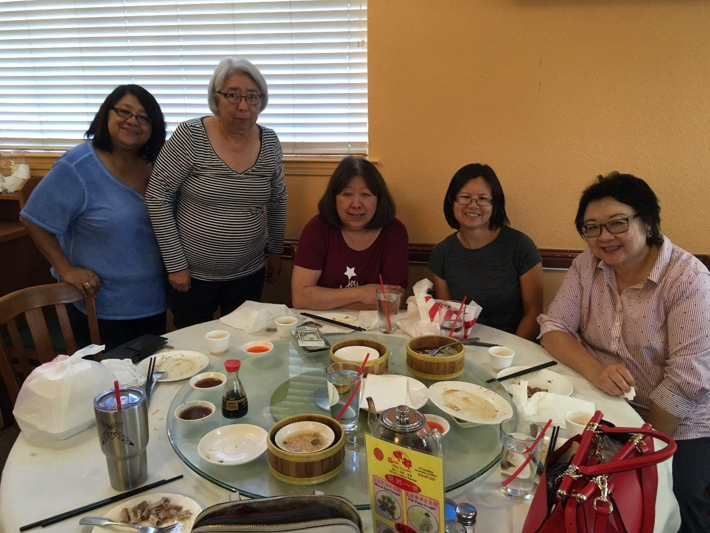

## Beef Brisket Stew

Source: Evelyn Wong

Submitted by: Diane Wong-Kone

*Note: this recipe has been modified since the previous version was published.*

2 pounds beef brisket (gnow nam)

1 pound beef ligament (gnow gun)

1 pound tough fibrous tissue (tendons, gnow mok)

2 large Chinese turnip (long white radish, lo bok)

8 dried mushrooms

4 dried bean curd (foo jook)

2 T. fermented red bean curd (nam yue)

1 T. brown bean sauce (meen see jeong)

1½ T. ginger (crushed)

2 T. sherry or rice wine (Shaoxing rice wine preferred)

4-5 star anise

2 t. salt or to taste

½ t. pepper

1 t. or more five spice

2-3 Thai red chili peppers or more, chopped (optional if you want more spice)

2 T. soy sauce

1 T. cornstarch

4 T. oil

Optional ingredients:

Hoisin

Red dates

Napa cabbage

Pre-soak dried bean curd. Slice brisket, ligament, and gnow mok into bite size pieces. Parboil beef ligament for about 1 hour. Heat wok with 2 tablespoons oil. Brown half of ginger. Stir fry beef brisket, remove and set aside. Heat 2 more tablespoons oil. Brown other half of ginger. Stir fry ligament and gnow mok. Add 2 cups water or enough to cover. Simmer 2-2½ hours. Add browned beef brisket, mushrooms, bean curd and seasonings. Simmer 15 minutes. Add turnips and simmer 15 minutes. Add soy sauce and salt to taste.

Evelyn’s tip: it’s easier to cut the tendon after parboiling first.

## Prime Rib Roast

Source: Lydia Lowe (*The Lily Wallace New American Cookbook*, 1946)

Submitted by: Mary Lowe

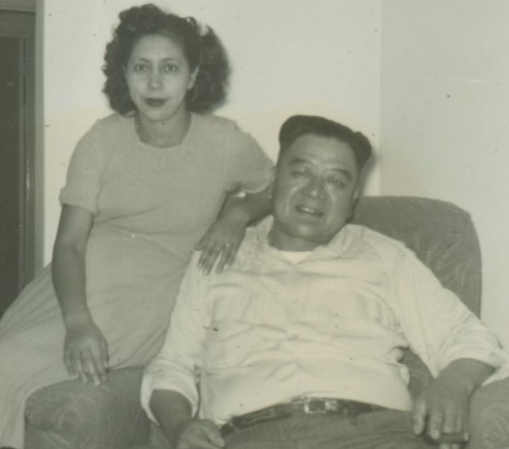*You may begin to prepare meat hours before dinner. Appropriate for small or large roast. A fool-proof method.*

Preheat oven to 375°F. Season meat and place in shallow pan, and bake for one hour. Turn off heat and leave meat in oven: DO NOT OPEN OVEN DOOR!! 40 minutes before serving time, turn on oven to 375°F and cook meat for 30-40 minutes more. Take out and let meat stand for 10 minutes before carving.

OR

Bake at 500°F for 18 to 20 minutes; then reduce temperature to 300°F. Cook:

16 to 18 minutes per pound for rare meat, 22 to 25 minutes per pound for medium,

30 minutes per pound for well-done.

## Standing Rib Roast

Source: Lydia Lowe (*The Lily Wallace New American Cookbook*, 1946)

Submitted by: Mary Lowe

1 (5-pound) standing rib roast   
1 T. House Seasoning, recipe follows

Allow roast to stand at room temperature for at least 1 hour.

Preheat the oven to 375°F. Rub roast with House Seasoning; place roast on a rack in the pan with the rib side down and the fatty side up. Roast for 1 hour. Turn off oven. Leave roast in oven, but do not open oven door for 3 hours. About 30 to 40 minutes before serving time, turn oven to 375°F and reheat the roast. Important: Do not remove roast or re-open the oven door from time roast is put in until ready to serve. For medium rare.

House Seasoning:   
1 c. salt   
¼ c. black pepper   
¼ c. garlic powder

Mix ingredients together and store in an airtight container for up to 6 months.

## Prime Rib

Source: Clifford Chan

Submitted by: Clifford Chan

Place prime rib in a roasting pan. Bake uncovered for 15 minutes at 450°F. Lower oven temperature to 350°F. Bake uncovered for 20 minutes per pound of prime rib. Make gravy from the drippings.

## Beef Stew

Source: George Louie

Submitted by: George Louie

1 lb. stew meat

Marinade:

1 t. soy sauce

1 t. garlic sauce

1 t. wine/Chinese whiskey

1 t. sugar

½ onion, chopped

3-4 celery stalks, chopped

2-3 carrots, chopped

1 small can tomato sauce (6 oz.)

1 t. sugar

1 t. brown bean sauce (min see sauce)

1 t. soy sauce or to taste

Sesame oil

Marinate stew meat for an hour. Brown in vegetable oil. Cover with water, boil for 1 hour, and then add tomato sauce and vegetables. Cook until tender. Add sugar, brown bean sauce, and soy sauce. Before serving, add a few drops of sesame oil.

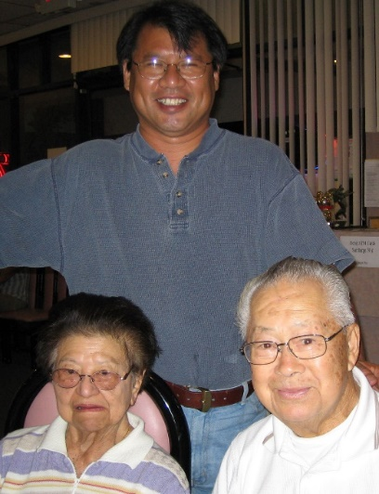

## Chili

Source: Shirley Wong-Jose

Submitted by: Shirley Wong-Jose

*This recipe can also be used as burrito filling.*

2½ lbs. beef, cut into ½ in. cubes

2 t. oil

1 c. beer (12 oz.)

1½ c. water

1 small can whole tomatoes

Brandon’s tip: Use an air fryer to skin peppers. Place peppers in basket and turn the fryer on high temperature (400°F) for 15 minutes. Flip the peppers half way through. Peppers will char. Leave them alone to cool in paper or plastic bag. The skins should come off easily, but if they are stubborn, cook for 5 more minutes.

1 small can tomato sauce

1 c. (4 oz.) mild green chili, dried

1½ green peppers

4 t. chili powder

1½ t. cumin

1 t. salt

½ t. oregano

½ t. garlic

½ t. paprika

½ t. black pepper

½ t. cayenne pepper

Brown beef in large pot. Add all other ingredients and simmer until beef cubes are tender (~1-2 hours).

## Cha Siu (Chinese BBQ Pork)

Source: Daisy Chan

Submitted by: Diane Wong-Kone

*A friend passed this to Daisy Chan, who then passed it to my mom. A good recipe.*

1. Cut about 2 lbs. of pork butt into rectangles about 1½“ thick.

2. Mash 1 t. brown bean sauce and 1 clove of very finely minced garlic (or use garlic powder).

3. Put brown bean sauce, garlic, ½ c. of water, 2 T. salt, 4 T. sugar and 1 T. light soy sauce into a pot and heat until mixture blends. Don’t bring to boil! Take pot off fire and add ½ t. of five spice powder, ½ t. red food coloring and 1 t. sherry.

4. Pour over pork and marinate at least 6 hours.

5. Preheat oven to 450°F and place a large pan of water into the oven so that the roasting rack is at least about 7”-8” above it. This keeps the meat tender.

6. Put pork on rack and bake at 450°F for 15 min. Then reduce heat to 350°F for 10 minutes. Don’t cook longer or it may dry out.

## Side Pork (Cau Yook)

Source: Daisy Chan

Submitted by: Evelyn Wong

~ 1 pound (strip) side pork (not too fat)

Marinade:

1-2 T. soy sauce

~1 T. whiskey

Crushed ginger

Chinese five spice powder (sprinkle over meat to taste)

Sugar (sprinkle over meat to taste)

Other ingredients:

Oil for frying meat

Lotus root, sliced (or substitute with fun gok - jicama)

Nam yue (fermented red bean curd)

Star anise (just a few)

Salt

Soy sauce

Marinate meat and then fry meat in a little oil until cooked through. Soak meat in cold water to remove the greasiness from the pork. Remove meat and discard water. Cut meat 1½ in. wide pieces across the grain. Slit meat and insert a piece of lotus root or fun gok (jicama) into each meat slice. Arrange in a Pyrex or heat-proof bowl. Top meat with mixture of nam yue (fermented red bean curd), a few star anise, salt and soy sauce. Steam in wok for about an hour.

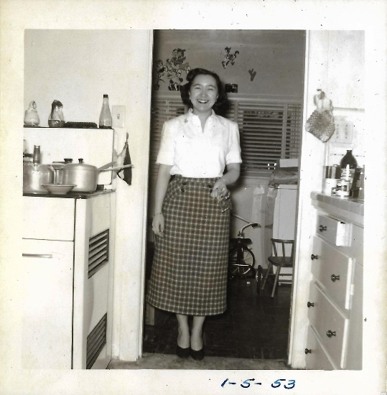

## Lop-yook (Chinese Bacon)

Source: Daisy Chan

Submitted by: Diane Wong-Kone

*Uncle David hung the strips of meat outside to dry.*

~ 2 pounds side pork (slice into strips that can be hung to dry)

salt

Sprinkle salt generously over pork and let marinate overnight to draw out the water from the meat. The next day, wash the meat thoroughly with hot water.

Marinade:

~ 1 c. dark soy sauce

1 t. heung liu fun (Chinese five spice powder)

1 T. sugar

Dash of whiskey

~1 T. garlic, chopped (This ingredient is very important as the garlic repels bugs while the meat is curing outside).

Dip meat in marinade. Wrap each piece in cheesecloth. Pierce cheesecloth and meat with a needle and thread. Hang on clothesline outdoors during the day. Bring the meat strips in at night. Continue to cure the meat for 3 days. Once the meat is dried, it is ready to cook and eat.

## Fun See, Pork and Hairy Melon

Source: *Treasured Recipes From Two Cultures - American and Chinese*, St. Mark’s United Methodist Church

Submitted by: Diane Wong-Kone

¼ pound pork butt or steak, cut in thin strips

2 T. dried shrimp (Hah Mai, pre-soaked 3 hours; save the water)

5 medium Chinese mushrooms (pre-soaked 3 hours, sliced; save water)

¼ pound Chinese vermicelli (Fun See, pre-soaked 1 hour and cut into short lengths)

2 small hairy melons (Jit Gwai, scrape off skin and cut into 2" matchsticks)

2 T. soy sauce

2 T. rice wine

Heat 4-5 T. oil. Add 1 t. salt, then the shrimp, and stir a few times. Then add the pork strips, and stir fry until lightly brown. Add sliced mushrooms, and stir fry 1 minute. Add melon and stir fry. Lower fire, cover and cook about 3-4 minutes. If dry, add a little of the mushroom soaking water. Add the fun see, and stir fry a few times. Add a mixture of: 2 T. soy sauce and 2 T. rice wine. Add the saved soaking liquids. Stir fry. If there's not enough liquid, add a little water. Cover and cook for 3-4 minutes, stirring occasionally. Garnish with chopped green onion or cilantro.

## Steamed Pork with Shrimp Paste

Source: Daisy Chan

Submitted by: Annette Chan & Yvonne Chan Cheng

1 lb. pork, cut into strips

1 t. salted shrimp paste

Soy sauce

Green onion

Rice wine

Ginger

Cornstarch

Mix everything together. Steam in a shallow dish for 20 minutes.

## Basic Recipe for Steamed Minced Pork Strips with Salted Fish (Jing Ger Yook)

Source: Recipe modified from *Treasured Recipes From Two Cultures - American and Chinese, St. Mark’s United Methodist Church*

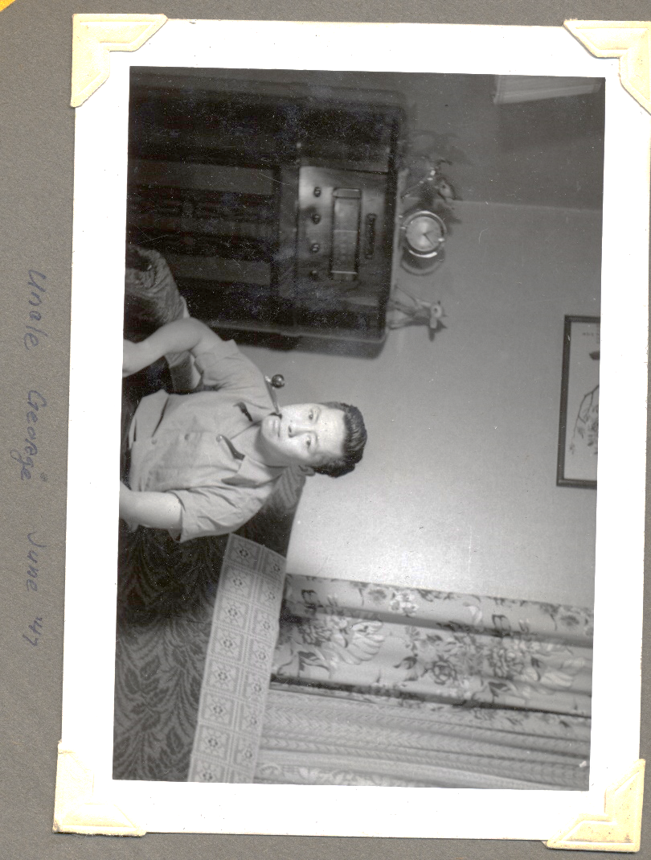Submitted by: George Louie

1 lb. pork butt or pork steak, preferably minced fine with cleaver, or ground fine

4 fresh water chestnuts, peeled and chopped. May be omitted if none on hand (or use canned).

1 t. cornstarch

½ t. salt

1 T. soy sauce

1 t. salad oil

Hom Yuer (salted fish)

Shredded ginger root, to taste

Slice pork into small pieces; add chopped water chestnuts and mince together with cleaver until very fine. Add cornstarch, salt, soy sauce, oil, and shredded ginger root. Mix thoroughly. Put salted fish on top of minced pork. Put in deep platter or shallow dish, shaping mixture to form a thin pancake (clay Chinese bowls work well). Steam 45 minutes.

## Steamed Pork Spareribs

Source: Daisy Chan

Submitted by: Annette Chan & Yvonne Chan Cheng

1 T. black beans, rinsed

2-3 cloves garlic

Juice from 1 slice of ginger

1 t. white wine

1½ T. light soy sauce

1 T. oyster sauce

¼ t. sugar

½ t. salt

¼ t. pepper

1½ lbs. pork spareribs

2 T. cornstarch

Mash together black beans, garlic, and ginger juice. Add white wine, soy sauce, oyster sauce, sugar, salt and pepper. Mix above mixture with the pork spareribs. Mix in cornstarch. Place pork spareribs in a shallow dish. Steam for about 40-50 minutes.

## Pork Shoulder

Source: David Chan

Submitted by: Karen Miyao

4-5 lbs. pork shoulder

Doug’s tip: If you break off the stem on the dried Chinese black mushrooms before soaking, the mushrooms will rehydrate faster..

½ c. soy sauce

¼ c. sherry

10 shitake mushrooms

1 large piece (about 1”x1”) of ginger

3 stalks green onions, chopped

2 c. water

2 star anise

4 T. rock sugar (or add more to taste)

Rinse pork shoulder with hot water to clean. Mix all ingredients in large pot. Bring to boil. Simmer around 4 hours or until tender. Turn pork over every hour so it does not stick to the pot. If there is too much liquid, turn up heat and boil liquid down.

## Roasted Pork Belly

Source: Doug Ng

Submitted by: Diane Wong-Kone

*Try this with the homemade plum sauce recipe in Miscellaneous section.*

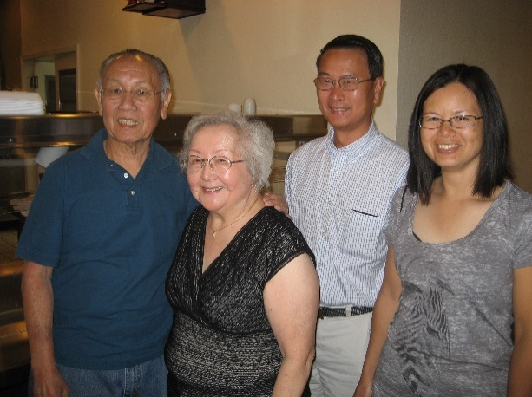2-2½ pounds fresh side of pork, lean with skin on

1 teaspoon salt

Marinade:

1 tablespoon dark soy sauce

¼ teaspoon salt

1 teaspoon sugar

1 clove garlic, crushed

1 teaspoon fresh ginger, grated

1 tablespoon mein see (brown bean sauce)

Lay pork on board, skin side up and pierce it all over with an ice pick. Rub salt on both sides. Mix all ingredients for marinade together. Place meat on broiling pan rack, skin side down, and rub the meaty side with the marinade. Let stand for one hour.

Heat oven to 350˚F. Turn the meat skin side up and place the pan on middle rack in the oven. Roast uncovered for 1½ hour, piercing the skin with an ice pick. Do this 3 or 4 times during baking. Then turn oven to broil and broil meat 15-20 minutes until skin is crisp. Be careful you do not burn the meat at this point. You want it to be dark golden brown. Chop to bite size pieces and garnish with green onion.

## Pulled Pork Recipe

Source: Clifford Chan

Submitted by: Clifford Chan

5-7 lb pork shoulder

Salt and pepper

Generously sprinkle salt and pepper on the pork shoulder. Place on a baking sheet and tightly cover the baking sheet with foil. Bake at 225 degrees F for 12 hours.

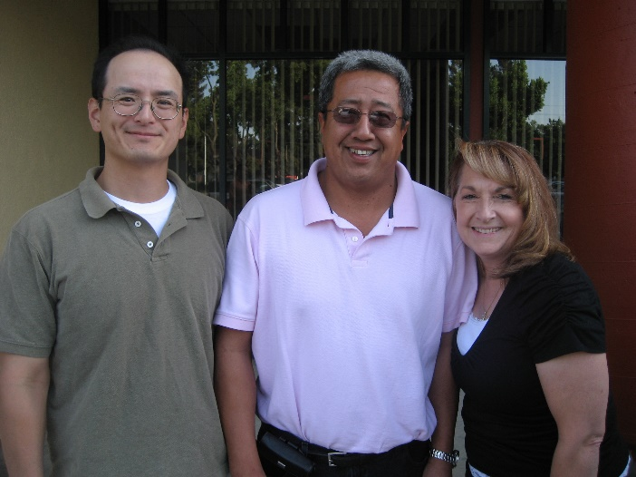

## Lamb Curry Stew

Source: Daisy Chan

Submitted: Annette Chan & Yvonne Chan Cheng

Pour boiling water over about 6 to 7 lbs. of lamb breast spareribs (cut into pieces).

Brown the spareribs with

4 cloves garlic

2 slices ginger

1 large onion, sliced

1 T. salt

1 T. sugar

2 T. curry

3 T. dark soy sauce

Put meat in a pot with

2 stalks celery, sliced

Pepper (2 twists of grinder)

1 c. white wine

Add boiling water to cover about ⅔-¾ of the meat. Add 1 peeled and chopped apple. Simmer until tender (1 hour and 20 minutes). Taste. Add 1 chopped green pepper and 1 T. dark soy sauce. Add peas. Can add potatoes (sautéed in oil) during last 20 minutes of cooking. Add mixture of cornstarch and water to thicken the stew.

## Steamed Dace with Salted Black Beans

Source: David Chan

Submitted by: Annette Chan & Yvonne Chan Cheng

1 can (8 oz.) fried dace with salted black beans (Pochy Brand or Eagle Coin Brand)

Pour contents of can into a bowl. Steam for about 10 minutes. Can remove some of the oil before serving.

## Minced Oyster, Pork and Vegetables (Ho See Seung)

Source: *Treasured Recipes from Two Cultures - American and Chinese*, St. Mark’s United Methodist Church

Submitted by: Diane Wong-Kone

*A favorite Chinese New Year's dish.*

10 medium sized dried oysters (Ho See, soaked for 2 days or at least overnight to soften; washed and cleaned; save top part of soaking water, throwing away portion with dirt sediments. Dice oysters.)

1 pound ground or minced raw pork

Any proportion, more or less, diced of the following:

8 Chinese mushrooms (pre-soaked 2 hours)

6 water chestnuts (peeled and washed)

½ c. canned bamboo shoots

½ c. celery

1 onion

4 T. oil

1 t. salt

2 t. soy sauce

1-2 T. oyster sauce

Pepper

Snow peas or frozen peas, optional

Chinese long beans (dow gok), optional

1 T. cornstarch

Water

Iceberg lettuce

Note - Oysters may be omitted if the taste is too strong.

Heat 4 tablespoons oil in a wok or skillet. Add 1 teaspoon salt. Add pork, and stir-fry a few times; add a little soy sauce (~2 teaspoons) and a little pepper. Lower fire, cover, and slowly cook pork for about 5 minutes, stirring occasionally. Add diced oysters, stir fry a few times, and if a little dry, add a little of the oyster soaking water to moisten. Add mushrooms, water chestnuts, bamboo shoots, celery, and onion, and about 1-2 tablespoons oyster sauce. Taste to see if proper amount of seasonings have been added.

Cover and cook for about 5 minutes. If desired, diced snow pea pods, a small amount of cooked frozen peas, or diced Chinese long beans (dow gok) may be added during the last 2 minutes of cooking. Blend mixture of 1 tablespoon cornstarch and 1 tablespoon water. Stir in to thicken gravy. Serve hot with lettuce leaves.

## Honey Walnut Prawns

Source: King Tang

Submitted by: Mary Lowe

*I learned how to make these from my old landlord, King Tang. He worked for Frank Fat before opening his own restaurant in Sacramento.*

1 lb. medium to large size prawns.

1 t. salt

Cold water (depends on amount of prawns; enough to cover prawns)

2 or 3 large egg whites

2 T. baking soda

Oil (enough to fill pan ½ inch)

2 c. mayonnaise (can use less, depends on amount of prawns)

*Honey

*Walnuts

*Cornstarch

Clean and devein prawns. Soak prawns in baking soda, salt and cold water. Place in refrigerator for 1 hour. After 1 hour, rinse prawns with cold water. Let water run to remove all of the baking soda and salt. Beat egg whites with fork until frothy. Dip prawns in cornstarch and lightly coat. Then dip in egg whites.

Preheat oil. Deep fry prawns in hot oil; cook quickly. Remove from oil and place on paper towel to soak up excess oil. After all prawns are cooked, put walnuts in hot oil to toast. Remove and place on paper to soak up excess oil. In a saucepan, add honey and mayonnaise. Heat at low heat until well blended. Put walnuts and prawns in mixture to coat. Serve right away.

*The amounts of cornstarch, honey and walnuts depend on the amount/size of prawns.

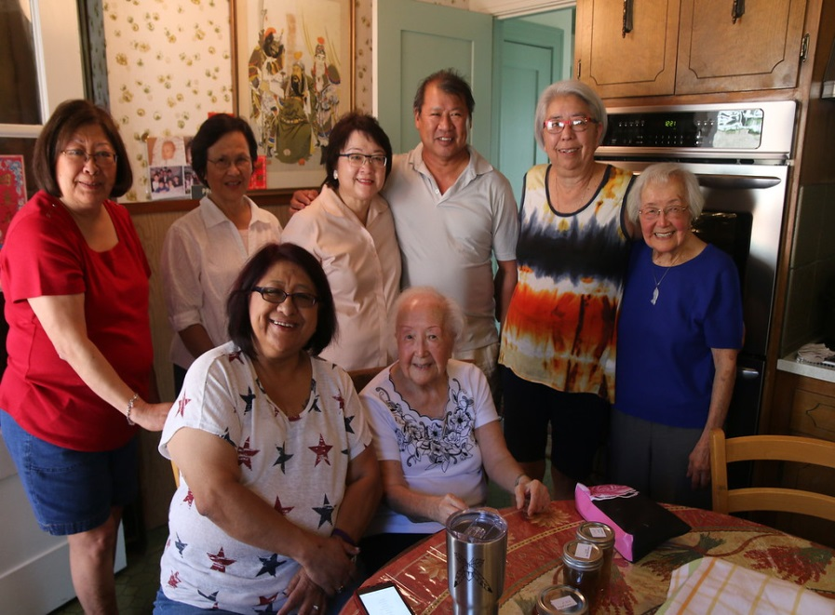

## Fried Rice

Source: Denise Chan

Submitted by: Annette Chan & Yvonne Chan Cheng

About 3 c. cooked rice (steamed, made with ½ long-grain rice and ½ California Calrose Rice)

½ can Spam or ham, chopped

5 eggs

½ c. frozen peas

3 T. light soy sauce

3 T. oyster sauce

5 dashes salt

4 T. vegetable oil

Beat eggs and salt together in a bowl. Heat about 2 T. vegetable oil in a wok. Pour egg and salt mixture into the wok and scramble the eggs until the eggs are almost done. Remove eggs from wok. Add about 2 T. vegetable oil to the wok. Add Spam and stir-fry for about 30 seconds. Add rice, soy sauce, and oyster sauce. Stir-fry until everything is mixed together and heated. Add green peas. Stir-fry until everything is mixed together and green peas are heated through. Add eggs. Stir-fry until eggs are completely cooked.

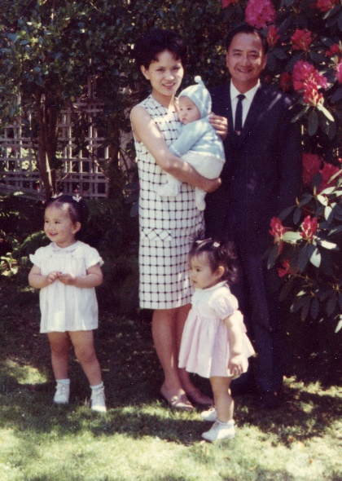

## Minute Rice Casserole

Source: David and Denise Chan

Submitted by: Annette Chan & Yvonne Chan Cheng

1 small onion, chopped

1 lb. ground beef

1 bay leaf

1 can (16 oz.) stewed tomatoes

1 can (10 ¾ oz.) cream of mushroom soup

⅛ t. thyme

1 c. Minute Rice

½ t. pepper

½ t. salt

1 can (9.3 oz.) corn

A little vegetable oil

Slices of cheese

Brown the chopped onion in a little vegetable oil. Mix in the ground beef, and brown it with a little more vegetable oil. Mix in the bay leaf, stewed tomatoes, cream of mushroom soup, thyme, Minute Rice, pepper, and salt. Heat until the mixture boils. Turn down the fire, and simmer for about three minutes. Mix in the corn. Put in glass casserole dish (about 9" x 13"). Bake 30 minutes at 350°F. Top with slices of cheese just before or just after baking. Take out of the oven. Let sit for about ten minutes. Serve.

Variation: Replace the beef with turkey. Use at least 2 cups cooked, chopped turkey. Add the turkey with the corn.

Variation: For more rice, add 1 extra cup cooked rice and 1 more can (10 ¾ oz.) cream of mushroom soup.

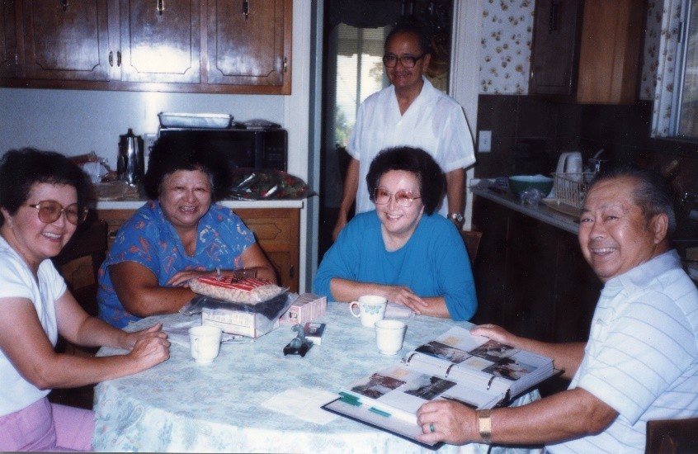

## Tuna Casserole

Source: Gladys Louie

Submitted by: Gladys Louie

*It doesn’t taste the same if you don’t use the potato chips!*

1 lb. wide egg noodles, boil according to directions

1 can tuna

2 cans cream of mushroom soup

1 can water (soup can)

Pepper to taste

½ bag of frozen peas

Crushed potato chips

Heat up soup with water. Add tuna, pepper, and peas. Layer cooked noodles in 9x13-inch pan. Pour soup mixture over noodles. Put crushed potato chips on top. Bake at 350°F for 20 minutes or until it bubbles.

## Rigatoni Casserole

Source: Captoria Young

Submitted by: Annette Chan & Yvonne Chan Cheng

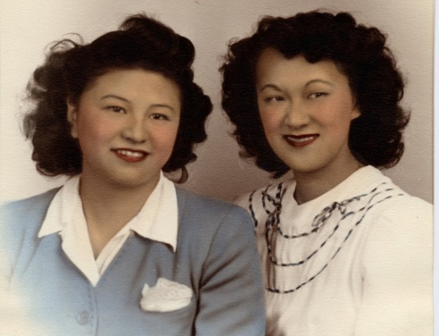1½ lb. rigatoni

2 small cans tomato sauce or canned tomatoes

1 small can chopped olives

1 c. chopped onions (yellow)

1½ lbs. ground beef mixed with 1 t. oil

1 small can Chef Boy-Ar-Dee with or without mushrooms (or Ragu tomato sauce)

2½ t. chopped parsley (optional)

1 small can chopped mushrooms

Cook rigatoni according to directions on package. Stir-fry ground beef and onions for about 3 minutes. Add one can of tomato sauce, Chef Boy-Ar-Dee sauce, chopped olives, chopped mushrooms, and parsley. Simmer at low flame about 10 minutes. Mix sauce mixture with rigatoni. Place rigatoni in large Pyrex dish. Cover rigatoni with aluminum foil and bake for 20 minutes at 350°F. Remove aluminum foil, and pour in the other can of tomato sauce on top. Return to oven without aluminum foil and bake for 10 minutes.

## Tamale Pie

Source: Evelyn Wong

Submitted by: Annette Chan & Yvonne Chan Cheng

1 lb. ground beef

1 large onion, chopped

Salad oil

Garlic to taste

2½ lb. can solid pack tomatoes

10 oz. can whole kernel corn

1-2 T. chili powder

2 eggs

½ c. milk

1 can pitted olives

1 c. yellow cornmeal

Pinch of pepper

1 t. salt

Sharp cheddar, grated

Sauté onion in oil with garlic. Add meat and brown. Add tomatoes, corn, salt, pepper, and chili powder. Cook over low heat for approximately 10 minutes. In a bowl, beat eggs, add milk and stir in cornmeal. Combine all ingredients. Cook 10 minutes more, stirring almost constantly. Add olives. Pour into 2 quart casserole. Bake at 350°F for 15 minutes. Top with grated sharp cheddar cheese. Bake 15 minutes longer.

## Cheese Pasta

Source: Yvonne Chan Cheng

Submitted by: Annette Chan

*Kids love this dish!*

1 package (12 oz.) spaghetti, cooked (or other pasta)

1 medium onion, chopped

Cooked chicken

1 can (10¾ oz.) cream of chicken soup

Parmesan cheese

2 c. cheddar, cubes or shredded

Stir fry chopped onion. Add cooked chicken, cream of chicken soup, and pasta. Mix together. Mix in Parmesan cheese. Top with cubes of cheddar (or shredded cheddar) and mix together.

## Tamale Pie

Source: Lydia Lowe

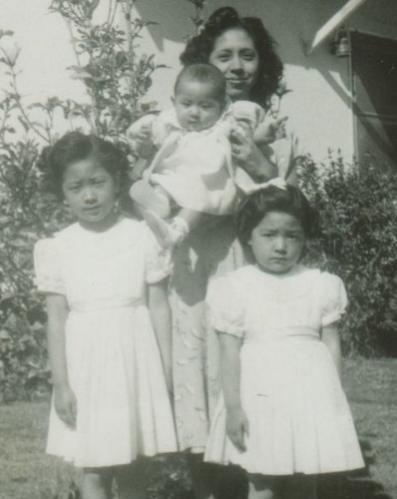Submitted by: Mary Lowe

1 T. California chili powder

2 cloves minced garlic

1 can tomato sauce (8 oz.)

3 T. flour

¼ c. oil

2 c. chicken broth

2 T. cumin

Salt, if needed

3 lbs. pork or chicken

2 c. Monterey jack cheese, grated

Water, if needed

Meat:

Boil chicken or pork. Add salt, onion powder and garlic powder to taste. After cooked, shred meat and set aside.

Sauce:

Put oil and flour in a pan and mix together and cook over high heat. Add California chili powder and mix. Add tomato sauce and mix. Add minced garlic. Slowly add liquid, stirring so it will not clump up. Add cumin. Add meat to sauce and let simmer for 20 minutes. If sauce is too thick, gradually add water or more chicken broth. This is the same sauce that is used in tamales.

Crust (recipe can be found on the box of Albers Cornmeal):

2¼ c. Albers Yellow Cornmeal

2 c. water

1 can (12 oz.) Carnation evaporated milk

1 T. salt

Preheat oven to 425°F. Grease a 13” x 9” baking dish.

Combine cornmeal, water, evaporated milk and salt in medium saucepan. Cook over medium high heat; stirring frequently for 5 to 7 minutes or until thickened. Reserve 2 c. cornmeal mixture; cover with plastic wrap. Spread remaining cornmeal mixture on bottom and up sides of prepared baking dish. Bake for 10 minutes. Cool in dish on wire rack. Spoon filling into cornmeal crust. Spread reserved cornmeal mixture over filling. Bake for 15 to 20 minutes. Sprinkle with cheese. Bake for an additional 5 to 10 minutes or until cheese is melted.

## Angel Hair Pasta with Shrimp

Source: Mary Lowe

Submitted by: Mary Lowe

*Developed through experimentation. Little Darrin likes this recipe.*

1 pound medium size prawns

½ c. sake

4 cloves minced/diced/pressed garlic

1 pint heavy cream

1 cube butter or margarine

½ pound grated fresh domestic parmesan cheese (I buy mine at Corti Bros.)

½-1 pound angel hair pasta (I buy mine at Bel Air, fresh, not frozen or dry, located with cold cuts, cheeses, etc.)

Parsley

Cook pasta in boiling water. While water is getting hot, clean prawns and marinate in sake for approximately 15 minutes. Cook pasta in boiling water for approximately 15 minutes or until done.

While pasta is cooking, melt butter and garlic in microwave for approximately 1-2 minutes on high. Add prawns and cook for 3-5 minutes or until cooked--they will be pink. (You don't have to use the microwave. It's just easier for me.) After prawns are cooked pour butter/garlic/sake mixture into large pan.

Cooking over medium heat, slowly pour in cream while stirring. Add cheese. Stir until cheese is melted. Add pasta to mixture and mix well. Add parsley.

Serve immediately with salad, garlic bread, and wine.

## Chow Fun

Source: David Chan

Submitted by: Annette Chan & Yvonne Chan Cheng

1 package dry rice sticks

About ½ c. oil

About 1 t. salt

1 to 2 c. chicken stock

Topping mixture

Soak the dry rice sticks overnight. Put oil in wok. Heat the oil. Add about 1 t. salt to the oil. Add the rice sticks. Stir fry until the rice sticks are soft but not sticky. Want the rice sticks to be translucent. Taste it. Better to overcook than to undercook. Add chicken stock (1 to 2 c.) as needed. Stir-fry about 5 to 6 minutes total. Can put topping (e.g. beef with asparagus) on the chow fun or mix the topping in with the chow fun and stir-fry together (can add some more chicken stock or water to keep the rice sticks from getting sticky and to make them softer).

## Tomato Beef Chow Mein

Source: *Treasured Recipes From Two Cultures - American and Chinese*, St. Mark’s United Methodist Church

Submitted by: Karen Miyao

*One of my favorite dishes as a child. My mom would make this at the store (American Way Market).*

1 lb. fresh egg noodles that may be purchased from a Chinese noodle factory, in some supermarkets and Chinese food stores

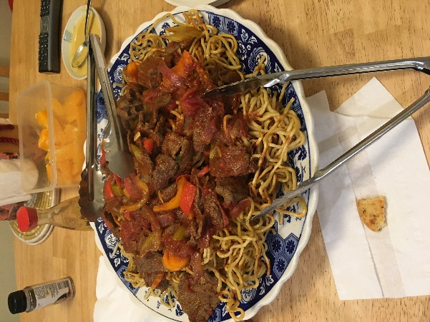

To fry noodles: Boil pot of hot water, drop in two coils (½ lb. each) egg noodles and cook for half a minute. Does not come back to a boil. Drain in colander. Do not rinse with cold water. Mix in ½ T. soy sauce and ½ T. oil in the noodles. Heat frying pan, adding a thin layer of oil, covering the bottom of the pan. An electric skillet at 375°F is excellent to use. Brown one side of noodles and turn, break up the noodles and brown the other side.

¾ lb. flank steak, cut in ⅛” strips, 1½” wide

1 dried onion, sliced

3 stalks celery, sliced ⅛” thin diagonally

1 green pepper, cut in chunks or sliced

4 tomatoes, peeled and cut in chunks

Heat 2 T. oil in wok, add ½ t. salt, add onion, celery, and green pepper. Stir fry 2 min. Remove.

Heat 2 T. oil in wok, add ½ t. salt, stir fry the flank steak, 1 t. sugar, 1 t. rice wine. Stir for half minute and remove.

Heat 2 T. oil in wok, add seasonings of:

Auntie Gladys’s tip: Add a dash of sugar to meat marinade before stir frying.

¾ t. curry powder

¼ bottle catsup (~⅓ c.)

½ c. water

2 T. sugar, approx.

1½ t. vinegar

1 t. salt

Stir fry and heat through. Make a paste of 1 T. cornstarch and 2 T. water and add to sauce to thicken. Taste. It may be necessary to add a little more sugar and vinegar.

Add cooked celery, onion, and green pepper to sauce. Add quartered fresh tomatoes (or may substitute canned tomatoes). Stir fry a minute. Add the cooked beef. Mix. Pour over fried egg noodles, mix and serve. Notes: For Tomato Curry Beef Chow Mein, add more curry powder. This makes a lot of sauce so adjust accordingly.

## Spaghetti Sauce

Source: Diane Wong-Kone

Submitted by: Diane Wong-Kone

*On one of my field jobs in Oregon, I was living in a remote area in a cabin that had no electricity. Having no refrigerator and a limited pantry supply (since the nearest “mercantile” was a good 45 minute drive down a mountain road), I was forced to get a bit creative when cooking. I used garbanzo beans (for protein) and added curry for extra flavor. Today, I still occasionally add curry to spaghetti sauce for extra zest.*

1 lb. ground mild Italian sausage

½ green bell pepper

½ red bell pepper

1 stalk celery

Diane’s tip: A little bit of sugar can be used balance the acidity of tomatoes in spaghetti sauce.

1 large carrot

2 cloves garlic

½ red onion

~1 T. fresh parsley

4 c. diced tomatoes

1 can (6 oz.) tomato paste

¼ c. red wine

1 bay leaf (crushed)

1 t. curry powder (optional)

½ t. basil

1-2 t. oregano

½-1 t. sugar

Salt and pepper to taste

Chop (dice) the peppers, onions, and tomatoes. Mince the carrots, celery, garlic, and parsley. Brown the sausage in a large pot. Once the sausage is browned, add the onions and cook until translucent. Add peppers and cook until tender. Add celery, carrots, parsley, garlic and cook about one to two minutes. Add tomatoes. Cook and stir until soft. Add spices and tomato paste. Add about ¼ c. of a dry red wine and a little sugar to balance the acidity of the tomatoes. Stir. Add salt and pepper to taste. Simmer on low heat for about 1-1½ hours.

## Pasticha

Source: Pierre’s Restaurant, San Marino, CA (1949)

Submitted by: Diane Wong-Kone

*My mom often made this for family dinners. This was a signature Greek dish at Pierre’s Restaurant.*

1 lb. elbow macaroni

1½ t. onion salt

¼ lb. butter

1 c. grated Parmesan cheese

¼ c. olive oil

Diane’s tip: To get garlic or onion smell off your hands after cutting, rub some fresh parsley between your fingers, or wipe hands on a stainless steel sink.

Large onion

6 cloves garlic

1 lb. ground beef

1 t. oregano

4 eggs

1 T. flour

½ c. milk

Salt to cook with pasta

Boil macaroni until just cooked (about 12 minutes). Add 1 teaspoon onion salt. Drain well. Brown half of the butter and add to macaroni with Parmesan. Mix well. Melt other half of butter in frying pan and add olive oil; chop onion and garlic fine; fry until well browned. Add beef. Cook until well done. Salt after cooking. Add oregano. Combine with macaroni mixture. Place in greased baking dish. Beat eggs until thick. Add flour, ½ teaspoon onion salt and milk. Beat until well blended. Pour over mixture in baking dish and bake in medium oven at 350oF for ¾ hour. Serves 6.

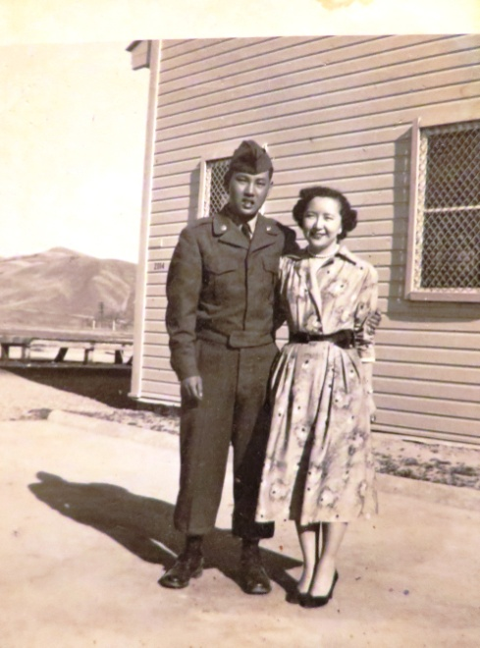

## Honey & Coconut Caramelized Chicken

Source: Seonkyoung Longest, http://seonkyounglongest.com/caramelized-chicken/

Submitted by: Jessica Hovland

*Tim was recently hospitalized, and I got to take care of him after his surgery. He got to see me*

*and what I do for a living: nurse extraordinaire! I cooked him this recipe, which he drooled over.*

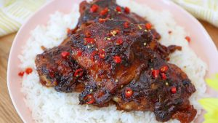Cook time 40 mins; Serves: 4

**For the Marinade**

1 Tbsp sugar

1 tsp salt

1½ Tbsp fish sauce

5 green onions, white part only, finely chopped

1 to 3 red chili, finely chopped (I used Thai chilies)

5 garlic cloves, finely chopped

1½ Tbsp sesame oil

4 bone-in, skin-on chicken thighs

**For Cooking**

2 Tbsp vegetable oil

1 large onion, sliced into 1-inch thick pieces

1½ cup 100% coconut water, strain any pulp

1½ Tbsp honey

**Instructions**

1. In a mixing bowl, combine all of the ingredients for the marinade and the chicken thighs.

Rub the ingredients into each thigh, and then leave the marinade for 1 hour in the fridge.

2. In a large frying pan (around 12 to 14-inch), over a medium heat, add the vegetable oil.

Scrap off the excess marinade from the chicken skin and lay the chicken, skin-side down and fry for 2 to 3 minutes, depending on size, until the skin is golden but without completely cooking the chicken. Take out and set aside to cool down. (The original recipe says sear the chicken one by one, but I just did all 4 at the same time.)

3. Remove any burnt bits of marinade, and add all of the chicken thighs back into the pan, skin-side facing up. Add the onion, coconut water and any excess marinade left in the bowl; then cover the pan with a lid and cook over a low heat for 25 minutes. This should cook the chicken through slowly, tenderizing the meat.

4. When the 25 minutes is up, take the lid off and increase the heat to high. Drizzle the honey on top of the chicken, making sure you do not at any point take your eyes off the pan. You will see caramelization take place very quickly (it took 20 minutes for me on my electronic stove) so keep turning the thighs over, allowing them to become evenly golden. You will see the liquid becomes syrupy and the chicken perfectly golden.

5. Not necessary, but quick blast under the broiler for 2 minutes will give a wonderful crispy skin- a bonus for sure.

6. Serve with fish sauce as a starter, or with jasmine rice as a main. Both are absolutely delicious.

## Best Instant Pot Ribs

Source: Catalina Castravet, <https://sweetandsavorymeals.com/instant-pot-ribs-recipe/>

Submitted by: Jessica Hovland

*My favorite Instant Pot recipe. Instant Pot Ribs are so tender they fall of the bone. The best part is that you can cook them start to finish in just a little over an hour.*

****Prep Time: 10 minutes

Cook Time: 50 minutes

Total Time: 1 hour

Servings: 2 racks

**Ingredients**

**Dry Rub:**

1 tablespoon dry mustard

2 tablespoons smoked paprika

3 tablespoons brown sugar

1 tablespoon onion powder

*Cooking is something that gives me joy. I currently work full-time at the hospital as a recovery nurse. I'm going back to school for my Doctorate in Nurse Executive Leadership (DNP). When I have free time and want to de-stress, I turn to cooking. I always look over at Tyler (my husband) to see if he liked what I cooked. Even if it tastes bad, he still tells me he likes it. I believe cooking always brings together family. I make sure when Hunter visits that he gets to taste my homemade meals. This year was his first time eating ribs, and he devoured it!*

1 tablespoon garlic powder

1 tablespoon ground black pepper

2 teaspoons salt

½ teaspoon cayenne pepper

1 teaspoon cinnamon

1 teaspoon nutmeg

1 teaspoon dill seeds

**Cooking the Ribs:**

2 racks baby back pork ribs about 2 lbs each*

2 cups unsweetened apple juice

¼ cup apple cider vinegar

2 tablespoons liquid smoke

3 bay leaves optional

**Homemade BBQ Sauce (optional):**

1 ½ cups brown sugar

1 ½ cups ketchup preferably no sugar added

½ cup red wine vinegar

½ cup water

1 tablespoon Worcestershire sauce

2 tablespoons dry mustard powder

1 tablespoon paprika or smoked paprika

2 teaspoons salt

1 teaspoon black pepper

1 tablespoon hot pepper sauce or more

**Dry Rub:**

1. Add all the dry rub ingredients in a medium bowl and using a fork whisk to combine.

2. Dry the ribs with paper towels of excess liquid or blood.

3. The ribs usually have a membrane on the back (the bony part of the ribs), remove it and discard it.

4. Place the ribs on a cutting board, season generously with the dry rub on both sides and use your hand to rub it all over the ribs.

**Cooking the Ribs:**

1. Add juice, apple cider and liquid smoke to the Instant Pot, stir to combine. Add bay leaves.

2. Add a small legged trivet to the Instant Pot (optional, but I prefer to keep the ribs out of the liquid as much as possible).

3. Place the ribs inside the Instant Pot, standing and pressing on the sides of the Instant

Pot. If needed trim the ribs; also make sure you don’t go over the Max fill line.

4. Secure the Instant Pot lid, close and point the valve to Sealed.

5. Cook on Manual, for 35 minutes on HP for thicker ribs if you want them to still have a slight pull when biting and be able to brown them on the grill or broil the rack without meat falling off the bone. You can do 40 minutes for extra tender, almost fall of the bone ribs.

6. Once the Instant Pot beeps, do a 15 minutes Natural Pressure Release. Unlock and remove the lid from the instant Pot.

**Homemade BBQ Sauce (optional):**

1. While the ribs are cooking prepare the BBQ sauce.

2. Add all the ingredients to a blender or food processor and blend until smooth. Stir and set aside.

3. Or just use about 2 cups of store-bought BBQ sauce.

**Broiling the Ribs:**

1. Preheat oven on the Broiler setting.

2. Carefully remove the ribs from the Instant Pot and place them onto a prepared baking sheet lined with aluminum foil for easy clean-up.

3. Brush the ribs generously with either homemade BBQ sauce or store-bought BBQ sauce on both sides.

4. Place under the broiler for about 6-10 minutes. Leave the light on, and keep a close eye on the ribs because they could burn quickly.

5. Serve immediately with extra BBQ sauce.

**Recipe Notes**

*I used a 6-quart Instant Pot and the 3 lbs baby back rib racks are too large for it. Use 2 lbs baby back rib racks.

## Slow-Cooker Kalua Pork Sandwiches With Crispy Asian Slaw Recipe

Source: Jennifer Olvera, https://www.seriouseats.com/recipes/2013/12/print/slow-cooker-kalua-pork-

sandwiches-crispy-asian-slaw-recipe.html

Submitted by: Jessica Hovland

*My favorite Kahlua Pork Slow Cooker Recipe*

Note: The pork can be made ahead and refrigerated or frozen for later use.

Yield: Serves 6 to 8

Active time: 10 minutes

Total time: 18 hours

**Ingredients**

For the Pork:

1 whole pork butt, 5 to 6 pounds

Kosher salt

1 tablespoon liquid smoke

2 tablespoons soy sauce

1 cup water

For the Slaw:

1 small head purple cabbage, cored and thinly sliced

1 small onion, peeled and thinly sliced

1 tablespoon sesame oil

½ tablespoon rice wine vinegar

Freshly ground black pepper

1 package Hawaiian bread rolls

**Directions**

1. For the Pork: Place pork in slow cooker and pierce all over with a fork. Rub with salt, liquid smoke, and soy sauce. Add water. Cover and cook on low for 18 hours, turning once.

2. For the Slaw: Combine cabbage, onion, sesame oil, and vinegar. Season with salt and pepper. Stir to combine and refrigerate until ready to use, at least one hour and up to overnight.

3. Remove pork from the slow cooker and shred meat. Mix with juices to moisten and season to taste with salt and pepper. Serve pork tucked into rolls, topped with slaw.

## Ger Guerk Cho - Black Vinegar Pigs Feet

Source: Mrs. Hazel Cheang, *Treasured Recipes from Two Cultures – American and Chinese*, St Mark’s United Methodist Church

Submitted by: Lowe Family Cookbook Editors

*This is traditionally served to new mothers to help them to recover from childbirth. Chicken Wine Soup in the soup section is also a tradition.*

6 pig’s feet (cut in half and each half in 4 sections by the butcher)

One quart Black Vinegar (hock my cho)

2 cakes Chinese brown sugar (wong tong)

2 large pieces of ginger, each (about the size of an apricot), peeled and sliced

½ cup raw peanuts (optional), shelled, not salted and without the brown skin

Water

Clean pig’s feet by blanching: Boil a big pot of water, add pig’s feet and return to a boil. Pour out the hot water. Wash pig’s feet, cutting out hair or discolorations with a razor blade. Wash again with cold running water.

Heat a little oil in large pot, add ginger slices and brown. Add pigs feet. Stir-fry a couple minutes. Add black vinegar, starting off with ½ quart (16 oz.). Add water to cover pig’s feet. Add the two cakes of Chinese brown sugar. Bring pigs feet to a boil and simmer until soft—about ¾ to 1 hour. Test periodically by poking with fork.

Add peanuts half hour before serving. Add salt to taste and more vinegar and sugar if needed. Serve.

## “Korean” Chicken Recipe

Source: Gary Ng

Submitted by: Gary Ng

*Here is a very simple recipe from when the kids were little. We would make this and BBQ on the front lawn on a little gas grill.  It’s nothing fancy but it’s surprisingly good.*

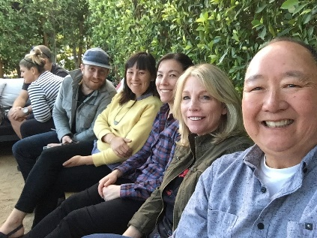Marinade chicken parts in:

¼ cup soy

2 green onions, cut up

2 cloves garlic, minced

2 tablespoons sugar

2 tablespoons sesame oil

2 tablespoons rice vinegar

Pepper

Minced ginger

Toasted sesame seeds

Marinade as long as you can and then BBQ.

## Claypot Chicken (No Claypot)

Source: modified from Lucky Peach

Submitted by: Cheryle Miyao-Quock

*This is an easy rice cooker or one pot recipe. I modified this with the addition of lop cheung (Chinese sausage) for extra flavor and fat.*

Yield: 4 servings

**Ingredients**  
4 boneless, skin-on chicken thighs, cut into 1″ pieces  
8 fresh shiitake mushroom caps, thinly sliced (or 4 dried shiitakes, soaked, stemmed, and thinly sliced)

1 or 2 lop cheung (Chinese sausage) links, sliced (optional)  
2 tbsp soy sauce  
1 tbsp oyster sauce  
1 tbsp Shaoxing wine  
1 tbsp white or red miso  
½ tsp kosher salt  
½ tsp sugar  
½ tsp sesame oil  
White pepper, to taste

1 cup jasmine rice, rinsed and drained  
1 cup chicken stock or water  
1 slice fresh ginger (¼” thickness)  
2 scallions, cut into 1″ pieces

**Prepare:** In a large bowl, whisk together the soy sauce, oyster sauce, wine, miso, salt, sugar, sesame oil, and a few grinds of white pepper. Add the chicken, mushrooms, and lop cheung, and fold to coat evenly.

Next, combine the rice, stock, and ginger in a rice cooker or a small Dutch oven.

**For a rice cooker:** Scrape the chicken mixture and all of the marinade on top of the rice. Scatter with scallions. Cover, start the rice cooker, and cook until the cycle is done. Open the lid and check the chicken for doneness.

(Depending on your model, the chicken may need a couple more minutes to cook through. If it does, set the rice cooker for another cycle, press start, and check again in 5 minutes.)

**For a Dutch oven:** Place over medium heat and cook for 5 minutes, until just simmering. Reduce the heat to low and cook until all the liquid is absorbed. The chicken should be cooked through, about 25 minutes. Fluff the rice, scraping up the crust from the bottom of the pot.

Scoop out and serve by the bowlful…or eat straight out of the rice cooker!

## Kung Pao Chicken

Source: Gary Ng

Submitted by: Gary Ng

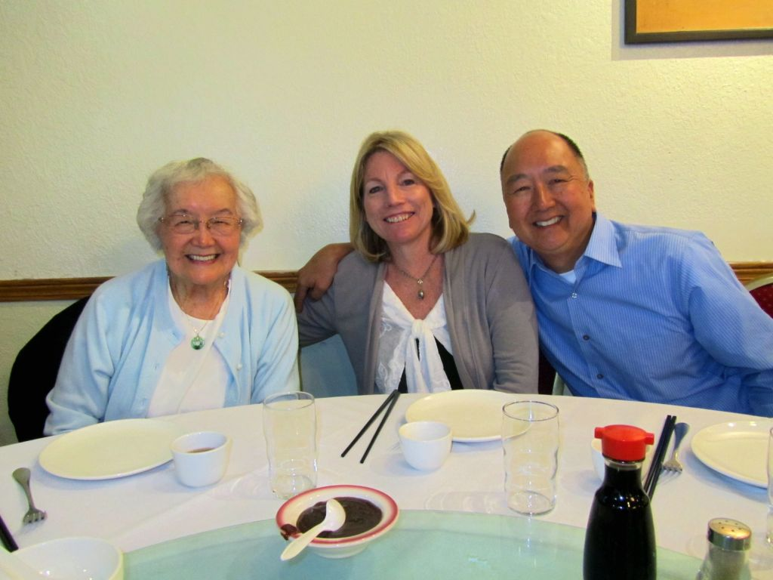*I like to cook; I am a novice when it comes to authentic Chinese food. (But I try!) I was after the best Kung Pao Chicken recipe and made about a dozen or so versions and variations and finally nailed this one. It does not use Sichuan peppercorns though they could easily be added if you want that numbing sensation.*

Chicken - cube up 4 or so chicken thighs.

Marinade chicken in this sauce:

2 tsp cornstarch

1 tsp sesame oil

1 tsp sherry or Shaoxing wine

1 tsp soy sauce

Garlic - a couple of cloves or so, minced

Marinade chicken for as long as you want, but at least 30 minutes.

Sauce:

2 tsp hoisin sauce

2 tsp hot bean sauce - I use Lee Kum Kee brand Chili Bean Sauce

2 tsp soy sauce

2 tsp sherry or Shaoxing wine

1 tsp rice vinegar

1 tsp sesame oil

Sambal hot sauce, add a spoonful or to taste

Honey, a spoonful or to taste or ½ tsp sugar (balance the heat with the sweetness - not too much sweetness, just enough)

Stir up the sauce and taste it to make sure you have the right level of heat and sweetness. This is where you can also add some fresh ground Sichuan peppercorns.

Cooking

1. Heat a bit of oil in the wok and brown a handful of peanuts and remove.

2. Cook up whatever veggies you want and then remove - green pepper, zucchini, celery, whatever.

3. With a bit more oil toss in some dried chilies and brown a bit. Remove and crank up the heat to high until the wok is smoking hot.

4. Toss in the chicken and then the chilies and cook until done - use super high heat as you want to char the chicken. Now toss in the veggies and then finally the sauce and peanuts. You don’t have to use all of the sauce depending on how much chicken and veggies you cook.

A few green onions on top never hurts!

## Mac and Cheeseburger

Source: Annette Chan

Submitted by: Annette Chan

1 lb. large or extra-large elbow pasta

2 Tbl. vegetable oil

½ onion, diced

2 cloves garlic, minced

8 oz. ground beef

1 tsp. black pepper

2 tsp. salt

8 oz. diced tomatoes

8 oz. cheddar cheese, shredded

Cook the pasta according to the package directions, and then drain the pasta. At the same time, cook the meat sauce. Time the cooking of the pasta so that it is done at approximately the same time as when the meat sauce has been cooked.

Meat Sauce: Add oil to a pot. Add onion and garlic, and stir-fry for about 2 minutes. Add ground beef and stir-fry until the beef is cooked (about 10 minutes). Drain out the grease. Add pepper, salt, and tomatoes. Cook for about 2 minutes.

Add the meat sauce and cheese to the pasta. Mix everything together.

## Ultimate Won Ton Filling

Source: Gary Ng

Submitted by: Gary Ng

8 oz. ground pork

¾ teaspoon sugar

½ teaspoon sesame oil

⅛ teaspoon white pepper

1 tablespoon Shaoxing wine

Dash soy

½ teaspoon cornstarch

Ginger - about an eighth of an inch, chopped

Mix above ingredients into a paste, then add:

Water chestnuts chopped - not too much, just for crunch

6 oz. shrimp, chopped, not minced - you still want chunks

Green onion, chopped finely

Add the above to the meat paste.

At this point, I make a small ball of the mixture and toss it into the microwave to cook so I can taste for seasonings. Add salt if needed and then start folding into won ton wrappers.

## Stroganoff Chicken

Source: Annette Chan

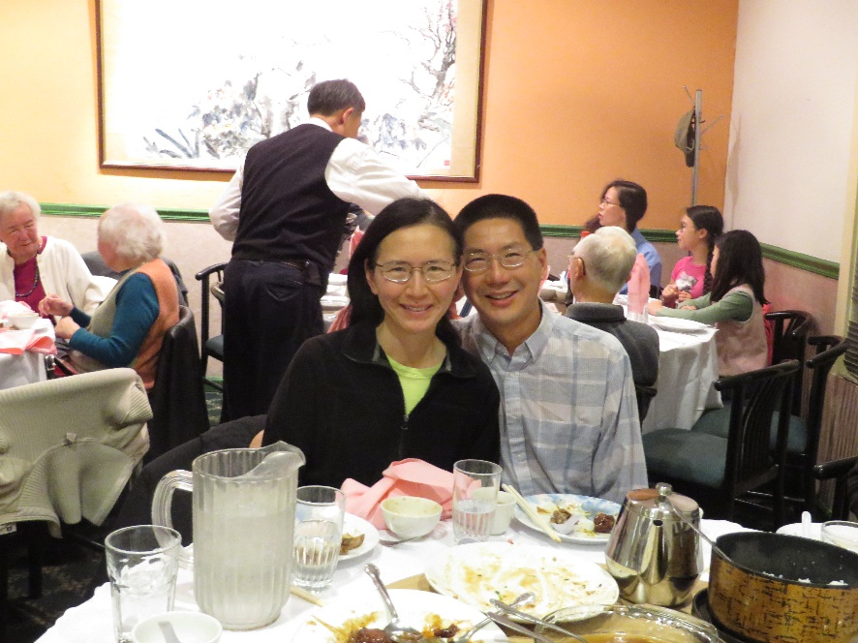Submitted by: Annette Chan

8 oz. sour cream

2 Tbl. flour

1 tsp. paprika

1 tsp. salt

2 Tbl. vegetable oil

½ c. onion, diced

8 oz. sliced mushrooms, canned or fresh

12 oz. boneless, skinless chicken thighs, cubed

Mix together the sour cream, flour, paprika, and salt. Fry the onion and mushrooms in the oil for about 2 to 3 minutes. Add the chicken pieces to the onion mix and cook until the chicken is done (about 10 minutes). Add the sour cream mixture. Bring to a boil, and cook for about 1 minute more.

## Instant Pot White-Cut Chicken

Source: Annette Chan

Submitted by: Annette Chan

5.25 to 5.5 lb. good-quality chicken (e.g., Sprouts Young Chicken)

5-6 slices of ginger

6 cloves of garlic

4 stalks of green onion, cut into large pieces

2 Tbl. salt

8 cups cold water

Add ginger, garlic, green onion, salt, and water into the Instant Pot. Mix everything together. Place the chicken into the Instant Pot with the breast side down. Close the lid and pressure cook at high pressure for 0 minutes (yes, zero minutes). Wait for 15 to 20 minutes, and then do a quick release. The amount of time to wait until you do a quick release depends on the size of the chicken.

Fill a large bowl with ice water.

Open the pot and check the temperature of the chicken. Make sure the temperature is at least 165°F. If the temperature is too low, cook for longer in the pot (sauté setting).

Carefully remove the chicken from the pot and submerge the chicken in the ice water (breast side down). Cool the chicken in the ice water for about 10-15 minutes.

Drain the chicken and cut it into pieces. Serve with soy sauce.

## Instant Pot Chicken Paprikash

Source: Annette Chan

Submitted by: Annette Chan

2 tsp. salt

½ tsp. pepper

2 Tbl. paprika

4 lbs. skinless chicken thighs, bone in

1 large onion, diced

3 garlic cloves, minced

3 c. chicken stock

¼ c. sherry

1 c. heavy cream

1 c. sour cream

5 Tbl. cornstarch mixed with 5 Tbl. water

Mix together the salt, pepper, and paprika.

Coat the chicken with the paprika mixture.

Add the onion, garlic, chicken, chicken stock, and sherry to the Instant Pot.

Stir everything together.

Close the Instant Pot. Set on Poultry, High Pressure, and 5 minutes.

Wait 10 minutes and then do a quick release.

Press sauté.

Mix in the heavy cream and the sour cream.

Mix in the cornstarch mixture and cook for about 2 minutes to thicken the sauce.

## Basil Chicken

Source: Annette Chan

Submitted by: Annette Chan

1 pound ground chicken or cubed pieces of chicken thighs

2 Tbl. minced ginger

2 Tbl. minced garlic

1½ Tbl. hoisin sauce

2 Tbl. soy sauce

1 Tbl. rice vinegar

1 Tbl. sesame oil

Handful of basil, rough chopped

1 tablespoon chili/garlic sauce or ground bean paste

1. Put the ginger and garlic in a bowl.
2. In another bowl, mix together the hoisin sauce, soy sauce, and rice vinegar.
3. Heat a large skillet over medium high heat and add the sesame oil.
4. Add the ginger and garlic and cook until fragrant.
5. Add the chicken and cook for about 5 minutes.
6. Add the hoisin sauce mixture.
7. Cover and cook for about 5 minutes.
8. Add the basil and stir-fry for about 2 minutes until the basil is wilted.
9. Mix in the chili sauce or ground bean paste.

## Instant Pot Braised Chicken

Source: Annette Chan

Submitted by Annette Chan

½ tsp. salt

¼ tsp. pepper

1 tsp. dried thyme

1 tsp. paprika

1 whole roasting chicken (about 4 lbs.) or 8 chicken thighs (with skin removed)

2 tbsp. olive oil

1 extra-large white onion, cut into eighths

3 cloves garlic, minced

2 tbsp. tomato paste

1 packet dry Italian dressing seasoning

1 cup chicken stock

½ cup Marsala or red wine

Cornstarch mixed with cold water (optional)

Mix together the salt, pepper, thyme, and paprika. Season the chicken with the salt mixture.

Set the Instant Pot to sauté. When the pot is hot, add the oil.

Add the onions and garlic. Sauté for about 3 minutes.

Add tomato paste and Italian dressing seasoning, and stir well.

Add the chicken stock and wine. Mix well.

Add the chicken to the pot (breast side up if using a whole chicken), and close the pot.

Set the pot to Poultry, high pressure, and 25 minutes.

Let the pressure release naturally.

Optional: After opening the pot, you can add the cornstarch and water mixture and boil for about a minute to thicken the sauce.

## Chicken and Egg Donburi

Source: Annette Chan

Submitted by: Annette Chan

1½ c. chicken broth

¼ c. soy sauce

⅓ c. rice wine or sherry

6 pieces of boneless, skinless chicken thighs, cut into pieces

1 onion, thinly sliced

3 zucchini, peeled and sliced thin (or 1 lb. broccoli cut into small pieces)

4 eggs, lightly beaten

In a large skillet, bring the chicken broth, soy sauce, and rice wine or sherry to a boil.

Add the chicken and vegetables.

Simmer, uncovered, stirring occasionally for about 5 minutes.

Gently pour the eggs on top, covering as much of the chicken mixture as possible.

Cover and simmer for about 5 minutes.

## Instant Pot Fall-Off-The-Bone Chicken

Source: Annette Chan

Submitted by Annette Chan

1 whole - 4lb. chicken or chicken thighs (with skin removed)

1 tsp. paprika

1 tsp. dried thyme

½ tsp. sea salt

¼ tsp. ground black pepper

1½ cups chicken broth

2 Tbsp. lemon juice

6 cloves garlic, peeled

In a small bowl, combine paprika, thyme, salt, and pepper. Rub seasoning over outside of chicken.

Mix together the chicken broth and lemon juice. Add to the pot.

Add the chicken (breast side up if using a whole chicken).

Add the garlic cloves.

Lock pressure cooker lid and set for 25 minutes on high.

Let the pressure cooker release naturally.

## **Vegetarian Sushi Bake**

Source: Annette Chan

Submitted by: Annette Chan

Follow the directions for the California Roll Sushi Bake, but omit the mayonnaise, sour cream, crab, and tobiko. You can add a layer of shredded carrots on top of the cucumber and avocado layers, sprinkle with furikake, and top with marinated shitake mushrooms.

Marinated Mushrooms

8 shitake mushrooms (enough to cover the top of the Sushi Bake)

2 Tbsp. water

6 Tbsp. sugar

6 Tbsp. soy sauce

4 ½ Tbsp. mirin

1. Soak the mushroom in hot water for 20 minutes until they become soft.
2. Remove the stems from the mushrooms and discard them.
3. Cut the mushroom into 1/4-inch wide strips.
4. Boil the water, soy sauce, sugar, and mirin in a small saucepan. Add the mushrooms. Cook about 5 minutes. Remove the mushrooms from the liquid and allow them to cool.

## Okonomiyaki

Source:  Adapted from <http://okonomiyakiworld.com/best-okonomiyaki-recipe.html>

Submitted by:  Diane Wong-Kone

*Adama calls these Japanese omelettes, aka Japanese pizza. Actual ingredients may vary and you can add whatever you like according to taste preference. Although restaurants here seem to add bacon or pork, I prefer to make these with vegetables or sometimes fish or shrimp. Measurements do not need to be exact. The batter should be thick, like pancake batter.*

scant 1 cup flour, use okonomiyaki flour if on hand, available in Japanese groceries

2/3 cup water with dashi powder or chicken stock

2-3 eggs

4 cups cabbage cut into small strips (note: I don’t think I use this much, but I don’t measure)

2 stalks green onions, sliced diagonally

½ cup raw shrimp or crab (imitation crab works too), or other meat (optional)

½ cup nagaimo, finely chopped, optional, but it helps bind batter, available in Asian grocery

½ cup mushrooms, finely chopped (optional)

Seasonings to taste (e.g. white pepper, salt, soy sauce, be creative – I usually add a little salt if I’m only using water instead of stock for the liquid)

Toppings (add as many as you wish):

Sriracha mayo (mix Sriracha and mayonnaise, to taste)

Seaweed flakes

Bonito flakes

Green onion

Tonkatsu sauce

Add your own!

Sauté cabbage a little bit to soften and set aside to cool. Nagaimo is a true yam with white flesh, but tan on the outside (looks like a root/tuber). Peel the nagaimo and grate or finely chop. It will be slimy. Beat egg, then mix all ingredients, including partially cooked cabbage. Heat a small frying pan then add a little oil. Add some batter to fill bottom of pan or fit your spatula. Wait until it bubbles, like cooking a pancake, and edges are dry enough that you can lift the “omelette” and flip it over with a spatula. Slide cooked okonomiyaki onto a plate. Add toppings.

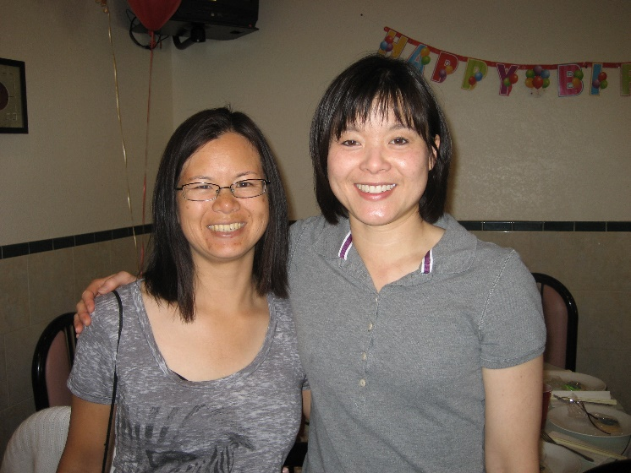

## Steamed Chicken

Source: *Stella Chan’s Secrets in the Art of Chinese Cooking* by Stella Chan

Submitted by: Evelyn Wong

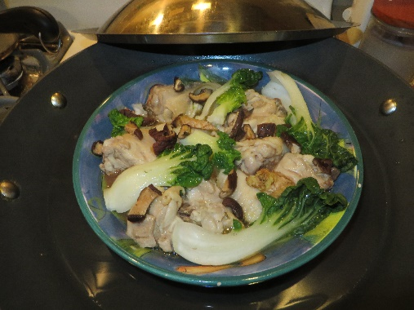

1 lb. chicken – cut into 1-inch pieces (bone included)

2 black mushrooms – soaked, sliced

2 teaspoons peanut oil

1 stalk green onion – diced

Marinade for chicken:

½ teaspoon sugar

1 teaspoon salt

¼ teaspoon MSG (optional)

1 teaspoon soy sauce

1 teaspoon corn starch

2 slices fresh ginger root – minced (1 teaspoon each slice)

½ teaspoon wine (rice wine or dry sherry)

Add marinade to chicken. Stir in 2 tsp. peanut oil. Let stand for 30 minutes. Spread chicken and mushrooms evenly in a large heatproof dish. Steam for 10 minutes. Stir well. Transfer to a serving dish. Top with diced green onion. Serve hot.

Secrets:

1. Coating the chicken with peanut oil helps to make the meat tender and juicy.
2. When steaming the chicken, make sure the dish is large enough so that the meat will be in only one layer. The meat will be cooked for a very short period of time. This way it will retain its flavor and remain tender and juicy.
3. The chicken will taste better if you steam it with the bone left in. However, if you prefer, you may steam the chicken meat without bone.

## Sushi Bake

Source: Annette Chan

Submitted by: Annette Chan

2 cups (not rice cooker cups) Calrose rice, cooked with 2 1/2 cups water in a rice cooker

6 Tbsp. rice vinegar

½ cup mayonnaise

1 cup sour cream

1½ Tbsp. Sriracha sauce

1 lb. crabmeat (can use finely chopped imitation crab)

8 oz. cooked tiny shrimp (can use canned), optional

8 oz. tobiko (masago orange fish eggs), optional

1 oz. furikake rice seasoning (Aji Nori Furikake roasted sesame and seaweed is good.)

10-20 pieces of seasoned seaweed wrappers

1. After cooking the rice, stir in the rice vinegar and then set it aside to cool.
2. Preheat oven to 375 degrees Fahrenheit.
3. Combine the mayonnaise, sour cream, and Sriracha sauce.
4. Stir in the crabmeat and shrimp.
5. Spread the rice into a 9” x 13” glass pan (vinegar can discolor metal pans). Pat the rice into the pan with wet hands.
6. Sprinkle about half of the furikake rice seasoning onto the rice.
7. Spread the crab and shrimp mixture onto the rice.
8. Sprinkle the tobiko over the mixture.
9. Sprinkle the rest of the furikake over the dish.
10. Bake for about 20 minutes.
11. Serve with the pieces of seaweed wrappers. Add a spoonful of baked sushi onto a piece of seaweed, fold it into a roll, and eat immediately.

## California Roll Sushi Bake

Source: Annette Chan

Submitted by: Annette Chan

2 cups (not rice cooker cups) Calrose rice, cooked with 2 1/2 cups water in a rice cooker

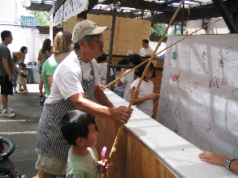6 Tbsp. rice vinegar

½ cup mayonnaise

1 cup sour cream

1 lb. crabmeat (can use finely chopped imitation crab)

2 large avocados

1 to 2 cucumbers, peeled and sliced thin, optional

8 oz. tobiko (masago orange fish eggs), optional

1 oz. furikake rice seasoning (Aji Nori Furikake roasted sesame and seaweed is good.)

10-20 pieces of seasoned seaweed wrappers

1. After cooking the rice, stir in the rice vinegar and then set it aside to cool.
2. Preheat oven to 375 degrees Fahrenheit.
3. Combine the mayonnaise and sour cream. Stir in the crabmeat.
4. Spread the rice into a 9” x 13” glass pan (vinegar can discolor metal pans). Pat the rice into the pan with wet hands.
5. Sprinkle about half of the furikake rice seasoning onto the rice.
6. Layer the cucumber on top of the rice.
7. Peel and slice the avocado. Layer the avocado on top of the cucumber.
8. Spread the crab mixture on top of the avocado.
9. Sprinkle the tobiko over the mixture.
10. Sprinkle the rest of the furikake over the dish.
11. Bake for about 20 minutes.

Serve with the pieces of seaweed wrappers. Add a spoonful of baked sushi onto a piece of seaweed, fold it into a roll, and eat immediately.

## Asparagus with Black Bean Beef

Source: *Stella Chan’s Secrets in the Art of Chinese Cooking* by Stella Chan

Submitted by: Evelyn Wong

½ lb. beef – sliced, marinated

1 lb. asparagus – sliced

¼ teaspoon baking soda – dissolved in 2 tsp. water

1 tablespoon Chinese fermented black beans – minced with 4 garlic cloves (½ tsp. each)

1 teaspoon rice wine

2 teaspoons soy sauce

Peanut oil

Marinade for beef:

1 teaspoon cornstarch

½ teaspoon sugar

1 teaspoon soy sauce

¼ teaspoon MSG (optional)

½ teaspoon rice wine

½ teaspoon salt

Gravy mixture:

1 teaspoon cornstarch

⅓ cup water

Stir baking soda solution into the beef (see secrets). Stir in the marinade. Then stir in 1 tsp. peanut oil and marinate the beef for one hour or more in the refrigerator.

Heat 1 tbsp. peanut oil over high heat, add ½ tsp. salt. Stir in asparagus. Add ¼ cup water. Cover pan for 2 minutes. When done, remove to a platter.

Over high heat, add 1 tbsp. oil. Stir-fry black beans and garlic mixture. Stir for a few seconds. Add beef. Stir-fry until barely done. Sizzle in 1 tsp. wine and 2 tsp. soy sauce. Stir in asparagus.

Add gravy mixture. Stir until thickened. Serve hot.

Secrets:

1. Cut the beef when it is partially frozen. Cut it across the grain into thin slices.
2. Adding baking soda helps to tenderize the beef.
3. When putting the marinade on the beef, make sure to stir the beef in the same direction in a circular motion. Coating the peanut oil on the marinated beef will help the beef to cook faster, hence the meat will be juicier.
4. Always cook the beef over high heat and cook quickly. Never overcook the beef or else it will become tough.
5. When you cover the pan and cook the asparagus for 2 minutes, do not remove the cover in between. The asparagus will stay green if you leave it covered for the whole time without peeping.

## Best Chicken Stew

Source: America’s Test Kitchen

Submitted by: Karen Miyao

Serves 6 to 8

2 pounds boneless, skinless chicken thighs, halved crosswise and trimmed

Kosher salt and pepper

3 slices bacon, chopped

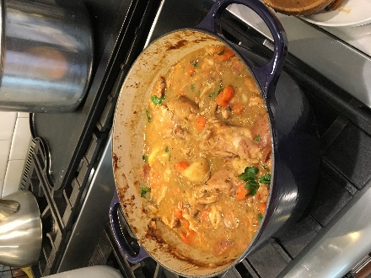1 pound chicken wings, halved at joint

1 onion, chopped fine

1 celery rib, minced

2 garlic cloves, minced

2 teaspoons anchovy paste

1 teaspoon minced fresh thyme

5 cups chicken broth

1 cup dry white wine, plus extra for seasoning

1 tablespoon soy sauce

3 tablespoons unsalted butter, cut into 3 pieces

*Karen made this for our 2018 cookbook gathering*.

⅓ cup all-purpose flour

1 pound small red potatoes, unpeeled, quartered

4 carrots, peeled and cut into 1/2-inch pieces

2 tablespoons chopped fresh parsley

Mashed anchovy fillets (rinsed and dried before mashing) can be used instead of anchovy paste. Use small red potatoes measuring 1½ inches in diameter.

1. Adjust oven rack to lower-middle position and heat oven to 325 degrees. Arrange chicken thighs on baking sheet and lightly season both sides with salt and pepper; cover with plastic wrap and set aside.
2. Cook bacon in large Dutch oven over medium low heat, stirring occasionally, until fat renders and bacon browns, 6 to 8 minutes. Using slotted spoon, transfer bacon to medium bowl. Add chicken wings to pot, increase heat to medium, and cook until well browned on both sides, 10 to 12 minutes; transfer wings to bowl with bacon.
3. Add onion, celery, garlic, anchovy paste, and thyme to fat in pot; cook, stirring occasionally, until dark fond (carmelized bits) forms on pan bottom, 2 to 4 minutes. Increase heat to high; stir in 1 cup broth, wine, and soy sauce, scraping up any browned bits; and bring to boil. Cook, stirring occasionally, until liquid evaporates and vegetables begin to sizzle again, 12 to 15 minutes. Add butter and stir to melt; sprinkle flour over vegetables and stir to combine. Gradually whisk in remaining 4 cups broth until smooth. Stir in wings and bacon, potatoes, and carrots; bring to simmer. Transfer to oven and cook, uncovered, for 30 minutes, stirring once halfway through cooking.
4. Remove pot from oven. Use wooden spoon to draw gravy up sides of pot and scrape browned fond into stew. Place over high heat, add thighs, and bring to simmer. Return pot to oven, uncovered, and continue to cook, stirring occasionally, until chicken offers no resistance when poked with fork and vegetables are tender, about 45 minutes longer. (Stew can be refrigerated for up to 2 days.)
5. Discard wings and season stew with up to 2 tablespoons extra wine. Season with salt and pepper to taste, sprinkle with parsley, and serve.

## Hachis Parmentier

Source: Christina Wong

Submitted by: Christina Wong

*Hachis Parmentier is a dish we tried for the first time when we went to France with Nat's parents. We came home and tweaked recipes we found online to create the version here.*

Ingredients:

Beef layer

1½ cups chopped leeks (chop the stems and discard leaves)

1½ cups chopped celery

1½ cups finely chopped carrots

2-3 cloves chopped garlic

1 bay leaf

1½ teaspoons herbes de Provence

salt and pepper to taste

1 cup dry white wine

1½ tablespoons tomato paste

2 lbs. ground beef

4 tablespoons unsalted butter

Potato layer

3¼ pounds gold potatoes

2-3 cloves chopped garlic

4 tablespoons unsalted butter (add more for more butter flavor if you like)

½ cup heavy cream

½ cup chicken broth

salt and pepper to taste

Cheese layer

8 oz. Gruyeré or Emmental, shredded (or sub mozzarella)

½ cup Parmesan, shredded (Parmesan/Romano blends are also good)

Directions:

* + - 1. Bring a large pot of salted water to boil. Peel potatoes and chop into cubes. Add the chopped potatoes to the boiling water and boil until tender, about 15 minutes. Drain.
      2. In the same pot, melt the butter and add garlic. Let the garlic cook for about a minute or until fragrant, and then add the cream and broth. When the liquid starts to boil, add the drained potatoes back to the pot and mash well. You can also do this in a food processor if you prefer by adding the liquid and the potatoes to a large food processor. Add salt and pepper to taste.
      3. Meanwhile, pre-heat a Dutch oven on the stove top and set to medium. When the Dutch oven has heated, melt the butter and add leeks, celery, and carrots. Add in the bay leaf and herbes de Provence, and salt and pepper. Stir and let the vegetables cook down for about 5 minutes. Add the garlic, and cook for a couple minutes more or until you can start to smell the garlic. Add the tomato paste and wine and stir. Remove the bay leaf. Add in the ground beef and mix well. Make sure the meat has moisture, adding water if necessary, and cover the Dutch oven. Let cook for 15 minutes, stirring occasionally. Add more water if necessary to ensure beef doesn't burn. When the meat has cooked, remove from heat and let cool.
      4. To assemble, spoon the beef mixture into a large casserole dish (you may want to oil it first) and top with a layer of the mashed potatoes.  Layer the top with shredded Gruyeré or Emmental (or mozzarella) and Parmesan. We usually have enough ingredients to make two casseroles. Bake uncovered for approximately 20 minutes at 400 degrees Fahrenheit or until top is browned.

## Brined Pork Tenderloin

Source:  Christina Wong

Submitted by:  Christina Wong

*This is a Sunday dinner favorite!*

Brine

4 cups water

½ cup kosher salt

3 tablespoons agave nectar or honey

6 garlic cloves, crushed

3 bay leaves

1-2 sprigs fresh rosemary

3-4 sprigs fresh thyme

1 tablespoon whole peppercorns

1 pork tenderloin, 2-3 lbs.

Cast iron skillet method:

2 garlic cloves, crushed

4 tablespoons unsalted butter

1 sprig fresh rosemary

2 sprigs fresh thyme

To prepare the brine, add 2 cups of the water and the rest of the brine ingredients in a small pot. Bring the brine to a boil while whisking to dissolve nectar/honey and salt, and then remove from heat. Add the remaining 2 cups of water to the brine and let it cool down to room temperature (a couple of hours). Transfer the brine to a large container or gallon Ziplock bag. Place the pork tenderloin in the brine and refrigerate for up to 4 hours. The longer you leave the pork in the brine, the saltier it will be. 4 hours is the maximum I would recommend.

After brining, rinse the pork in water and pat dry. Let rest for 1 hour or until room temperature.

Grill method: Grill the pork tenderloin on a hot grill for approximately 8 minutes on each side, or until it reaches desired temperature.

Cast iron skillet method: While the pork is resting at room temperature, heat a large cast iron skillet in an oven set to 375° Fahrenheit for at least 15 minutes. Leaving the oven on, transfer the skillet to the stovetop and set to medium heat. Let the skillet heat for 10 minutes. Sear the pork on all sides until brown. When the sides have browned, add the butter, garlic, and herbs to the pan and immediately start spooning the hot butter over the pork on all sides. Place herbs and garlic on top of tenderloin and transfer skillet back to the oven for 15 minutes or until it reaches the desired temperature.

When the pork has cooked, cover with foil and rest for 15 minutes before slicing.

## Pork Chops with Curry & Green Chile Rub

Source: Charles Saunders, chef/owner of Eastside Oyster Bar & Grill and SunnySide Coffee Club and Blues Bar in Sonoma, California; Fine Cooking, 1994

Submitted by: Dean Quock & Cheryle Miyao-Quock

*This recipe is one of the first recipes we cooked together when we were dating; it’s now one of our favorite dishes. Besides pork chops, you can also rub this mix on duck or chicken before roasting, or try sprinkling it on grilled vegetables and serve with basmati rice tossed with pine nuts and currants.*

4 (1½ inch thick) center cut pork chops, boneless or bone-in

Oil

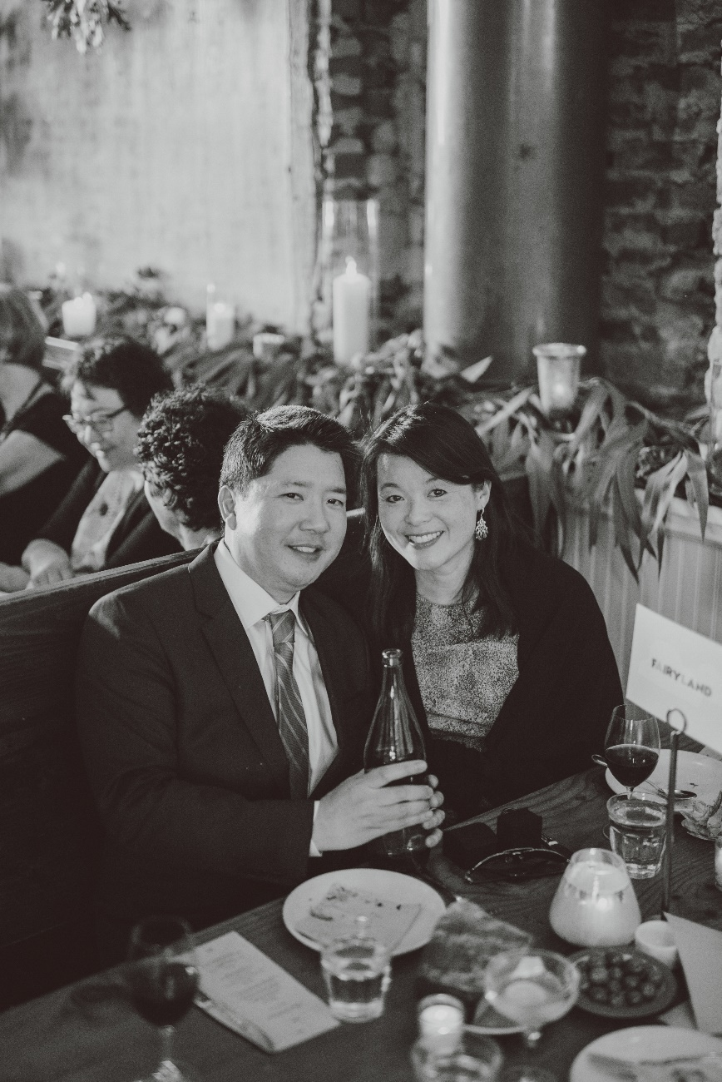2-4 T. Curry & Green Chile Rub

Curry & Green Chile Rub:

Makes ½ cup

*With fine bits of green chile peppers and the woody flavor of cumin seeds, each bite gives a different sensation. If you don’t want to go through the trouble of grinding your own spices, you can use pre-ground, add ¼- ½ teaspoon more than the recipe recommends.*

1 tsp. whole cloves

2 Tbs. cumin seed

4 Tbs. curry powder

1 or 2 jalapeños, seeded and finely chopped

3 Tbs. kosher salt

Toast the cloves and cumin in a frying pan over medium heat until the cumin browns slightly and the spices release their aroma. Grind these spices coarse in a spice grinder. Combine all the ingredients in a bowl and toss well.

Heat oven to 400° F. Generously rub curry/chile mixture on each side of pork chop, about 2 teaspoons for each side (we like heavy seasonings so we cover the entire chop). Heat a 10”-12” cast-iron skillet or heavy ovenproof pan on high heat with 1 T. oil. Let the oil heat until it ripples. Place the chops in the pan without crowding them. Sear the chops after the crust turns golden brown, about 1-2 minutes. Put pan in oven to finish cooking. On average, thin chops (½ inch thick) take about 8 minutes to finish cooking, while thick chops (1 to 1½ inches) can take 10 to 12 minutes.

Note: If you don’t have an ovenproof pan, fry pork chops as directed and then transfer meat to ovenproof baking dish.

## Pork Chops with Scalloped Potatoes

Source: *Taste of Home*

Submitted by: Karen Miyao

*I wanted to do something different from my usual panko breaded pork chops and found this recipe. Recommend using boneless, medium thick pork chops.*

3 tablespoons butter

3 tablespoons all-purpose flour

1½ teaspoons salt

¼ teaspoon pepper

1 can (14½ ounces) chicken broth

6 pork rib or loin chops (¾ inch thick)

2 tablespoons canola oil

Additional salt and pepper, optional

6 cups thinly sliced peeled potatoes

1 medium onion, sliced

Paprika and minced fresh parsley, optional

1. In a small saucepan, melt butter; stir in the flour, salt and pepper until smooth. Add broth. Bring to a boil; cook and stir for 1 minute or until thickened. Remove from the heat and set aside.
2. In a large skillet, brown the pork chops on both sides in oil; sprinkle with additional salt and pepper if desired.
3. In a greased 13-in. x 9-in. baking dish, layer potatoes and onion. Pour broth mixture over layers. Place pork chops on top.
4. Cover and bake at 350°F for 1 hour; uncover and bake 30 minutes longer or until meat and potatoes are tender. If desired, sprinkle with paprika and parsley.

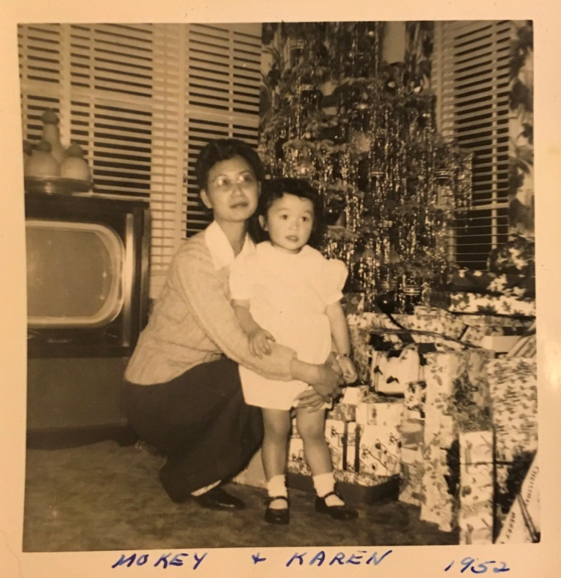

## Chicken (or Pork) Adobo

Source: Chef Dioniso Esperas of Sacramento Natural Food Co-op

Submitted by: Karen Miyao

3 lb chicken thighs

⅓ c. soy sauce

⅓ c. white vinegar

3 Tablespoons brown sugar

4 cloves garlic, coarsely chopped

1 Tablespoon grated ginger

2 bay leaves

¼ teaspoon cracked black peppercorns

1 c water or more to cover chicken

Salt to taste

1. Combine all ingredients in a small stock pot. Add enough water to cover the chicken by ½ inch and then bring to a simmer. Cover and simmer for at least 45 min until chicken is tender.

2. Remove chicken from pan and keep warm. Simmer liquid for 5--7 minutes to intensify flavor. Pour sauce over chicken and serve with steamed rice.

Remove bay leaves before serving.

OPTIONAL SAUCE IDEA--add 1 c of (I use Thai Kitchen organic) coconut milk to sauce in step 2 as you reduce simmering liquid.

My changes/tweaks to this original recipe:

1. I brown chicken or pork first in olive oil.

2. I do add the coconut milk, which I think is a must because it just makes it that much more tasty!!

Delish served over rice!

## Chicken with Snow Peas

Source: *Stella Chan’s Secrets in the Art of Chinese Cooking* by Stella Chan

Submitted by: Evelyn Wong

½ lb. snow peas – peeled (stem and string), parboiled (2 minutes)

½ cup cloud ears – soaked, washed

½ cup chicken breast meat – slivered

1 teaspoon rice wine

Salt to taste

Peanut oil

Marinade for chicken:

1 teaspoon cornstarch

1 teaspoon salt

¼ teaspoon sugar

1 teaspoon MSG (optional)

1 tablespoon egg white – slightly beaten

1 tablespoon peanut oil

Gravy mixture:

2 teaspoons cornstarch

⅔ cup chicken stock – fresh or canned

Marinate chicken. Place in the refrigerator for 30 minutes.

Heat a clean frying pan over high heat. Add one cup peanut oil. Pour chicken in warm oil. Wait until meat turns white. Remove.

Drain off oil, leaving about 1 tbsp. in frying pan. Over high heat, stir in chicken. Sizzle in 1 tsp. wine. Add snow peas and cloud ears. Stir well. Add salt to taste.

Add gravy mixture. Cook until thickened. Remove to a platter and serve hot.

Secrets:

1. The best way to keep the snow peas green is to parboil them, then rinse them under cold water. Any green vegetable will remain green for a long time if you use this method. Stir ½ tsp. baking soda into the parboiling water right before you rinse the peas under cold water to make them stay green.
2. Cooking chicken in warm oil helps to make the meat tender and juicy.
3. When sizzling in wine, make sure to sizzle it onto the frying pan rather than into the food.

## Lo Han Jai

Source: Modified from *Treasured Recipes from Two Cultures – American and Chinese*, with information from <http://archives.starbulletin.com/98/01/14/features/story1.html> (accessed 10/4/2018).

Submitted by: Diane Wong-Kone

*Gung Hay Fat Choy! Jai is a traditional vegetarian “monk’s” dish eaten on Chinese New Year. Southern Chinese often incorporate dried oysters because they symbolize good luck. Many of the foods in jai are symbolic: fat choy and gum jum – wealth, bok gwo – fortune, peanuts – birth, fried tofu and foo jook – blessings to house, dong gu – welcomes spring, fun see, jook soon and wun yee – long life, snow peas and water chestnuts – unity, and carrots – good luck and wealth. Note that soaking times may be decreased if you use warm water (soak 15-30 minutes for items normally taking 2 hours to overnight).*

12 dried oysters (Ho See) – soaked for 2 days, washed of broken shells, and sliced. Save soaking liquid. (Optional)

1 can braised bamboo shoot tips or 1 piece dried bamboo shoots (Gum Soon or Soon Ha) 5” x 10” --soaked 3 days with daily water changes. To prepare, cut off hard joints, cover with water, bring to boil and discard water. Do this twice. Cut bamboo shoots in thin diagonal slivers 2” wide. Heat a little oil in pan, stir fry Gum Soon with a little fermented white bean curd (Foo Yue), add a little water and simmer for half an hour.

¼ pound bean stick, round type (Foo Jook) -- soaked overnight and cut in 2” lengths. Cover with cold water, bring to boil, discard water. Cover again with cold water and boil until soft. Do not add salt as salt will break up the sticks OR ¼ pound Tiem Jook (sweet dried yuba), soaked overnight. Cover with cold water, bring to boil, discard water. Cut in 1” wide strips.

2 Chinese red dates (Hung Joe) -- soaked overnight, cut open in several places

12 dried Chinese black mushrooms (Dong Gu) -- soaked several hours, washed and sliced thin. Save soaking liquid.

1 cup Chinese ginko nuts (Bok Gwo) -- shelled, boiled 10 minutes to slip off skin OR 1 cup raw peanuts

½ pound Chinese vermicelli (Fun See) -- soaked 2 hours, cut in short lengths

1 can bamboo shoots (Jook Soon) -- sliced in thin slivers 2” x ½”. Save juice from can

½ cup dried cloud fungus (Wun Yee – smaller in size than the similar looking tree ear fungus or Ha Mok Yee) -- soaked 2 hours with 1 Tablespoon salt and 1 Tablespoon salad oil to clean dirt out. Wash and drain.

1 cup dried tiger lilies (Gum Jum Choy) -- soaked 2 hours until soft. Knot each strand.

6 water chestnuts (Mah Tai) -- peeled and sliced

1 cup hair seaweed (Fat Choy) -- soaked 2 hours. Cover with cold water, boil, and discard water. Cover again with cold water and boil a few minutes. Drain. Add this at serving time.

12 chestnuts (Fung Lut) -- boiled 3 minutes and shelled. Boil nuts until soft. Add last at serving time.

¼ pound fried bean cake (Dow Foo Pok), rinsed with running hot water. Cut each cube in half.

Optional: fresh vegetable such as bok choy, Napa cabbage, sugar peas, and carrots, cut to bite-size chunks. Stir fry in a little oil until half-cooked.

Make seasoning mixture:

1 tablespoon Chinese whiskey or wine

⅓ cup soy sauce

3 tablespoons oyster sauce (Ho Yow)

4 cakes fermented white bean curd (Foo Yue)

OR

½ fermented red bean curd (Nam Yue)

Few drops of sesame oil (Gee Mah Yow)

1 piece fresh ginger, about a 2” chunk, slapped flat with a cleaver

2 tablespoons sugar (optional)

Heat ¾ cups or more oil in large pot until very hot. Add 2 teaspoons salt. Add ho see, foo jook, mushrooms, fun see, bamboo shoots, cooked gum soon, hung joe, and bok gwo. Stir fry 3 minutes.

Add soaking juices from mushrooms, oysters, and bamboo shoots. Add clear chicken broth or water to cover. Cook for a few minutes.

Add seasoning mixture. Stir frequently. Cook 10 minutes.Taste and, if needed, add more foo yue or oyster sauce for desired flavor.Add gum jum choy, wun yee, mah tai, and dow foo pok. Cook 10 minutes, stirring frequently. If desired, stir in cooked fresh vegetables. Last, add cooked chestnuts and fat choy when ready to serve

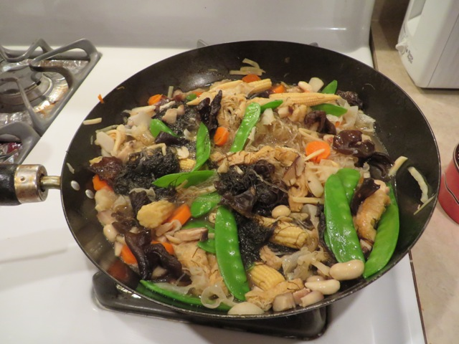

## Lucky Black-Eyed Peas

Source: Evelyn Wong

Submitted by: Diane Wong-Kone

Servings: 8

*Hoppin’John, or Black-Eyed Peas are eaten in the South for the New Year for luck. Mom (Evelyn) uses this recipe from an old newspaper clipping to make this every year.*

1 pound dried black-eyed peas

3 cups chicken broth

1 smoked turkey leg

2 tablespoons butter

½ cup onion, chopped

½ cup green bell pepper, chopped

1 tablespoon fresh garlic, minced

1 tablespoon fresh thyme leaves, chopped

1 bay leaf

Sea salt and pepper, to taste

In a large bowl, cover the black-eyed peas with water and soak for 1 hour. Drain the water off the peas. In a large sauce pan, bring chicken broth to a boil. Add smoked turkey, reduce heat to low. Cover pot and cook for 30 minutes. Remove turkey leg and set aside to cool.

In a small skillet, melt butter. Sauté onion, bell pepper and garlic for 7 to 10 minutes. Add butter and vegetable mixture to the pot of chicken broth. Stir in thyme, bay leaf and peas. Cover and cook on low for 45 minutes.

Remove smoked turkey meat from the bone and chop into small pieces. Remove bay leaf from the peas and discard. Stir in chopped meat. Season with salt and pepper to taste.

## Pesto-Crusted Salmon with Wilted Spinach

Source: Kari Nakama, adopted from *Food & Wine Magazine*

Submitted by: Cheryle Miyao-Quock

*A simple, elegant dish.*

⅓ c. fresh basil leaves

⅓ c. plain dry bread crumbs

3 T. pine nuts

3 T. freshly grated Parmesan cheese

2 cloves garlic

5 T. extra-virgin olive oil

2 strips bacon, coarsely chopped

Salt & pepper to taste

Four 7-ounce skinless salmon fillets, about 1” thick

2 medium shallots, fine chopped

4 lbs baby spinach

Lemon wedges for serving

Preheat the oven to 400°F.

Cook bacon pieces until crisp. Blot on paper towels. In food processor or blender, combine basil, bread crumbs, bacon, pine nuts, Parmesan cheese, and garlic. Finely chop. With the machine running, add 3 T. extra-virgin olive oil in a steady stream until smooth. Season with salt and pepper. Spread a rounded tablespoon of the pesto evenly on the skinned side of each salmon fillet.

Heat ½ T. olive oil in large, non-stick skillet. Add 2 of the salmon fillet, pesto side down, and cook over moderately high heat without turning until the pesto is browned, 1-2 minutes. Carefully invert the fillets into a large baking dish. Repeat with remaining 2 salmon fillets. Bake in the oven for ~10 minutes, or until the salmon is just cooked through. Do not overcook.

Meanwhile, wipe out the skillet and heat the remaining 1 T. olive oil. Add the shallots and cook over moderately high heat for 30 seconds. Add the spinach and cook until the spinach wilts. Season with salt and pepper.

Set each salmon fillet in the center of a warmed plate, pesto side up. Arrange spinach around the fish and serve with lemon wedges.

Serves 4.

## Andy’s Spaghetti Saturday Pasta

Source: Andy Cheng

Submitted by: Yvonne Chan Cheng

2 packages of linguine fine

⅓ c. diced mushrooms

6 cloves of garlic

the white bulb of three green scallions

fresh oregano from the garden

3 egg whites

1 T. white wine

1 can of diced tomatoes

1 jar of tomato sauce

Dice mushrooms to fill a third cup. Mince the bulb of three scallions and add them to the mushrooms. Add three egg whites. Add one tablespoon of white wine. Use a garlic crusher to crush six cloves of garlic and place in a separate dish. While the pasta cooks for eight minutes, prepare the sauce as follows: sauté the crushed garlic in a skillet greased with a slice of melted butter. Add the mushroom mixture and cook until browned. Add a can of diced tomatoes and stir. Finally, add the tomato sauce and simmer until the pasta is ready.

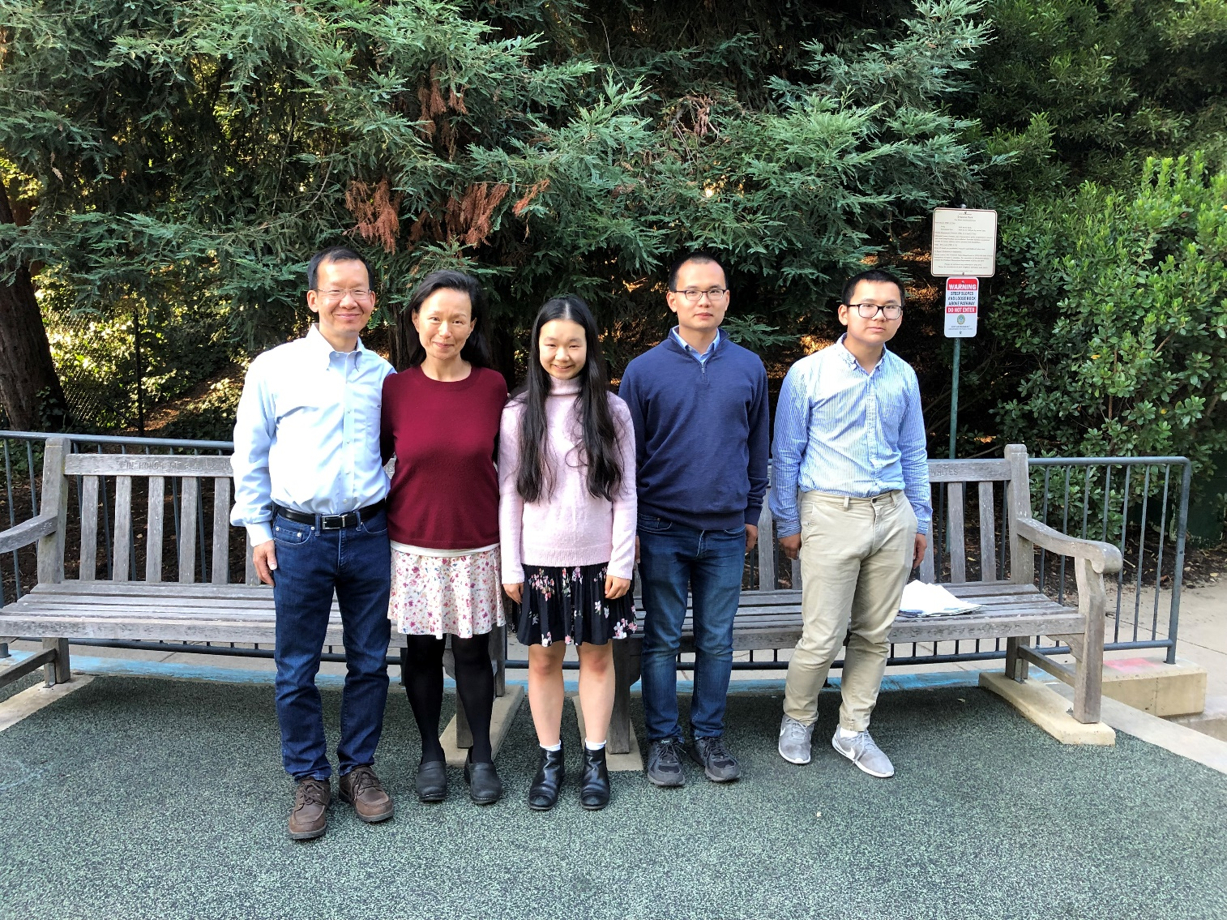

# Desserts

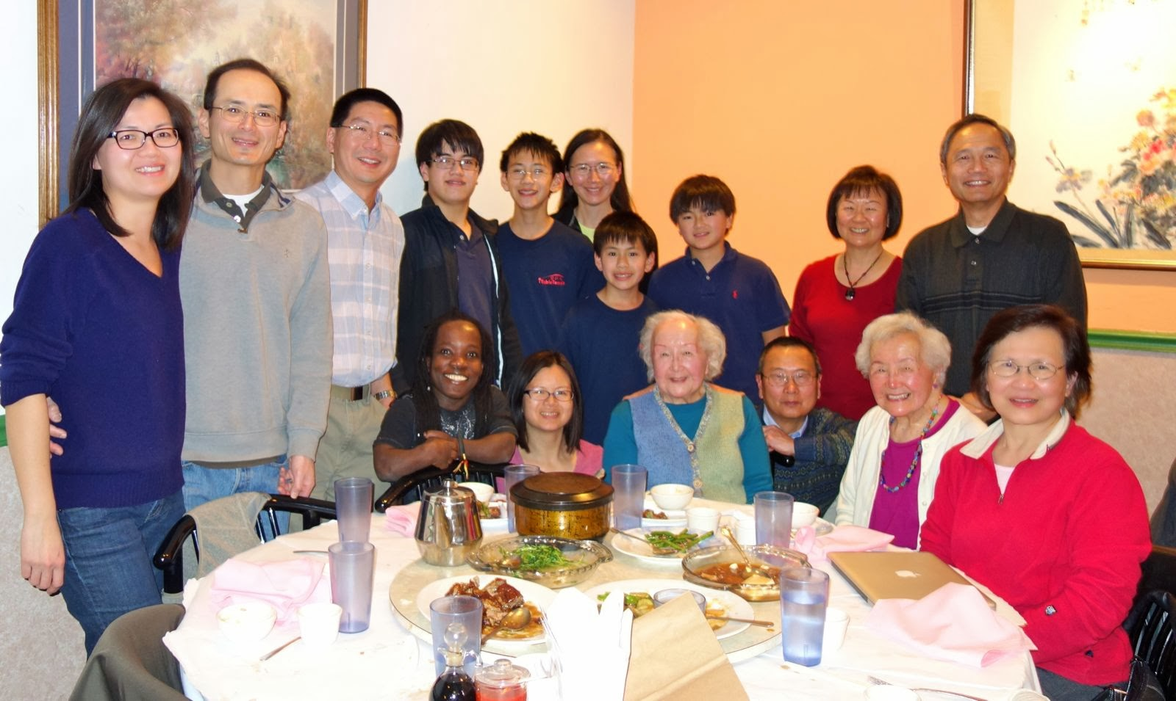

Family get-together at King Palace Restaurant, San Ramon, December 2013. Left to right, top row: Jennifer Chan, Clifford Chan, Charles Lee, Nicholas Chan, Philip Lee, Annette Lee, Thomas Lee, Matthew Chan, Wendy Chang, and Sammy Chang; bottom row: Adama Kone, Diane Wong-Kone, Evelyn Wong, Douglas Ng, Elsie Ng, and Denise Chan.

**Desserts**

Strawberry Jello Salad 156

Almond Jello 156

Jello Cream Cheese 157

Seven-Layer Finger Jello 158

Emerald Isle Mold 158

Lime Jello Mold 159

Danger!! Cookies!! 159

Rosettes 160

Bow Tie 160

Russian Tea Cakes 160

Almond Cookies 161

Ice Box Cookies 161

Macadamia Butter Cookies 162

Shortbread Cookies 162

Sugar Cookies 163

No-Sugar Sugar Cookies 164

Snickerdoodles 165

Oatmeal-Chocolate Chip Cookies 166

Cinnamon Refrigerator Cookies 167

Jamborees 167

Nut Tree Cookies 168

Pecan Pie Bars 169

Chewy Noels 169

Amber Apple Cake 170

Fresh Apple-Nut Cake 170

Karen’s Triple Chocolate Decadent Ecstasies 171

Chocolate Chiffon Cake 172

Red Cake 173

Nut Tree Chocolate Fudge Cake 174

Fruit Basket Cake 175

Butter Sponge Cake 176

King’s Pineapple Fluff Cake 177

Sour Cream Pound Cake 178

Coffee Ice Cream Pie 178

Eggnog Pie 179

Easy Fruit Cobbler 179

Sprinkles Strawberry Cupcakes 180

Lemon Meringue Pie 181

Black Bottom Cupcakes 182

Southern Sweet Potato Pie 182

Mascarpone and Fruit Trifle 184

Malasadas 185

Peanut Brittle 186

Caramel Crispix Mix 186

Carmel Corn 187

Clifford’s Sour Cream Pound Cake 187

Mocha Cake 188

Almost Flourless Chocolate Cake (The Winning Hearts and Minds Cake) 189

Dark Chiffon Cake 190

Coffee Crunch Topping 191

Blum’s Coffee Crunch Cake 192

Got Milk? Cookies 194

Macadamia Cookie 194

Lemon Snaps 195

Doug’s Lemon Tart 196

Blueberry Pie 197

Caramel-Glazed Custard 198

Salted Toffee Chocolate Bars 199

Doug’s Apple Galette 200

Foolproof Pie Dough for a Single-Crust Pie 200

Melt-in-Your-Mouth Macadamia Shortbread 201

Jin Duey: Simple Way (deep fried glutinous rice balls) 202

Chinese Steamed Cake 203

Red Bean Soup Dessert 203

Whiskey Rice or Sweet Fermented Rice (Lao Zao) 204

## Strawberry Jello Salad

Source: Unknown

Submitted by: Karen Miyao

2 small boxes or 1 large box strawberry Jello

2 c. boiling water

2 small packages or 1 large package frozen strawberries

1 size #2 (20 oz) crushed canned pineapple

2-3 mashed bananas

½ pint sour cream

1 pkg nuts, sliced

Dissolve 2 packages of Jello with boiling water. Let cool, then add berries, pineapple, bananas, & nuts. Mix together. Pour ½ of mixture into mold and let thicken. Freeze for 10 minutes. Then remove from freezer & spread sour cream on top. Then pour other ½ of mixture on top and put in refrigerator until set.

## Almond Jello

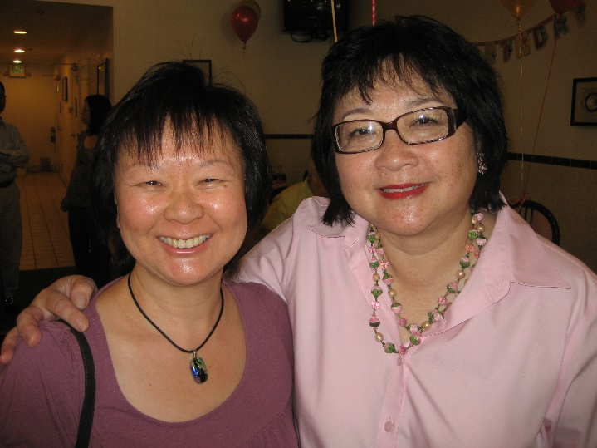Source: Unknown

Submitted by: Wendy Chang

*Everyone I know loves this recipe!*

2½ c. water

1 c. sugar

4 packages Knox gelatin dissolved in ½ c. cold water

1 T. almond extract

2½ c. milk

Bring water to boiling. Add the sugar, stir to dissolve. Turn down the heat, and stir in the dissolved gelatin. Add the almond extract and the milk. Pour into a 9 x 13-inch dish. Refrigerate. Cut into cubes.

Serve with:

1 can of lychee (including syrup), plus fresh fruit of your choice. I usually like to add ½ honeydew melon, cubed, and some sliced strawberries. My brother-in-law likes to add fresh mango.

## Jello Cream Cheese

Source: Bessie Chun

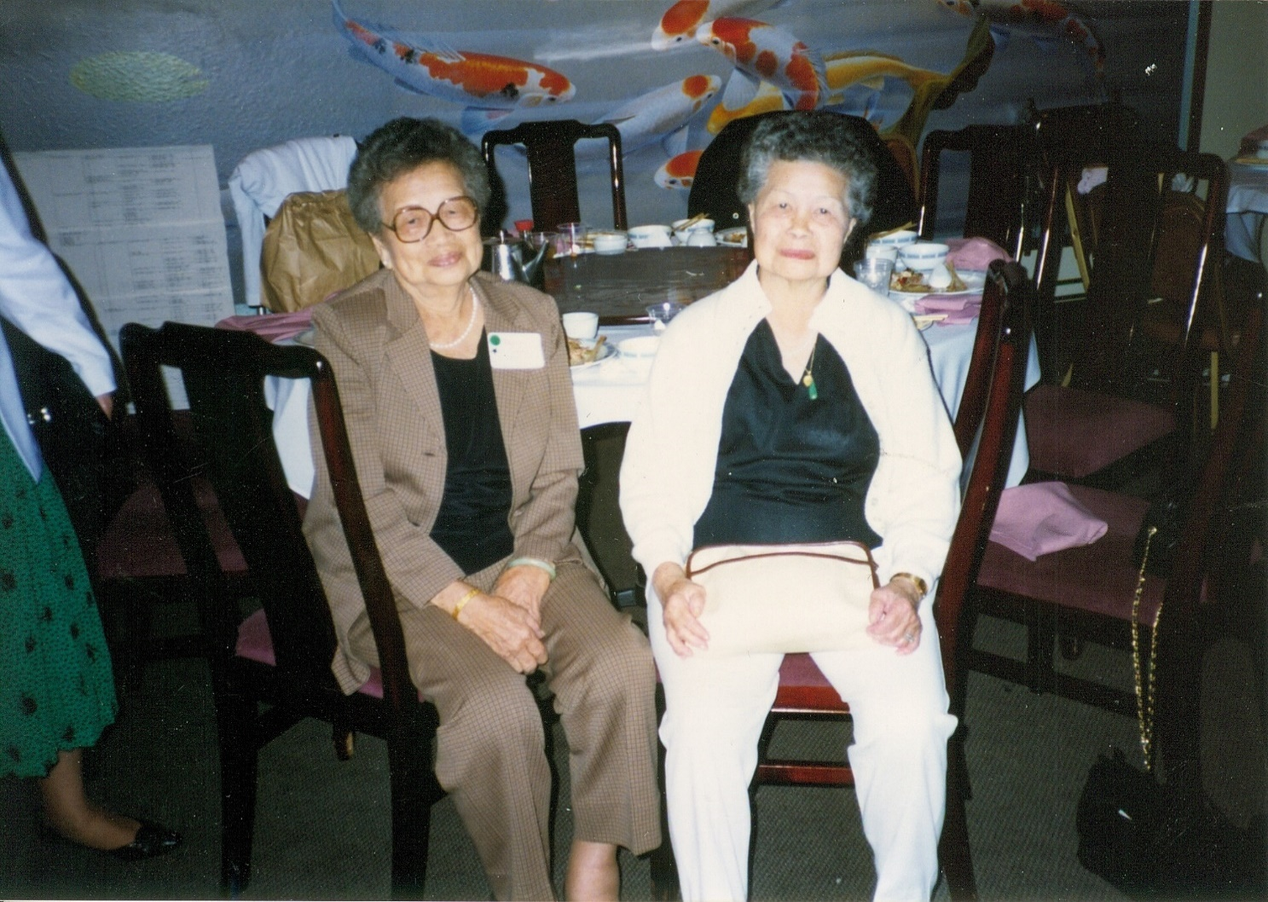Submitted by: Mary Lowe

*This recipe came from Auntie Bessie of Hawaii.*

Crust:

Preheat oven to 375°F

1½ cubes of butter

⅜ c. brown sugar or ½ c. brown sugar

¾ c. nuts (chopped walnuts)

1½ c. flour

Cream butter and sugar. Add in nuts and flour. Lay into 9" x 13" pan and press dough around, making an even layer. Bake in oven for 10 to 15 minutes or until done.

Second Layer:

1 box lemon Jello

1 c. hot water

Dissolve and cool.

8 ounces cream cheese

¾ c. sugar

1 carton whipped cream

Cream sugar and cream cheese. Whip cream. Fold together lemon Jello and cream cheese mixture and whipped cream. Pour into cooled crust layer and refrigerate until cream cheese mixture has set. About 20 minutes.

Third Layer:

3 boxes Jello (lime, orange, strawberry, etc.) plus 4½ c. hot water. Cool but not thicken. Chill and pour on gently into cream cheese mixture. Keep in refrigerator until Jello has set.

## Seven-Layer Finger Jello

Source: Maya Murashima

Submitted by: Diane Wong-Kone

*This was a popular dessert at family get-togethers for a while, before Jello Jigglers were invented.*

4 3-oz. packages Jello (different flavors)

6 envelopes Knox gelatin

1 can Borden's sweet milk

Dissolve 1 package Jello and 1 envelope gelatin with 1 c. hot water for each layer.

Mix together 1 can sweet milk and 1 c. of water. Dissolve 2 envelopes gelatin with 1 c. of hot water. Mix milk mixture and dissolved gelatin together and divide into three equal parts.

In oblong 9" x 13" pan, alternate one layer of flavored Jello and one part milk mixture until seven layers are made. Be sure each layer is set until almost firm before adding the next layer. Cut into bite-sized pieces.

## Emerald Isle Mold

Source: Mrs. Caroline Mow, *Treasured Recipes from Two Cultures - American and Chinese*, St. Mark’s United Methodist Church

Submitted by: Diane Wong-Kone

*My mom made this recipe for many family parties, and it was my favorite dessert when I was a young girl.*

Dissolve one 3-oz. package lime gelatin in 1 c. hot water, and add ¾ c. juice from canned lychee. Add 1 c. soft vanilla ice cream; mix well. Pour into 1½-quart mold. Chill until firm.

For second layer: dissolve one 3-oz. package lime gelatin in 1 c. hot water, and add 1 cup ginger ale, and 1 cup drained cut lychees. Add to first layer. Chill until firm.

## Lime Jello Mold

Source: Karen Miyao

Submitted by: Cheryle Miyao-Quock

*The quintessential holiday dish; I think everyone in our family has this recipe. This tastes best with homemade whipped cream. Make sure you mix this thoroughly or else you’ll have mayonnaise globs floating through it (yes, I learned this from experience).*

32 large marshmallows

2 c. whole milk

Karen’s tip: I always use Best Foods mayonnaise.

2 small pkgs of lime Jello

12 oz. softened cream cheese

2 16-oz. cans crushed pineapple, drained

2 c. whipped cream

1⅓ c. mayonnaise

Chopped walnuts (optional)

Melt marshmallows with milk. Pour mixture over lime Jello. Stir until dissolved. Then stir in cream cheese until incorporated. Add pineapple. Then set aside to cool. Blend in whipped cream after mixture is cool. Add mayonnaise. Add nuts if desired. Pour into mold or 9x13-inch dish. Let set.

## Danger!! Cookies!!

Source: Unknown

Submitted by: Karen Miyao

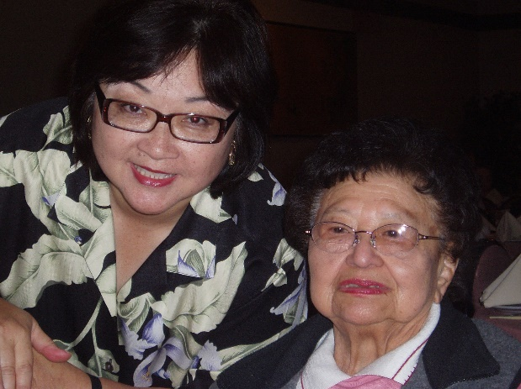*Goo-Paw loved these cookies, which she often called “Ranger cookies.” The original recipe calls for 1 c. shortening + 1 c. butter.*

2. c. butter

1 c. sugar

1 c. brown sugar

1 t. vanilla

2 eggs

1 t. salt

1 t. baking soda

1 t. baking powder

2 c. flour

2 c. Rice Krispies

2 c. oatmeal

2 c. coconut (8 oz. bag)

Cream shortening, butter, sugars, vanilla and eggs. Combine salt, baking soda, baking powder, flour, Rice Krispies, oatmeal, & coconut. Add dry mixture to creamed mixture, and mix thoroughly. Drop by teaspoonful on ungreased pan. Bake 10 minutes at 350°F.

## Rosettes

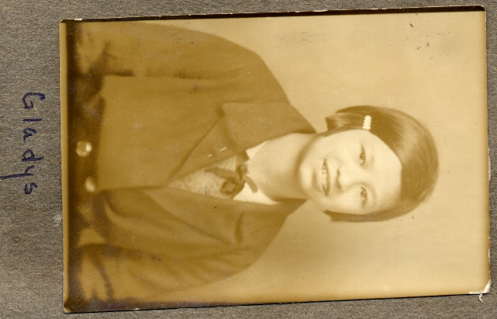Source: Unknown

Submitted by: Gladys Louie

1 box cornstarch

1 c. sugar

1 c. flour

2 eggs

3½ c. water

½ c. canned milk

Mix together. Dip rosette iron into batter and fry in oil.

## Bow Tie

Source: Unknown

Submitted by: Gladys Louie

*I make this for Chinese New Year. Tastes best the same day.*

2x5 “Bow Tie” skins (similar to wonton skins but larger)

Corn syrup

Place 2 on top of each other and cut 3 slits lengthwise, about 1”. Pull one end through the middle to create a twist. Deep fry and drain on paper towels. Dip in corn syrup.

## Russian Tea Cakes

Source: *Betty Crocker Cookbook*

Submitted by: Karen Miyao

*This recipe is from my 7th grade home economics class.*

1 c. butter, softened

½ c. sifted powdered sugar

1 t. vanilla

Sift together and stir in:

2¼ c. sifted flour

¼ t. salt

½ c. finely chopped walnuts

Roll batter into 1-inch balls. Place 2 inches apart on ungreased cookie sheet. Bake at 400°F for 10-12 minutes until set but not brown. While still warm, roll in powdered sugar again.

## Almond Cookies

Source: Daisy Chan

Submitted by: Annette Chan & Yvonne Chan Cheng

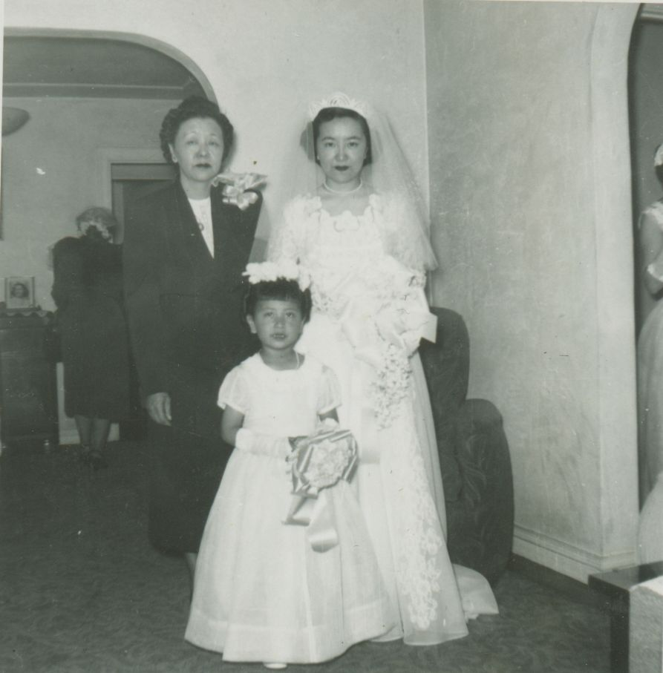

*Note: this recipe has been modified since it was previously published.*

3 c. sifted flour

1 t. soda

½ t. baking powder

½ t. salt

1 c. sugar

1½ c. shortening

1 t. almond extract

1 egg beaten

1 c. blanched almonds

Egg white for glaze

Sift flour, soda, baking powder, and salt together. Cream shortening with sugar; add egg and almond extract. Thoroughly mix. Add dry ingredients, and mix well with hand. Roll into balls.* Flatten slightly. Top with almond; brush the cookie with egg white for a glaze. Place on cookie sheet. Bake at 350°F for 20 minutes.

*Can roll in sesame seeds (instead of topping with almonds).

## Ice Box Cookies

Source: Lydia Lowe

Submitted by: Mary Lowe

4 c. flour

1 T. baking soda

1 T. baking powder

Pinch of salt

2 c. brown sugar

1 c. butter (2 cubes)

1 t. vanilla

Chopped walnuts

2 eggs

Cream butter with half the sugar. Beat eggs and add to butter mixture. Put in 4 cups of flour or more if needed. Add rest of sugar, vanilla, baking soda, baking powder, and chopped nuts. Shape into long tube shape. Wrap in wax paper and put in refrigerator overnight. Cut into ⅛-inch slices, and put on ungreased baking sheet and bake in 425°F oven for 5-7 minutes.

## Macadamia Butter Cookies

Source: Evelyn Wong (Sunset Magazine)

Submitted by: Mary Lowe

*Found this in my mother’s (Lydia Lowe’s) recipe collection.*

1⅓ c. macadamia nuts (6 ounces)

1 c. butter or margarine

1¼ c. sugar

1 large egg

1 t. vanilla

2½ c. flour

1 t. baking soda

Chop 1 c. nuts; set aside. With electric mixer, beat butter and 1 c. sugar until fluffy. Add egg and vanilla and beat until well combined.

In another bowl, stir together flour, baking soda, and chopped nuts. Add to butter mixture. Stir together then beat to blend thoroughly. Shape dough into 2-t. size balls. Place balls 1 inch apart on ungreased cookie sheet. With a flat bottom glass dipped in sugar, press ball to ¼-inch thick. Press a whole or a chunk of macadamia nut into center of cookie. Bake at 350°F until cookie is brown or for about 12 minutes.

## Shortbread Cookies

Source: Karen Miyao (Cook’s Vanilla)

Submitted by: Mary Lowe

*From Karen but with my modifications. I added cranberries and/or chopped pecans or walnuts. Karen strongly recommends using Cook’s vanilla for this recipe.*

3 cubes of butter

1 c. sugar

3 t. Cook’s Vanilla

4 c. flour

Cream butter, sugar and vanilla together. Gradually add flour. Mixture will be coarse like a pie crust.

Put mixture into a 13 x 9-inch pan. Pat mixture evenly in pan. Using a fork, poke holes throughout the cookie mixture so that it will not raise off the pan. Bake in a 350°F oven for 30-35 minutes. After done, let cool for 5 minutes, and then cut into squares.

## Sugar Cookies

Source: *Betty Crocker Cookbook* – Modified by Karen Miyao

Submitted by: Cheryle Miyao-Quock

*Mom makes these every Christmas, and I’ve adopted this tradition as well. This recipe makes a sweet and delicate cookie with a hint of almond flavoring. The almond flavor isn’t overwhelming and gives the cookies a unique flavor; I don’t recommend omitting this ingredient. Mom highly recommends decorating with vanilla butter frosting instead of sprinkling cookies with sugar. (Note: this recipe has been modified since it was last published).*

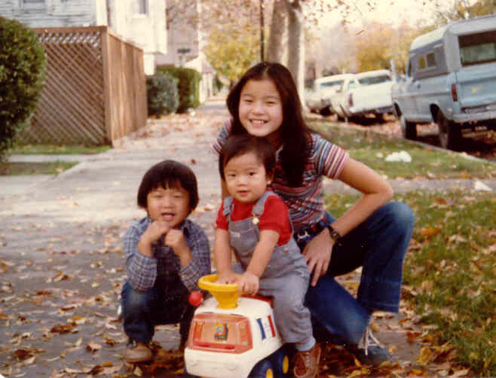

1½ c. powdered sugar

1 c. butter

1 egg

1 t. vanilla

½ t. almond extract

2½ c. all-purpose flour

1 t. baking soda

1 t. cream of tartar

Granulated sugar

Mix powdered sugar, butter, egg, vanilla and almond extract. Mix in flour, baking soda and cream of tartar. Cover and refrigerate at least 2 hours. Heat oven to 375˚F. Divide dough into halves. Roll each half 3/16 ” thick on lightly floured cloth-covered board. Cut into shapes.

Sprinkle with granulated sugar; place on lightly greased sheet. Bake until edges are light brown, 7 to 8 minutes. Makes about 5 dozen 2-inch cookies.

Vanilla Butter Frosting

3 c. powdered sugar

⅓ c. butter, softened

1½ t. vanilla

About 2 T. milk

Mix powdered sugar and butter. Stir in vanilla and milk; beat until frosting is smooth and of spreading consistency. Add food coloring and frost cooled sugar cookies. Also fills and frosts two 8-or 9-inch layers or frosts a 13” x 9” cake.

## No-Sugar Sugar Cookies

Source: Unknown

Submitted by: Mary Lowe

*Found it on the internet while looking for sugar free desserts.*

¾ c. unsalted butter

¼ c. light butter

1 c. SPLENDA

1 T. vanilla extract

¼ c. egg substitute

¼ c. water

¾ t. vinegar (white or cider)

1½ c. all purpose flour

1½ c. cake flour

¼ t. salt

1 t. baking powder

Preheat oven to 350°F. Lightly oil a cookie sheet and set aside. Blend together butter, SPLENDA granular and vanilla in a medium sized mixing bowl. Blend until butter is softened. Add egg substitute, water, and vinegar. Mix briefly. Add flours, salt and baking powder. Mix using low speed (or by hand) until dough is formed. Do not over mix.

Remove dough from bowl and place on a floured work surface. Divide dough in half. Pat each half into a circle. Cover with plastic wrap and refrigerate approximately 1 hour, allowing dough to chill

Remove dough from refrigerator and roll out on a floured work surface to desired thickness (approximately ¼ inch). Cut with cookie cutters. Place cookies on a lightly oiled cookie sheet.

Bake in a preheated 350°F oven 10-12 minutes or until lightly browned on the back. Cool on a wire rack. Makes approximately 4 dozen cookies.

## Snickerdoodles

Source: Lydia Lowe

Submitted by: Mary Lowe

1 c. shortening

1½ c. sugar

2 eggs

2¾ c. flour

2 T. cream of tartar

1 T. baking soda

½ T. salt

Cream shortening, sugar and eggs. Mix in remaining ingredients. Chill dough and form into small balls. Roll in mixture of 2 tablespoons sugar and 2 teaspoons cinnamon. Put on greased cookie sheet at 350°F for 12-15 minutes. Makes 8 to 10 dozen.

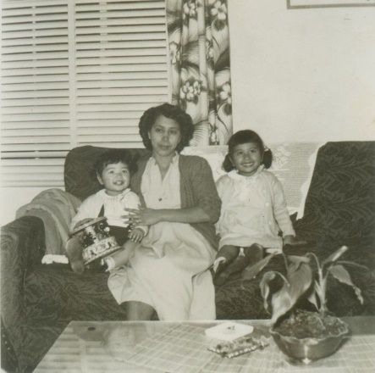Baby Ruth Cookies

Source: Evelyn Wong

Submitted by: Diane Wong-Kone

*My mom sent these cookies to my Dad when he was stationed in Germany for the Korean Conflict. They were his favorite cookies. The original recipe was printed on the back of Baby Ruth Bars, which were larger then. (Only 1 bar was used in the original recipe).*

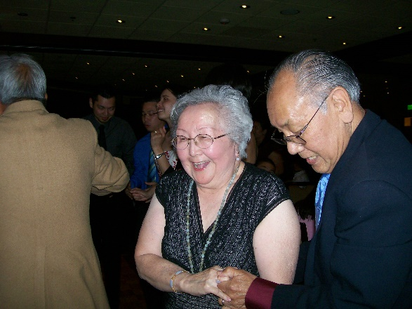

2¼ c. unsifted flour

½ t. baking soda

½ t. salt

½ c. (1 stick) margarine

¼ c. sugar

1 egg, slightly beaten

1 t. vanilla

2 Baby Ruth candy bars, chopped (4.2 oz. total)

1. Preheat oven to 350°F. Generously grease cookie sheet or sheets; set aside. Mix flour, baking soda, and salt in a bowl; set aside.

2. In medium mixing bowl, cream margarine and sugar until light and fluffy. Beat in egg and vanilla. Stir in flour mixture and chopped candy until just mixed. Do not overmix. Chill at least 30 minutes.

3. Drop dough by rounded teaspoon onto cookie sheets. Bake for 10 to 12 minutes, or until golden brown. Remove quickly from cookie sheets and cool on wire racks.

## Oatmeal-Chocolate Chip Cookies

Source: a variation of the Vanishing Oatmeal Raisin Cookies on the lid of the Quaker Oats canister

Submitted by: Yvonne Chan Cheng

1 stick of butter

½ cup firmly packed brown sugar

¼ cup granulated sugar

Diane’s tip: Try adding 1-2 teaspoons of instant coffee to your favorite chocolate chip cookie recipe.

1 egg

1 teaspoon vanilla

¾ cups all-purpose flour

½ teaspoon baking soda

1 teaspoon ground cinnamon

1½ cups Old-Fashioned Quaker Oats

½ cup Guittard extra dark chocolate chips

Heat oven to 350 degrees. In a large bowl, beat butter and sugars until creamy. Add eggs and vanilla; beat well. Add combined flour, baking soda, and cinnamon; mix well. Add oats and chocolate chips; blend well. Drop dough by rounded tablespoonfuls onto an ungreased cookie sheet. Bake for thirteen minutes.

## Cinnamon Refrigerator Cookies

Source: Daisy Chan

Submitted by: Annette Chan & Yvonne Chan Cheng

3½ c. sifted all-purpose flour

1 t. baking soda

¼ t. salt

1 c. shortening or margarine

1 c. brown sugar

1 c. white sugar

2 eggs

1 c. chopped nuts

1 T. cinnamon

Sift the flour, soda, cinnamon, and salt together. Cream the shortening or margarine until light and soft, gradually adding both the brown and white sugar. Beat the eggs until light and stir them into the creamed mixture. Stir in the sifted dry ingredients, about a cupful at a time, and then add the nuts.

Work the dough into long rolls with diameters about the size of silver dollars, and wrap in wax paper. Leave overnight in refrigerator. Slice and bake on a well-greased baking sheet at 350°F for 7-10 minutes.

## Jamborees

Source: Daisy Chan

Submitted by: Annette Chan & Yvonne Chan Cheng

*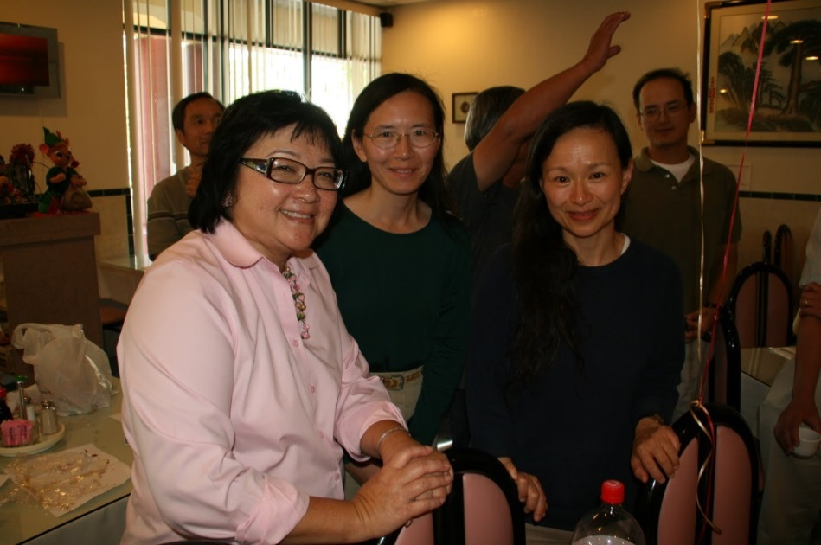This recipe might be from Aunt Evelyn or Cousin Karen.*

½ c. (1 stick) plus 2 T. butter

Add gradually:

½ c. sugar

Beat in:

1 egg

1 t. vanilla

Sift together and add gradually to butter mixture:

1½ c. flour

¼ t. salt

Put into cookie press. Make the cookies with the cookie press. Bake at 375°F on an ungreased cold cookie sheet for 10 to 12 minutes.

## Nut Tree Cookies

Source: Nut Tree

Submitted by: Cheryle Miyao-Quock

*On our way to the Bay Area, we would often stop at Nut Tree in Vacaville to ride the kiddie train and pick up one of these signature cookies.*

⅔ c. dark honey

1 c. sugar

⅓ c. shortening

1 egg

⅓ c. water

4 c. flour

1 t. baking soda

½ t. salt

1 t. cinnamon

1 t. cloves, ground

Icing

3 egg whites, room temperature

1 lb. powdered sugar

½ t. cream of tartar

Food coloring, optional

Preheat oven to 325°F. Bring to a boil sugar, honey, and shortening. Cook for 5 minutes, stirring occasionally. Allow to cool. Beat egg and add to water. Mix and sift the flour, soda, salt & spices.

Add the sifted dry ingredients alternately with liquid ingredients to the honey mixture. If the dough is allowed to ripen for several days before rolling out, the flavor and texture are somewhat improved. Roll out the dough about ¼” thick and cut. Bake at 325°F until edges are golden brown. 12-15 min.

Icing

Place all icing ingredients in mixing bowl and mix with electric beater for about 10 minutes. After mixing, be sure to keep bowl covered with a damp cloth at all times. Icing dries quickly and hard. If you wish, add food coloring to make colored lines.

## Pecan Pie Bars

Source: Lydia Lowe

Submitted by: Mary Lowe

Prep: 15 min Cook: 52 min

1¾ c. all-purpose flour  
⅓ c. firmly packed brown sugar  
¾ c. butter or margarine  
1 c. firmly packed brown sugar  
4 large eggs  
1 c. dark corn syrup  
¼ c. butter or margarine, melted  
1 t. vanilla extract  
⅛ t. salt  
1¼ c. chopped pecans

Combine flour and ⅓ c. brown sugar; cut in ¾ c. butter with a pastry blender until crumbly. Press mixture evenly into a greased 13 x 9-inch pan. Bake at 350ºF for 15 to 17 minutes.

Combine 1 c. brown sugar and next 5 ingredients, stirring well. Stir in pecans. Pour filling over prepared crust. Bake at 350º for 35 minutes or until set. Cool in pan on a wire rack. Cut into bars. Yield: 2½ dozen.

## Chewy Noels

Source: Penelope L. Wilson, *Better Homes and Gardens*, 1970

Submitted by: Diane Wong-Kone

*This easy and quick recipe is a family favorite during the Christmas holiday.*

2 T. butter or margarine

⅓ c. sifted all-purpose flour

⅛ t. baking soda

⅛ t. salt

1 c. brown sugar

1 c. chopped nuts

2 beaten eggs

1 t. vanilla

Confectioner’s sugar

In 9 x 9 x 2-inch pan, melt butter or margarine. Sift together flour, soda, and salt; stir in brown sugar and nuts. Stir in eggs and vanilla. Carefully pour batter over butter in pan. Do not stir. Bake in 350°F oven for 20-25 min. Sprinkle with confectioner’s sugar if desired. Cut into bars. Makes 2 dozen.

## Amber Apple Cake

Source: Barbara Trygg

Submitted by: Karen Miyao

1 pkg rolls (canned biscuits)

2 apples, sliced

½ c. packed brown sugar

½ c. evaporated milk, light cream or whole milk

½ c. dark corn syrup (or e maple syrup)

½ c. butter or margarine, melted

Grease 8” x 8” pan and layer bottom of pan with apples, then biscuits. Sprinkle brown sugar on top of biscuits. Then pour milk, corn syrup (or maple syrup) and melted butter over biscuits. Bake at 375°F for 20-30 minutes. You can also use canned fruit (about 1 lb. drained) but fresh fruit is preferred.

Fresh Apple-Nut Cake

Source: Evelyn Wong

Submitted by: Annette Chan & Yvonne Chan Cheng

*This recipe is almost identical to a recipe written by Martha Lee and originally appeared in the food section of the local newspaper in the 1970’s. Today, the article is torn and yellowed with age, but this recipe still remains a family favorite. This is Art Wong’s favorite cake recipe.*

3 c. sifted flour

1 t. baking powder

1 t. baking soda

1½ t. salt

1 t. cinnamon

¾ c. vegetable oil

4 c. peeled and chopped apples (about 5-6 medium)

1 t. vanilla

2 eggs

1½ c. sugar

1 c. chopped nuts

Raisins (optional)

Measure flour; add baking powder, soda, salt, and cinnamon; and sift together in a large bowl. Add oil, apples, and vanilla. Beat by hand or mixer until well blended.

Beat eggs, add sugar gradually, and continue beating until light and fluffy. Fold egg mixture into apple mixture, blending thoroughly. Stir in nuts and raisins. Pour into lightly greased tube pan. Bake at 350°F for 1 hour and 10 minutes.

## Karen’s Triple Chocolate Decadent Ecstasies

2nd Place Winner of The Sacramento Bee Brownie Contest

Source: Karen Miyao

Submitted by: Cheryle Miyao-Quock

*Mom entered this recipe in the Sacramento Bee’s brownie contest and won 2nd place. We think she should have won 1st place, but at least she got her 15 minutes of fame and a nice head shot in the newspaper.*

5 oz. unsweetened chocolate

¾ c. + 1 T. butter

1 T. vanilla

4 eggs, room temperature (remove from refrigerator at least 30 minutes before using)

1⅔ c. sugar

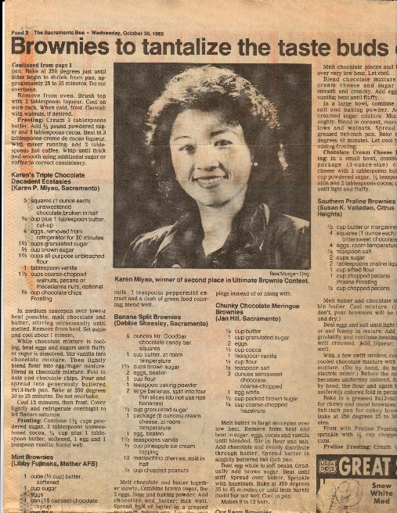⅔ c. brown sugar, packed

1⅔ c. unbleached flour

1⅓ c. chopped walnuts or pecans

⅔ c. chocolate chips

Generously butter 13 x 9-inch pan. Preheat oven to 350°F. Melt chocolate and butter over very low heat. Cool for about 1 minute, and then add vanilla.

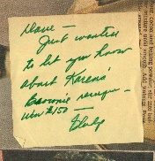Beat eggs with sugars for about 4 minutes, making sure it is well-blended. Carefully blend in flour. Then blend in melted chocolate mixture. Fold in nuts and chocolate chips. Bake for 30 minutes or until edges pull away from pan. Cool and frost.

**Frosting**

1½ c. powdered sugar

*The Chans have the newspaper clipping in their recipe collection.*

2 heaping T. unsweetened chocolate powder

¼ c. + 1 T. butter

1 egg

1 t. vanilla

Mix all ingredients well. Frost brownies and refrigerate at least 30 minutes before cutting. (For health and safety reasons, Mom suggests using water or milk instead of egg. Add enough liquid until the consistency is thick but spreadable).

## Chocolate Chiffon Cake

Source: Lydia Lowe

Submitted by: Mary Lowe

¾ c. boiling water

½ c. unsweetened cocoa (not Dutch process type)

1¾ c. flour, sifted before measuring

1¾ c. sugar

1 T. baking powder

½ T. salt

7 eggs, separated and at room temperature

½ c. oil

2 T. vanilla

½ T. cream of tartar

Position a rack in the lower third of an oven (not on the bottom) and preheat the oven to 325°F.

Combine the boiling water and cocoa in a small bowl and stir to dissolve; set aside. Sift together the sifted flour, sugar, baking powder and salt into a mixing bowl. Add the cocoa mixture, egg yolks, oil and vanilla. Using a whisk or an electric mixer set on low, beat until thoroughly combined.

In a clean bowl, using clean beaters, beat together the egg whites and cream of tartar until stiff and glossy but not dry. Using a rubber spatula, gently mix one-fourth of the whites into the chocolate mixture to lighten it, and then fold in the remaining whites taking care not to deflate the batter. Pour and scrape the batter into an ungreased 10-inch tube pan and smooth the top.

Bake for 55 minutes. Raise the oven temperature to 350°F and continue baking until a toothpick comes out clean and dry, 10-15 minutes longer. Remove the cake from the oven and invert the pan (use a narrow-neck bottle to rest the tube section if the cake pan does not have supports). Let cool completely before removing, about 2 hours. Top with fruit.

Serves 8. Makes one 10-inch cake.

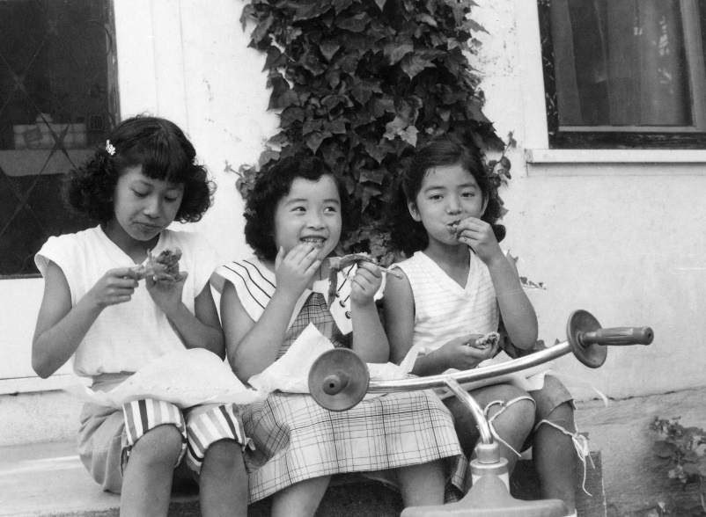

## Red Cake

Source: Karen Miyao

Submitted by: Cheryle Miyao-Quock

*This is known as Red Velvet Cake, a traditional Southern cake. When I was a kid, Mom would bake this cake in a heart shaped pan for my birthday and for Valentine’s Day. This tastes even better with cream cheese frosting.*

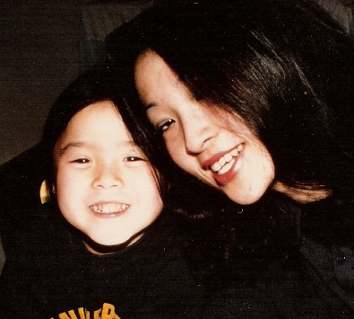

Cake:

½ c. Crisco

1½ c. sugar

2 eggs

2 oz. red food coloring

3 T. Nestle Quick (chocolate)

2 c. buttermilk

2¼ c. cake flour

1 t. salt

1 t. vanilla

1 T. vinegar

1 t. baking soda.

Cream Crisco with sugar. Add eggs, red food coloring, and Nestle Quick. Then add buttermilk, flour, salt and vanilla. Mix well. Mix vinegar and baking soda in a separate bowl. Add to cake mixture. Grease two 9” pans and fill with cake batter. Bake 30-35 minutes at 350°F.

Frosting

1 cube butter

8 T. Crisco

1 c. sugar

3 T. flour

½ c. warm milk

1 t. vanilla

Mix together ingredients and beat with mixer. Beat until it is the consistency of whipped cream (this takes a LONG time). Will stay this way for days.

Cream Cheese Frosting (alternative to the above frosting)

1 pkg (8 oz.) cream cheese, softened  
¼ c. (½ stick) butter, softened  
1 t. vanilla  
1 pkg (16 oz.) powdered sugar (about 4 c.), sifted

Beat cream cheese, butter and vanilla in large bowl with electric mixer on medium speed until well blended. Add sugar gradually, beating until well blended after each addition.

## Nut Tree Chocolate Fudge Cake

Source: Nut Tree

Submitted by: Mary Lowe

¾ c. butter

½ c. cocoa

1½ c. sugar

1 t. vanilla

3 eggs, separated

2 ½ c. sifted cake flour

3 t. baking powder

1 c. cold water

Beat: Egg whites until stiff, set aside.

Cream: Butter

Add: Cocoa and sugar; beat until light and fluffy,

Add: Vanilla. Beat egg yolks into mixture one at a time.

Sift: Together dry ingredients.

Add: Alternating with water – beating smooth after each addition.

Fold in egg whites.

Bake: Line two 9-inch cake pans with waxed paper. Grease and flour. Add the batter. Bake at 300°F for 40-45 minutes.

Chocolate Frosting

3 egg whites

1½ c. powdered sugar

¾ c. butter

⅓ c. cocoa

½ t. vanilla

Beat: In a small bowl, egg whites to soft peak. Gradually add ¾ c. sugar beating until stiff. Set aside.

In a large bowl, beat butter until creamy.

Mix: Remaining ¾ c. sugar with cocoa. Gradually beat into butter mixture.

Fold: In vanilla and egg whites until blended.

Fill and frost cooled cake.

## Fruit Basket Cake

Source: Karen Miyao

Submitted by: Cheryle Miyao-Quock

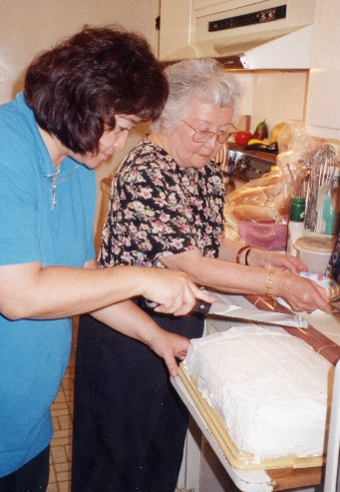*Mom often made this cake for special occasions and birthdays. We recommend making the whipped cream from scratch.*

Cake

3 eggs

1 c. granulated sugar

⅓ c. water

1 t. vanilla

1 c. cake flour

1 t. baking powder

¼ t. salt

Confectioners’ (powdered) sugar

Heat oven to 375°F. Line jelly roll pan, 15 ½ x 10 ½ x 1 inch, with aluminum foil; grease. In small mixer bowl, beat eggs about 5 minutes or until very thick and lemon colored. Pour eggs into large mixer bowl; gradually beat in granulated sugar. On low speed, blend in water and vanilla. Gradually add flour, baking powder, and salt, beating just until batter is smooth. Pour into pan, spreading batter to corners.

Bake 12 to 15 minutes or until wooden pick inserted in center comes out clean. Loosen cake from edges of pan; invert on towel sprinkled with confectioners’ sugar. Carefully remove foil; trim off stiff edges if necessary. Cut into three even layers.

Whipped Cream

1 qt. heavy whipping cream

Powdered sugar, to taste

1 t. vanilla

Pour cream into mixing bowl and beat with mixer on medium speed for a minute. Add powdered sugar and vanilla to taste. Beat until soft peaks form.

Note: Before beating whipped cream, mom recommends chilling the mixing bowl, beaters, and heavy whipping cream in freezer for at least 20 minutes.

Fillings

Karen’s tip: When making whipped cream, chill the mixing bowl, beaters, & heavy cream in freezer 10-20 minutes before beating.

1st layer filling - bananas & strawberries:

1-2 bananas, sliced

1-2 c. strawberries, sliced

1 c. whipped cream

Spread half of whipped cream on cake. Sprinkle sliced bananas and strawberries evenly over layer. Spread remaining whipped cream over fruit. Top with 2nd layer of cake. Then add pineapple filling (below).

2nd layer filling - pineapple:

1 can (20 oz.) can undrained crushed pineapple

1 can (3 oz.) pkg instant vanilla pudding

2 c. whipped cream

Mix pineapple and vanilla pudding together. Let stand for 5 minutes. Fold into whipped cream. Spread on cake layer. Place 3rd layer on top of pineapple filling. Spread remaining whipped cream over entire cake. Decorate. Serve immediately or refrigerate and serve within a few hours.

## Butter Sponge Cake

Source: Bessie Chun

Submitted by: Diane Wong-Kone

*Note: This recipe has been modified since it was last published.*

6 eggs (well beaten)

3 c. sugar

1¼ c. fresh milk (heated to boiling point)

¼ pound butter, melted

3 c. flour

1 t. salt

3 t. baking powder

1½ t. vanilla extract

1 t. lemon extract

Beat eggs well until a light lemon color. Add sugar gradually. Sift flour, baking powder and salt together, and add to egg mixture. Pour in hot milk and melted butter, which was heated to the boiling point. Add lastly vanilla and lemon extracts. Fill two 9” round cake pans. Bake 30 minutes at 350°F.

## King’s Pineapple Fluff Cake

Source: King Family

Submitted by: Diane Wong-Kone

*This is the Kings’ family recipe for my mom and dad’s wedding (4/20/52) cake. The Kings owned the hop ranch where Uncle Bob and Aunt Lydia worked and lived. Today, the hop ranch land belongs to Rancho Cordova in Sacramento, CA*.

1st part:

6 egg whites

¼ t. salt

¾ c. sugar

Beat up egg whites with salt until stiff and stand in peaks. Gradually add ¾ c. sugar and beat well.

2nd part:

6 egg yolks

¾ c. sugar

1 T. lemon juice

¼-½ c. unsweetened pineapple juice

1½ c. flour

1 T. baking powder

Beat egg yolks until thick. Add ¾ c. sugar and beat thin. Add lemon juice and pineapple juice and beat well until sugar is dissolved. Add flour with baking powder and beat well.

Fold in egg white mixture (use wire beater) until mixed well. Bake in ungreased angel cake pan 325°F for 1 hour. Invert cake and cool.

Frosting:

½ pint pastry cream whipped until stiff. Add enough powdered sugar (about ¾ c.) and mix well with spoon. Then add about ¾ c. crushed pineapple, well drained.

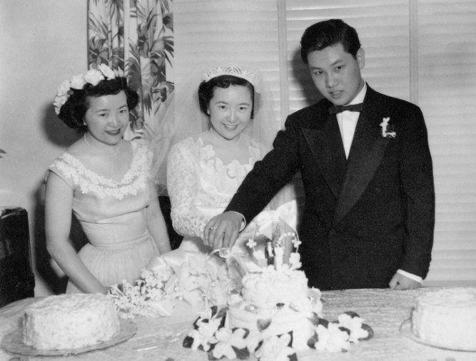

## Sour Cream Pound Cake

Source: Bessie Chun

Submitted by: Annette Chan & Yvonne Chan Cheng

*Yvonne overcooked this cake by an hour, and it was still edible!*

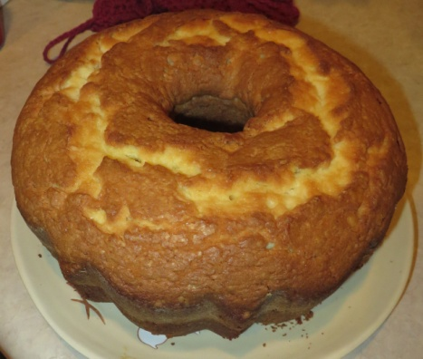

2¾ c. sugar

1 c. butter or margarine

6 eggs

¼ t. soda

½ t. salt

3 c. cake flour

1 c. sour cream

½ t. lemon extract

½ t. orange extract

½ t. vanilla

Cream together sugar and butter till light and fluffy. Add eggs one at a time, beating well after each addition. Sift together flour, salt and soda. Add to creamed mixture alternately with sour cream, beating well after each addition. Add extracts and vanilla, and beat well. Pour batter into greased and floured tube pan or bundt pan. Bake at 350°F for 1½ hours or till cake tests done (check after 1 hour). Cool 15 minutes. Remove from pan.

## Coffee Ice Cream Pie

Source: Sacramento Casa de Los Niños

Submitted by: Cheryle Miyao-Quock

*This is from my mom’s recipe collection.*

Crust:

1 ½ c. Oreo cookies, crushed

1 cube butter, softened

Mix together cookies and butter.Press firmly above mixture into bottom and sides of 10 inch springform pan.

Filling:

1 c. Hershey Chocolate Syrup

½ gallon coffee twirl ice cream, softened

1 c. walnuts or any nuts, coarsely chopped

4 Heath Bars (chocolate covered toffee bars), coarsely chopped

Pour on cookie crust ½ c. Hershey Chocolate Syrup then add 1 quart softened coffee twirl ice cream on top of cookie crust. Sprinkle on top of ice cream walnuts or any nuts of your choice – coarsely chopped and freeze until set.

When set, add ½ cup Hershey’s Chocolate Syrup and 1 quart softened coffee twirl ice cream as before, top with 4 Heath Bars, coarsely crushed. Freeze until set. Serves 12-14.

## Eggnog Pie

Source: Unknown

Submitted by: Mary Lowe

*I found this while surfing the Internet. I made it, and everyone loved it.*

Ingredients:

1 4¾ oz. package of vanilla pudding and pie filling

2 c. dairy eggnog

1¼ c. milk

1 T. light rum

⅛ t. nutmeg

1 9-inch pie crust, baked

Whipped cream

Nutmeg

Preparation:

Cook mix as directed on package for pie filling, except using 2 c. of eggnog and 1¼ c. milk. Stir in rum and nutmeg; pour into crust. Cover surface with plastic wrap; chill several hours. Top with whipped cream and sprinkle with nutmeg. Makes 8 servings.

## Easy Fruit Cobbler

Source: Karen Miyao

Submitted by: Karen Miyao

**Fruit filling**

6 cups fruit

¾ c sugar

⅓ c flour

**Crumble**

1 c. flour

½ c. sugar

1 teaspoon baking powder

½ teaspoon salt

1 beaten egg

½ c. (one cube) melted butter

Heat oven to 350°F.

Mix first three ingredients together to thicken. Pour in 9”x9” pan. Mix flour, sugar, baking powder, and salt. Add beaten egg and mix to crumble. You may add more flour if dough is sticky. Spread over the fruit; drizzle melted butter over top. Bake 30-40 minutes.

## Sprinkles Strawberry Cupcakes

Source: Oprah.com 6/15/2009

Submitted by: Diane Wong-Kone

⅔ cup fresh or frozen whole strawberries (thawed if frozen)

1½ cups all-purpose flour, sifted

1 tsp. baking powder

¼ tsp. coarse salt

¼ cup whole milk, room temperature

1 tsp. pure vanilla extract

½ cup (1 stick) unsalted butter, room temperature

1 cup sugar

1 large egg, room temperature

2 large egg whites, room temperature

Preheat oven to 350°. Line a 12-cup muffin tin with cupcake liners; set aside.

Place strawberries in a small food processor; puree. You should have about ⅓ cup of puree.

Add a few more strawberries if necessary, or save any extra puree for frosting; set aside.

In a medium bowl, whisk together flour, baking powder and salt; set aside. In a small bowl, mix together milk, vanilla and strawberry puree; set aside.

In the bowl of an electric mixer fitted with the paddle attachment, cream butter on medium-high speed, until light and fluffy. Gradually add sugar and continue to beat until well combined and fluffy. Reduce the mixer speed to medium and slowly add egg and egg whites until just blended.

With the mixer on low, slowly add half the flour mixture; mix until just blended. Add the milk mixture; mix until just blended. Slowly add remaining flour mixture, scraping down sides of the bowl with a spatula, as necessary, until just blended.

Divide batter evenly among prepared muffin cups. Transfer muffin tin to oven and bake until tops are just dry to the touch, 22 to 25 minutes. Transfer muffin tin to a wire rack and let cupcakes cool completely in tin before icing.

**Sprinkles Strawberry Frosting**

½ cup frozen whole strawberries, thawed

1 cup (2 sticks) unsalted butter, firm and slightly cold

Pinch coarse salt

3 ½ cups confectioners’ sugar, sifted

½ tsp. pure vanilla extract

Place strawberries in the bowl of a small food processor; process until pureed. In the bowl of an electric mixer fitted with the paddle attachment, beat together butter and salt on medium speed until light and fluffy. Reduce mixer speed and slowly add confectioners’ sugar; beat until well combined. Add vanilla and 3 tablespoons strawberry puree (save any remaining strawberry puree for another use); mix until just blended. Do not over mix, or frosting will incorporate too much air. Frosting consistency should be dense and creamy, like ice cream. Servings: Makes 1 dozen.

## Lemon Meringue Pie

Source: Annette Chan

Submitted by: Annette Chan

Pie Shell:

1 c. plus 2 T. flour

¼ t. salt

⅓ c. shortening

Cold water

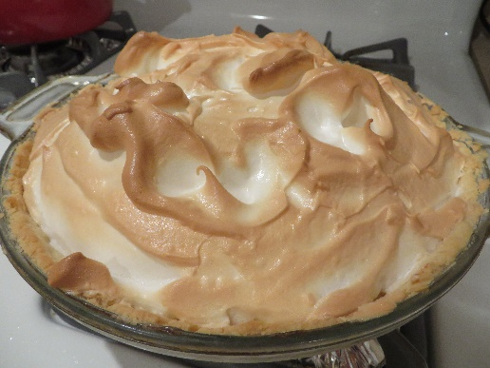Preheat the oven to 425°F. Mix the flour and salt together. Cut in the shortening with a pastry blender until the mixture looks like tiny peas. Sprinkle water over the flour mixture, one T. at a time, and mix lightly with a fork, using just enough water so that the dough holds together when pressed gently into a ball. Line an 8-inch pie pan with the pastry dough, prick the dough all over with a fork, and bake for about 16-18 minutes, until lightly browned. Let the pie shell cool before filling it with the lemon filling.

Lemon Filling:

1½ c. sugar

5 T. cornstarch

¼ t. salt

1½ c. cold water

½ c. lemon juice (use sour lemons, not Meyer lemons)

2 T. butter

5 eggs yolks, beaten

1-3 t. grated lemon peel

Mix the sugar, cornstarch, and salt in a saucepan. Gradually stir in the water and lemon juice. Add butter. Cook over medium heat, stirring constantly, until the mixture thickens and boils. Boil, stirring constantly, for 10 minutes. Remove from the heat. Stir ½ cup of the hot mixture into the egg yolks, and then stir the yolks into the remaining hot mixture. Cook, stirring constantly, for another 3 minutes. Remove from the heat and stir in the lemon rind. Spoon hot filling into the pie crust.

Meringue:

3 egg whites, at room temperature

⅓ c. sugar

¼ t. cream of tartar

Preheat the oven to 350°F. In a small mixer bowl, beat egg whites and cream of tartar at high speed until foamy. Gradually beat in remaining ⅓ cup sugar until stiff peaks form. Spread meringue evenly over cool filling, sealing to crust. Bake for 15-20 minutes or until golden brown. Cool. Refrigerate uneaten portions.

## Black Bottom Cupcakes

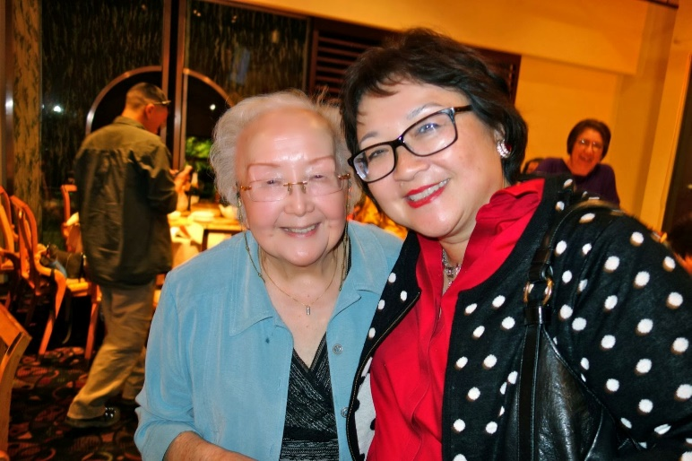Source: Unknown

Submitted by: Karen Miyao

Cream cheese topping:

8 oz. room temperature cream cheese

1 egg

⅓ c. sugar

⅛ t. salt

1 c. chocolate chips

Combine cream cheese, egg, sugar, and salt. Beat well. Add 1 c. chocolate chips.

Chocolate Batter (black bottom):

1½ c. flour

¼ c. unsweetened cocoa

½ t. salt

1 c. sugar

1 t. baking soda

1 c. water

1 T. vinegar

⅓ c. oil

1 t. vanilla

Sift all dry ingredients together. Add water, vinegar, oil, vanilla and mix well. Line cupcake pan with cupcake liners. Fill cups with ⅓ c. of chocolate batter and add 1 heaping teaspoons of cream cheese/chocolate chip mixture. Bake 350°F for 35 minutes. Let sit ½ hour before serving.

Makes 12.

## Southern Sweet Potato Pie

Source: Unknown

Submitted by: Karen Miyao

*I got this recipe from a co-worker. This is one of several pies I make every year for Thanksgiving and Christmas. (Editors’ note: this is better than pumpkin pie!)*

Unbaked pie crust (recipe below)

Filling for 9” pie:

1¾ c. cooked & mashed sweet potatoes

1 t. salt

1½ c. milk

3 eggs

1 c. sugar

1 t. cinnamon

½ t. nutmeg

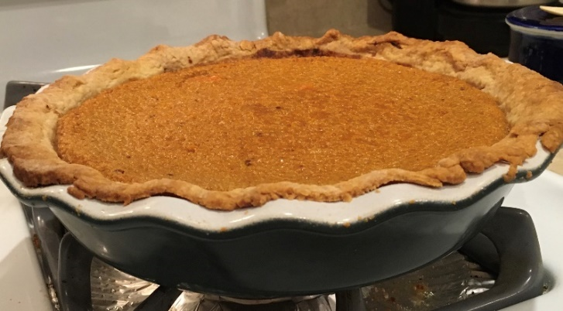½ t. ginger

1 T. butter, melted

1 t. vanilla

Pinch of baking powder

Filling for 8” pie:

1¼ c. + 2 T. cooked & mashed sweet potatoes

¾ t. salt

1 c. + 2 T. milk

2 eggs

¾ c. sugar

¾ t. cinnamon

Diane’s tip: To smooth out filling mixture, use an immersion or regular blender.

¼ t. nutmeg

¼ t. ginger

2 t. butter, melted

1 t. vanilla

Pinch of baking powder

Prepare pie crust (recipe follows). Do not bake yet; set aside. Combine all filling ingredients. Pour into pie crust and bake at 375°F for 50 to 55 minutes or until filling rises and starts to brown (will have slight cracks). Serve with fresh whipped cream.

Pie crust

Source: *Betty Crocker Cookbook*

8-inch pie crust 9-inch pie crust

⅓ c. plus 1 T. shortening ¼ c. shortening, ¼ c. butter

1 c. all-purpose flour 1½ c. flour

½ t. salt ½ t. salt

2 to 3 T. cold water 4-5 T. ice cold water

Cut shortening into flour and salt until particles are size of small peas. Sprinkle in water, 1 tablespoon at a time, tossing with fork until all flour is moistened and pastry almost cleans side of bowl (1 to 2 teaspoons water can be added if necessary).

Gather pastry into a ball; shape into flattened round on lightly floured cloth-covered board. Roll pastry 2 inches larger than inverted pie plate with floured stocking-covered rolling pin. Fold pastry into quarters; unfold and ease into plate, pressing firmly against bottom and side.

Trim overhanging edge of pastry 1 inch from rim of plate. Fold and roll pastry under, even with plate; flute. Fill and bake as directed in recipe.

## Mascarpone and Fruit Trifle

Source: *Sacramento Bee*

Submitted by: Mary Lowe

*This is from a class I went to that Sacramento Bee had at the Food Co-op. Karen asked that I submit this recipe.*

Prep: 30 minutes

Chill time: 1 hour

Servings: 12

This easy dessert makes a big impression. Vary the fruit according to what you have on hand. The recipe can also be made in individual parfait glasses. Note: Look for mascarpone where your market sells exotic cheeses.

24 ounces mascarpone

3 T. sweet Marsala wine

2 c. heavy cream, chilled, divided use

¾ c. powdered sugar, divided use

10 package of crisp cookies such as biscotti, Newman’s Own Orange Chocolate Chip or Famous Chocolate wafers, coarsely chopped.

2-4 c. assorted fruit, such as peaches, strawberries, plums or kiwi, diced

½ c. blueberries

Use a mixer to blend the mascarpone, Marsala, ¾ c. heavy cream and ½ c. powdered sugar. Beat until smooth.

In a trifle bowl, layer chopped cookies, fruit and Mascarpone mixture twice to create 6 layers. Cover with plastic wrap and refrigerate 1 hour or up to 3 hours. Whip the remaining cream; add remaining ¼ c. of powdered sugar. Just before serving, top the trifle with the whipped cream and sprinkle with blueberries.

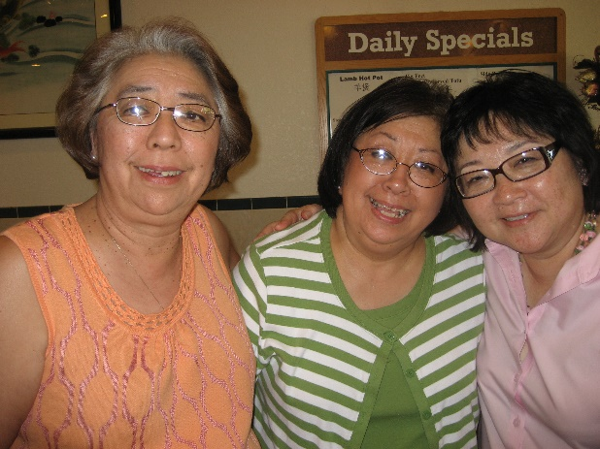

## Malasadas

Source: Bessie Chun

Submitted by: Mary Lowe

*The first time I had these was in Hawaii in 1972. This was my first trip to Honolulu to visit Auntie Bessie and Brenda. They took me to many sites and restaurants. I especially remember going to a bakery near her home. There was a line of cars and people waiting in line to purchase these Malasadas fresh and warm. When I visited Hawaii in 1991, I took my girlfriend to the bakery (yes, it was still there). She wanted to know what was so special about these. I told her to wait until she tried them. So I bought some, and we ate them all. They were exactly the way I remembered them. Before we returned to Sacramento, we went back to that bakery three times. This is the recipe that the bakery uses. I like it with sugar instead of the syrup.*

2 pkgs dry yeast

½ c. sugar

1 t. sugar

½ c. margarine (1 stick melted)

¼ c. warm water

1 c. evaporated milk

6 eggs

1 c. warm water

6 c. flour

½ tsp. salt

Dissolve yeast and 1 teaspoon sugar with ¼ cup warm water. Beat eggs until thick. Put flour in a large bowl or pan. Make a well in center. Add yeast, eggs and remaining ingredients; beat to a smooth dough. Cover and let rise until doubled. Punch down and let rise again. Drop with tablespoon or hands into hot, fat, 375°F and fry until brown. Drain on absorbent paper, shake in a bag with sugar or dip in simple syrup. Makes 7 dozen.

Simple Syrup:

1 c. sugar

1 c. water

1 t. vanilla

Boil sugar and water for 10 minutes. Add vanilla. Mix thoroughly.

## Peanut Brittle

Source: Unknown

Submitted by: Mary Lowe

*When I bought my first microwave, I attended classes to learn how to use it and received a lot of recipes. This one is easy to make and my father loved this peanut brittle so much that every time he came to visit, he brought peanuts so that I could make him peanut brittle. (Note: this recipe has been modified since it was last published.)*

1 c. sugar

½ c. white corn syrup

1 c. roasted salted peanuts

1 T. butter

1 t. vanilla extract

1 t. baking soda

In a 1½ quart casserole stir together sugar and corn syrup. Microwave at High (100%) for 4 minutes. Stir in peanuts. Microwave at High for 3 - 5 minutes until light brown.

Add butter and vanilla to syrup, blending well. Microwave at High for 1 - 2 minutes more. Peanuts will be lightly browned and syrup very HOT. Add baking soda and gently stir until light and foamy.

Pour mixture onto lightly greased cookie sheet or buttered non-stick coated cookie sheet. Let cool ½ to 1 hour; when cool, break into small pieces and store in airtight container.

Note: I line my pan with aluminum foil and butter it. When it is cool, I lift the foil off the pan and break the pieces. You can use this same recipe and use macadamia or cashews.

## Caramel Crispix Mix

Source: Evelyn Wong

Submitted by: Diane Wong-Kone

1 pound butter

2 c. brown sugar

¾ c. light corn syrup

2 t. vanilla

¼ t. baking soda

2 boxes (14-oz.) Crispix cereal

4 c. popcorn (popped)

Melt first four ingredients. Cook until shiny. Add baking soda. Spread on popcorn and Crispix and put in three 9" x 13" pans. Bake at 225°F for 1 hour, stirring every 15 minutes.

## Carmel Corn

Source: *Sacramento Bee*

Submitted by: Karen Miyao

2 cubes butter

2 c. firmly packed brown sugar

½ c. corn syrup

1 t. salt

½ t. baking soda

1 t. vanilla

6 quarts popped corn

Melt butter. Stir in sugar, corn syrup and salt. Bring to a boil, stirring constantly; boil without stirring 5 minutes. Remove from heat; stir in baking soda and vanilla. Gradually pour over popped corn, mixing well. Turn into two large shallow baking or roasting pans. Bake 250°F for 1 hour, stirring every 15 minutes. Remove from oven. Cool completely. Break apart and store in tightly covered container. Makes about 5 quarts.

## Clifford’s Sour Cream Pound Cake

Source: Clifford Chan

Submitted by: Clifford Chan

1 cup butter, softened

3 cups sugar

6 large eggs

3 cups all-purpose flour

¼ tsp baking soda

¼ tsp salt

1 cup sour cream

2 tsp vanilla extract

In a mixer, mix the butter until light and fluffy. Add the sugar and continue beating (about 5 minutes). Add the eggs, one at a time. Beat until light and fluffy (about 5-10 minutes). Add the vanilla extract. Combine flour, baking soda, and salt. Add flour mixture alternately with the sour cream; beat on low until blended.

Pour into a greased and floured Bundt cake pan for 1¼ hours at 325°F or until a toothpick comes out clean.

## Mocha Cake

Source: Hersheys

Submitted by: Diane Wong-Kone

*This is one of the cake recipes I’ve made over the years.*

⅔ cup cocoa

2 cups flour

1 cup sugar

1⅔ cup sugar

1⅓ cup water

⅔ cup unsalted butter, soft

3 eggs

2 teaspoons instant coffee

1½ teaspoon baking soda

1 teaspoon vanilla

½ teaspoon baking powder

½ teaspoon salt

Grease 2 round cake pans. Dust with cocoa. Pre-heat oven to 350˚F. Mix butter and sugar until fluffy. Add eggs. Add rest of ingredients and mix. Pour into pans. Bake 30 minutes. Remove from pans and cool on rack.

Frosting:

1 16-oz. package powdered sugar

½ cup unsalted butter, soft

¼ cup cocoa

¼ cup water

1 teaspoon instant coffee

1 teaspoon vanilla

⅛ teaspoon salt

Mix on low speed. Frost cake when cool.

## Almost Flourless Chocolate Cake (The Winning Hearts and Minds Cake)

Source: *A Homemade Life* by Molly Wizenberg

Submitted by: Alexis Paddock

*This is my go-to cake recipe and it could not be easier. As long as you keep bittersweet chocolate bars in your pantry (and I do), you'll always have the ingredients on hand. The result is a dense, gooey cake that borders on brownie-like. I made this cake so often in law school that friends still ask for it when we see each other (and law school was more than 10 years ago).*

7 oz bittersweet chocolate, finely chopped

1¾ sticks (7 oz) unsalted butter, cut into ½ inch cubes

1 cup plus 1 tbsp granulated sugar

5 large eggs

1 tbsp unbleached all-purpose flour

Lightly sweetened whipped cream for serving (recommended but entirely optional)

Preheat the oven to 375°F. Butter an 8-inch round cake pan, line the bottom with a round of parchment paper, butter again.

Put the chocolate and butter in a medium microwavable bowl and microwave on high for 30 seconds at a time, stirring often, until smooth. Alternatively, melt the butter and chocolate in a double boiler set up on the stove (use a big enough pot or bowl on the upper level so that you can add in all of the other ingredients).

When the mixture is smooth, add the sugar and stir until well incorporated. Let the mixture cool for 5 minutes.

Crack eggs into the mixture one at a time, stirring well after you add each egg. Add the flour and stir to mix well. The batter will be dark and silky.

Pour the batter into the prepared pan and bake for 25 minutes or until the top is lightly cracked, the edges are puffed and the center looks set. You may want to start checking the cake at the 20 minute mark and then in 2 minute increments after that. Test the cake by jiggling the pan and watching the center. The cake is done when the center only jiggles slightly if at all.

Move the cake from the oven to a cooling rack and let the cake cool for 15 minutes. Carefully turn it out of the pan onto a plate (top side down) and peel off the parchment, then flip is back onto your preferred serving platter/plate. Cool completely before serving. Serve with lightly sweetened whipped cream.

## Dark Chiffon Cake

Source: Vi Waldron

Submitted by: Cheryle Miyao-Quock

*To paraphrase pastry chef-owner Valerie Gordon, who grew up in the Bay Area and recreated Blum’s Coffee Cake, this is the taste of my childhood; I associate this with our family celebrations. San Francisco Chinatown’s Eastern Bakery sells a knock off of the original Coffee Crunch Cake, which I’ve also included in this cookbook. My mother’s version is a combination of her former co-worker’s cake recipe topped with whipped cream and the coffee crunch candy from THE “yellow cookbook.”*

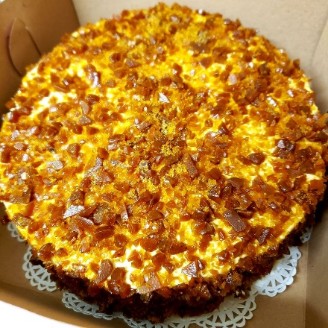

2 eggs, separated

1½ c. sugar

1¼ c. sifted cake flour

1 t. salt

3 t. baking powder

½ c milk

⅛ t. baking soda

⅓ c. cooking oil

½ c. cold strongly brewed coffee

2 t. vanilla

*I have not made this cake (yet). Picture is from Yelp*.

Whipped cream (see Fruit Basket Cake recipe)

Coffee Crunch Topping (next page)

Preheat oven to 350°F. Grease two 8” deep cake pans. Beat eggs whites until frothy; gradually add ½ c. sugar and continue beating until stiff and glossy. Sift remaining sugar, flour, baking powder, and salt. Combine milk, coffee, and baking soda. Pour all oil into flour mixture and vanilla. Beat 1 minute using medium speed. Scrape bowl constantly.

Add remaining coffee mixture and egg yolks. Beat 1 minute longer, scraping constantly. Fold in egg whites lightly, but thoroughly. Bake 30-35 minutes.

Make whipped cream. When cool, cut each cake in half, making four layers. “Frost” each layer with whipped cream, sprinkling with coffee crunch. Then “frost” the outside and sprinkle the coffee crunch on top and sides.

Note from Vi: “It’s better to refrigerate the cake for a couple of hours or even overnight to sort of let the candy melt a little on the whipped cream.”

## Coffee Crunch Topping

Source: Mrs. Laura Sun, *Treasured Recipes from two Cultures – American and Chinese*, St Mark’s United Methodist Church

Submitted by: Cheryle Miyao-Quock

1 ½ c. sugar

¼ c. corn syrup, clear

¼ t. instant coffee

¼ c. hot water

1 T. baking soda

Combine sugar, coffee, corn syrup, water and cook to hard crack stage, 300° F (use candy thermometer). Remove from heat and immediately add baking soda. Move quickly. Stir vigorously but only until mixture blends. Pour into greased shallow pan. Cool and break into small pieces. A quick way to do this is to put it in a paper bag and hit with a rolling pin.

Article from <http://www.spotlightchinatown.com/eastern-bakery>

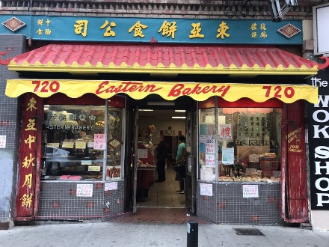EASTERN BAKERY is the oldest Chinese bakery in Chinatown. It was founded in 1924 by the Lee Family and has been continually operating for 93 years. Orlando Kuan and his family bought it from the Lee’s in 1985. “We have to carry on the tradition of the place — all the old recipes like the Coffee Crunch cake and mooncakes,” he said.

Most of the menu and decor remains the same — the bright yellow walls with mooncake packaging scattered about, still baring [sic] the original design featuring the Moon Goddess from the Lunar New Year folk tale. Kuan boasts that their mooncakes uses lotus paste made in-house. “It takes eight hours to make,” he said. “Most bakeries don’t do that.”

Aside from their mooncakes, another famous item is the Coffee Crunch cake, a yellow sponge cake with mocha whipped cream and toffee crumbles glittering on the outside. It’s a revered San Francisco classic, with its origin tied to the Blum’s — a now defunct bakery in Union Square, though Eastern Bakery developed their own version. “I’ve been here 31 years and I still can’t resist having a slice,” said Kuan.

Their last iconic dish are their Smackles, a slightly savory cookie in cool retro packaging. They had purchased the brand from another bakery and continue the tradition of manufacturing these cookies nicknamed “cow ear cookies” (or ngo yi in Chinese.)

Orlando Kuan comes from bakery royalty — he opened Golden Gate Bakery with his brother down the street in 1976, which was created out of a need to find work. “When you come to the United States, you have to look for something.” Their something was dan tat, Chinese egg tart with sweet yolk in a flaky pastry shell -- so popular that there’s often a line in front of Golden Gate Bakery (when they’re open at least.) Kuan carries on that same tradition at Eastern Bakery with one of their variations of the egg tart -- the Custard Tart. It has a creamier taste, which he attributes to that “special ingredient.” Special indeed.

Signature dishes: Lotus Mooncake, Coffee Crunch Cake, Smackles

Established: 1924

Proprietor: Orlando Kuan

Address: 720 Grant Ave

Hours: open daily; 9:30am-8:30pm

Phone: (415) 433-7973

Web: [www.easternbakery.com](http://www.easternbakery.com)

Cash only

## Blum’s Coffee Crunch Cake

Source: *Love to Bake Pastry Cookbook*, published in the *San Francisco Chronicle*, 2/27/18

Fritsche, Sarah, “Lost San Francisco dishes you thought you might never taste again”

Submitted by: Cheryle Miyao-Quock

Aside from It's-It ice cream sandwiches, if there's one dessert that is inextricably linked with San Francisco, it has to be the coffee crunch cake from the late, great bakery-soda fountain chain, Blum's.

The cake was invented in the 1940s by Ernest Weil, operations manager for the beloved bakery, after one confectioner accidentally made some candy too hard to chew. To salvage the cook's mistake, Weil smashed the candy and spread it over a three-layer sponge cake coated in coffee-flavored whipped cream.

Weil eventually moved on from Blum's to open his own bakery, Fantasia Confections in Laurel Heights, which he operated until 1989. There, he continued to make and sell the famous cake. Several years before Weil passed away in 2010, he penned a cookbook, "Love to Bake Pastry Cookbook." The book, now out of print, featured his signature recipes — including the coffee crunch cake.

A handful of local bakeries, including Yasukochi's Sweet Stop in Japantown and Chinatown's Eastern Bakery, continue to make knockoff versions of the classic cake. And, of course, you can make it at home thanks to this recipe from a 1997 column by the late cookbook author Flo Braker, who proclaimed the coffee crunch cake to be her "all-time favorite" classic dessert.

**Cake**

1¼ cups cake flour, sifted

1½ cups sugar, divided

½ teaspoon salt

6 egg yolks

1 cup (7 to 8) large egg whites

1 teaspoon cream of tartar

1 teaspoon vanilla

1 tablespoon fresh lemon juice

1 teaspoon grated lemon zest

**Coffee Crunch**

Unflavored vegetable oil

1 tablespoon baking soda, sifted

¼ cup strong brewed coffee

1½ cups sugar

¼ cup light corn syrup

**Frosting**

2 cups heavy cream

2 tablespoons sugar

2 teaspoons vanilla

**To make the cake:** Adjust rack in lower third of oven; preheat oven to 350 degrees.

Sift flour, ¾ cup sugar and the salt onto a sheet of wax paper; set aside.

Using an electric mixer, beat egg yolks with ¼ cup sugar until thick and pale yellow. Add ¼ cup water and beat until thickened, about 4 minutes. Set aside.

In a clean bowl, using cleaned beaters or the whip attachment, whisk egg whites using a heavy-duty mixer just until frothy. Add cream of tartar; whisk until soft peaks form. Add remaining ½ cup sugar in a steady stream, whisking until thicker, stiffer, glossy peaks form — about 2 to 3 minutes. Whisk in vanilla, lemon juice and lemon zest. Pour yolk mixture over whites. Fold together with a rubber spatula.

Using a metal spatula, scoop up a third of the flour mixture and sprinkle over mixture; fold in with a rubber spatula. Repeat two more times just until ingredients are incorporated. Gently pour batter into an ungreased 10-inch round tube pan with removable bottom (such as an angel food pan). Level top with a rubber spatula. Bake for 50 to 55 minutes, or until top springs back slightly when lightly touched. Invert pan over a long-necked bottle to cool for about 45 minutes.

To remove cake from pan, slip a flexible metal spatula down one side of pan; slowly trace perimeter to release the cake. When sides are free, push up on bottom to release cake. Tilt cake, with removable bottom still attached, and gently tap bottom against counter to loosen cake. Rotate cake, tapping a few more times, until it appears free. Cover cake with a rack, and invert; remove bottom of pan.

**To make the coffee crunch**: Generously oil a large baking sheet; sift baking soda onto a sheet of wax paper; set nearby. Combine coffee, sugar and corn syrup in a heavy, 4-quart saucepan. Place over medium-low heat, stirring occasionally, until sugar dissolves. When mixture is clear and begins to boil, increase heat to medium-high; cook until mixture reaches 290 degrees on a candy thermometer. Toward the end of cooking (270 to 280 degrees), stir occasionally to prevent mixture from scorching and becoming too foamy). Remove from heat and stir in baking soda (mixture will foam up fiercely). While still foaming, pour out onto oiled baking sheet. Do not spread; let cool undisturbed for at least 1 hour.

**Crush into very small pieces.** (Place between 2 sheets of wax paper and tap or roll with rolling pin.) Store in an airtight container.

**To make the frosting**: Combine cream, sugar and vanilla in a heavy-duty mixer; beat on high speed until cream holds soft peaks.

**To assemble:** Slice cooled cake into 3 equal layers using a serrated knife. Spread whipped cream between each layer, carefully stacking layers. Spread remaining whipped cream over top and sides of cake. Refrigerate.

Just before serving, generously sprinkle top and sides with the coffee crunch.

## Got Milk? Cookies

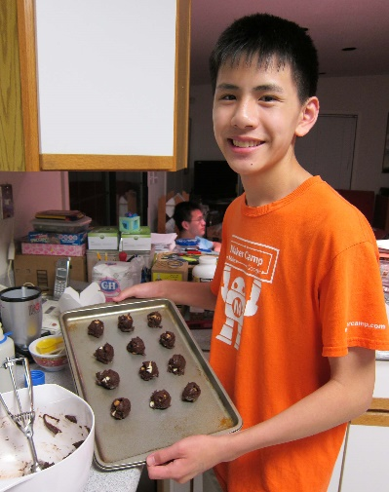Source: Thomas Lee

Submitted by Thomas Lee

⅓ cup butter

2 oz. semisweet baking square

¾ cup dark brown sugar

1 egg

1 tsp vanilla

¾ cup flour

½ tsp baking powder

¼ tsp salt

¼ cup each white chocolate chips, semisweet chocolate chips, and peanut butter chips

Preheat oven to 375°F.

Melt butter with the chocolate. Mix in the sugar, egg, and vanilla. In a separate bowl, mix together the flour, baking powder, and salt. Mix the flour mixture and chips into the chocolate mixture. Drop batter onto baking sheet, about 1 tablespoon of batter per cookie.

Bake for 10 minutes. Let sit for one minute to cool, and then move cookies to cookie rack.

Makes about 1½ dozen cookies.

## Macadamia Cookie

Source: Robin Wu

Submitted by: Robin Wu

*Here's a favorite cookie recipe I always use for our annual mother/daughter cookie exchange during the holidays. I got the recipe years ago from a friend and former coworker who grew up in Hawaii. The cookie is like a snowball or Mexican wedding cookie but uses macadamia nuts.*

1 cup butter (2 sticks)

5 Tablespoons powdered sugar

2 teaspoons vanilla

2 cups flour

1 cup macadamia nuts, chopped

Powdered sugar for rolling

Mix well and then add chopped macadamia nuts. Roll in walnut-sized balls. Bake at 350 degrees for 30 minutes. Cool and then roll in powdered sugar.

## Lemon Snaps

Source: Modified from *The International Cookie Cookbook* by Nancy Bagget

Submitted by: Diane Wong-Kone

*This is what I like to make when I visit California and my cousins give me Meyer lemons from the yard. Recipe from Australia. Coffee break cookies.*

2 medium lemons

1 cup plus 1½ tablespoons sugar

2 cups unbleached white flour

2¼ cups baking powder

¼ teaspoon baking soda

¼ teaspoon ground ginger

½ cup (1 stick) unsalted butter, slightly softened

1 large egg

2 teaspoons golden syrup or light corn syrup

1 teaspoon fresh lemon juice

Lemon zest

Zest lemon. Preheat oven to 375˚F. Grease baking sheets and set aside.

In large bowl, mix flour, baking powder, baking soda, and ginger.

In mixer, beat butter, lemon zest, and 1 cup sugar on medium speed until light and smooth. Add egg, syrup, and lemon juice and continue beating until blended. Gradually beat in dry ingredients. As dough stiffens, stir in remaining dry ingredients with a large wooden spoon.

To form cookies, pull off small pieces of dough and roll between palms to form 1-inch balls. Place on baking sheets 2¼ inches apart. Lightly grease the bottom of a flat drinking glass and lightly dip the surface into reserved sugar. Press dough balls down with the glass bottom until about ¼ inch thick and about 1¾ inches in diameter.

Place in upper third of oven and bake 8-10 minutes, or until cookies are golden and just slightly darker around the edges. Remove baking sheets and cool 1-2 minutes before transferring cookies to wire racks to cool.

Makes 45-50 2½ inch cookies.

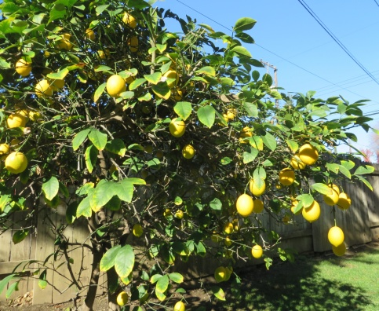

## Doug’s Lemon Tart

Source: Doug Ng

Submitted by: Doug Ng

*I make this for potluck get-togethers and sometimes I put blueberries on top. Charlie’s nose knows good food!*

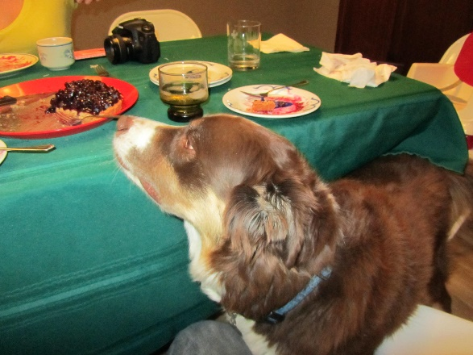

Crust:

10 Tablespoons (1¼ stick) unsalted butter, melted

¼ cup sugar

1 teaspoon pure vanilla extract

¼ teaspoon salt

1¼ cups flour

¼ teaspoon baking powder

One 9½ inch tart pan with removable bottom

Lemon Curd:

4 large eggs plus 3 yolks

1 cup lemon juice

Grated zest of one lemon

6 oz (1½ stick) unsalted butter (cut up)

1 cup sugar (or ¾ cup if you want it more tart)

Make the crust: Preheat the oven to 350˚F.

Combine the melted butter, sugar, vanilla, and salt in a bowl. In a separate bowl, mix the flour and baking powder thoroughly. Add the flour mixture to the butter mixture, and mix until well blended. The dough will be gooey.

Press the dough evenly over the bottom and up the sides of the tart pan. Use the back of a spoon to pack the flutes on the side first, then even out the bottom. There will be just enough dough. Bake on a baking sheet in the lower third of the oven for 20-25 minutes, until the crust is golden brown all over. Remove from oven, but leave the oven on.

Make the lemon curd when the crust is baking. The curd takes about 10 minutes to make; try to time it so that the curd is finished a couple of minutes before the crust. Whisk the eggs and yolks in a large stainless steel saucepan to blend. Add the zest, juice, and sugar. Add the butter. Whisk over medium heat, until the butter has melted and the mixture is thickened and beginning to simmer around the edges. Continue to whisk 10 more seconds and then remove from heat. Strain the filling into the hot crust. You will have more filling than you need. Put the tart back into the oven for about 5 minutes to set the curd.

Cool. Add fresh berries on top if desired. May be served at room temperature or chilled.

## Blueberry Pie

Source: Modified from *Allrecipes* and from *America’s Test Kitchen* recipes for blueberry pie

Submitted by: Annette Chan

4 cups fresh blueberries

¾ cup white sugar

3 tablespoons cornstarch

¼ teaspoon salt

½ teaspoon ground cinnamon

1 Granny Smith apple

1 tablespoon butter

2 9-inch pie crusts

1. Preheat oven to 400°F

2. Put 1½ cups of blueberries in a saucepan. Use a masher to mash the blueberries a little (press down on the blueberries and break them open a little). Cook on medium heat, stirring constantly, for about 8 minutes. It should look like jam. Cool a little.

3. Add the cooked blueberries to the remaining blueberries.

4. Mix in the sugar, cornstarch, salt, and cinnamon.

5. Grate the apple. Put the apple in a towel and squeeze out the liquid in the apple by twisting the towel.

6. Add the apple (about ⅔ cup) to the blueberries in the bowl. Mix everything together.

7. Line a pie dish with one pie crust.

8. Pour blueberry mixture into the crust, and dot with butter.

9. Place the second pie crust on top of the pie, and trim and crimp the edges. Or make a lattice top, and trim and crimp the edges.

10. Place pie on a cookie sheet that had been lined with aluminum foil.

11. Bake for 30 minutes at 400°F. Reduce to 350°F, and bake for 30 minutes.

12. Let sit for 4 hours before eating.

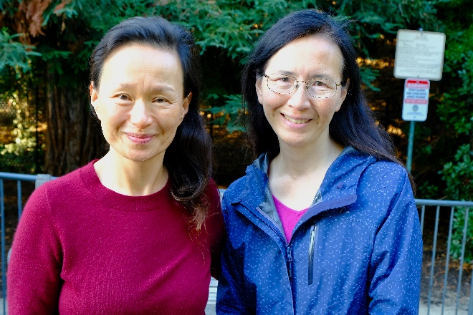

## Caramel-Glazed Custard

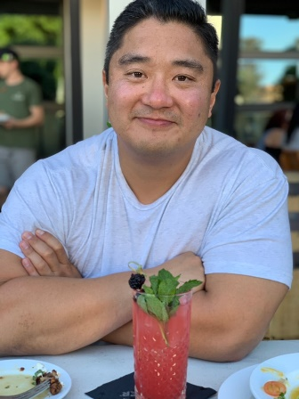Source: Unknown

Submitted by: Cheryle Miyao-Quock

*Derrick made this recipe when he was about 10 years old—he spent all day making it. This dessert is also known as crème caramel or flan.*

1¾ c. sugar

¼ c. water

3 whole eggs

5 eggs yolks

2 cans (12 oz each) evaporated milk

2 t. vanilla

Preheat oven 350 degrees. In heavy saucepan, combine 1 cup of sugar and the water and stir well. Place over medium heat, cover, and heat for about 4 minutes. Remove the cover and continue to cook, swirling the pan, until the syrup turns amber, about 8 minutes longer. If sugar crystals begin to form around the sides of the pan just above the bubbling syrup, brush them away with a wet brush. Carefully pour the hot syrup into the reserved pan or cups and quickly swirl the containers(s) to coat the bottom and about one third of the way up the sides. Set the container(s) aside to cool.

In large mixing bowl, combine the whole eggs and egg yolks and beat lightly with a fork; avoid overbeating at any point to prevent too many air bubbles from forming. Stir in remaining ¾ cup sugar, the milk and vanilla. Slowly strain the mixture through a fine-mesh sieve into the sugar-lined pan or cups. (Use a 2 quart metal baking pan, or six 8-oz metal baking containers, or eight 6-oz metal baking cups.) Cover the container(s) with a lid or aluminum foil and place in a large pan. Pour enough hot water (not boiling) into the pan to reach halfway up the sides of the container(s).

Bake until a knife inserted near the edge of the custard comes out barely clean, about 1 hour for a large container or about 25 minutes for the cups; the center should still wobble slightly when a container is shaken. Regulate oven temperature during baking to maintain water at the almost simmering stage; do not allow to boil. Remove from the hot-water to a countertop and remove lid(s).

To serve warm, let cool for about 15 minutes, then run a thin, sharp knife blade between the custard and the baking dish, cover with an inverted serving plate or individual serving plates, and invert custard(s). Lift off container(s). Carmel syrup will run down the sides and on to the serving dish(es) to surround the custard.  Spoon some of the syrup over each portion when serving.

To serve cold, let cool to room temperature, then cover tightly and refrigerate until well chilled, at least 3 hours or as long as overnight. Just before serving, immerse the bottom of the container(s) in a pan of hot water for about 30 seconds and run a thin, sharp knife around the side of the container(s) to loosen the custard. Invert and serve as above.

## Salted Toffee Chocolate Bars

Source: Unknown

Submitted by: Karen Miyao

Makes: 24 servings

Prep time: 15 minutes; 25 minutes total

12 graham crackers, broken into 24 squares

½ pound butter

1 cup brown sugar

¾ cup chopped pecans

½ teaspoon coarse salt

¾ cup bittersweet chocolate chips

Heat oven to 350°F. Line a cookie sheet with aluminum foil. Place the crackers on the foil-lined sheet, with their edges touching. In a small saucepan, melt the butter over low heat, then stir in the brown sugar. Turn the heat to medium high, bring the mixture to a boil, then reduce heat to simmer, stirring occasionally, and cook for 10 minutes until sugar has melted. Pour the sugar mixture over the graham crackers, and spread with a spatula to cover evenly.

Sprinkle with pecans and bake for 10 minutes, until bubbly. Place pan on a cooling rack and use the tip of a spatula to nudge the crackers apart. Sprinkle with coarse salt.

When pan has cooled, melt chocolate and drizzle over the crackers. Let cool until firm; remove from pan, and break into pieces. Store, tightly covered, at room temperature for up to a week.

## Doug’s Apple Galette

Source: Doug Ng

Submitted by: Doug Ng

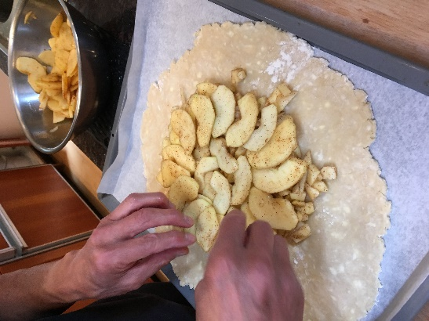*Who needs a pie plate?*

1 pie crust (Foolproof Pie Dough for Single-Crust Pie recipe)

4 medium apples (1.5 – 2 lbs.), ½ sliced, ½ chopped

Combine:

2 tablespoons sugar

½ teaspoon cinnamon

1 tablespoon honey (optional)

1 tablespoon butter cut into small pieces (optional)

Roll out dough to approximately 12 inches, transfer to a sheet of parchment on a cookie sheet and refrigerate for about 15 minutes to firm it up. Put chopped apples in the center 8 inches of the dough. Drizzle honey. Top with sliced apples and sugar/cinnamon mixture. Dab with butter. Fold dough over edges of fruit. Bake 400˚F for about 1 hour.

## Foolproof Pie Dough for a Single-Crust Pie

Source: *Cook’s Illustrated*, November 1, 2007

Submitted by: Doug Ng

*Use cold ingredients: Cold butter, cold shortening, cold water, cold vodka.*

1¼ cups unbleached all-purpose flour (6 ¼ ounces)

½ teaspoon table salt

1 tablespoon sugar

6 tablespoons cold unsalted butter (¾ stick), cut into ¼ - inch slices

¼ cup chilled solid vegetable shortening, cut into 2 pieces

2 tablespoons vodka, cold

2 tablespoons cold water

Process ¾ cups flour, salt, and sugar together in food processor until combined, about 2 one-second pulses. Add butter and shortening and process until homogenous dough just starts to collect in uneven clumps, about 10 seconds (dough will resemble cottage cheese curds with some very small pieces of butter remaining, but there should be no uncoated flour). Scrape down sides and bottom of bowl with rubber spatula and redistribute dough evenly around processor blade. Add remaining ½ cup flour and pulse until mixture is evenly distributed around bowl and mass of dough has been broken up, 4-6 quick pulses. Empty mixture into medium bowl.

Sprinkle vodka and water over mixture. With rubber spatula, use folding motion to mix, pressing down on dough until dough is slightly tacky and sticks together. Flatten dough into 4-inch disk. Wrap in plastic wrap and refrigerate at least 45 minutes or up to 2 days.

Remove dough from refrigerator and roll out on generously floured (up to ¼ cup) work surface to 12-inch circle about ⅛ inch thick.

|  |  |
| --- | --- |
|  |  |

## Melt-in-Your-Mouth Macadamia Shortbread

Source: Unknown:

Submitted by: Karen Miyao

2 c. (4 sticks) butter, softened

1 c. plus 2 Tablespoons sugar

1 teaspoon vanilla

½ teaspoon salt

3 c. plus 2 Tablespoons flour

1 c. cake flour

1¾ c. finely chopped Macadamia nuts

¼ c. raw (also called turbinado) sugar

Heat 350°F oven. Lightly oil baking sheets or I use parchment paper (no greasing required).

Cream butter, sugar, vanilla and salt until light and fluffy. Add flours; beat until smooth.

Combine nuts and raw sugar in small bowl. Form dough into 1 inch balls and roll in nut-sugar mixture. Place 2 inches apart on baking sheets. Bake 15 minutes or until golden brown.

## Jin Duey: Simple Way (deep fried glutinous rice balls)

Source: Bessie Chun, from Gladys Louie’s recipe collection

Submitted by: Cheryle Miyao-Quock

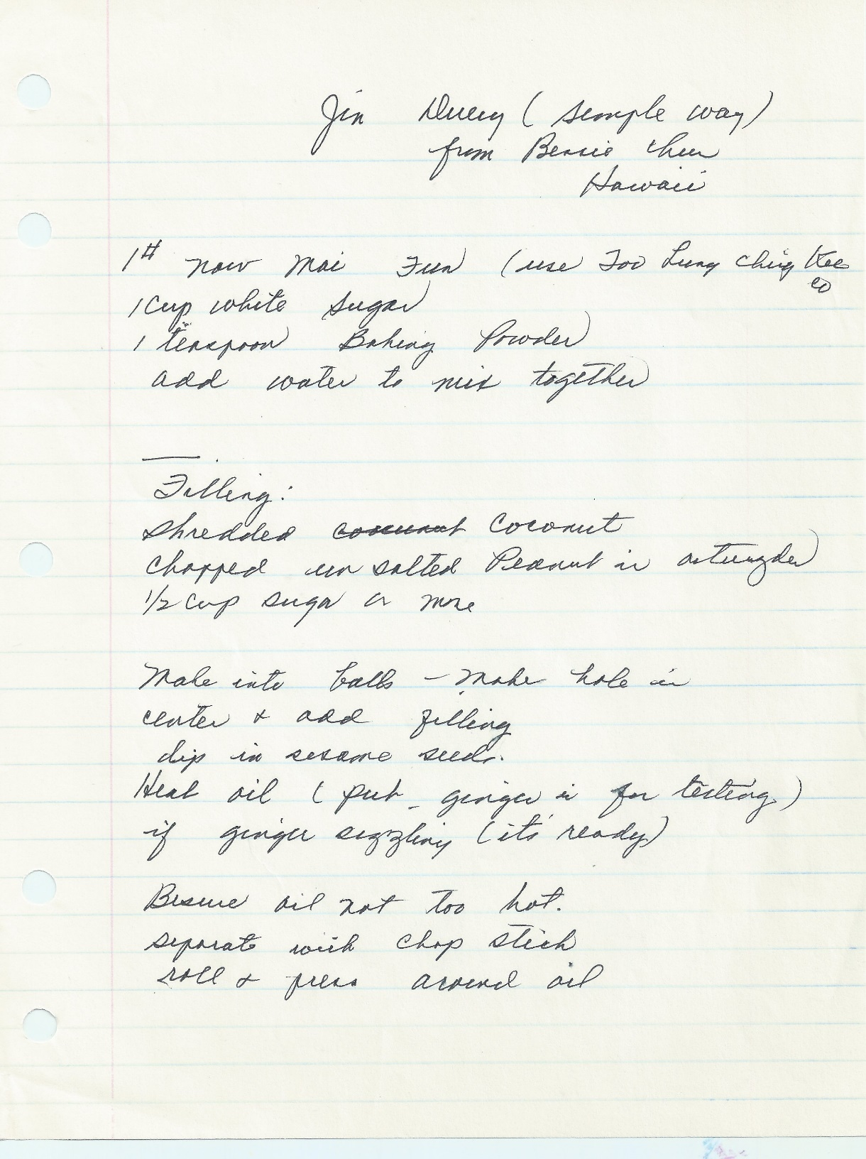

## Chinese Steamed Cake

Source: Annette Chan

Submitted by: Annette Chan

5 eggs, room temperature

1 cup white sugar

1 Tbl. water

1 cup cake flour

½ tsp. baking powder

1½ tsp. almond extract

¼ cup confectioner’s sugar

1. Arrange steamer or wire rack over simmering water.

2. Line a 9-inch square or 9-inch round pan with waxed paper.

3. Separate the eggs. Place the yolks in a large bowl with the sugar and water. Beat with an electric mixer on medium speed until the mixture has increased about 3x in volume (about 5 to 10 minutes).

4. Whisk together the flour and baking powder.

5. Gently fold the flour mixture into the yolk mixture.

6. Blend in the almond extract.

7. Beat the egg whites with an electric mixer to stiff, not dry, peaks. Fold the egg white mixture into the batter.

8. Pour the batter into prepared pan. Rap the pan on the counter to get rid of large air bubbles.

9. Place the pan into the steamer.

10. Steam for about 20 minutes, or until a toothpick inserted into the center comes out clean.

11. Cool cake on a wire rack.

12. Dust with confectioner’s sugar.

## Red Bean Soup Dessert

Source: Susanna Wong

Submitted by: Diane Wong-Kone

1 bag dried red bean (14 oz.)

1 bag (box) rock sugar (16 oz.)

¼-½ c. tapioca powder

3-4 pieces dried tangerine or orange peels

Cook red beans in 4½ qt. water for 1½ hours. Turn to medium heat after boiling. Add rock sugar, tangerine or orange peels, and tapioca and cook for ½ hour.

## Whiskey Rice or Sweet Fermented Rice (Lao Zao)

Source: Cheryle Miyao-Quock & Karen Miyao

Submitted by: Cheryle Miyao-Quock

*Paw-Paw (Edith) always seemed to have a Bell jar of this fermenting in her “ice box”. Unfortunately, we don’t have Paw-Paw’s recipe, but thanks to the internet, Mom and I came up with a version that is almost as good. This sweet, fizzy rice takes up to 3-5 days to make. We love to eat it for dessert or as a snack, ice cold, straight out of the fridge. It hits the spot on a hot summer day in Sacramento.*

2 c. sweet glutinous rice

1 Chinese distiller’s yeast balls (also known Shanghai yeast balls), ground to a powder

2 T. sugar or more to taste

1. 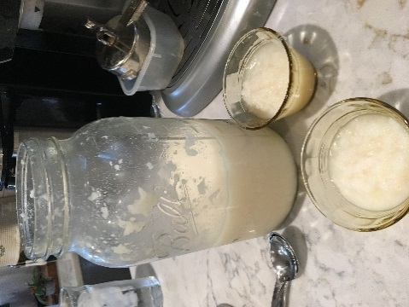Thoroughly clean and sterilize anything that will come in contact with the rice and yeast: utensils, bowls, and hands. Contamination will potentially cause mold to grow during fermentation.
2. Wash rice and soak overnight. Cook according to your rice cooker’s instructions.
3. Transfer cooked rice to baking sheet and spread rice to cool to room temperature. (It’s important to cool the rice down so it won’t kill the yeast once it’s added.)
4. Separate grains using wet, clean hands. Eliminate all clumps. Transfer to a clean bowl.
5. Crush yeast ball(s) into a powder using a mortar and pestle. Set aside ½ teaspoon.
6. Add yeast, less the ½ teaspoon, and 2 T. sugar to rice. Mix thoroughly, using wet, clean hands, distributing yeast and sugar evenly throughout the rice.
7. Pack the rice down and poke a 1 inch hole in the center of the bowl that goes all the way down to the bottom, making a well. This will fill up with fermented liquid (rice wine) as it sits.
8. Sprinkle the remaining ½ teaspoon of yeast over the top of the rice.
9. Loosely cover bowl with plastic wrap. Place in dark, warm place, 75-80°F. Ferment for 3-5 days, checking every day for mold. (If mold forms, throw it away and start over.) The well will be filled with liquid as the rice ferments.
10. When it is ready, stir rice and add more sugar if needed. Put in clean glass jar(s), leaving room at the top since it will continue to slowly ferment; refrigerate. Can be stored up to 2 months.

Other suggestions:

1. Serve warm as a porridge. Add mochi balls and/or a poached egg.
2. Add to sweet Asian breads, replacing part of the sugar and yeast in the recipe.
3. Use it as a substitute for rice wine, adding to braised fish or pork dishes to give them a little bit of sweetness.
4. Freeze as a sorbet.
5. Marinate with fish, then steam.

To make a mild whiskey, squeeze rice with cheese cloth. Transfer liquid to bottle and refrigerate. Eat leftover rice.

# Miscellaneous

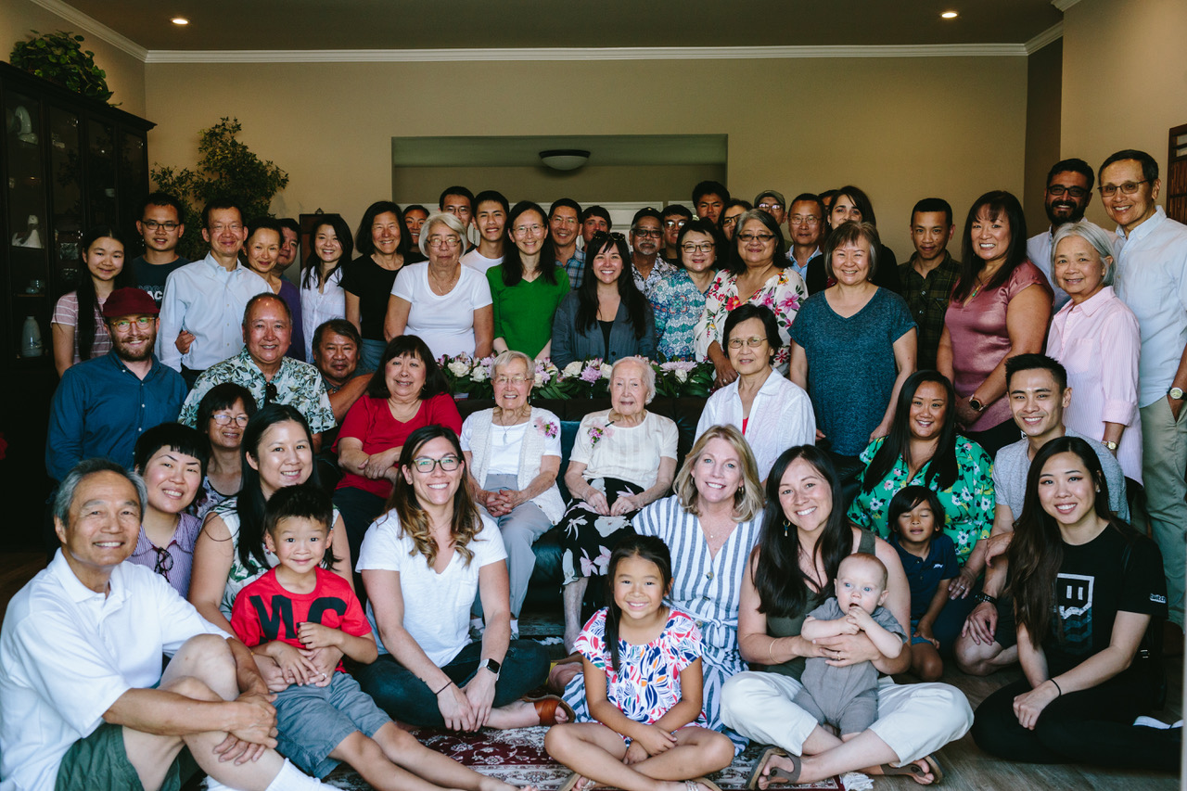

Celebrating Evelyn and Elsie’s 90th birthday at Wendy and Sammy’s house, Danville, CA, July 20, 2019. Top rows standing behind couch: Annie Cheng, Samuel Cheng, Andrew Cheng, Yvonne Chan Cheng, Dean Quock, Cheryle Miyao-Quock, Robin Louie, Ryan Louie, Barbara Lowe, Philip Lee, Thomas Lee, Annette Lee, Charles Lee, Paul (friend), Carly Ng, Kenneth Miyao, Nicholas Chan, Karen Miyao, Matthew Chan, Jennifer Chan, Roberta Lowe-Taylor, Clifford Chan, Douglas Ng, Christina Wong, and Nathaniel Wong; middle couch row: Brian Larson, Gary Ng, Brandon Louie, Mary Lowe, Elsie Ng, Denise Chan, Wendy Chang, Shirley Wong, Edgar Ortega, Susanna Wong, and Arthur Wong; bottom sitting rows: Sammy Cheng, Debbie Chang, Diane Wong-Kone, Jennifer Chang, William Chang, Bethany Ng, Emiko Chang, Jamie Brean-Ng, Aubree Larson holding Arleigh Larson, Courtney Ortega holding Leo Ortega, Tim Jose and Flo (friend).

**Miscellaneous**

Punch 207

Fruit Punch 207

Winter Melon Soup Tonic 207

Sangria Punch 208

Lee Family Boba Tea Recipe 208

Klingon Bloodwine 210

Gnamakoudji (Ginger Juice) 211

Salad Dressing 211

Brown Sugar Glaze for Ham 211

Thousand Island Dressing 212

Sweet Sour Sauce (simple) 212

Sweet and Sour Sauce 213

BBQ Sauce for Spareribs 213

Mustard Ham Sauce 214

Chinese Plum Sauce 214

Dung Min Fun (Har Gow or Shrimp Dumpling Skins ) 215

Chinese Salt 216

Five-Spice Powder 216

Cure for a Cough 216

Basic Dry Rub 217

Beef Jerky 217

Salted Eggs (hom don) 217

Dog Food 218

Dog Biscuits 218

## Punch

Source: Evelyn Wong

Submitted by: Annette Chan & Yvonne Chan Cheng

2 cans of frozen fruit concentrate (e.g. raspberry lemonade)

2 2-liter bottles of 7-Up or Sprite

2 trays of ice cubes

Put ice cubes in a large bowl. Add frozen fruit concentrate and soda. Mix.

## Fruit Punch

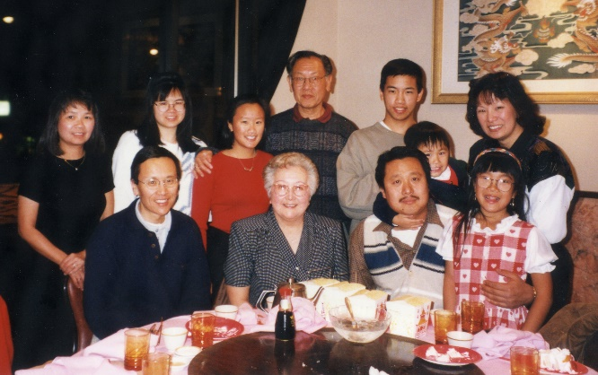Source: Shirley Wong-Jose

Submitted by: Shirley Wong-Jose

*This is a great punch for parties!*

1 46-oz. can pineapple juice

2 6-oz. cans frozen lemonade concentrate

4 c. cranberry juice

1 8-oz. jar maraschino cherries (optional)

2 oranges sliced

1 qt. ginger ale or 7-Up

Mix all ingredients in large punch bowl with ice. Float orange slices on top.

## Winter Melon Soup Tonic

Source: Daisy Chan

Submitted by: Evelyn Wong

*A good tonic recipe to use after the holidays or when rich food has been eaten.*

2 lbs. winter melon (with rind)

2-4 dried oysters (soaked and cleaned)

Cilantro (small bunch)

Water

Use an old, mature melon. Wash the winter melon to get the powder off. Do not peel. Cover melon with water in a pot. Then add oysters and cilantro. Simmer for 2 hours. Drink the broth. This is good for cooling and cleansing the system.

## Sangria Punch

Source: Grandpa Jerry

Submitted by: Alexis Paddock

*This is my Grandpa Jerry's (my mother's father) sangria recipe. It has been making appearances at family gatherings for as long as I can remember, and we always have a pre-made pitcher on hand during the holiday season for guests.*

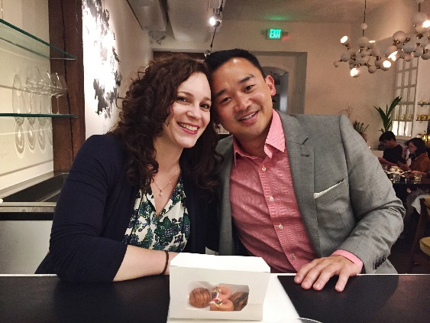750 ml bottle of red wine (burgundy or zinfandel - my grandpa liked to use Carlo Rossi jug wine as his base and make a big batch)

½ cup sugar

½ cup lemon juice

1 orange, thinly sliced

1 lemon, thinly sliced

1 oz triple sec or other orange liqueur

1 oz brandy

7 oz bottle of club soda

Mix wine, sugar, lemon juice, triple sec and brandy in a large pitcher. Cover and place in refrigerator to let the flavors blend for as long as you can (preferably at least overnight). For individual servings, pour sangria and a couple of citrus slices into glasses with ice, top with the desired amount of club soda and stir. If you would prefer to serve the sangria in a punch bowl, combine sangria and all club soda in the punch bowl and add ice cubes or an ice ring.

## Lee Family Boba Tea Recipe

Source: Thomas and Philip Lee

Submitted by: Thomas and Philip Lee

INGREDIENTS (PER SERVING) FOR THE TEA

1 bag Red Rose Original Blend Tea Bag (black tea bags)

2 to 2.5 tablespoons non-dairy creamer (Coffee-Mate)

2 tablespoons sugar

½ tablespoon honey (optional, added to make honey milk tea)

⅓ cup boba (Black Tapioca Pearls, Wu Fu Yuan is a good brand)

INGREDIENTS FOR THE SUGAR SYRUP (ENOUGH FOR 2 SERVINGS OF TEA)

1 tablespoon sugar

⅓ cup water

PREPARE TEA

Boil water in kettle (8 oz. per serving). Put 1 tea bag per serving into a large measuring cup.

Add one cup of boiling water per serving into measuring cup with tea bag(s). Wait minimum of 15 minutes (longer the better). Use a slotted spoon to remove the tea bag(s) from measuring cup.

PREPARE SUGAR SYRUP

Add 1 tablespoon of sugar into measuring cup. Add ⅓ cup of boiling water into measuring cup and mix until sugar dissolves. Pour sugar syrup into a bowl (optional).

*Can make more sugar syrup if have more boba.

PREPARE BOBA

Add 1 cup of water to pot per serving of boba. Once water boils, add ⅓ cup boba per serving into the pot. Stir until all bobas float. Cover pot, turn fire down to medium, and cook for two and a half minutes. Turn off fire, wait another two and a half minutes. Use a slotted spoon to remove boba from water and transfer to sugar syrup. Wait ~15 minutes (very approximate, probably doesn’t really matter how long).

ASSEMBLE MILK TEA

Get shaker (like a water bottle). Per serving, add 2 to 2.5 tablespoons of creamer and 2 tablespoons of sugar into the bottle. For honey milk tea, add ½ tablespoon of honey into bottle per serving.

When tea is ready, pour the hot tea into bottle Shake bottle until completely mixed.

ASSEMBLE THE DRINK

Take a large cup. Use slotted spoon to add boba to cup (Drain out the sugar syrup. Sugar syrup can be saved in a separate bowl and refrigerated to be reused. Only reuse one or two more times. Add ice cubes (5). Add tea. Stir until cold throughout.

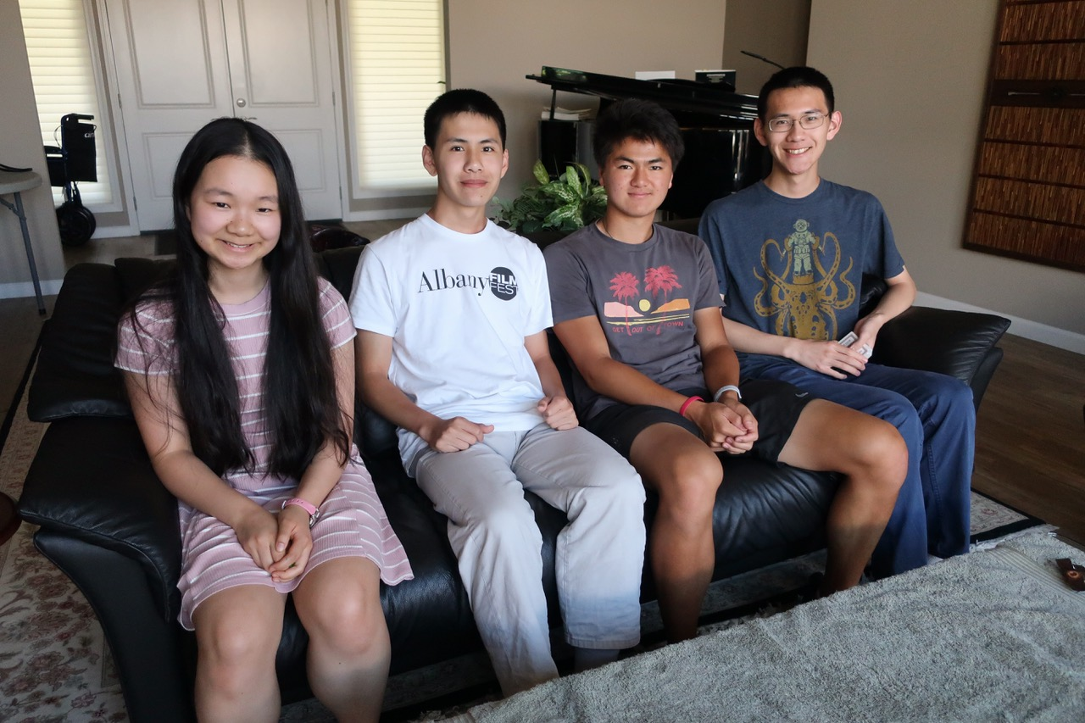

## Klingon Bloodwine

Source: *Star Trek Cookbook* by Ethan Phillips and William J. Birnes (Pocket Books, 1999)

Submitted by: Annette Chan

*In the television show Star Trek, the alien race Klingons loved to drink Klingon bloodwine, which is fermented blood with sugar. Here is a recipe from Star Trek Cookbook for re-creating this drink. I make this when we celebrate Star Trek Day, September 8th.*



1 part cranberry juice

1 part dark grape juice

Fresh or frozen cranberries or red raspberries (optional)

Mix together the cranberry juice and grape juice. If you would like your drink to appear to have floating red corpuscles in it, you can blend the fruit in a blender and add it to the juice mixture.

Note: Romulan ale is a blue alcoholic drink that is drunk by the alien race Romulans. BevMo! and Amazon sometimes sell an alcoholic Romulan ale. For a nonalcoholic version, you can use any blue drink, like blue Gatorade.

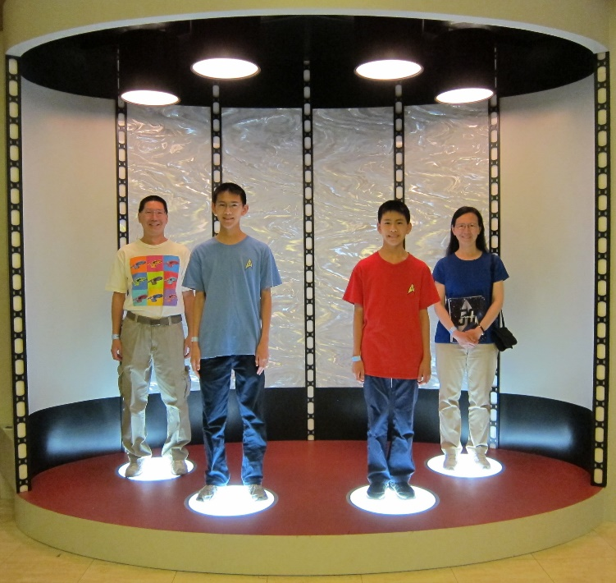

## Gnamakoudji (Ginger Juice)

Source: Adama Kone

Submitted by: Diane Wong-Kone



*This is a traditional juice from Côte d'Ivoire. I’ve never actually weighed out the ginger but use 1½ - 2 large pieces. When I make this recipe, the amount of water I use is limited by the size of my soup pot. I generally add less sugar and add to taste. The sweetness tames the spiciness of the ginger, so the amount of sugar needed really depends on the hotness of the ginger.*

300 grams ginger, peeled and cut into chunks

2 pounds sugar

3 lemons sliced into thin rings

1 bunch fresh mint, leaves only

2 teaspoons vanilla sugar (or substitute a teaspoon of vanilla extract)

6 liters (~1.5 gallons) water

Traditionally, the ginger is pounded with water in a mortar and the juice is strained out through a cheesecloth. Instead, I add ginger pieces and some water and puree in a blender. Mix blended ginger juice with 4 liters of water. Stir in sugar until dissolved and add lemon slices. Cover and set aside to infuse for at least 30 minutes before adding the mint leaves (crushed in a mortar first) and the vanilla sugar. Chill at least 2 hours in refrigerator. Strain out the ginger, mint, and lemon solids. Serve with ice on a hot day.

## Salad Dressing

Source: Daisy Chan

Submitted by: Annette Chan & Yvonne Chan Cheng

2 T. catsup

2 hard boiled eggs, chopped up

5 T. mayonnaise

4 T. Thousand Island Dressing

Lemon juice and sugar to taste.

## Brown Sugar Glaze for Ham

Source: Betty Crocker Cookbook

Submitted by: Karen Miyao

Mix 1 c. brown sugar, ½ t. dry mustard, 1 T. vinegar. Makes about ¾ cup.

For glazed ham, remove ham from oven 30 minutes before done. Pour drippings from pan. Remove any skin from ham. Score fat surface of ham lightly, cutting uniform diamond shapes. If desired, insert whole cloves in each. Pat or brush glaze on ham. Continue baking for 30 minutes.

## Thousand Island Dressing

Source: Evelyn Wong

Submitted by: Diane Wong-Kone

*Goes well with Shrimp or Crab Louie salads, or hamburgers.*

1 cup mayonnaise or low calorie salad dressing

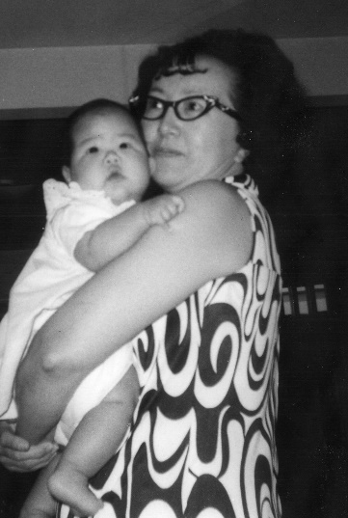¼ cup chili sauce

1 tablespoon lemon juice.

2 green onions, minced

1 hard-cooked egg, chopped

2 chopped sweet gherkin pickles

¼ teaspoon black pepper

Dash Tabasco

Blend all ingredients and chill until ready to serve.

## Sweet Sour Sauce (simple)

Source: Evelyn Wong

Submitted by: Diane Wong-Kone

¾ c. vinegar

¾ c. water

¾ c. sugar, part brown

1 T. cornstarch

1-2 tomatoes, cut in wedges

Green onions, chopped (optional)

Bell pepper, chopped (optional)

Mix cornstarch with sugar. Mix vinegar with water. Add the sugar-cornstarch mixture to the vinegar-water mixture. Cook slowly over low heat. At end of cooking (when it begins to thicken), add a tomato or two, cut in sixth or eighths. Some sliced green onions or pepper strips may be added. This sauce may be used as a dip for fried wonton or egg rolls, or as a sauce for sweet and sour pork.

## Sweet and Sour Sauce

Source: Seung Lowe

Submitted by: Annette Chan & Yvonne Chan Cheng

*This is a recipe from cousin Jerry Gong’s father. Jerry Gong’s real name is Jerry Lowe. This recipe is 50-60 years old.*

1 t. soy sauce

½ c. sugar

½ c. pineapple juice

¼ c. ketchup

¼ c. apple cider vinegar

2 T. cornstarch

2 T. water

Mix together the soy sauce, sugar, pineapple juice, ketchup, and vinegar. Bring this mixture to a boil, and simmer for about one minute. If you want the sauce to be thicker, stir together the cornstarch and water, and add just enough of this cornstarch and water mixture to the simmering sauce while stirring to reach the desired thickness.

## BBQ Sauce for Spareribs

Source: Ginger Grey

Submitted by: Karen Miyao

1 c. ketchup

1 T. Gebhardt’s chile powder

¼ c. red wine vinegar

½ c. dark brown sugar

¼ c. soy sauce (Kikkoman)

Salt

Pepper

Garlic powder

Dump everything in saucepan. Stir and bring to boil. Simmer for 2-3 minutes. Brush sauce on ribs 10 minutes before they’re done.

## Mustard Ham Sauce

Source: *Colorado Cache Cookbook*

Submitted by: Karen Miyao

½ c. sugar

2 T. flour

2 eggs, slightly beaten

½ c. prepared mustard

½ c. vinegar

½ c. beef bouillon

¼ c. butter

Sift flour and sugar together. Add eggs and mix well. Add remaining ingredients. Cook over low heat, stirring constantly until thick. Serve hot. Refrigerate leftover sauce and use for ham sandwiches.

## Chinese Plum Sauce

Source: Doug Ng

Submitted by: Diane Wong-Kone

*I added 2 red jalapeño peppers. When it was simmering, that seemed like enough to give it*

*a small kick, but the heat seemed to disappear after processing. I also used rice vinegar for this batch. The recipe originally had ¼ cup light soy. So, maybe it could use some salt.  - Doug*

3 lbs plums

½ cup cider or rice vinegar

½ to ¾ cup chopped onion

1 cup sugar

¼ cup sweet chili sauce

3 cloves garlic, minced

thumb sized piece of ginger, minced

½ tsp five spice

Combine everything into a stainless pot. Simmer for 20 minutes.

The plums should break down by the end of the 20 minutes. Mash with potato masher for coarse texture or use an immersion blender to puree. Process for 20-30 minutes. Makes approximately 6 half pints.

## Dung Min Fun (Har Gow or Shrimp Dumpling Skins )

Source: Edith Lowe

Submitted by: Diane Wong-Kone

*When Yvonne and Annette were young, they would help their mother (Denise Chan) and grandmother (Daisy Chan) make these har gow skins. Their mother and grandmother would cut the dung min fun dough into small pieces, and they would take turns flattening the dough with a Mexican tortilla press.*

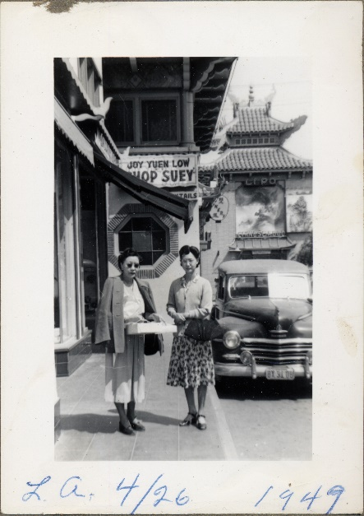

3 c. dung min fun (wheat starch)

3 c. boiling water

½ t. salt

Hom:

½ lb. prawns (diced)

½ lb. pork (diced)

6 Chinese mushrooms (pre-soaked and then diced)

5 water chestnuts

3 T. bamboo shoots

4 stalks green onion

Put Dung Min Fun (wheat starch) and salt in mixing bowl. Pour boiling water in bowl and mix. Don’t touch it at all. Just cover with pot cover for about 10 minutes. Then knead with some oil until nice and smooth. Cut, flatten, and fill with “hom.”

Dip in oil before steaming. Steam 20 minutes. Dip in oil after steaming and fan the finished product.

Note: According to Denise Chan, dough made with just dung min fun and water cracks easily if the amount of dung min fun and water isn’t just right. Adding tapioca starch to the dough makes it easier to work with the dough. The following recipe from Dim Sum by Rhoda Yee (1977) works well.

1 c. wheat starch

⅔ c. tapioca starch

½ t. salt

2 t. oil

1 c. and 2 T. boiling water

Mix together the wheat starch, tapioca starch, salt and oil. Add the boiling water. Cover dough, and let cool for 15 minutes. Knead dough on a lightly oiled surface until smooth.

## Chinese Salt

Source: Unknown

Submitted by: Diane Wong-Kone

*This recipe is useful for other Chinese recipes such as the Cantonese Chicken Pineapple Salad recipe by Daisy Chan.*

Salt

Szechuan peppercorn or Chinese five-spice powder

Use slightly more salt than spice. Grind with a mortar and pestle (or rice bowl and blunt end of a cleaver). Cook in a pan over low heat until browned to bring out the flavor.

## Five-Spice Powder

Source: *A Dash of Spice* by Kathryn Haskins and Gail Duff

Submitted by: Diane Wong-Kone

*If you have whole spices, try dry roasting them in a pan over medium heat for 3-5 minutes to release the aroma before crushing.*

1 tablespoon star anise

1 tablespoon Szechwan peppercorns

1 tablespoon fennel seeds

1 small piece of cinnamon, flaked (or up to 1 tablespoon ground cinnamon)

½ tablespoon cloves

Grind all spices together to form a powder. Store in an air-tight jar for up to 3 months.

## Cure for a Cough

Source: Bessie Chun

Submitted by: Evelyn Wong

1 dosage:

6-8 dried oysters

½ bunch lung lei yip (Chinese leaf herb, can be found at a Chinese herb store)

2-3 t. washed dow see (black bean)

2 t. nom hung (flat, southern almond)

2 t. buck hung (dried, northern almond)

Combine together. Add 4 rice bowls* (6 cups) of water - boil down to 1 bowl (~1½ cups). If you find it good, then boil again. I am quite sure taking this 2 times will do. This old remedy helps a lot of people who have a cough for a long time.

*rice bowl = ~ 1½ cups

## Basic Dry Rub

Source: Gary Ng

Submitted by: Gary Ng

*Use this on everything from smoked meats to BBQ chicken. I triple the batch and store it so I always have it on hand.*

Combine:

3 T. salt

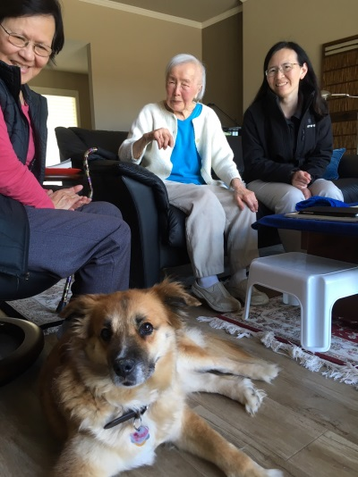3 T. pepper

1 T. garlic powder

1 T paprika

1 ½ t. cayenne pepper

1 ½ t. dry mustard

## Beef Jerky

Source: Gladys Louie

Submitted by: Karen Miyao

6 lbs. top round

1 c. soy sauce

1 c. brown sugar

1 c. oyster sauce

½ c. honey

½ c. whiskey (VO or scotch)

Set oven to lowest setting in oven (170°F). Combine & mix all ingredients except for beef. Trim fat & slice beef thinly. Combine beef with marinade. Lay pieces of beef on cake rack. Bake for 3½-4 hours, checking occasionally. Leave oven door open halfway while cooking.

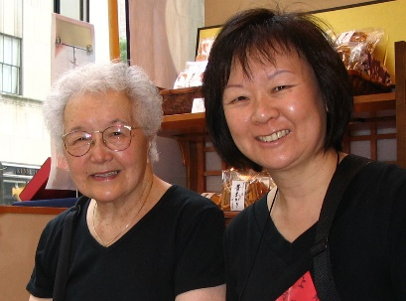

## Salted Eggs (hom don)

Source: Elsie Ng

Submitted by: Wendy Chang

2 dozen chicken eggs

2 cups kosher salt (don’t substitute)

4 quarts of water

Bring the water to boil in a pot. Turn off heat and add the salt. Stir to dissolve. Let cool. Place the eggs in a 1-gallon jar. Pour the cooled, salted water over the eggs to completely submerge them. Cover jar with a cheesecloth or waxed paper punched with a few holes. Let sit unrefrigerated. After 20 days, shift the bottom eggs to the top of the jar and the top eggs to the bottom. After 4 weeks, take one egg out to test for saltiness. If not salty enough, continue soaking. May take up to 4-6 weeks.

## Dog Food

Source: Modified from *Allrecipes*

Submitted by: Cheryle Miyao-Quock

*I make this for my favorite dog niece, Taro. This can be made ahead and frozen into individual servings.*

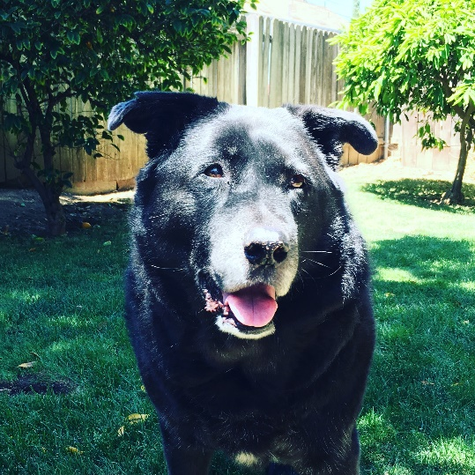

6 c. water

1 lb. ground turkey

2 c. brown rice

1 t. dried rosemary

8 oz. frozen carrots and/or green beans

Place the water, ground turkey, rice, and rosemary into a large Dutch oven. Stir until the ground turkey is broken up and evenly distributed throughout the mixture; bring to a boil over high heat, then reduce heat to low and simmer for 20 minutes. Add the frozen vegetables, and cook for an additional 5 minutes. Remove from heat and cool. Refrigerate until using.

## Dog Biscuits

Source: Modified recipe from Amy Matsunaga

Submitted by: Karen Miyao

1½ c. whole wheat flour

¾ c. oatmeal (not quick cooking)

¼ c. honey crunch wheat germ

¼ c. chunky or smooth peanut butter

¼ c. salad oil

¼ c. honey

1 t. baking powder

In large bowl, with mixer at low speed, mix 1 cup flour with remaining ingredients with ½ cup water until well blended. With spoon, stir in remaining ½ cup flour. Preheat oven to 350°F. With floured hands, on a well-floured surface, knead dough until dough holds together. Roll dough ¼” thick. With 5” x 2” bone-shaped cookie cutter, cut out as many bone shapes as possible. Re-roll scraps and cut. Repeat with remaining dough. Bake on large ungreased cookie sheet for 20 minutes. Turn oven off. Let cookie sheet remain in oven 1 hour. Remove bones from cookie sheet to wire rack. When cool, store in airtight container or freeze if not using right away. Makes about 20 dog bones.

**Our Furry Family Members**



# Homage to The Yellow Cookbook

Cheryle Miyao-Quock

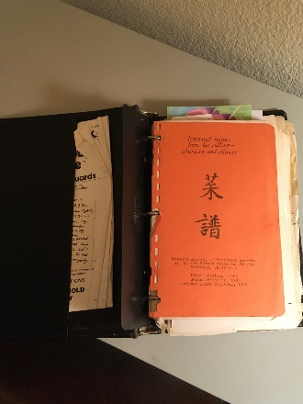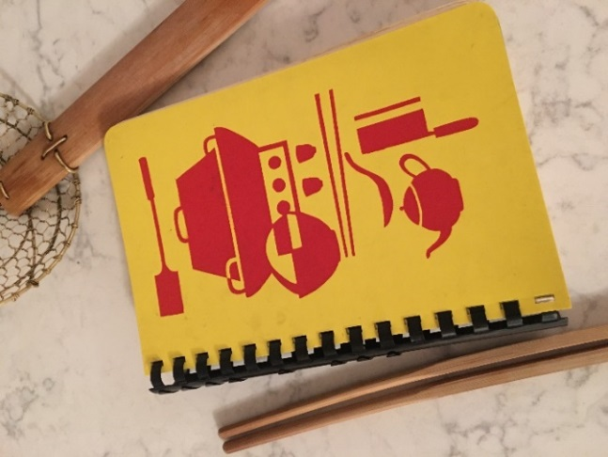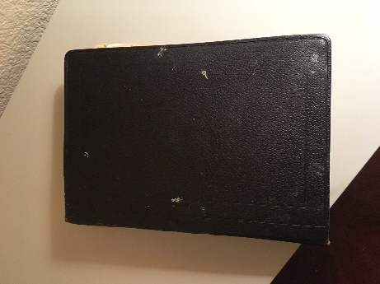Are you familiar with this cookbook? Maybe you don’t recognize it because your mother’s copy no longer has a cover and it’s now held precariously together by an old, disintegrating rubber band or it’s now bound by a black binder?

Evelyn’s copy is in a black binder so for years Diane didn’t realize when I referenced “the yellow cookbook” it was the same as “the black binder”.

Goo-Paw (Auntie Gladys) gave me this intact, updated version, republished in 1984. And the binding is coming apart.

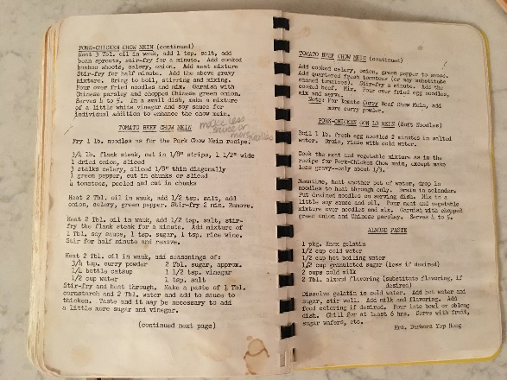My mom and I refer to this beloved recipe collection as “the yellow cookbook”. It wasn’t until we put together the first *Lowe Family Cookbook* that I took the time to read the title page and learn its true name: *Treasured Recipes from Two Cultures—American and Chinese,* published in 1966 by Women’s Society of Christian Service of St. Mark’s United Methodist Church in Stockton. I consider this a go-to resource for old school Northern California Cantonese-American cuisine. Over the years, our family has used this to guide us in the creation of various dishes for gatherings (Chicken In Foil), Chinese New Year (Kau Yook), and everyday meals (Jing Ger Yook). This cookbook is the source for several submitted recipes, including my favorite, Tomato Beef Chow Mein.

# A Brief History of the Mar Family

Annette Chan

Our great-grandfather, Ching Lowe, was married to May Mar, whose family has a long history in the United States. In fact, the Mar family has been in America for eight generations, and many of the cooks in this cookbook are members of both the Lowe and Mar families. In October 2014, I attended a Mar family reunion in Monterey, CA, to connect with members of our extended family and to learn more about our family history. On the first day of the reunion, we had dinner together in Monterey. The next day, we went to the Pacific Grove Museum of Natural History, which has an exhibit about our family, and the Hopkins Marine Station, which is currently on the site of the Chinese fishing village that our Mar family ancestors helped to found when they arrived in this country. The organizers of the reunion had arranged tours for us of the museum exhibit and the marine station. The following brief history is primarily from notes that I took during those two tours.

Around the 1850s and 1860s, two boats with people from Guangdong Province came to California. One boat landed in Mendocino, and the other landed in Monterey. Whole families were on the boats, not just men. Eventually, many of these Chinese settlers, including members of the Mar family, formed a fishing village at Point Alones. This village became the largest and most significant Chinese village in the U.S. during that time period, and these early Chinese founded the Monterey Bay fishing industry.

The Chinese fishermen caught fish and abalone, which they dried and sent to San Francisco and China. At first, no one paid much attention to them. Then, in the late 1800s, Italian and Portuguese fishermen, who competed with the Chinese for fish, began vandalizing the Chinese boats and nets. Some of the Chinese villagers went to court over this, but they were unsuccessful in their fight for justice. At that point, the Chinese changed to squid fishing. At night, they burned pitch in lanterns and hung the lanterns on the sides of their boats. The light from the lanterns attracted the squid, allowing the fishermen to catch them. Because the Italians and Portuguese fished during the day, they no longer conflicted with the Chinese.

The Chinese fishermen cleaned the large squid, dried them on wooden racks, and sold them. Small, low-quality squid were placed in barrels packed with salt, and this squid was sold to people in China as fertilizer. However, the people who purchased this squid were primarily interested in the salt. At the time, there was a high salt tax in China. By shipping salt to China in this way (essentially as packing material), the fishermen could avoid this tax. Squid fishing in Monterey is now one of the largest fishing industries in the U.S. Eventually, the fishing village became a tourist attraction, and the Chinese sold abalone shells to the tourists. Back then, the abalone were sometimes the size of dinner plates, and they had large, beautiful shells.

The village was at the edge of Pacific Grove. When the train came into the area, Pacific Grove was developed, and more people moved to Pacific Grove and nearby Monterey. The newcomers complained about the bad smell from the drying, dead fish, and the Chinese were asked to leave. People even petitioned to have them evicted. However, the Chinese fought back, and their landlords reluctantly allowed them to stay.

On April 18, 1906, the big earthquake hit San Francisco, and more Chinese people moved to the fishing village from San Francisco. Shortly after that, on May 16, 1906, a fire broke out in the village, burning much of it to the ground. Although never proven, it is believed that an arsonist may have destroyed the village.

People living in the area did not want the Chinese to rebuild their village. One villager went to court to stay in Point Alones; however, he lost his fight to remain there. Some of the Chinese relocated to McAbee Beach, and others dispersed elsewhere. The village that founded the fishing industry was now gone.

The Pacific Grove Museum of Natural History has a collection of glass plate negatives of Chinese people. These photos were taken by a man in Pacific Grove, and it is believed that they might have been taken for identification cards. As part of the Chinese Exclusion Act (1882 to 1943), people of Chinese origin in the U.S. were required to carry identification certificates at all times, or they could be arrested, forced to do hard labor, and deported.

The Hopkins Marine Station was founded in 1892, and it is the oldest marine station on the west coast of North America. Originally, it was a summer facility, located at Lovers Point. When the marine station was at Lovers Point, the Chinese community from the fishing village would interact with the Hopkins scientists. The Chinese boats were capable of going out farther than the scientists’ boats, and the Chinese would sometimes collect specimens and sell them to the scientists, such as embryos of hagfish, which are ordinarily very difficult to get. In 1917, the marine station under Stanford University was relocated to the site of the original fishing village. The facility became a year-round marine facility after that.

Most of the fishing village was located between the Hopkins Marine Station library and the Monterey Bay Aquarium and across the street from the current day American Tin Cannery. Several years ago, archaeologists from Stanford did an archaeological dig at the site and found objects, such as intact rice bowls and Chinese coins. In the Hopkins Marine Station library, a display shows Native American artifacts on one side and Chinese artifacts from the area on the other side. An urn in the marine station was the largest piece found at the site.

An unusual rock marks the location of the village. It looked like it had large teeth along its side, and people called it Monkey-Face Rock. In 1989, a large piece of the rock fell off during the Loma Prieta earthquake. People used a crane to pull the rock out of the intertidal zone. Then, they tried to drill holes into the piece to reattach it to the main rock, but they almost attached the piece upside down. They decided to stop and just leave the piece a short distance from the main rock. One of the faculty members at San Francisco State University where I work told me that he was doing research at the marine station at that time and was among the people trying to repair Monkey-Face Rock. It is good to know that people are still doing research on the Chinese fishing village and preserving remnants of it.

Additional Reading

Choy, Philip P. *Canton Footprints: Sacramento’s Chinese Legacy*. Chinese American Council of Sacramento, 2008.

Lydon, Sandy. *Chinese Gold: the Chinese in the Monterey Bay Region*. Capitola Book Company, 1985.

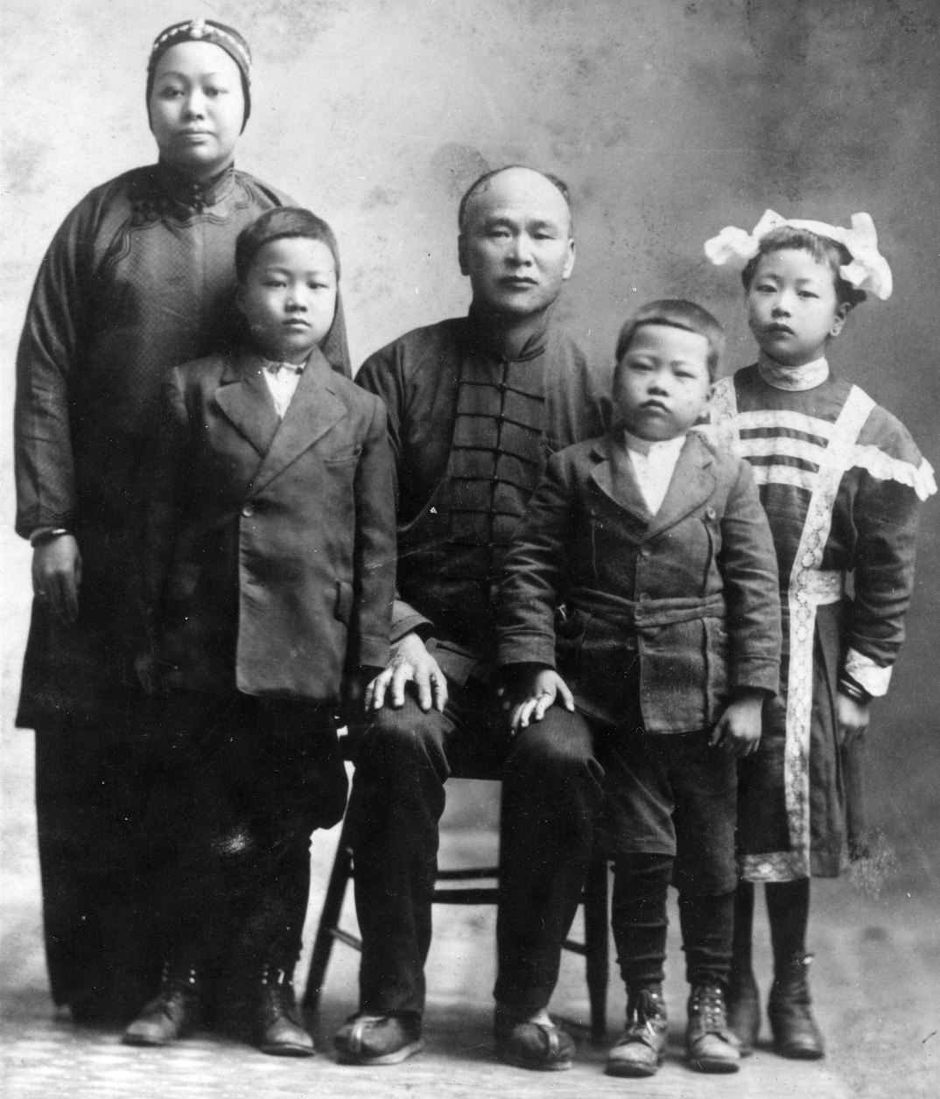

The Lowe Family

May, Herbert, Ching, Albert, & Daisy

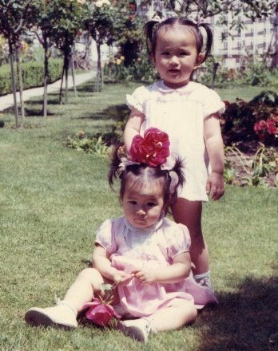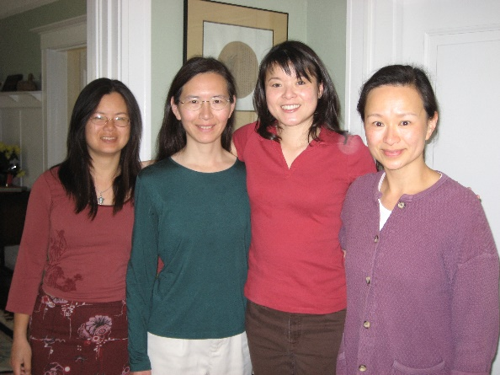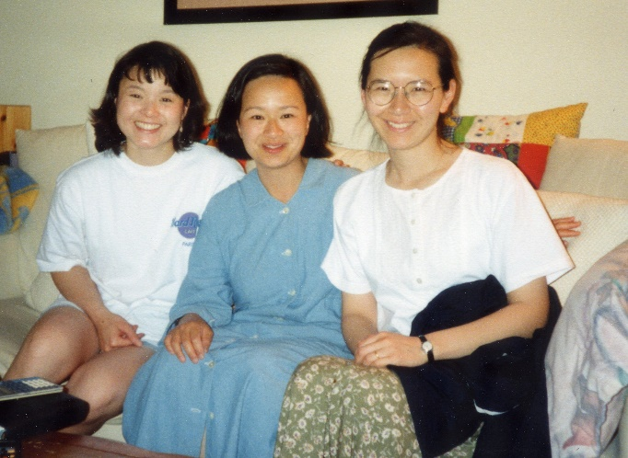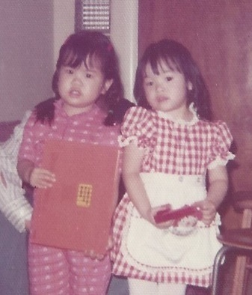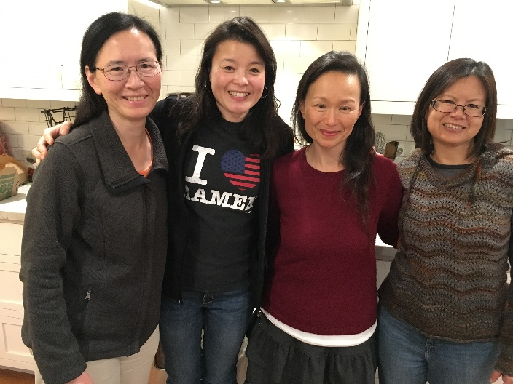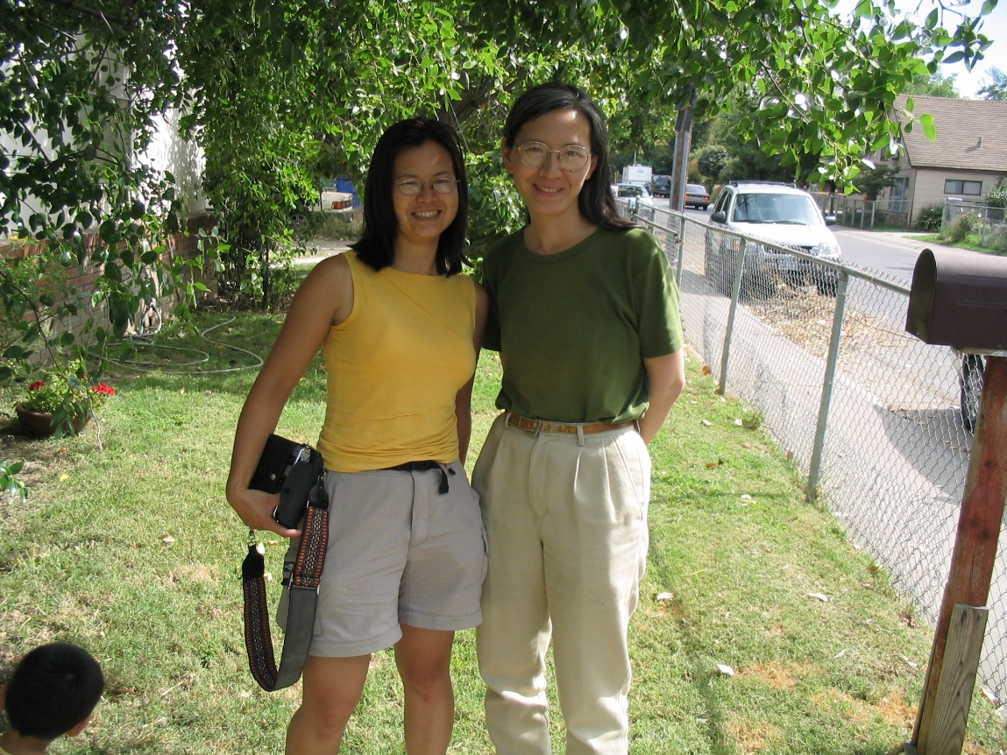

# Photo Captions

*Editors’ note: Some last names in the photos change due to married status.*

**Page 6, left to right**

Annette Chan, Diane Wong-Kone, Cheryle Miyao-Quock, and Yvonne Chan Cheng in Yvonne’s house. December 21, 2019.

**Page 7**

What better way to inspire a cookbook writing session than by cooking family recipes and eating together! Upper right photo, left to right:Cheryle Miyao-Quock, Diane Wong-Kone, Annette Chan, Yvonne Chan Cheng, and Karen Miyao in Karen’s kitchen, December 8, 2018.Bottom left photo, left to right: Diane Wong-Kone, Karen Miyao, Annette Chan, and Yvonne Chan Cheng in Karen’s kitchen, December 8, 2018.

**Page 13**

Cousins celebrating Reagan’s 6th birthday in Sacramento. Left to right: Barbara Lowe, Karen Lowe, Mary Lowe, Reagan Louie, Roberta Lowe, and Brandon Louie.

**Page 14, left to right**

Gladys Louie, George Louie, and Derrick Miyao.

**Page 16, left to right**

Art Wong and his grandson, Leo Ortega.

**Page 17, left to right**

Mary Lowe, Elsie Ng, Karen Miyao, and Annette Chan.

**Page 20, left to right**

Tim Jose, Shirley Wong, and Jessica Jose.

**Page 21, left to right**

Thomas and Philip Lee and a plate of Spam musubi!

**Page 22**

Diane Wong-Kone camping in the eastern Sierras with Charlie.

**Page 23, left to right**

Dean Quock and Cheryle Miyao-Quock.

**Page 26**

Edith Lowe.

**Page 27, left to right**

Elsie Ng, Gladys Louie, Ching Lowe, Edith Lowe, and Albert Lowe.

**Page 28, left to right**

Diane Wong-Kone and Adama Kone.

**Page 32, left to right**

Warren Ng, Lydia Lowe, and Elsie Ng.

**Page 34**

Daisy Chan holding newborn granddaughter Annette Chan and Denise Chan with first-born Yvonne Chan on Christmas day, December 1967.

**Page 36, left to right**

Joshua Cheng, Samuel Cheng, and Yvonne Chan Cheng, July 20, 2019.

**Page 39. left to right**

Carlton Chan and daughter Maria Chan.

**Page 44**

Top: George Louie.

Bottom: Photos of the second generation of pomelo from Edith Lowe’s tree, now growing in Douglas Ng’s backyard.

**Page 47, left to right**

1980 Christmas photo at Dennis Grey’s house: Parents Karen and Ken Miyao, sitting with their children (left to right) Cheryle, Derrick, and Klinton.

**Page 48, left to right**

Raymond Young, Elsie Ng, and Captoria Young at the Mar Family Reunion in Monterey, CA, 1990.

**Page 50, left to right**

Denise Chan and Elsie Ng in Denise’s kitchen in Piedmont, CA.

**Page 51**

On the King’s hops ranch in Sacramento, CA. Back row, left to right: Daisy Chan, David Chan, and Gladys Louie.

Front row, left to right: Barbara Lowe, Brandon Louie, and Karen Miyao (Lowe).

**Page 54, left to right**

Aloha! Karen and Ken Miyao.

**Page 55, left to right**

Karen Miyao and Cheryle Miyao-Quock marketing Ray Yeung’s heirloom tomatoes in Sacramento, which is sometimes called “the Big Tomato”.

**Page 56, left to right**

Denise Chan, Evelyn Wong, and Diane Wong-Kone celebrating Evelyn’s 90th birthday, July 2019.

**Page 58**

Cade Joji, born in January 2020 to Klinton and Alexis Miyao, was the newest addition to our family at the time of book publishing.

**Page 59, left to right**

Thomas Lee, Annette Chan, and Philip Lee.

**Page 65, left to right**

Wedding dinner for Evelyn and Sam Wong on April 20, 1952. Circling clockwise around the table: Daisy Chan, David Chan, Alfred Wong, Evelyn Wong, Sam Wong, Jr., Elsie Chan, Anna Wong, Sam (Pops) Wong, and Chester Chan.

**Page 66, left to right**

Carlton and Regina Chan.

**Page 68, left to right**

Klinton Miyao, Derrick Miyao, and Cheryle Miyao-Quock.

**Page 69, left to right**

Cheryle Miyao-Quock, Gladys Louie, Dean Quock, and George Louie October 21, 2006.

**Page 71, left to right**

Daisy Chan with son David.

**Page 73, left to right**

Gladys Louie (in background), Daisy Chan, Karen Miyao (Lowe), and Edith Lowe in Oakland, CA, circa 1951.

**Page 74, left to right**

Christina Wong and Nathaniel (Nat) Wong.

**Page 76**

David Chan enjoys a moment at home with daughters Yvonne (right) and Annette (left).

**Page 79, left to right**

Brothers, Clifford and Carlton Chan.

**Page 80**

Top: Reagan Louie on the Kings hops ranch in Sacramento.

Bottom, left to right: Reagan Louie and Robin Wu.

**Page 85**

Daisy Chan on the ferry from Oakland to San Francisco.

**Page 86**

Denise Chan cooking in her home with a giant wok.

**Page 87, left to right**

Cousins Carlton Chan and Cheryle Miyao-Quock circa 1970.

**Page 88**

Proud grandparents (standing) Sammy and Wendy Chang with son James, holding daughter Emiko, and daughter-in-law Jennifer, holding new son William.

**Page 89**

George Louie.

**Page 90, left to right**

Siblings David, Evelyn, and Elsie Chan on the ranch in Sacramento, CA, circa 1931.

**Page 91**

Sacramento cousins growing up (left to right) on the Louies’ front porch: Karen Miyao (Lowe), Brandon Louie, Mary Lowe behind Roberta Lowe, Barbara Lowe, and Reagan Louie.

**Page 93**

Bottom, left to right: brothers Derrick and Klinton Miyao.

**Page 94, left to right**

Ken and Karen Miyao, May 2018.

**Page 96, left to right**

Warren and Elsie Ng.

**Page 99, left to right**

Annette and Yvonne Chan at a pumpkin patch in 1971.

**Page 100, left to right**

Evelyn Wong, Diane Wong-Kone, and Shirley Wong at the Mar Family Reunion in Monterey in 2014.

**Page 101, left to right**

Klinton, Ken, and Derrick Miyao, October 22, 2006.

**Page 103**

Cousins enjoying a Chinese lunch in Sacramento (left to right): Roberta Lowe-Taylor, Barbara Lowe, Mary Lowe, Diane Wong-Kone, and Karen Miyao.

**Page 105, left to right**

Lydia and Robert Lowe.

**Page 106**

Brandon Louie with parents Gladys and George Louie at the Mayflower Restaurant, celebrating Cheryle Miyao-Quock and Dean Quock’s upcoming wedding, October 2006.

**Page 108**

Evelyn Wong in Edith Lowe’s house on W Street in Sacramento in 1953.

**Page 110**

George Louie.

**Page 112, left to right**

Sam Wong, Evelyn Wong, Douglas Ng, and Diane Wong-Kone.

Bottom picture, left to right: Clifford Chan, Calvin Lowe, and Debi Lowe.

**Page 115**

Party at Denise’s house in Piedmont, CA. Back row, left to right: Mary Lowe, Denise Chan, Karen Miyao, Brandon Louie, Barbara Lowe, Elsie Ng. Front row, left to right: Roberta Lowe-Taylor, Evelyn Wong.

**Page 116**

Denise and David Chan at their Piedmont house with children Yvonne (left), Carlton (in Denise’s arms), and Annette (right) in 1969.

**Page 117, left to right**

Elsie Ng, Gladys Louie, David Chan, Evelyn Wong and George Louie gathered around David’s kitchen table.

**Page 118**

Gladys Louie and Captoria Young.

**Page 120**

Lydia Lowe with daughters (left to right) Mary, Roberta, and Barbara.

**Page 124, left to right**

Sam and Evelyn Wong.

**Page 126, left to right**

Hunter Hovland, Jessica Hovland, and Tyler Hovland.

**Page 129, left to right**

Brian Larson, Aubree Larson, Beth Ng, Jamie Ng, and Gary Ng.

**Page 131, left to right**

Elsie Ng, Jamie Ng, and Gary Ng.

**Page 133, left to right**

Annette Chan and Charles Lee.

**Page 137, left to right**

Diane Wong-Kone and Cheryle Miyao-Quock.

**Page 139**

Ken Miyao with Philip at the Japanese Food & Cultural Bazaar at the Buddhist Church of Sacramento.

**Page 144, left to right**

Dean Quock and Cheryle Miyao-Quock May 2018.

**Page 145, left to right**

Edith Lowe and daughter Karen in 1952.

**Page 152**

Top, left to right: Yvonne Chan Cheng and Andy Cheng.

Bottom, left to right: Parents Andy Cheng and Yvonne Chan Cheng with their children Annie, Samuel, and Joshua.

**Page 156, left to right**

Wendy Chang and Karen Miyao.

**Page 157**

Bessie Chun from Hawaii at the Mar Family Reunion, 1990.

**Page 159, left to right**

Karen Miyao and Gladys Louie.

**Page 160**

Gladys Louie.

**Page 161**

Wedding day portrait with mom Daisy Chan, daughter Evelyn, and flower girl Mary Lowe, 1952.

**Page 163**

Cheryle Miyao-Quock and her brothers, Klinton (left) and Derrick (right), pose for the annual

Christmas photo.

**Page 165**

Lydia Lowe relaxing with daughters Barbara (left) and Mary (right).

**Page 166, left to right**

Evelyn and Sam Wong, dancin’ the night away.

**Page 167, left to right**

Karen Miyao, Annette Chan, and Yvonne Chan Cheng.

**Page 170, left to right**

Karen Lowe, Barbara Lowe, and Mary at the Louies’ home in Sacramento, July 26, 1953.

**Page 172**

Mary Lowe, Karen Miyao (Lowe), and Barbara Lowe enjoy favorite family recipes at Mary’s birthday party in 1957 at Aunt Gladys and Uncle George’s house in Sacramento, CA.

**Page 173**

Karen Miyao (right) with daughter Cheryle.

**Page 175**

Karen Miyao and Evelyn Wong get ready to serve the fruit basket cake at a family gathering at the Miyaos’ home in 1998.

**Page 177**

Evelyn and Sam Wong prepare to cut their wedding cake on April 20, 1952, as maid of honor Elsie Ng looks on.

**Page 182, left to right**

Evelyn Wong and Karen Miyao.

**Page 184, left to right**

Barbara Lowe, Mary Lowe, and Karen Miyao.

**Page 185**

Mary Lowe.

**Page 187**

Clifford Chan relaxing at Wendy and Sammy’s house in Danville.

**Page 194**

Thomas Lee preparing to pop cookies into the oven.

**Page 197, left to right**

Yvonne Chan Cheng and Annette Chan.

**Page 198**

Derrick Miyao.

**Page 201**

Douglas Ng making his Foolproof Pie Dough for a Single-Crust Pie.

**Page 203, left to right**

Susanna Wong, Nat Wong, and Christina Wong.

**Page 207**

The Wong family enjoys dinner at the old Silver Dragon Restaurant in Oakland Chinatown in the mid-1990s (left to right): Susanna Wong, Art Wong, Diane Wong, Courtney Wong, Evelyn Wong, Sam Wong, Nat Wong, Joel Jose, Tim Jose, Jessica Jose, and Shirley Wong-Jose.

**Page 208, left to right**

Alexis Paddock and Klinton Miyao.

**Page 209, left to right**

Cousins Annie Cheng, Thomas Lee, Matthew Chan, and Philip Lee.

**Page 210**

The Lee family, Charles, Annette, Philip, and Thomas, living the Trekkie dream.

**Page 212**

Evelyn Wong with daughter Diane, circa 1970.

**Page 215**

Daisy Chan (left) and Edith Lowe (right) shopping in Los Angeles Chinatown in 1949.

**Page 217**

Top, left to right: Denise Chan, Elsie Ng, and Annette Chan with Lucy, Elsie’s dog, 2019.

Bottom, left to right: Elsie Ng with daughter Wendy Chang.

**Page 218**

Derrick’s dog, Taro.

**Page 224**

Left column, starting from top: 1) left to right: Annette Chan, Cheryle Miyao-Quock, Yvonne Chan Cheng, and Diane Wong-Kone, December 2018. 2) Yvonne Chan Cheng standing and Annette Chan sitting; 3)Diane Wong-Kone; 4) Cheryle Miyao-Quock.

Middle column: 1) Annette Chan; 2) Yvonne Chan Cheng; 3) left to right: Diane Wong-Kone and Cheryle Miyao-Quock.

Right column, starting from top, 1) left to right: Diane Wong and Annette Chan in front of Aunt Gladys and Uncle George’s house in Sacramento, CA (2005); 2) left to right: Cheryle Miyao-Quock, Yvonne Chan Cheng and Annette Chan on Cheryle’s couch in Southern California on April 26, 1997, where the idea for the first Lowe cookbook all started; 3) left to right: Diane Wong-Kone, Annette Chan, Cheryle Miyao-Quock, and Yvonne Chan Cheng.

# pearl river delta100.jpgFinding Home

Diane Wong-Kone

One day a few years back, while visiting the California Museum in Sacramento, I found a book titled *Canton Footprints* by Philip Choy in the back of the gift store on the bottom shelf. Finding this book became the start of my search to find our family’s home in China. I picked up this book because it contained a map of the Pearl River Delta, our family’s home. I showed the map to my mom, Evelyn Wong, who informed me that her family (Lowe) was from the Sam Yup District.

Guangdong Province districts, 1852 from (Choy, 2007).

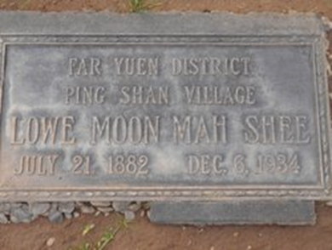Maybe a year later, my cousin Mary Lowe sent a photo of my great grandmother May Mar’s gravestone from Sacramento’s East Lawn Cemetery. The stone contained the name of the district and family village. May Mar was married to Ching Lowe, my mom’s grandfather.

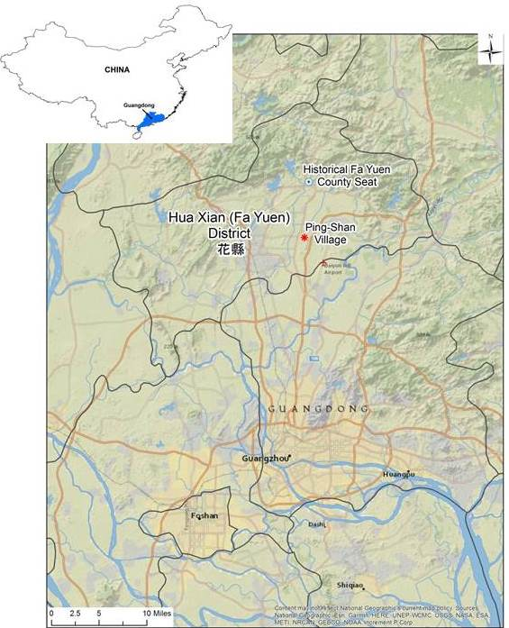Fa Yuen, fortunately, was depicted in the map in Choy’s book. Unfortunately, and to my dismay as an American-born Chinese who is unfamiliar with reading Chinese characters, I found that finding Ping-Shan on a map was not an easy task. Maps written in English letters typically included names in Chinese, not Cantonese, and spellings were inconsistent. I found that Fa Yuen could be alternately called Fahsien in Cantonese and Hua-Hsien or Huaxian in Chinese. Originally, I could not read my great grandfather Ching Lowe’s gravestone because it was in Chinese, but mom showed me the characters for Fa Yuen and Ping Shan. Using modern technology and a lot of squinting, I was then able to compare the Chinese characters on the maps from China. I found one 1950 topo map showing the location of Ping-Shan and having found that, I was able to search Google Maps online. On this map, a transparent “ghost” road named Ping-Shan Road was visible and I found a dot labeled Pingshancun, located west of the Guangzhou Baiyun International Airport. When my cousin, Yvonne, informed me that “cun” means village in Chinese, I knew I had finally found our family’s home in the Pearl River Delta. Although urban development of Guangzhou may soon transform the old farm fields of the local villages, I find it gratifying to know the location of our ancestral village.

Map showing the location of Ping-Shan Village in Fa Yuen District, north of Guangzhou (23°25'15.73"N / 113°15'21.51"E Mapdatum WGS 84).

Moon “May” Mar’s headstone from East Lawn Cemetery.